Q. Compare a server-rendered application (e.g. PHP) - having its presentation layer in server-side logic - with a Rich-web approach (having is presentation layer as client-side logic). Mention two advantages of each approach

A. The benefits of a php server-rendered application is that these are used for mostly used in a website for displaying images and text, which means that there is little space for errors. There is little error for inactivity. Obviously this is becoming obsolete as continuous development has brought out the method of rendering pages on the client side. This is where the rich web approach comes into place. These are built using a server to provide continuous data processing on the client side. This enhances the webpage immensely and obviously makes the server rendered method a thing of the past.

Q. Explain how the box model works in CSS using example code in your answer

A. In the CSS box model as stated in the name each element is presented as a box as shown in the figure below from the slides.

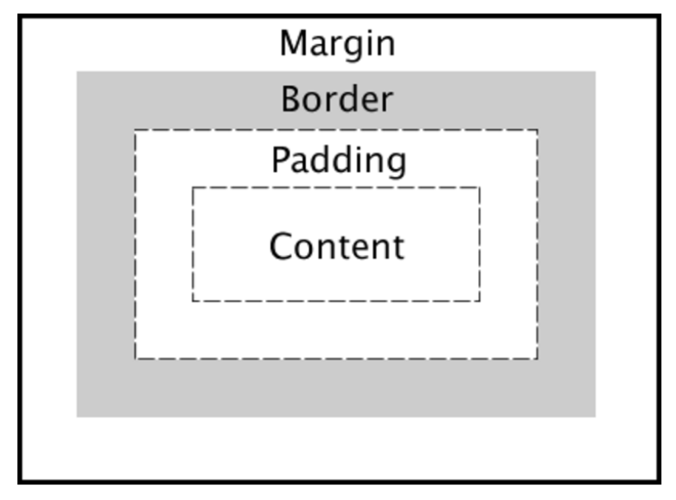

When a web page loads it renders the it works out what styles are used to the content of each box. It sees how big the surrounding layers are e.g. wrappers and where the boxes reside in relation to one another. Coding example below

div {

    width: 320px;  
    padding: 10px;  
    border: 5px solid black;  
    margin: 0;

}

Q. Suppose your web App has to run on an older browser that does not have built-in support for the fetch() API. Sketch an outline of how the fetch() API could be poly-filled in Javascript based on the XMLHttpRequest() API

A. To begin with this I would check the version of the browser you are using. If the browser is the older then use the Http request method using the Http request to go to the event target. As shown in the code below.

function httpGetAsync(URLhere, callback)

{

var xmlHttp = new XMLHttpRequest();

xmlHttp.onreadystatechange = function() {

if (xmlHttp.readyState == 4 && xmlHttp.status == 200)

callback(xmlHttp.responseText);

}

xmlHttp.open("GET", URLhere, true);

xmlHttp.send(null);

}

Q. CSS allows the reuse of code for styling DOM elements. Javascript functions can all be used for element styling and support code reuse. Compare the two code sharing approaches

A. CSS is used by a programmer to design a web page. It can be used to alter or design the page how the programmer sees fit. In Javascript for example a function can be created and information can be pulled from a user based website by asking URL. The URL could then be amended and the URL would pass the function to return a JSON object as seen in lab 2. When it runs it will first the information about the user of will be returned and then the information linked to said user. Like github used in lab 2.

Q. Describe the Web Component abstraction and explain its perceived advantages as a separation-of-concerns mechanism over other single responsibility approaches

A. In this component you can separate all aspects of a web page into their different components and If there are bugs the component can be removed and fixed the easily slotted back in this component also maintains a kind of MVC model.

Q. Describe how a React JS stateful class component is created and how its instantiated life-cycle can be managed

A. Components in react let you divide the UI into independent, reusable pieces and alter each piece as you like. It is created by accepting a “props” with data that returns a react element. To prolong lifecycles of the of the component it is imperative to look after the garbage disposal e.g. when components are destroyed. In react the functions componentDidmount and componentWillUnmount are used to accomplish this. Managing these correctly and handling the garbage disposal in an efficient manor the life-cycle can be optimised.

Q. In asynchronous programming, we have three approaches to handling data which may or may not arrive at some point in the future, namely callbacks, promises and streams. Describe each of these approaches. Are there any significant drawbacks of each in your opinion?

A. In relation to asynchronous programming callback functions implement the logic when you provide and I/O request and it will execute at the point when the request has been filled. Whenever the code needs to make a request that will take a long time to complete this when the callback method can be implemented. In relation to the browser it stores this function for execution. In relation to promises, these are values which are used to deliver said values when the response arrives and the value will either be a success or an error. These can also be passed into functions as arguments. In relation to stream these are abstractions used to model asynchronous data sources. If you don’t know the size or when it will arrive at your application the stream is an efficient way to process the data in these circumstances. Streams act like arrays e.g. ordered lists of data, they also implement the observer pattern.

Q1. From my understanding and a bit of research it seems that rich web application development is developing web apps with similar characteristics to that of a desktop application software e.g. social messaging app. There is not much contrast between this and traditional web development. Both are built using the same web technologies and the main contrast between the two is probably their purpose.

Websites are generally used to promote information and may use JavaScript to enhance input etc. but CSS can achieve most of these goals, whereas Web apps are generally processing data and therefore rely a lot more on JavaScript as a whole. HTML and CSS are generally both used as well but more towards styling the app and less on functionality.

Q2. The Document Object Model is a logical structure documents and the way it is assessed and manipulated, a browsers internal representation of the page content. The DOM is generally a tree-structure representing hierarchical relationship between enclosing documents and their enclosed elements. It is created and styled with HTML and CSS. JavaScript is also used for read and write access to the DOM and also has complete access while doing this.

To get access to the DOM, one must first get a reference to one or more nodes by one of a number of native accessor methods. When a web page is loaded the browser creates a DOM of the page. Then JavaScript has all the power to create a dynamic HTML.

* JavaScript can alter any HTML element in the page
* Can change all CSS styles in the page
* Can add or remove HTML elements to the page
* Can create new HTML events in the page

1. The big idea in functional programming is the separation of the functions that operate on data from the data on which they operate

* This separation lends itself to the idea of function composition where in chained pipelines of functions operate on data transforming at each stage and passing the results onto the next phase
* The benefit is the resultant composition can implement potentially complex transformations in a very readable and maintainable way
* The functional expression of a problem is often more obvious and easier to reason about

A functor is a data object that can hold elements of any data type and also implements the map operation. The functor’s map function takes, as an argument, another function and calls that function for each element of the functor resulting in a new functor. Example in notes

// Javascript arrays are functors

['123', '456', '789']

   .map(s => parseInt(s))

   .map(n => n / 10)             // => [12.3, 45.6, 78.9]

2. The flex box model aims to give a more efficient way to lay out align and distribute space among items in a container (.container {}). The main idea is to get the most out of the available space given to the container e.g. fit different size screens width/height and so on.

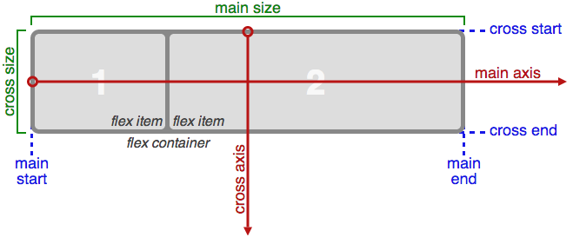

* stream is a sequence of data elements
* stream is an abstraction for some data which may or may not be present
* streams implement the observer pattern
* useful for styling and ui
* RxJS library is useful for network responses which would mean less coding and and time saved importing from what is needed from the libraries