**SessionOn**

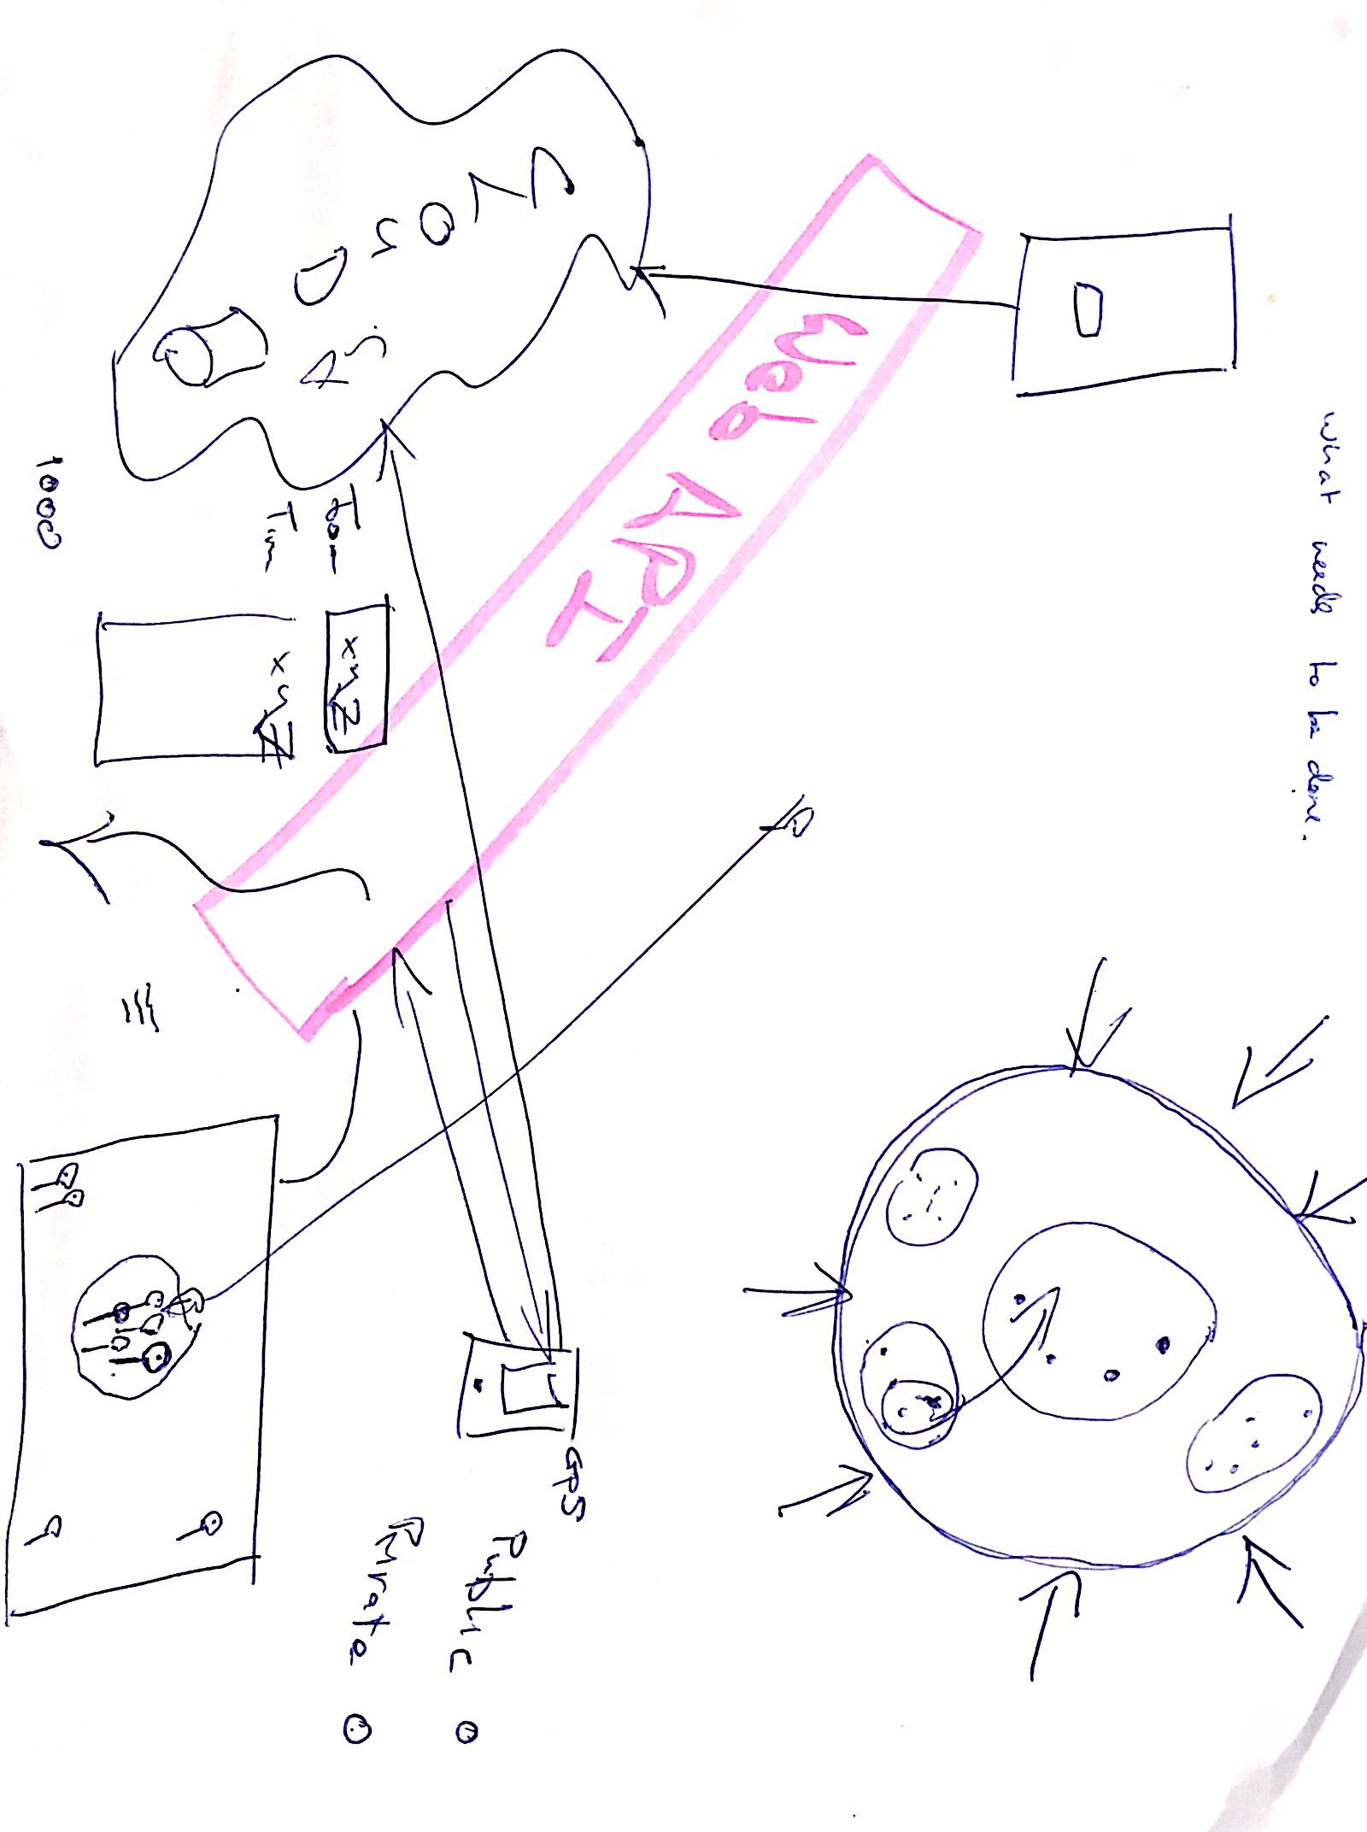

**What each part needs**

**App**

* Needs to connect to cloud through API
* Have a user friendly UI
* Have a login and password
* Options to broadcast location, see others location, check into location, see others locations, choice to join the sesh.

**API**

**Cloud**

* Needs to store user info and location using SQL or firebase
* Process data e.g. give live updates (maybe every 2 seconds) and store co-ordinates

**Geo Location**

**Phone**