Part 1 : Answers

Implement a user’s table having a username and hashed password fields. Use the PostgreSQL crypt() and gen_salt() functions to implement the password hashing

Implement a protected resource table (e.g. a “products” table) to which you can use to demonstrate your authentication features

Steps:

Create Database

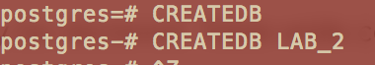

Create Password and Username

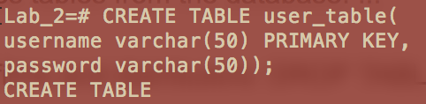

Select * from user_table;

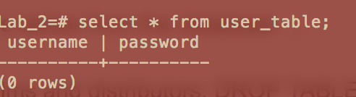

Inserting into the table

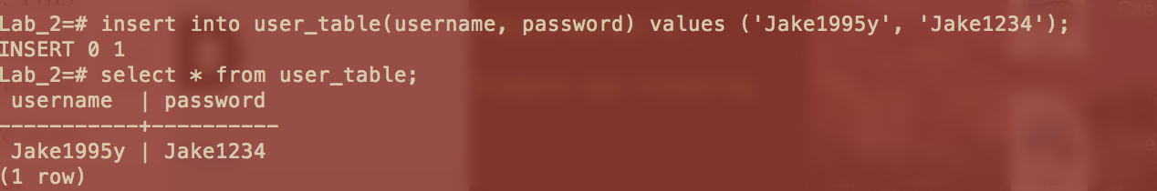

Using Crypt()

