This uses node.js, postgres, express and sequalize

cd auth-system

node server.js

register

check your cookies

under localhost

there should be a userid, which holds the JWT

upon Logout it will be deleted

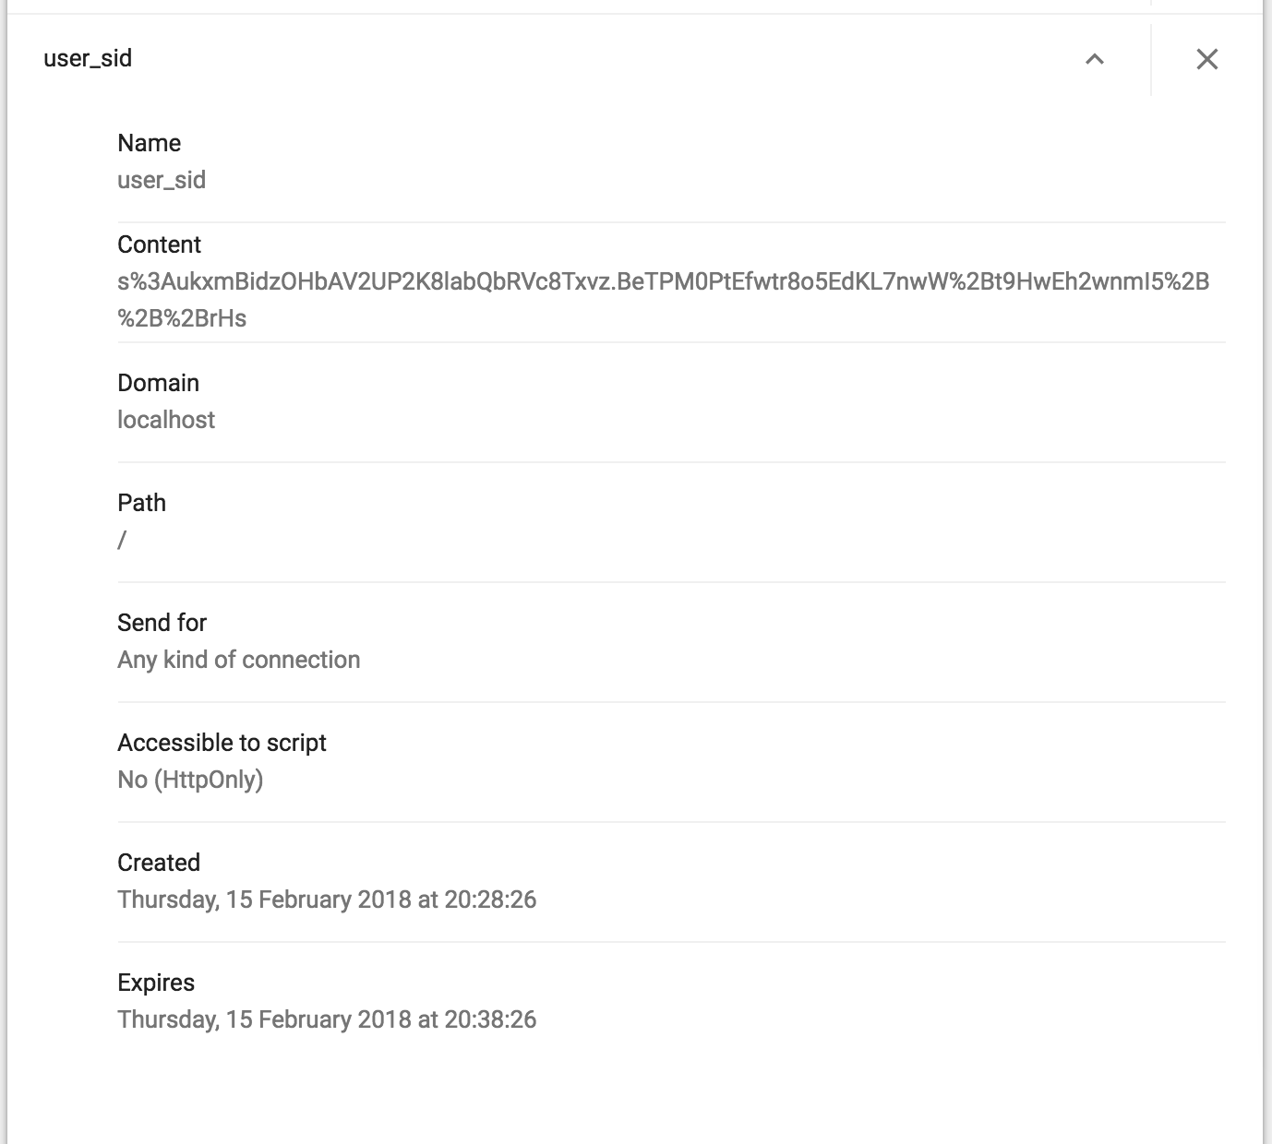

Cookies show the JWT as well as the expiry which is 24hrs