

International School
Capstone Project 1
CMU-SE 450 – C1SE.04

Project Proposal
Version 1.0 Date: Aug 27th, 2026

SocraticKid: A Pedagogically Safe Agentic Tutor with Dynamic Scaffolding

Submitted by
Thong, Nguyen Cao
Thien, Luu Vu
Thong, Le Huu
Bao, Nguyen Gia

Approved by
MSc Linh, Le Duy

Proposal Review Panel Representative:

Name Signature Date

Capstone Project - Mentor:

Name Signature Date

PROJECT INFORMATION

Project acronym | SK
Project Title | SocraticKid: A Pedagogically Safe Agentic Tutor with Dynamic Scaffolding
Start Date | 21 August 2026 | End Date | 06 December 2026
Lead Institution | International School, Duy Tan University
Project Mentor | Linh, Le Duy
Scrum master | Thien, Luu Vu
Partner Organization | Duy Tan University
Project Web URL
Team members | Name | Email | Tel
 | Thong, Nguyen Cao | pandatech0610@gmail.com | 0934909569
 | Thien, Luu Vu | warface2005tk@gmail.com | 0919324219
 | Thong, Le Huu | bass030196@gmail.com | 0768463655
 | Bao, Nguyen Gia | ngbaog@gmail.com | 0938086668

The following signatures are required for approval of this document.

Thong, Nguyen Cao  Student ID: 29219053135  Team Member | Signature | Date
Thien, Luu Vu  Student ID: 29211140533  Scrum Master | Signature | Date
Thong, Le Huu  Student ID: 29219038101  Team Member | Signature | Date
Bao, Nguyen Gia  Student ID: 29219053725  Team Member | Signature | Date

REVISION HISTORY

Version | Date | Comments | Author
1.0 | Aug 27th, 2026 | Initial Release | C1SE.04 Team

TABLE OF CONTENT
1. Introduction 5
1.1 Purpose of Document 5
1.2 Project Goal 5
2.Problem Definition 5
2.1 Business need 6
2.2 Solution 6
3. Current Status of Art 7
4. Engineering Approach 8
4.1 System context diagram 8
4.2 System context description 8
4.3 Technical Constraints Technical to develop: 9
5.Tasks and Deliverables 10
6. Project Management 12
6.1 Cost/Budget for Project 12
6.2 Tentative Schedule 13
6.2.1 Master Plan 13
6.2.2 Scrum Process 15
7. Project Constraints 16
8. Conclusion 17
9. References 17

1. Introduction

1.1 Purpose of Document
The document provides an overview of the project includes the purpose and scope of the project.
Identify business needs, problems or situations related to the initialization and construction projects.
Provide solutions for business needs and give the overview of system architecture.
Provide overview about resources, schedule, solution and budget for the project.

1.2 Project Goal
The primary goal is to develop an advanced educational platform, SocraticKid, that acts as a pedagogically safe agentic tutor to enhance student learning. The project aims to achieve dynamic scaffolding by using specialized AI agents to estimate current knowledge, detect logical errors, and determine the appropriate level of hints without providing direct answers. Additionally, the system is designed to enforce "intentional friction," requiring students in grades 4–9 to perform a reasoning step before receiving further assistance. Another core objective is pedagogical safety, ensuring all content is age-appropriate and effectively correcting misconceptions

2.Problem Definition
In the context of the rapid integration of artificial intelligence in education, fostering independent thinking is more urgent than ever. Providing immediate support to students is essential, but current AI chatbots often fail to deliver a sound pedagogical experience because they rely heavily on giving direct answers too early. Students interacting with these models can easily become dependent on the AI, which significantly reduces their own cognitive effort and self-reflection. This over-reliance leads to a high answer leakage rate and hinders the development of critical thinking skills. There are also substantial challenges for educators, as they struggle to accurately measure learning gains or identify specific misconceptions when students simply copy AI-generated solutions. In addition, young learners need guidance to navigate complex subjects safely, but lack access to a structured tutoring system that adapts to their current understanding. Therefore, there is a pressing need for a comprehensive multi-agent system that balances automated assistance with the cognitive effort required from the learner.

2.1 Business need
Ensuring pedagogical safety and promoting independent cognitive effort for students.
Make it easier for educators and parents to monitor student progress and trace knowledge.
More effective at enforcing "intentional friction" to prevent answer leakage and reliance on AI.
Help students receive dynamic, customized hints and immediate corrections for their misconceptions.
The application can help, share and inspire students to truly learn subjects like Math, English.

2.2 Solution
To address these critical educational needs, the proposed solution is the SocraticKid system, a comprehensive Multi-Agent AI tutoring platform that connects students, educators, and parents into a single learning ecosystem. The solution automates the scaffolding process using specialized AI agents (Knowledge Tracing, Misconception, Scaffolding, and Safety Agents) to estimate current knowledge, ensure age-appropriate content, and provide targeted hints without giving away the final answer. It features a robust Misconception Agent capable of detecting logical errors in real-time to gently guide the student back on track. For pedagogical effectiveness, the system automatically enforces "intentional friction," requiring the learner to complete a reasoning step before unlocking the next hint. The platform provides distinct dashboards: a statistical and monitoring view for educators/parents to review learning gains, hint appropriateness, and student independence, and an interactive tutoring interface for public users (students) to engage with subjects like 5th-grade fractions, 7th-grade equations, and A1-A2 English safely.

3. Current Status of Art

 | SocraticKid | Standard Chatbots (ChatGPT/Claude) | Educational AI Tutors (e.g., Khanmigo) | Traditional ITS (Rule-based Tutors)
Conversational AI Interface | X | X | X
Direct Answer Prevention (Intentional Friction) | X |  | X | X
Misconception Detection | X | X | X
Dashboard (Learning History) | X |  | X | X
Multi-Agent Architecture | X
Dynamic Scaffolding & Learner Model | X |  | X | X
Our system overcomes the limitations of existing educational AI solutions that cause student over-reliance and hinder independent thinking, by:
Providing a unified Multi-Agent AI platform for monitoring a student's learning progress, detecting misconceptions, and adjusting scaffolding in real time.
Enhancing user convenience by delivering clear, visual, and easily understandable learning analytics (such as learning gain and student independence) through a web-based dashboard.
Allowing educators and parents to directly access learning history, identified logical errors, answer leakage rates, and hint logs without complex procedures.
Enabling the system and educators to actively monitor cognitive progress, apply "intentional friction" dynamically, and respond pedagogically to knowledge gaps before the student becomes frustrated.

4. Engineering Approach

4.1 System context diagram

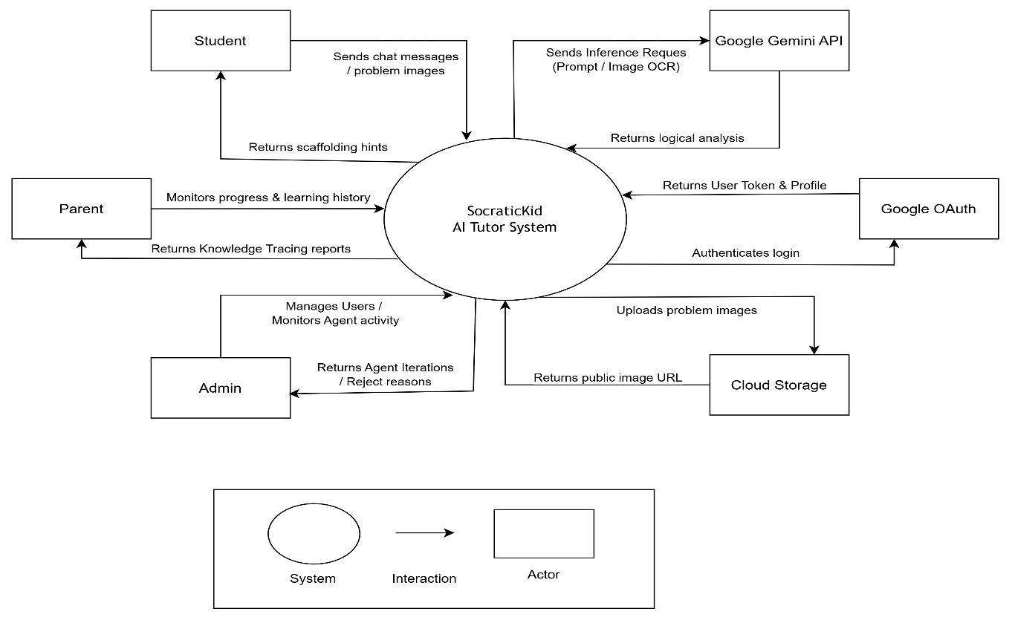

4.2 System context description
- Student:
  - Students can authenticate identity securely via Google OAuth.
  - Students can submit chat messages, problem descriptions, and image uploads (OCR).
  - Students can submit reasoning steps and answer reflection prompts to trigger intentional friction.
  - Students receive progressive scaffolding hints instead of direct answers.
  - Students can view their learning history and chat sessions.
- Parent:
  - Parents can monitor student learning progress and chat history.
  - Parents receive Knowledge Tracing reports to evaluate the student's mastery level.
  - Parents can track Student Independence metrics to ensure the child is not overly reliant on AI.
- Administrator:
  - Administrators can authenticate identity securely via Google OAuth.
  - Administrators can manage user accounts (Students and Parents).
  - Administrators can monitor detailed Agent activity.
  - Administrators can track Reviewer reject reasons to validate pedagogical safety.
  - Administrators can extract research metrics and log evidence to evaluate the effectiveness of the Socratic method.
- Google Gemini API:
  - LLM Service processes inference requests containing system prompts, chat context, and image data.
  - LLM Service acts as the reasoning engine for specialized agents.
  - LLM Service generates and returns structured logical analysis to the core system.
- External Utilities (OAuth & Cloud Storage) :
  - Google OAuth: Handles the authorization flow and returns User Profile & Token.
  - Cloud Storage (AWS/Cloudinary): Processes and stores uploaded problem images, returning public URLs for LLM processing.

4.3 Technical Constraints Technical to develop:
  - Programming language: TypeScript (Frontend), Python (Backend).
  - Library: Next.js (React), FastAPI, Google Generative AI SDK, Prisma ORM.
  - Technology: Client–Server Architecture, RESTful API, Agentic AI, Prompt Engineering.
  - Database: PostgreSQL (Neon Serverless).
  - Deployment & Hosting: Vercel (Frontend), Render (Backend), Cloudinary (Cloud Storage).
  - Version Control System: GitHub.
  - Team Management: TechKan, Discord.
  - Develop tools: Visual Studio Code, Postman.
- Environments:
  - Internet Connection
  - Supported Browsers: Google Chrome, Microsoft Edge.
- Other Constraints:
  - Resource: 4 people.
  - Budget: Limited.
  - Time: The project must be completed within 4 months.
  - These features are not available in the first version of the product.

5.Tasks and Deliverables

No. | Task name | Description
1. | Initial & Requirement Gathering
1.1 | Project kick off meeting | Meeting the developer team and stakeholder to clear out the goal, defining of the base elements for the project and other project planning activities.
1.2 | Create Proposal & Define Architecture | Drafting the project proposal, defining the core technology stack, and designing the Multi-Agent system architecture.
2. | Development
2.1 | Sprint 1: | Initiation, Workflows & Core Infrastructure Setting up the developer environments, establishing Git workflows, deploying CI/CD pipelines, and connecting to the foundational PostgreSQL database.
2.2 | Sprint 2: | Authentication & Core User Management Integrating Google OAuth for secure login, implementing JWT authorization middleware, and managing user profiles alongside academic grade settings.
2.3 | Sprint 3: | UI/UX Foundation & App Layout Defining the global Design System, building the core 3-pane responsive layout, and developing the foundational chat input box with auto-scroll capabilities.
2.4 | Sprint 4: | Markdown Rendering, Mathematics & Chat Bubbles Integrating Markdown and LaTeX renderers to correctly display formulas, and finalizing the interactive Chat Bubble UI to distinguish user and AI messages.
2.5 | Sprint 5: | Core AI Integration & Orchestrator Architecture Establishing end-to-end communication with the Gemini AI via Next.js proxy and FastAPI, and developing the Orchestrator Agent to accurately route user intents.
2.6 | Sprint 6: | Multi-Agent System & Socratic Pedagogy Developing specialized AI Agents that strictly follow the Socratic method (providing hints, not direct answers), and building a Reviewer Agent loop to enforce pedagogical quality.
2.7 | Sprint 7: | Session Management & Persistent State Designing database schemas to persist chat histories and building the Sidebar interface for users to create, auto-save, and seamlessly resume past learning sessions.
2.8 | Sprint 8: | Advanced Chat Interactions & State Refactoring Implementing advanced chat session interactions (Rename, Pin, Delete) and refactoring the frontend to use a robust Global State management system (Zustand).
2.9 | Sprint 9: | Multimedia & Image Processing Enabling client-side image compression and Cloud storage uploads, while integrating Multimodal OCR capabilities so the AI can read and solve math problems from student photos.
2.10 | Sprint 10: | UI/UX Upgrades & Animations Applying a premium Dark Mode (Midnight Forest) theme with glassmorphism effects, and integrating interactive Lottie animations (SocraticOwl mascot) to engage students.
2.11 | Sprint 11: | Reflection Flow, Warnings & Knowledge Tracing Building the Reflection flow to correct student misconceptions (changing UI colors and disabling image attachments), logging AI internal thoughts, and tracking the student's knowledge level.
2.12 | Sprint 12: | Admin Dashboard & Content Management Creating a protected Admin Dashboard to visualize user analytics and AI logs, alongside developing a comprehensive CRUD library for teachers to input math problems.
2.13 | Sprint 13: | Optimization, Testing & Final Deployment Executing end-to-end testing, optimizing performance/SEO, addressing security vulnerabilities (XSS/CORS), and finalizing project documentation for the official product launch.
3 | Project’s Retrospective Meeting | Private meeting between members to make plan what will be presented to customer in the final release
4 | Final Release | Release the final version to product owner with complete function

6. Project Management

6.1 Cost/Budget for Project

Full Name | Role | Salary Rate (USD/hour)
Thong, Nguyen Cao | Team Member | 2
Thien, Luu Vu | Scrum Master | 2
Bao, Nguyen Gia | Team Member | 2
Thong, Le Huu | Team Member | 2
Table 1. Cost person/hours

No | Criteria | Price (USD) | Total (USD)
1 | Development Working Hours | 2 (per hour) | 1792
2 | LLM APIs Cost (Gemini API – Free Tier) | 0 | 0
3 | Database Hosting (Neon PostgreSQL - Free Tier) | 0 | 0
4 | Domain, SSL Certificate & Contingency Fund | 80 | 80
 | Total |  | 1792
Table 2. Total cost estimation

Description | Amount | Unit
Number of members | 4 | Person
Total estimated working hours per member | 224 | Hours
The cost per hour per member | 2 | USD
Miscellaneous & Contingency | 80 | USD
Table 3. Description
The explanation for the table
  - Working Hours Cost: 4 members * 224 hours/member * 2 USD = 1792 USD. (Note: This represents the billable hours strictly allocated for core system integration and final deployment phases).
  - Miscellaneous & Contingency (80 USD): By strategically utilizing the Gemini API Free Tier and a zero-cost database plan (Neon PostgreSQL Free Tier), the project eliminates direct infrastructure running costs for the MVP. The 400 USD budget is therefore securely allocated as a contingency fund for emergency technical scaling, premium UI/UX assets, and registering a custom domain with SSL certificates for the final public release

6.2 Tentative Schedule

6.2.1 Master Plan

NO | Task Name | Duration | Start | Finish
1 | Initial & Requirement Gathering | 10 days | 17 – Aug – 2026 | 26 – Aug – 2026
1.1 | Project Kick-off Meeting | 4 days | 17 – Aug – 2026 | 20 – Aug – 2026
1.2 | Create Proposal & Define Architecture | 6 days | 21 – Aug – 2026 | 26 – Aug – 2026
2 | Development | 93 days | 27 – Aug – 2026 | 27 – Nov– 2026
2.1 | Sprint 1: | 9 days | 27 - Aug -2026 | 4 - Sep - 2026
2.2 | Sprint 2: | 7 days | 5 - Sep - 2026 | 11 - Sep - 2026
2.3 | Sprint 3: | 7 days | 12 - Sep - 2026 | 18 - Sep - 2026
2.4 | Sprint 4: | 7 days | 19 - Sep - 2026 | 25 - Sep - 2026
2.5 | Sprint 5: | 7 days | 26 - Sep - 2026 | 2 - Oct- 2026
2.6 | Sprint 6: | 7 days | 3 - Oct- 2026 | 9 - Oct- 2026
2.7 | Sprint 7: | 7 days | 10 - Oct - 2026 | 16 - Oct - 2026
2.8 | Sprint 8: | 7 days | 17 - Oct - 2026 | 23 - Oct - 2026
2.9 | Sprint 9: | 7 days | 24 - Oct - 2026 | 30 - Oct - 2026
2.10 | Sprint 10: | 7 days | 31 - Oct - 2026 | 6 - Nov - 2026
2.11 | Sprint 11: | 7 days | 7 - Nov - 2026 | 13 - Nov - 2026
2.12 | Sprint 12: | 7 days | 14 - Nov - 2026 | 20 - Nov - 2026
2.13 | Sprint 13: | 7 days | 21 - Nov - 2026 | 27 - Nov - 2026
3 | Project’s Retrospective Meeting | 3 days | 28 – Nov – 2026 | 30 – Nov – 2026
4 | Final Release | 1 days | 1– Dec– 2026 | 1– Dec– 2026

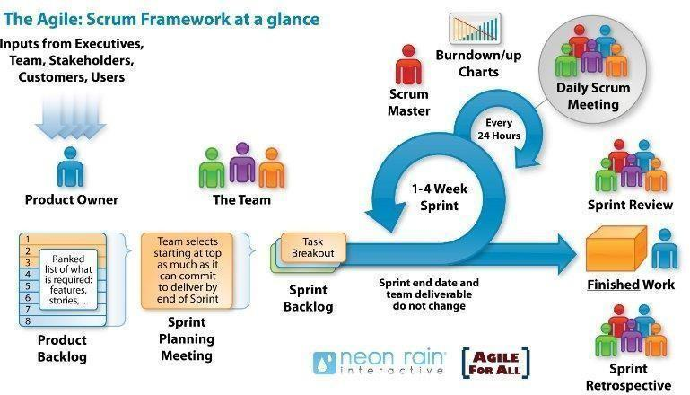
6.2.2 Scrum Process

- Scrum is an iterative and incremental agile software development framework for managing software projects and product or application development.
- Scrum focuses on project management institutions where it is difficult to plan ahead.
- Mechanisms of empirical process control, where feedback loops that constitute the core management technique is used as opposed to traditional command-and
-control management.
- Its approach to planning and managing projects is by bringing decision-making authority to the level of operation properties and certainties.
- Benefit of the methodology:
  - Project can respond easily to change.
  - Problems are identified early.
  - Customers get the most beneficial work first.
  - Work done will better meet the customer’s needs.
  - Improved productivity.
  - Ability to maintain a predictable schedule for delivery.

7. Project Constraints

Constraint | Constraints Description | Guidelines for Acceptance
Economic | High ongoing API costs for Large Language Models (Google Gemini) at scale.  Cloud server hosting and database storage expenses. | System operational cost per active user must remain within the allocated budget. The pricing model (if commercialized) must be affordable for target families.
Environmental | Data processing on cloud centers contributes to energy consumption.  High client-side processing can drain mobile/laptop batteries quickly. | Optimize AI queries (e.g., caching frequent answers) to reduce GPU/CPU energy consumption and minimize device battery drain.
Ethical | Strict compliance with child privacy laws (e.g., COPPA, GDPR-K).  Risk of AI generating inappropriate, harmful, adult, or manipulative content. | Personal data must be strictly anonymized and encrypted. Must implement robust content moderation (Guardrails) with 100% reliability to block unsafe AI outputs.
Public health, safety, and welfare | Risk of emotional dependency or over-reliance on AI.  UI must be clear to avoid distracting drivers. | Chatbot must include built-in screen time limit reminders and encourage children to consult parents or teachers for emotional and physical health concerns.
Social and Global | Need for educational equity (accessible to children from low-income or remote areas).  Interfaces must be intuitive for young age groups. | The system should be accessible, easy to use, and support equitable learning opportunities for a diverse user population.
Cultural | Compliance with Vietnamese educational values and social norms.  Alignment with local school curricula | AI must adopt respectful Vietnamese communication standards. Educational contents must align with the Vietnamese General Education Curriculum and family values.
Sustainability | The system should use maintainable technologies and a modular architecture that supports future expansion, new subjects, and AI model upgrades. | Code must be maintainable and scalable for future teams to update or expand.

8. Conclusion
This product provides a comprehensive AI-powered educational solution designed to support children in their learning journey while assisting parents and educators in monitoring academic progress. The system leverages advanced artificial intelligence technologies to deliver personalized tutoring, answer student questions in real time, and adapt learning content to individual needs and skill levels. By offering accessible and engaging educational support, the chatbot aims to improve learning outcomes, increase student motivation, and reduce barriers to quality education. The project is expected to be completed within 04 months at a cost of no more than $1,792.

9. References
[1]. Software Development Standards for the Guidance and Control Software Project: https://sw-eng.larc.nasa.gov
[2]. General Software Coding Standards and Guidelines: https://www.nws.noaa.gov/oh/hrl/developers_docs/General_Software_Standards.pdf
[3]. Scrum and best practices: https://docs.microsoft.com/en-us/azure/devops/boards/sprints/best-practices-scrum?view=azure-devops
[4]. The Scrum Guide: https://www.scrum.org/resources/scrum-guide
[5]. The ISO/IEC & IEEE/EIA Standard 12207, IEEE standards: IEEE-829 [3], IEEE-1008 [5], IEEE-1012
[6]. Gemini API Documentation: https://ai.google.dev/api
[7]. LangChain Documentation: https://python.langchain.com/docs/

