
International School

Capstone Project 1
CMU-SE 450 AIS

Project Proposal
Version 1.3
Date: 24/08/2021

Online Clinic Booking System

Submitted by

Truong Gia Huy
Tran Nguyen Thanh Hong
Le Van Xuan
Ngo Van Kha

Approved by
Master Nguyen Tan Thuan

Proposal Review Panel Representative:

Name Signature Date

Capstone Project 1- Mentor:

Name Signature Date


PROJECT INFORMATION
Project acronym | OnClinic
Project Title | Online Clinic Booking System
Start Date | 15 Aug 2021 | End Date | 15 Dec 2021
Lead Institution | International School, Duy Tan University
Project Mentor | Master Thuan, Nguyen Tan  Email: nguyentanthuan@dtu.edu.vn
Scrum master / Project Leader & contact details | Every member of the team takes turns in charge
Partner Organization | N/A
Team Members
Student ID | Name | Email | Tel
24211206450 | Huy, Truong Gia | truonggiahuy7799@gmail.com | 0972173687
24207106137 | Hong, Tran Nguyen Thanh | thanhhong24102000@gmail.com | 0782363961
24211207159 | Xuan, Le Van | levanxuan5518@gmail.com | 0905596460
21211210573 | Kha, Ngo Van | ngokha437@gmail.com | 0935950384

REVISION HISTORY
Version | Date | Comments | Author | Approval
1.0 | 22 AUG 2021 | Add payment feature by e-wallet | Team
1.1 | 24 AUG 2021 | Comments and corrections. | Team
1.2 | 1 SEP 2021 | Fix minor mistakes and edit font | Team
1.3 | 12 SEP 2021 | Comments and corrections. | Team

Table Of Contents

1. Introduction 5
1.1. Purpose 5
1.2. Scope 5
2. Problem Definition 5
3. Current Status of Art 5
4. Engineering Approach (including solution alternatives) 7
4.1. System Context Diagram 7
4.2. Technology Constraints 8
5. Tasks and Deliverables 9
5.1 Task 9
5.2 Deliverables 10
6. Project Management 11
6.1. Cost/Budget for Project 11
6.2. Tentative Schedule 12
6.2.1. Master Schedule 12
6.2.2. Human Resource 13
7. Project Constraints 13
8. Conclusion 15
9. References 15

1. Introduction

1.1. Purpose
The online clinic booking system will build an android app so that people can book medical appointments. At the same time, the patient can measure the heart rate through the camera system. In particular, this app uses AI to meet the minimum needs of patients when it is not possible to come directly to the hospital.

1.2. Scope
This document provides an overview of the project. It includes an overview of the product, an overview of the process, and an overview of the project team.
This document provides a plan for each stage of the software development process based on the Scrum process including start time, end time, and a number of working days. This is the general plan and will be updated with detail of the software development process in the next document.
→ The online clinic booking system was built to make medical examination and treatment easier for everyone, especially in the complicated situation of the Covid-19 epidemic. Take advantage of the era of advanced technology and the application of technologies to solve the medical examination and treatment needs of everyone.

2. Problem Definition
Currently, with the Covid-19 situation, most economic activities are affected. Most of the activities have stopped working. To help people stay at home can be convenient for medical examinations.
In addition, the increase in people's living standards leads to an increase in the need for medical examination and treatment, but most subjects such as office workers or the elderly have limited mobility to visit, as well as meet the technology needs of the 4.0 area.
Our team decided to build an online clinic booking system for patients and doctors at home. Users manipulate the system through mobile applications.

3. Current Status of Art
Currently, there are many online clinics and medical examination booking applications, including some applications such as: "EDoctor", "Bookingcare", "YouMed", "SUNS APP", ... In where "Edoctor" and "Bookingcare" are the two most-used apps.
- Edoctor is a mobile application for health care and monitoring for all subjects. Edoctor supports users to book appointments at some clinics, request medical examinations and tests at home. This application is also programmed quite well when allowing users to create online medical records to track the progress of medical examination and treatment, medical history of themselves and their families. (https://suns.com.vn/top-10-app-dat-lich-kham-benh-tot-nhat-hien-nay/)
- YouMed is an application that supports accurate search by symptom, disease name, doctor name. Support to book an appointment for yourself or a loved one in 3 simple steps, and an accurate appointment will save you from waiting in line. (https://suns.com.vn/top-10-app-dat-lich-kham-benh-tot-nhat-hien-nay/)
- SUNS App is an appointment booking application that allows patients to choose the time frame, visit date, choose the doctor they want, and remind the patient before the time of medical examination and treatment and re-examination. (https://suns.com.vn/top-10-app-dat-lich-kham-benh-tot-nhat-hien-nay/)
- BookingCare is a comprehensive Healthcare Platform that provides a technology platform that makes it easy for patients to choose the right doctor from a network of qualified specialists, with verified information and quick booking. (https://bookingcare.vn/page/cau-hoi-thuong-gap-p3)
Advantage:
· Common feature of these applications is to book clinic appointments. Saves patients from having to queue or wait for offline visits to hospitals or clinics
· The application provides users with an attractive preferential price. Because the examination is online, it will help users save travel costs along it will help people save more money than going to the doctor offline.
· Schedule an appointment to help patients save more time. Help patients receive prompt and timely treatment.
· Helps users feel safe, not worrying about their health.
· Allows users to create online medical records to track the progress of medical examination and treatment, medical history of themselves and their families.
Disadvantages:
· Applications that allow booking clinic appointments do not yet allow online examination, and online examination applications do not allow booking appointments at clinics.
· Online medical examination and treatment applications are not very accurate. The doctor just listens to the patient's description and then makes a diagnosis. However, there are a few apps that allow testing and then diagnosis. However, testing methods are limited. Not exactly.
· There are cases of fake clinics, deceiving customers, but clinic booking applications have not eliminated these problems.
Solution:
· Integrates two scheduling systems, including online appointment booking and offline appointment booking.
· Using AI technology to measure the patient's heart rate, blood pressure, ... and other health indicators. Making online diagnostics more accurate and for user retention.
· Create a ranking of hospitals, clinics, doctors, ... to help patients choose the hospital, clinic, doctor, ... more suitable for themselves. Along with that, helping patients avoid bad hospitals, bad clinics, bad doctors, ...
→ Because of the above advantages, disadvantages, and solutions, our team has launched an application called "Clinic Booking".

4. Engineering Approach (including solution alternatives)
OnClinic allows connecting patients with doctors:

The application allows patients to access basic functions such as book a clinic, examine, pay, review medical history, vote and evaluate for the user who is a patient. In addition, all patient history information is also kept confidential.

The users who are doctors can register for new clinics (if any) and use functions such as schedule management, patient management, review medical history.

Moreover, the system has the function of direct examination through the camera by using AI technology to measure the patient's heart rate. About design, build user interface based on user experience, simplicity, and ease of use.

4.1. System Context Diagram

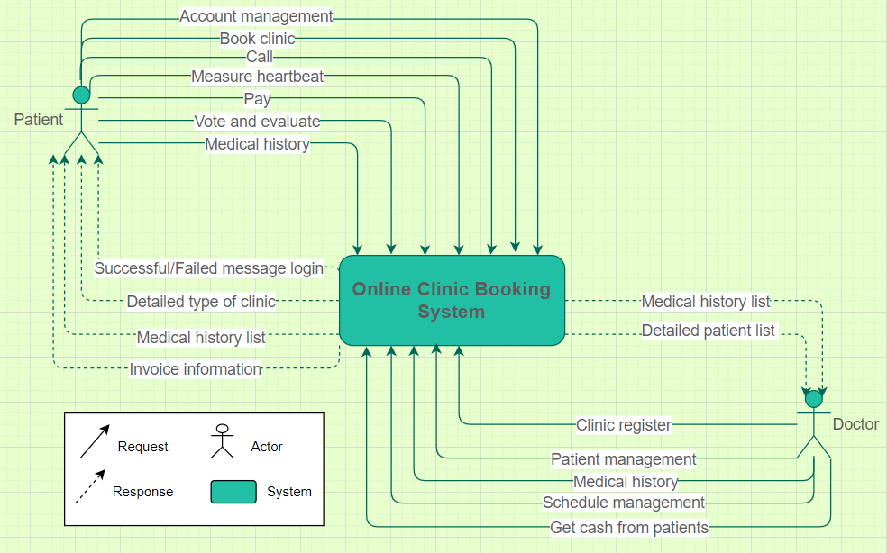
Figure 1: System Context Diagram
The “Online Clinic Booking System” with key features that meet business requirements includes:
For patient role:
· Account management: user can update profile information, change password or forgot password
· Book clinic: allows user to choose online or person-to-person examination, choose the suitable clinic place
· Call: for the user to examine online through a video call with the doctor
· Measure heartbeat: user measures heart rate with the phone's camera
· Pay: user will paying online when finished examine by e-wallet
· Vote and evaluate: user rate stars and leave a comment for the clinic or doctor to let them know and improve
· Medical history: when the user finished examining, a medical history will auto-create, and you can check again here
For doctor role:
· Clinic register: Registering a clinic for the first time using the system, clinic information will be saved in the system for patients to be able to search and book an appointment.
· Patient management: allows the doctor to manage patient information such as viewing, editing, deleting patients
· Schedule management: The doctor arranges the schedule on the system, confirms the appointment with the patient
· Medical history: when the user finished examining, a medical history will auto-create, and you can check again here
· Get cash from patients: allows the doctor to receive money from the patient when the examination is complete

4.2. Technology Constraints

- For Mobiles application development:
- Language: Java, Python
- Database: SQLite
- Technique: OpenCV, Real-Time Heart Rate Monitoring From Facial RGB Color Video Using Webcam by H. Rahman, M.U. Ahmed, S. Begum, P. Funk.
- Business constraints:
- Resource: 04 people
- Budget: Limited
- Time: The project must be completed in 3 months
- Environment: Android, Virtual Machine.

5. Tasks and Deliverables

5.1 Task

WBS NUMBER | TASK TITLE
1 | Preparation
2 | Learn About The "Agile" Process
3 | UI Design
4 | Learn Mobile Application Programming Knowledge In Java Language
5 | Develop a Database Of Actors
6 | Coding Online Medical Examination Function
7 | Coding Offline Medical Examination Function
8 | Integrated Online And Offline Medical Examination System
9 | Coding Ranked List Of Clinics And Hospitals
10 | Coding The Functions Of Login, Registration, Forgot Password
11 | Testing
12 | Integrate
13 | Deploy
14 | Release

5.2 Deliverables

NO | ACTIVITIES | DELIVERABLES
1 | Project Proposal | Project Proposal Document
2 | Project Plan | Project Plan Document
3 | Product Backlog | Product Backlog Document
4 | Architecture Document | Architecture Document
5 | Database Design | Database Design Document
6 | Interface Design | Interface Design Document
7 | Test Plan | Test Plan Document
8 | Test Case | Test Case Document
9 | Sprint Backlog & Burndown Chart | Sprint Backlog & Burndown Chart
10 | Team Reflection | Team Reflection

6. Project Management

6.1. Cost/Budget for Project
o Cost Estimation
Description | Amount | Unit
Number of members | 4 | Persons
Number of working hours per day | 5 | Hours
The number of working days | 112 | Days
Salary for one hour | 2 | $

o Detail Cost Estimation:
· The explanation for the table
· Amount of working hours = 114 * 4 * 5 = 2280 hours
· Total Cost Estimate = 2280 * 2= 4560$
· Responsibility
· The detail of Responsibility will be mentioned in the later documents of each phase.

6.2. Tentative Schedule

6.2.1. Master Schedule

No. | Task | Duration | Starting Day | Ending Day
1 | Start-Up | 28 days | 23/8/2021 | 19/9/2021
1.1 | Gathering Requirement | 2 days | 23/8/2021 | 24/8/2021
1.2 | Create Proposal Document | 4days | 25/8/2021 | 28/8/2021
1.3 | Project’s Kick-off Meeting | 1 day | 29/8/2021 | 29/8/2021
1.4 | Create Documents:  + Project Plan  + Database Design  + Product Backlog & US  + Test Case  + UI, Architecture Design | 20 days | 30/8/2021 | 18/9/2021
1.5 | Review Documents | 1 day | 19/9/2021 | 19/9/2021
2 | Development | 84 days | 20/9/2021 | 12/12/2021
2.1 | Sprint 1 | 21 days | 20/9/2021 | 10/10/2021
2.2 | Sprint 2 | 21 days | 11/10/2021 | 31/10/2021
2.3 | Sprint 3 | 21 days | 01/11/2021 | 21/11/2021
2.4 | Sprint 4 | 21 days | 22/11/2021 | 12/12/2021
3 | Project Meeting | 1 day | 13/12/2021 | 13/12/2021
4 | Final Release | 1 day | 14/12/2021 | 14/12/2021
Total: |  | 114 days

6.2.2. Human Resource

Full Name | Position | Phone | Email
Ngo Van Kha | Member | 0935950384 | ngokha437@gmail.com
Truong Gia Huy | Member | 0972173687 | truonggiahuy7799@gmail.com
Tran Nguyen Thanh Hong | Member | 0782363961 | thanhhong24102000@gmail.com
Le Van Xuan | Member | 0905596460 | levanxuan5518@gmail.com

7. Project Constraints

Constraint | Constraints Description
Economic | · Offers a free app that is easily accessible to all basic smartphone users.
Environmental | · Creating an airy, quiet, civilized environment for the clinic because the application has a preset schedule with a fixed time, or online medical examination, avoiding the crowd scene at the clinic.  · The application is installed on mobile simply, consumes less performance and memory of the phone.
Ethical | · The app has identity authentication by the login.  · Does not collect user personal data for personal purposes.  · Ensure the safety of users' personal information
Public health, safety, and welfare | · The application is completely safe for users’ health.  · Stimulating people to take care of their health, as well as promoting the development of clinics everywhere, ensuring the health of the majority of people.  · Features easy-to-use home camera heart rate measurement, providing a measurement system to all basic smartphone users to warn of health risks.
Social and Global | · The application brings a convenient tool in the 4.0 technology era, thereby encouraging people to pay more attention to their health care.  · It is also aimed at the elderly with limited mobility, office workers with little free time during office hours, the application is easy to install, easy to use, practical, and easy to receive.  · Online medical examination is suitable for the pandemic.
Cultural | · It is an easy app to reach any culture in the world.  · Motivate people to go to the clinic for health care
Sustainability | · The application only requires a smartphone and does not require high performance to use.  · The application will have a comment section so that users can give comments, the team will consider editing or develop more features if necessary.  · Need little personnel to maintain the app because it's not too complicated to maintain.  · The need, as well as the convenient biometric heart rate measurement feature of the application, will retain users.

8. Conclusion
Recently, many systems have emerged that allow rescheduled visits to clinics and hospitals. However, the limitations of these systems are that they do not allow online diagnosis and the lack of trust from some clinics has not been properly evaluated. The solution here is that our application will provide online medical examination and treatment services and online payments, as well as add a feature to rate and feedback clinics that allow customers to have an objective view of the quality of the clinic.
The application is built in java language, runs on the android platform, uses android studio tool to code. In addition, the biometric feature - measuring heart rate by camera built in python language with pycharm to execute.
The team consulted similar platforms to come up with ideas and paths, with references across similar platforms. In particular, the group also researched biometric technology - measuring heart rate by a camera that was studied by researchers H. Rahman, M.U. Ahmed, S. Begum, P. Funk at The 29th Annual Workshop of the Swedish Artificial Intelligence Society (SAIS 2016).
The total cost for the whole project is 4000$ for 4 members to implement. Completed in an estimated time of 125 days.
The project is conducted on the scrum process. Each team member is rotated to take on different roles in the process.

9. References
No. | References | Document Information
1 | Scrum model | https://www.scrum.org/professional-scrum-certifications/professional-scrum-master-assessments
2 | Real-Time Heart Rate Monitoring | https://www.researchgate.net/publication/301790316_Real_Time_Heart  _Rate_Monitoring_from_Facial_RGB_Color_Video_Using_Webcam
10. Attachment: DESCRIPTION OF PRODUCT REQUIREMENTS FORM

- END –

- Mentor's confirmation:
