LAPORAN QUIZ 3
Pemrograman Web

Zenith Bites — Web Food (Fullstack)
Tech Stack: React (Vite) + Express.js + MySQL (Sequelize) + Node.js

Nama: Steve Valentino Wijaya
NIM: 242310026

1. Screenshot Code Backend

1.1 Routes routes/menuRoutes.js
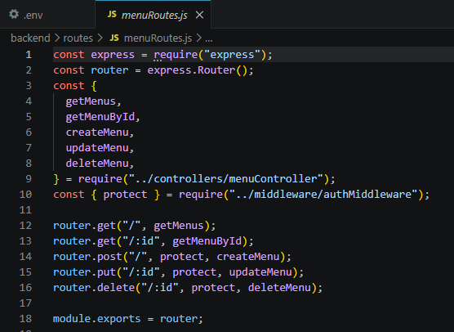routes/orderRoutes.js
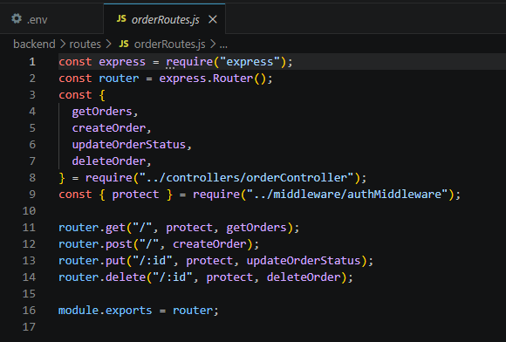routes/authRoutes.js
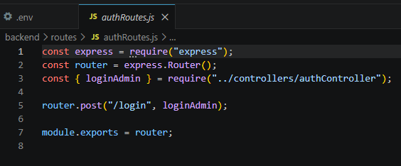

1.2 Controllers controllers/menuController.js
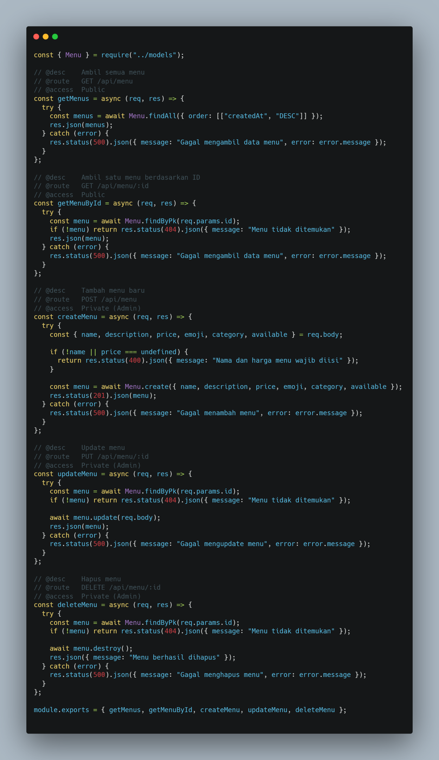

controllers/orderController.js

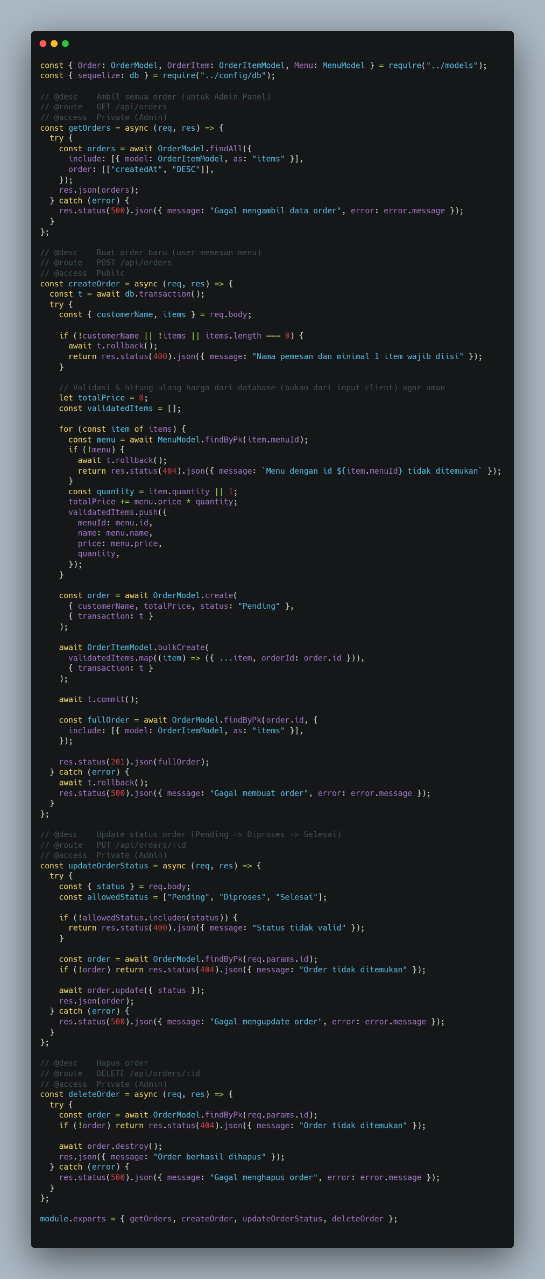

controllers/authController.js

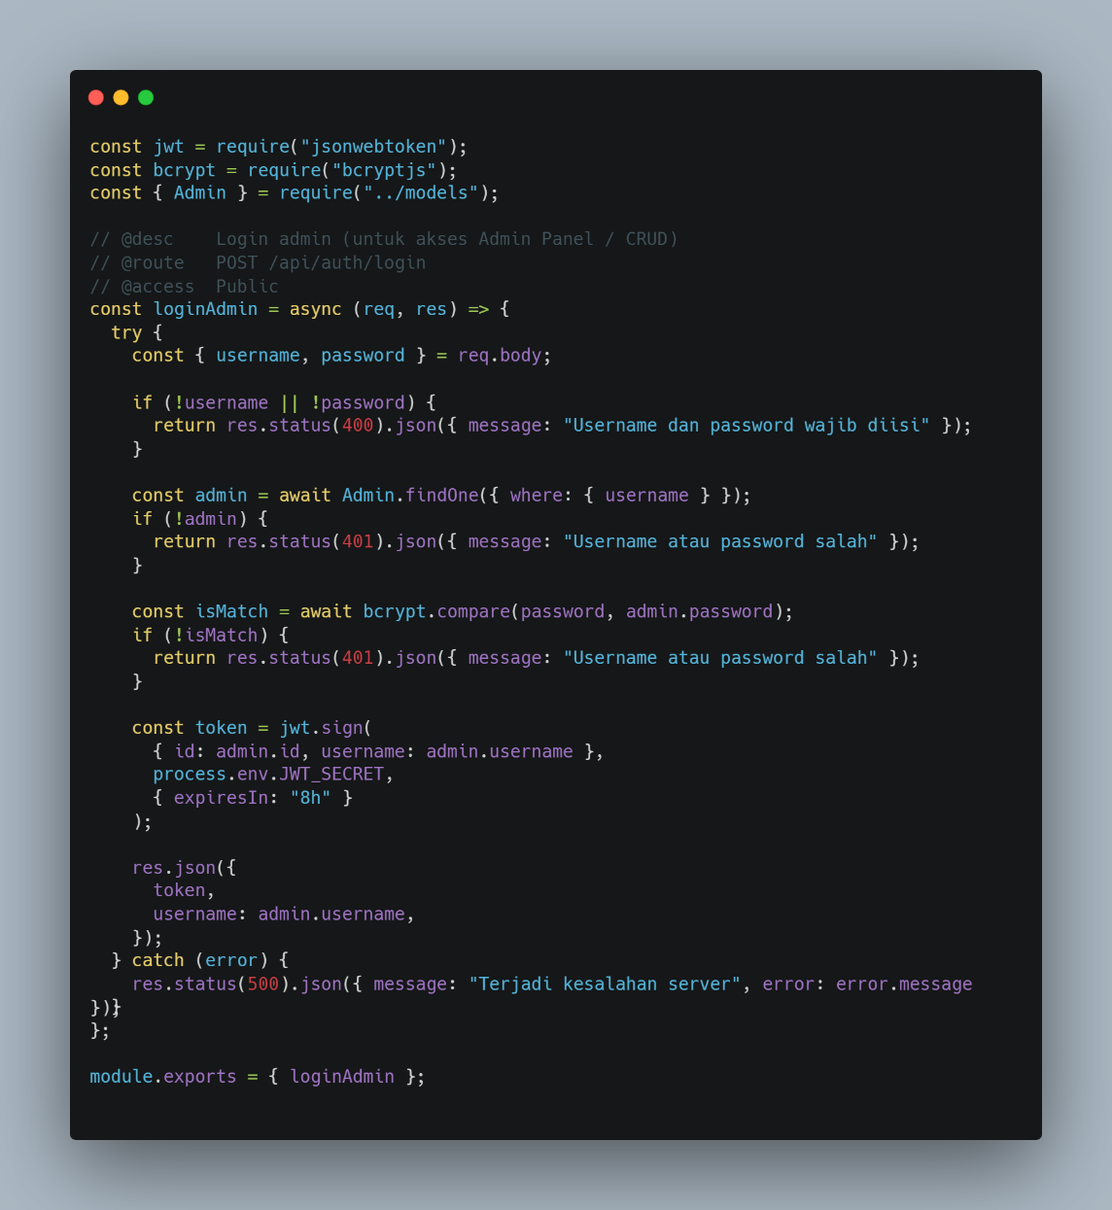

1.3 Models (Sequelize) models/Menu.js
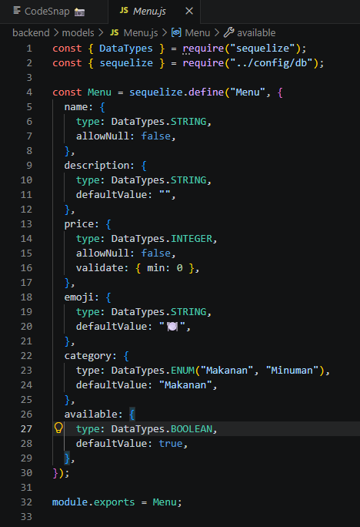
models/Order.js
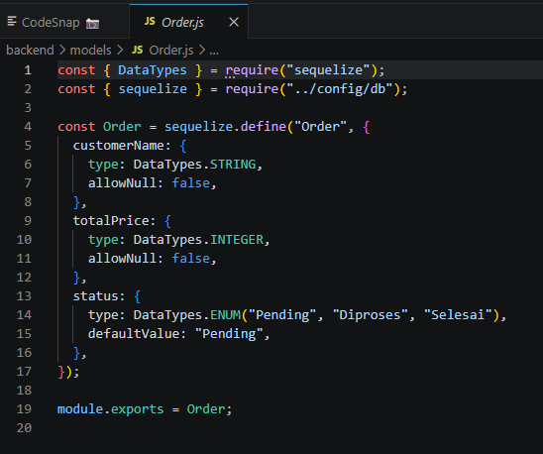
models/OrderItem.js
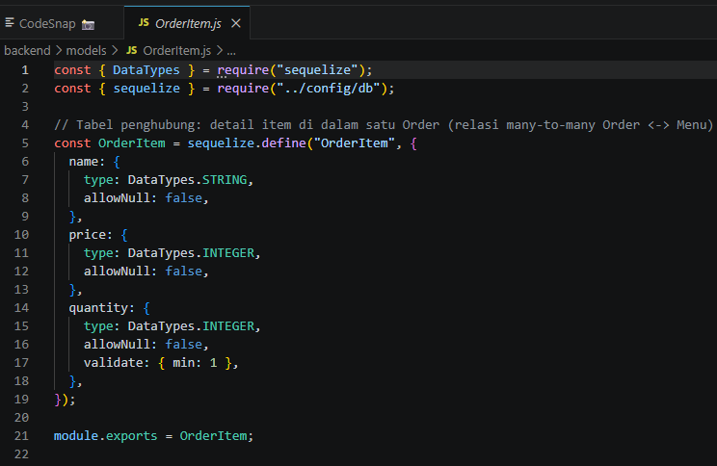models/Admin.js

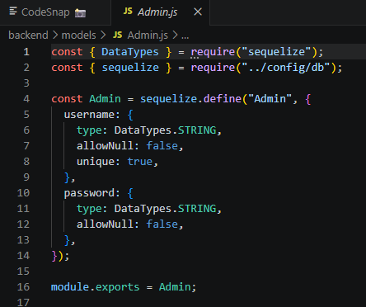models/index.js (relasi antar tabel)

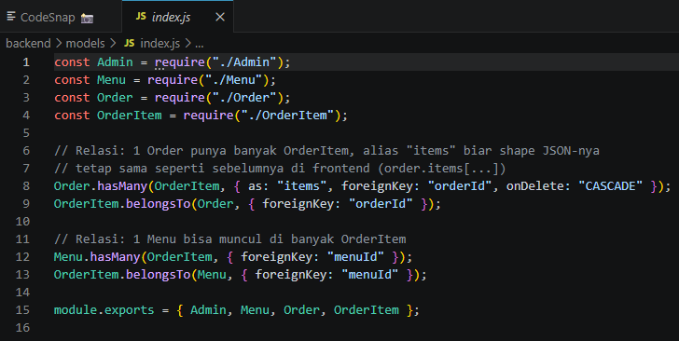1.4 Middleware & Server Entry
middleware/authMiddleware.js 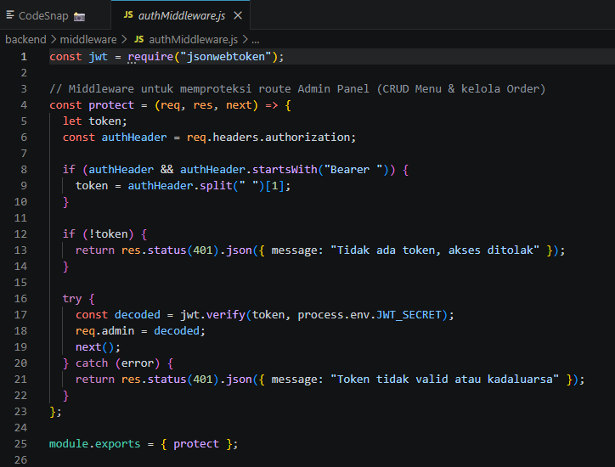server.js

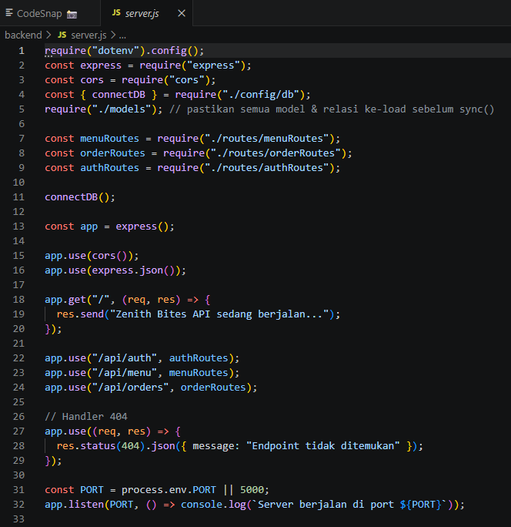

2. Screenshot Code Frontend

2.1 Struktur Komponen (folder src/)
src/
■■■ App.jsx <- routing utama (Home / Admin Login / Admin Dashboard) ■■■ main.jsx
■■■ index.css
■■■ api/
■ ■■■ api.js <- axios instance + auto-inject token JWT
■■■ context/
■ ■■■ ThemeContext.jsx <- state global dark/light mode
■ ■■■ AuthContext.jsx <- state login admin
■■■ components/
■■■ Navbar.jsx
■■■ Hero.jsx
■■■ Features.jsx
■■■ MenuList.jsx <- fetch menu dari backend (useEffect + useState)
■■■ OrderCart.jsx <- fitur pemesanan (keranjang -> submit order)
■■■ Footer.jsx
■■■ ThemeToggle.jsx <- komponen toggle Dark Mode
■■■ admin/
■■■ AdminLogin.jsx
■■■ AdminDashboard.jsx
■■■ MenuManager.jsx <- komponen CRUD Menu
■■■ OrderManager.jsx <- komponen kelola status Order
■■■ ProtectedRoute.jsx <- proteksi akses Admin Panel
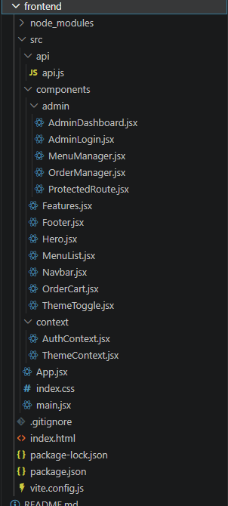

2.2 Komponen ThemeToggle (Dark Mode)

components/ThemeToggle.jsx
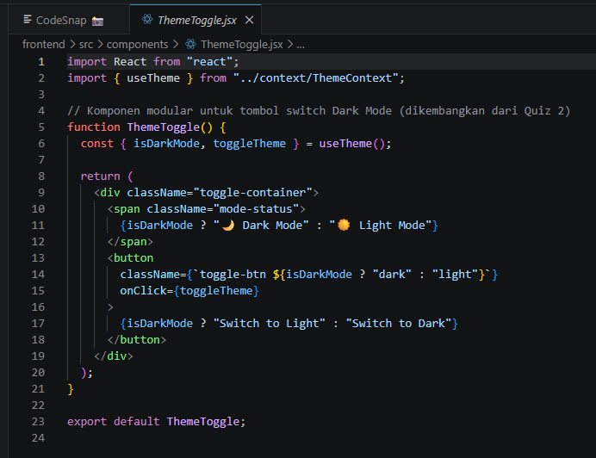
context/ThemeContext.jsx
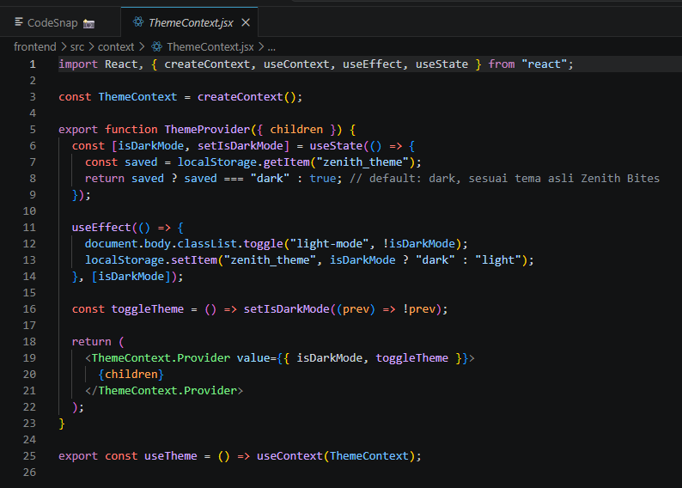

2.3 Komponen CRUD / Admin Panel components/admin/MenuManager.jsx (CRUD Menu) 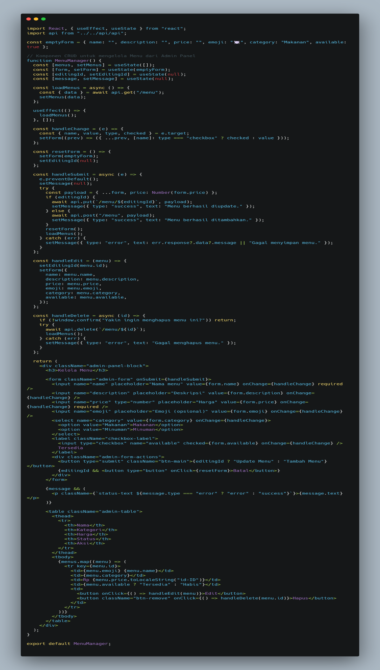

components/admin/OrderManager.jsx (Kelola Order)

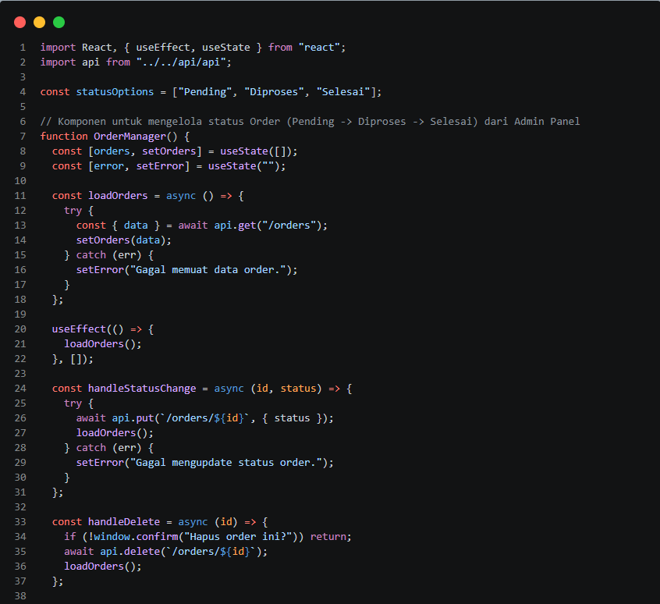
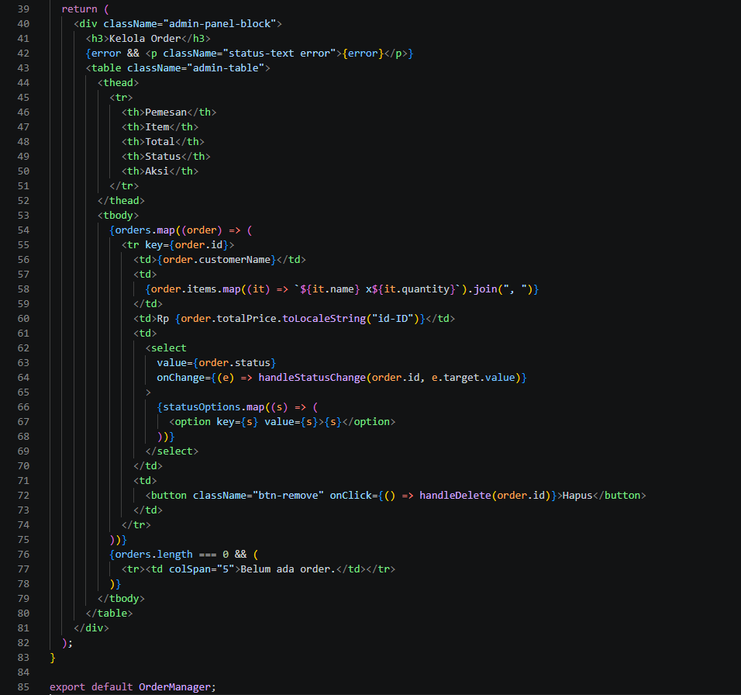

2.4 Fetching Data dari Backend (useState + useEffect) components/MenuList.jsx

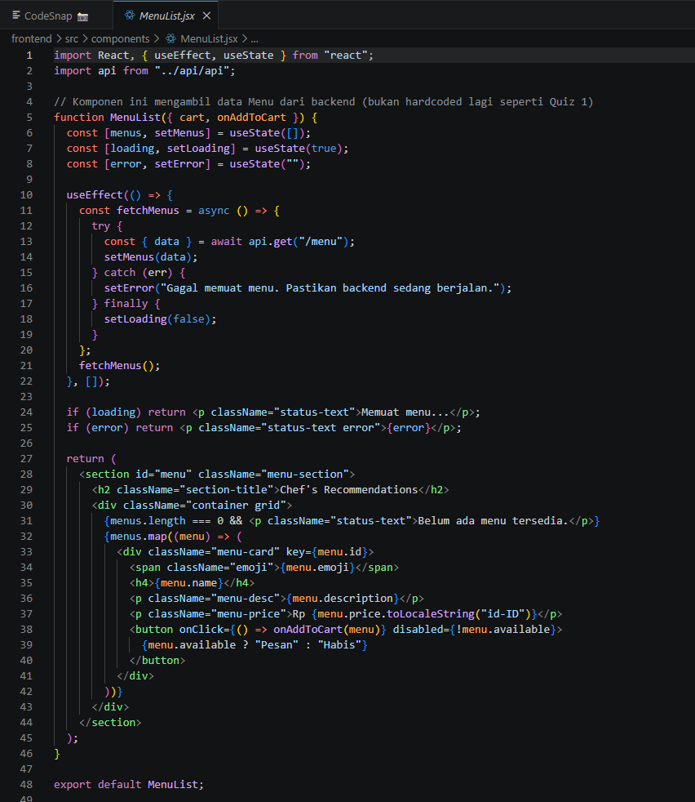

3. Screenshot Tampilan Aplikasi (Light & Dark Mode)

3.1 Halaman Utama — Light Mode
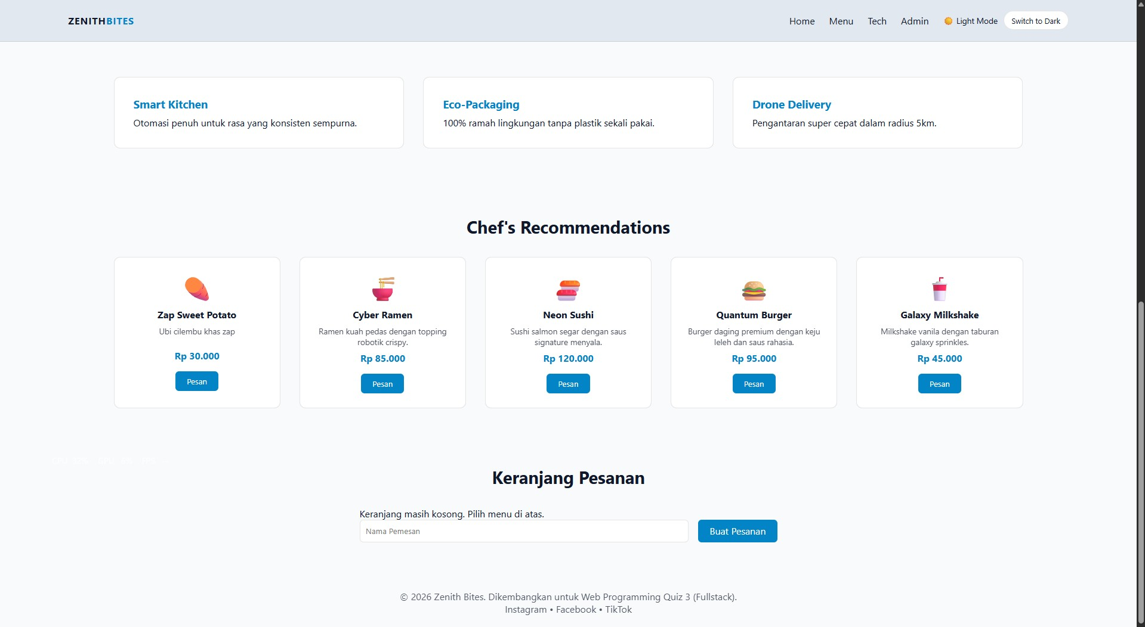
Halaman utama Zenith Bites dalam Light Mode, menu diambil dari database.

3.2 Halaman Utama — Dark Mode
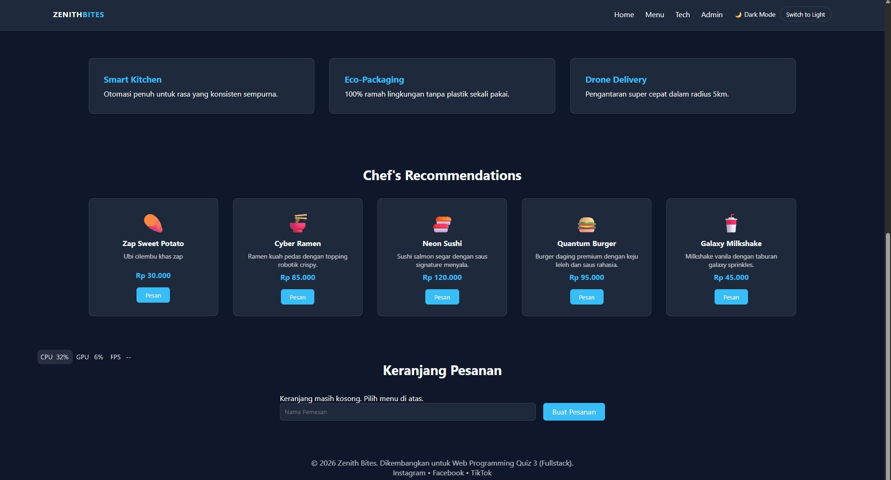
Halaman utama Zenith Bites dalam Dark Mode.

3.3 Admin Panel — Light Mode
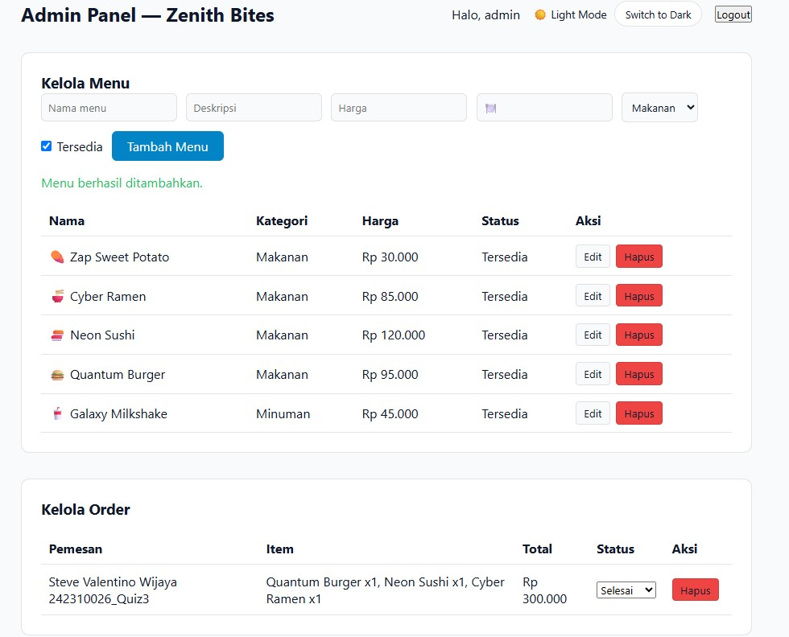
Admin Panel (kelola Menu & Order) dalam Light Mode.

3.4 Admin Panel — Dark Mode
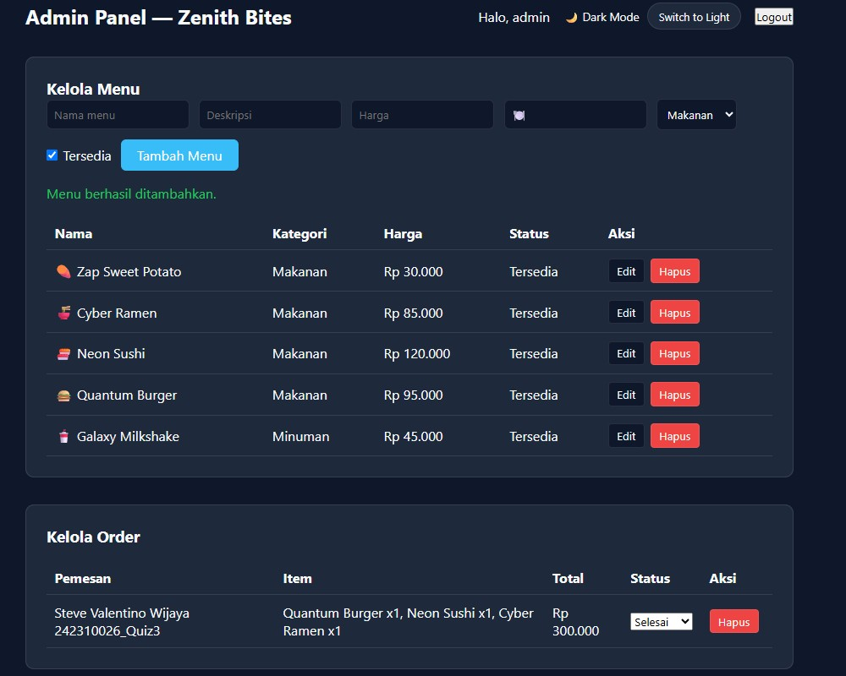
Admin Panel dalam Dark Mode, status mode ditampilkan di navbar.

4. Screenshot Data Tersimpan di MySQL

4.1 Struktur Tabel di phpMyAdmin
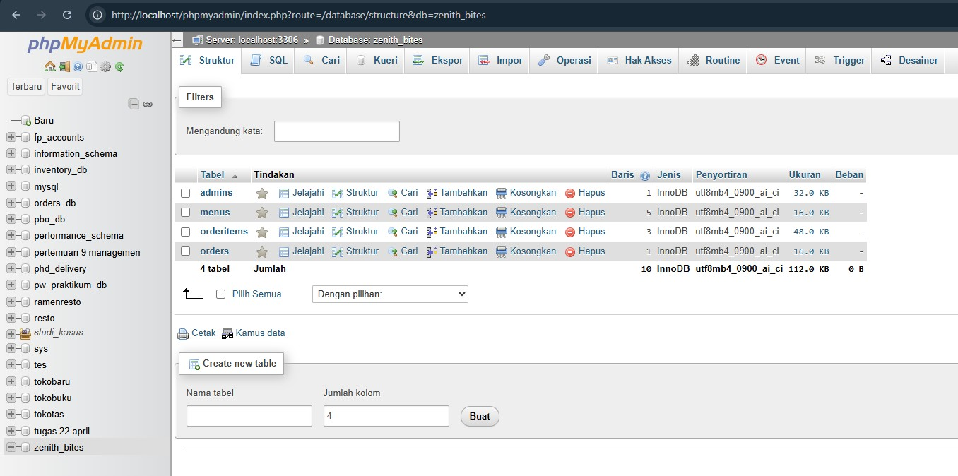
Database zenith_bites berisi 4 tabel: admins, menus, orders, orderitems.

4.2 Data pada Tabel Menus
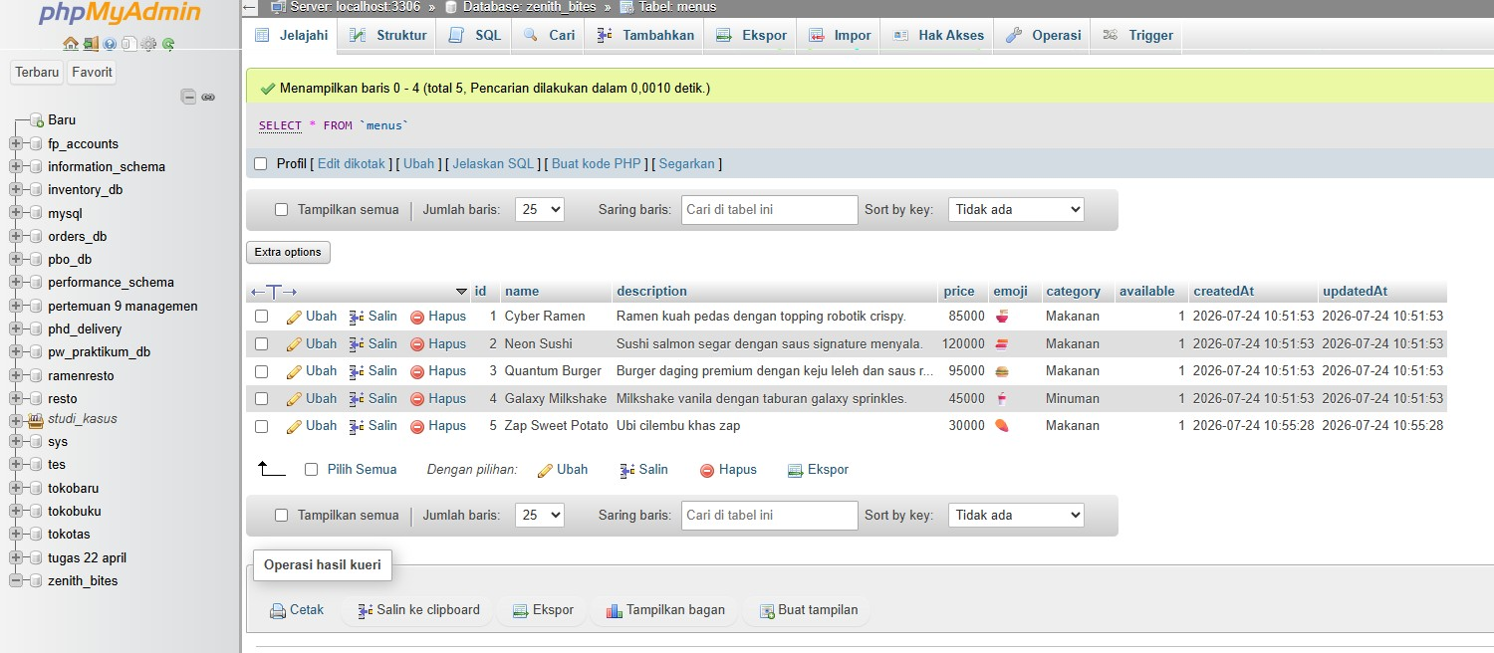
Data menu tersimpan di tabel menus, hasil CRUD dari Admin Panel.

