Vision and Language Tuning - 2023 Autumn
1、What’s the task
Contrastive Vision-Language Pre-training, known as CLIP, has provided a new paradigm for learning visual representations by using large-scale contrastive image-text pairs. It shows impressive performance on zero-shot knowledge transfer to downstream tasks. You need to further enhance CLIP's few-shot/zero-shot capability as few parameters as possible.
How to use clip and test clip zero-shot performance?
https://github.com/openai/CLIP
2、Dataset and Codebase
Dataset：ImageNet，This task does not need to use the entire ImageNet, only a small part of ImageNet.
Note：
- Codebase: You can follow the COOP[1] and CLIP-Adapter[2] to try this task briefly.
[1] Learning to Prompt for Vision-Language Models.
https://arxiv.org/pdf/2109.01134.pdf
[2] CLIP-Adapter: Better Vision-Language Models with Feature Adapters
- This task doesn’t require a lot of computational resources, since you only need train few parameters;
- Since CLIP has many backbones, you can choose ResNet-50.
- You must demonstrate the flow of your approach.
- Base performance:
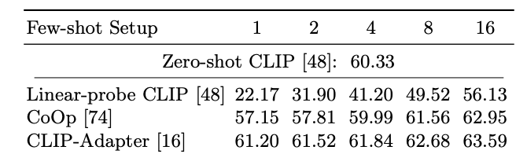
3、What to hand in
- Code with necessary libs or other stuff to make it work.
- A brief and clear experiment report, including but not limited to
- How to run your code, a short example will be appreciated.
- Your method and its novelty.
- How do you analyse your predictions (show me your code or illustration).
- Please turn in your work into folder ‘UpLoad’, with the form of .rar file , named like this:
‘组长学号-组员1学号-组员2学号.rar’
We will use a script to detect who has turned in this homework, so any violation of this name rule may result in ZERO point of this homework. Just be careful with this.
- Notes
- You are allowed to use ANY method to solve the problem, including different deep learning platforms. If your method supports training-free mode, you can also explore the zero-shot capability of your method in ImageNet.
- DDL：TBD
- Methods based on deep learning probably outperform traditional machine learning methods, but since deep learning heavily depends on your GPU, where different team may have different computing resources, it seems unfair to judge your grade based on the performance of your algorithm only. So we value your exploration, fantastic ideas or understanding about the problem, which should be stated clearly in your experiment report.
- Your grade = 60% * score_of_your_report + 40% * high_quality_code_or_analysis , so be serious with your report.
- Name your report with a standard name among “report.docx, report.doc, report.txt, report.md”, do not use Chinese words. In your report, remember to give your team member names and student IDs.
- Honor Code: do NOT just download an well-trained model and then use it to product results without any analysis. ANY cheating will lead to zero point of this assignment.

