Name: Krishna N. Vyas

Jenkins Assignment: 01

1. **In instance’s cli :**

#yum install java-11-amazon-corretto.x86_64

#cd /mnt

# mkdir servers

# cd servers/

# wget <https://dlcdn.apache.org/tomcat/tomcat-9/v9.0.89/bin/apache-tomcat-9.0.89.zip>

# ls -ltr

# unzip apache-tomcat-9.0.89.zip

# rm -rf apache-tomcat-9.0.89.zip

# chmod -R 777 apache-tomcat-9.0.89/

# cd apache-tomcat-9.0.89/

# cd webapps/

# wget https://get.jenkins.io/war-stable/latest/jenkins.war

# ls -ltr

# cd ..

# cd bin

# ./startup.sh

# yum install httpd -y

# service httpd start

# chkconfig httpd on

# yum install git -y

1. **Job 1: repo1 for git-repo-1**

Execute shell :

cd /root/.jenkins/workspace/repo1

git clone https://github.com/C2-80496/git-repo-1.git

cp index.html /var/www/html/index.html

chmod -R 777 /var/www/html/index.html

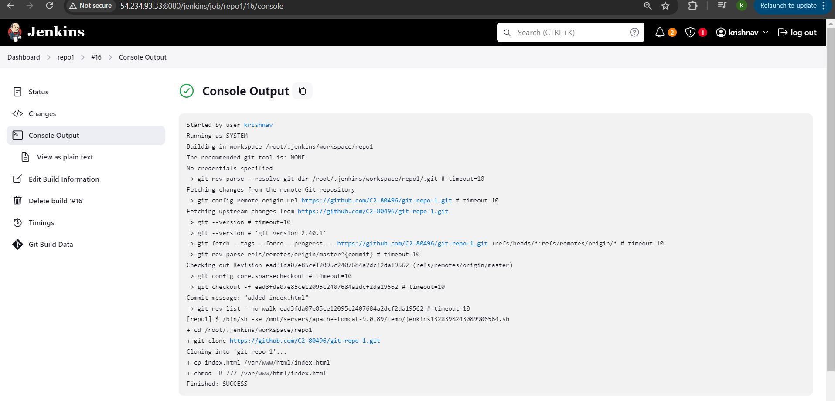

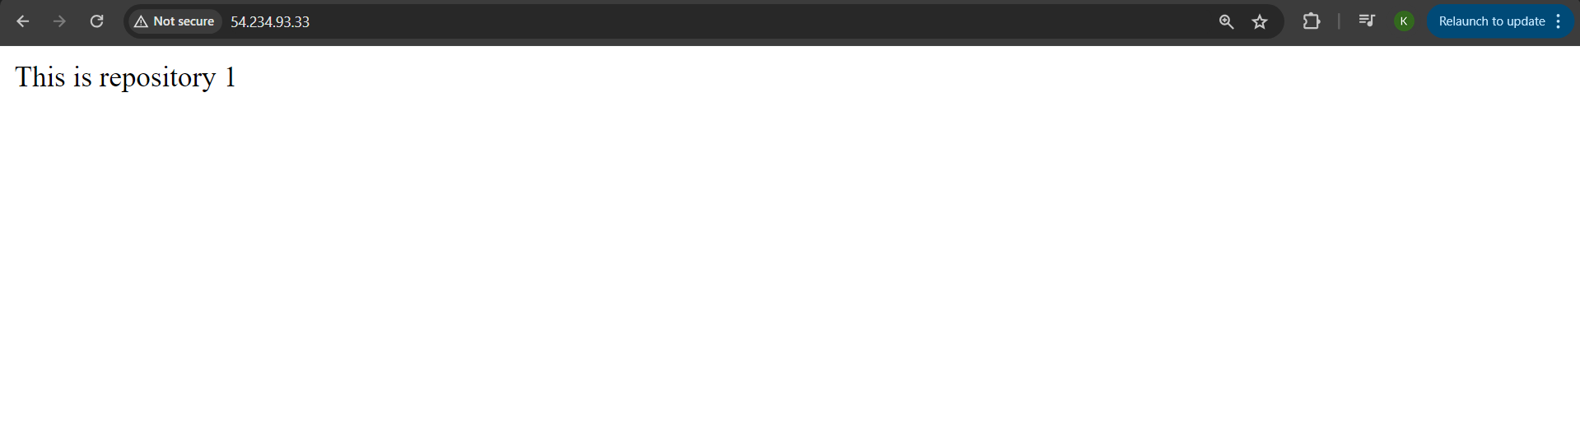

1. **Job 2: repo2 for git-repo-2**

Execute shell :

cd /root/.jenkins/workspace/repo2

git clone https://github.com/C2-80496/git-repo-2.git

cp index.html /var/www/html/index.html

chmod -R 777 /var/www/html/index.html

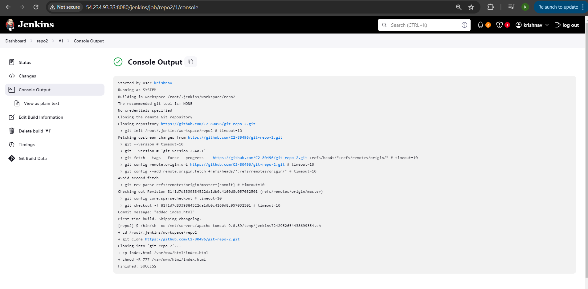

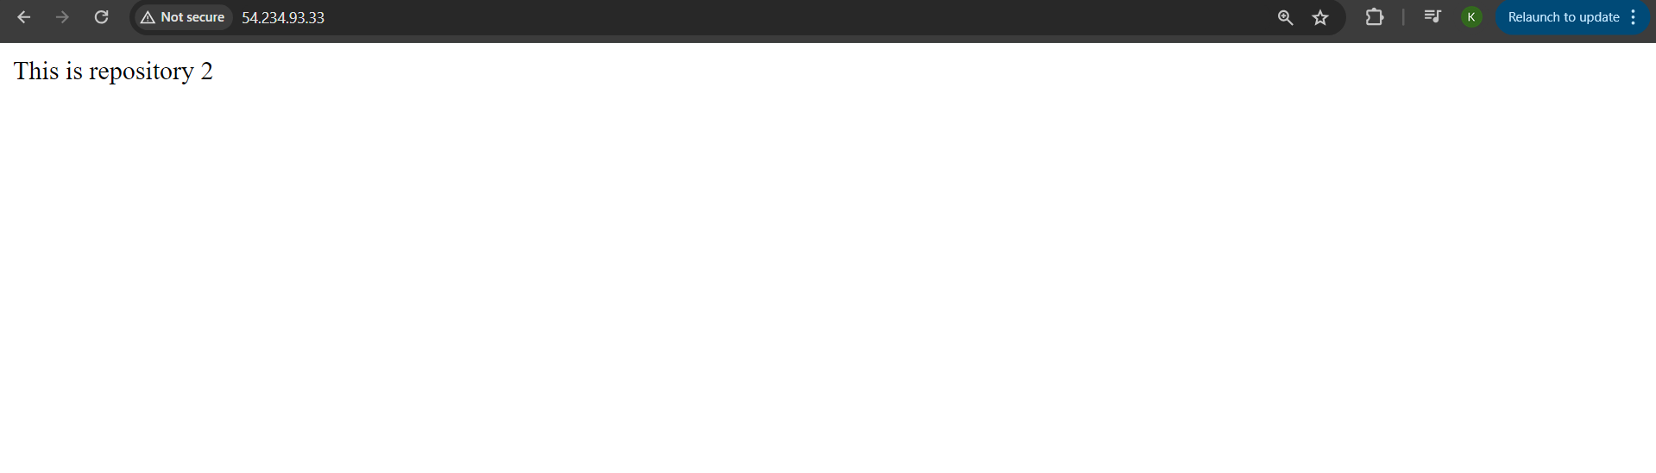

1. **Job 3: repo3 for git-repo-3**

Execute shell :

cd /root/.jenkins/workspace/repo3

git clone https://github.com/C2-80496/git-repo-3.git

cp index.html /var/www/html/index.html

chmod -R 777 /var/www/html/index.html

