**Name : Krishna N. Vyas**

**Assignment 03: Build application war file on master and deploy onto other ec2-instance (non-slave)**

**Prerequisites:**

1. Install java 11

#yum install java-11-amazon-corretto.x86_64

1. Install httpd

#yum install httpd –y

# systemctl start httpd

# systemctl enable httpd

# systemctl status httpd

1. Install apache-tomcat-9.0.89

# cd /mnt

# mkdir servers

# cd servers

# wget<https://dlcdn.apache.org/tomcat/tomcat-9/v9.0.89/bin/apache-tomcat-9.0.89.zip>

# unzip apache-tomcat-9.0.89.zip

# rm -rf apache-tomcat-9.0.89.zip

# chmod -R 777 apache-tomcat-9.0.89/

# cd apache-tomcat-9.0.89/

1. Install jenkins stable version

# cd webapps/

# wget https://get.jenkins.io/war-stable/latest/jenkins.war

# ls -ltr

# cd ..

# cd bin

# ./startup.sh

1. Install git

# yum install git -y

1. Install maven

# cd /mnt

# mkdir build-tools

#cd build-tools

# wget <https://dlcdn.apache.org/maven/maven-3/3.9.6/binaries/apache-maven-3.9.6-bin.zip>

**Jenkins Job:**

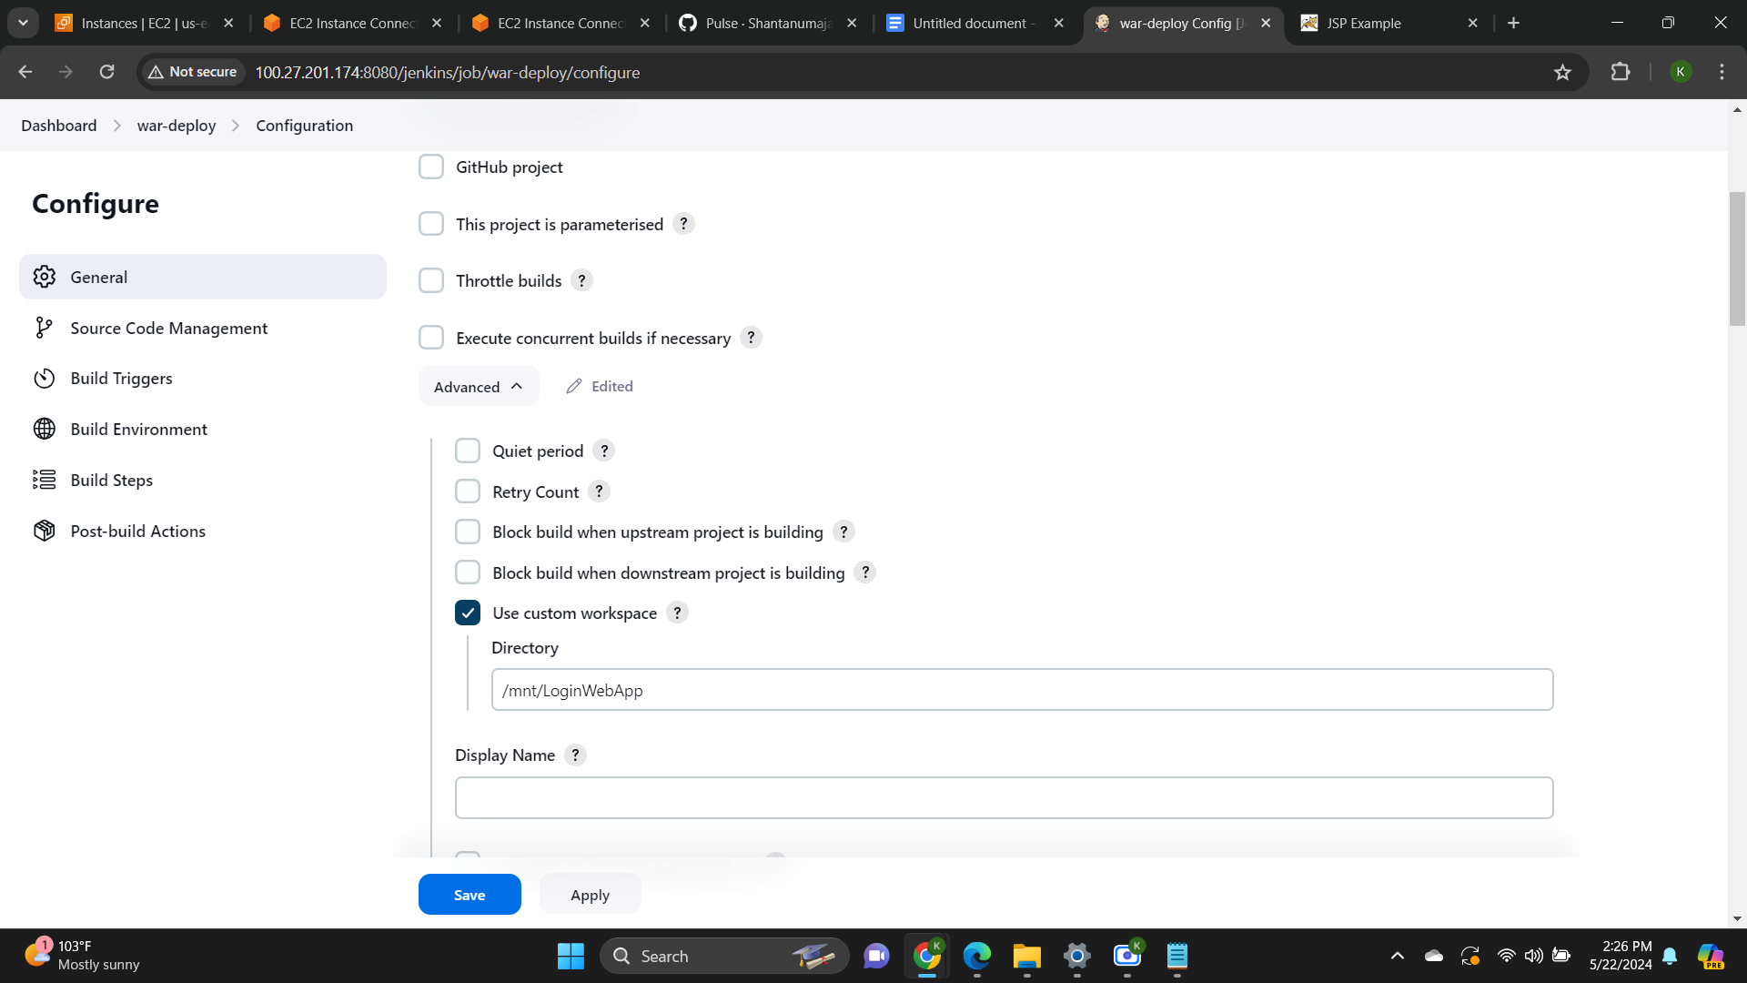

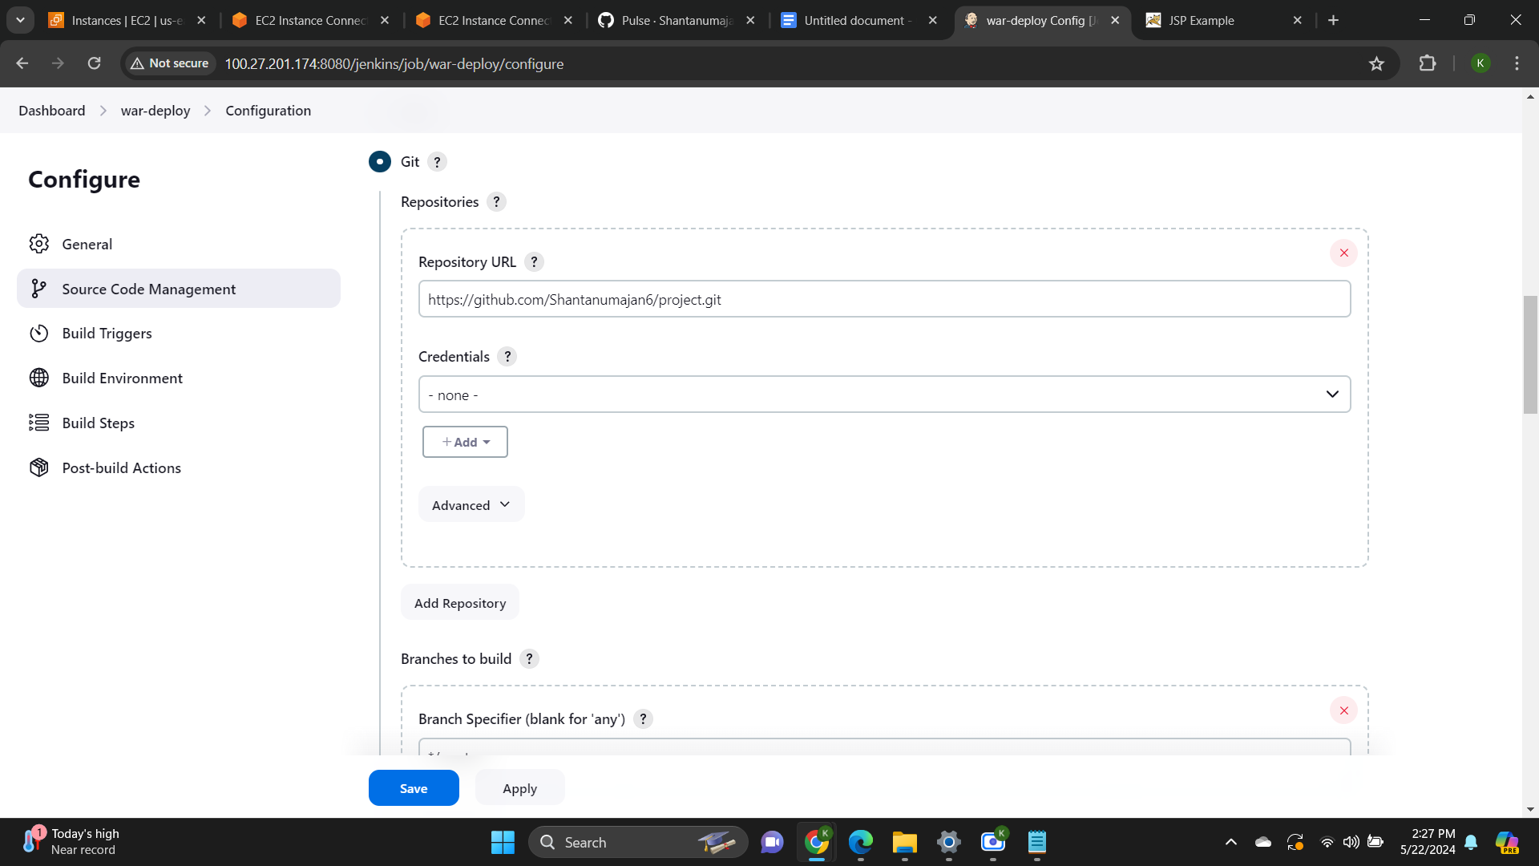

Execution shell 1:

rm -rf /root/.m2/repository

Invoke Top-level Maven Targets:

clean install -e -X

Execution shell 2:

rm -rf /mnt/servers/apache-tomcat-9.0.89/webapps/LoginWebApp*

scp -i /root/key-pair2.pem /mnt/LoginWebApp/target/LoginWebApp.war ec2-user@34.228.70.249:/mnt/servers/apache-tomcat-9.0.89/webapps/LoginWebApp.war

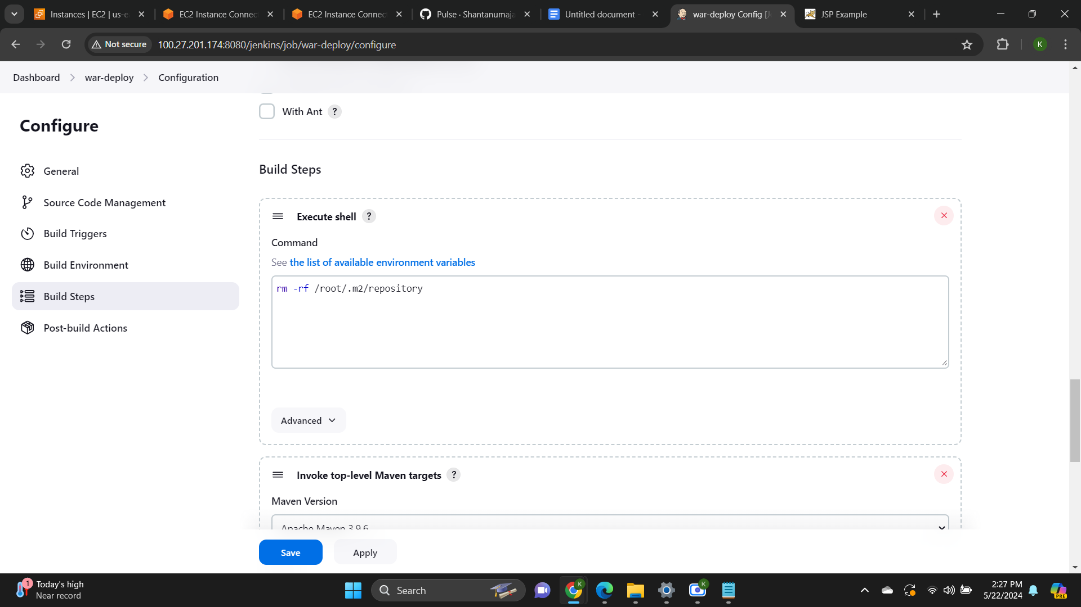

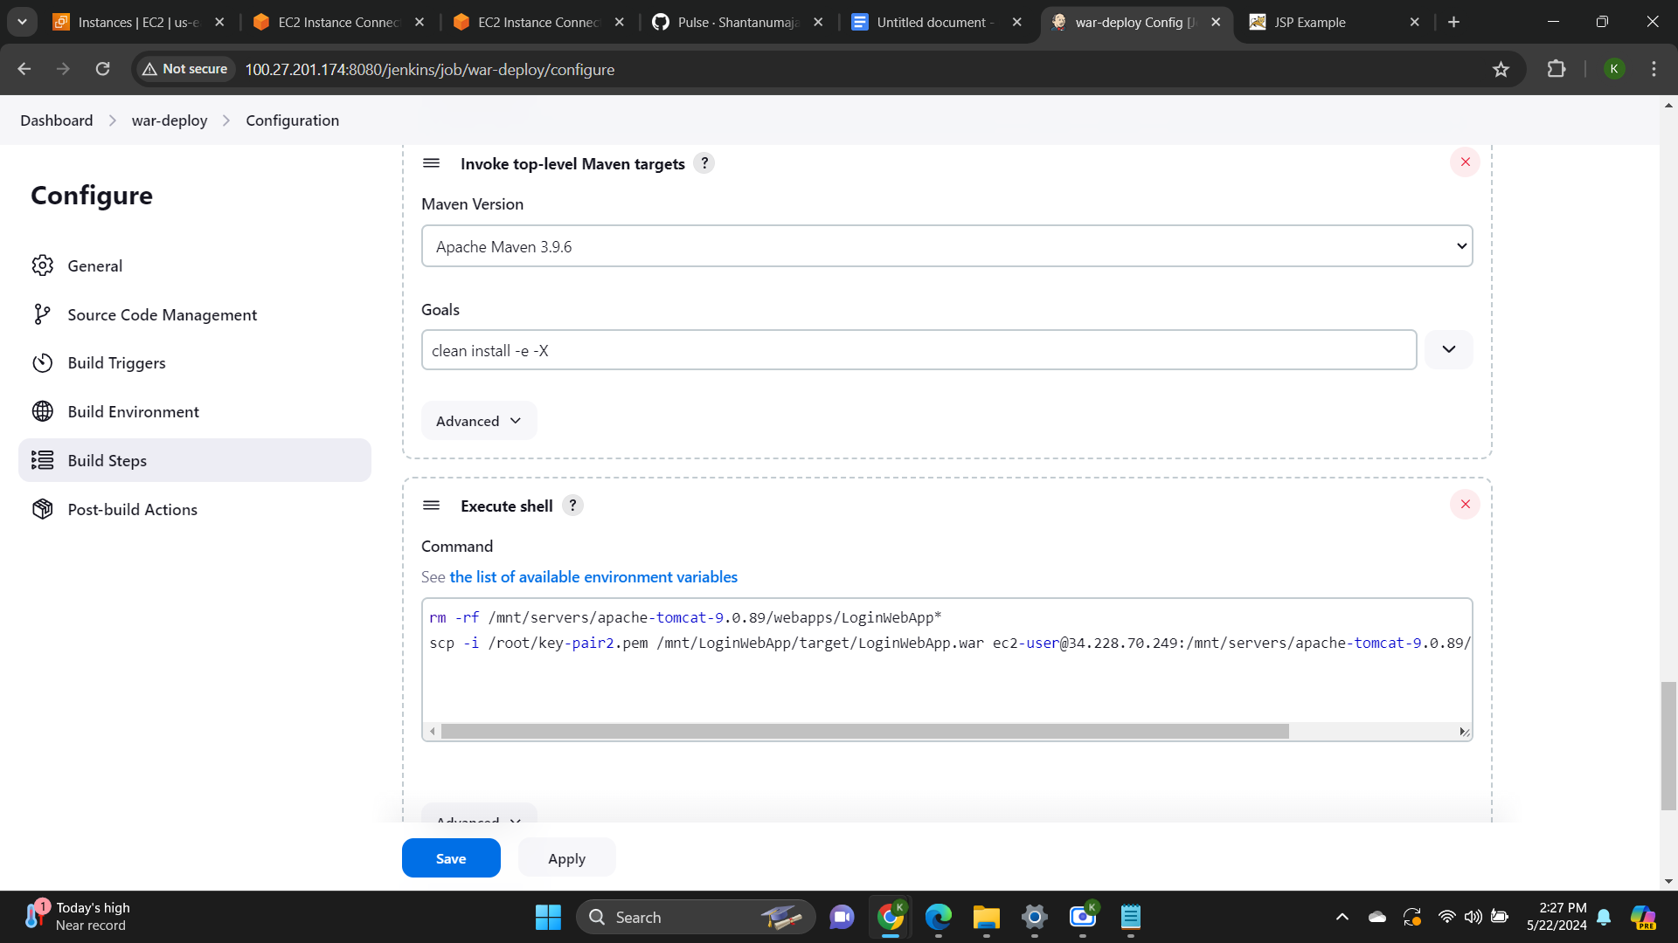

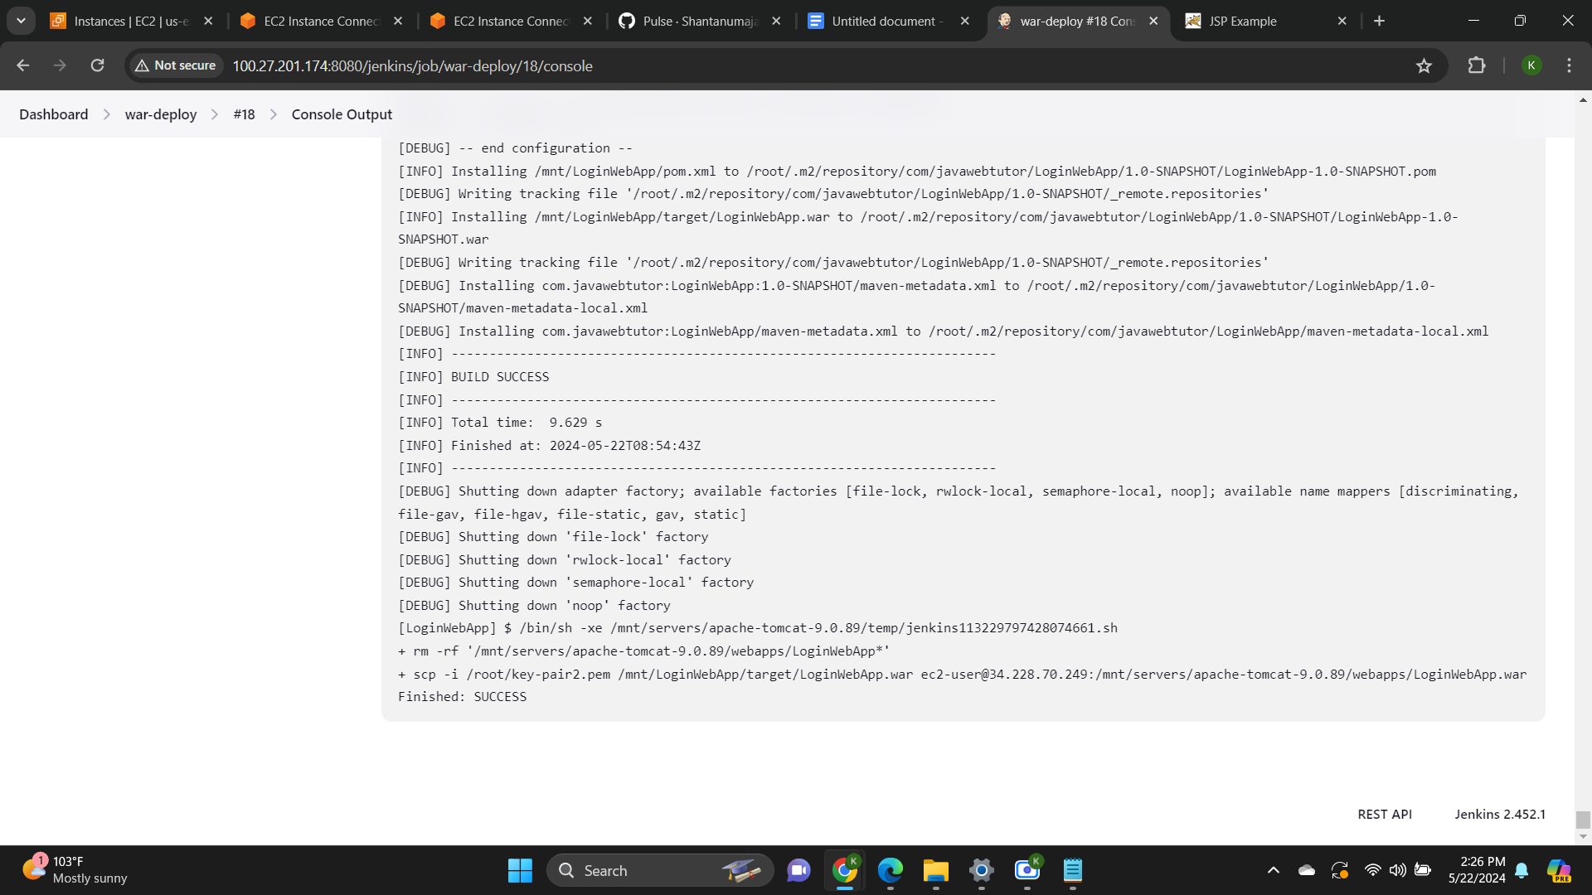

**100.27.201.174**

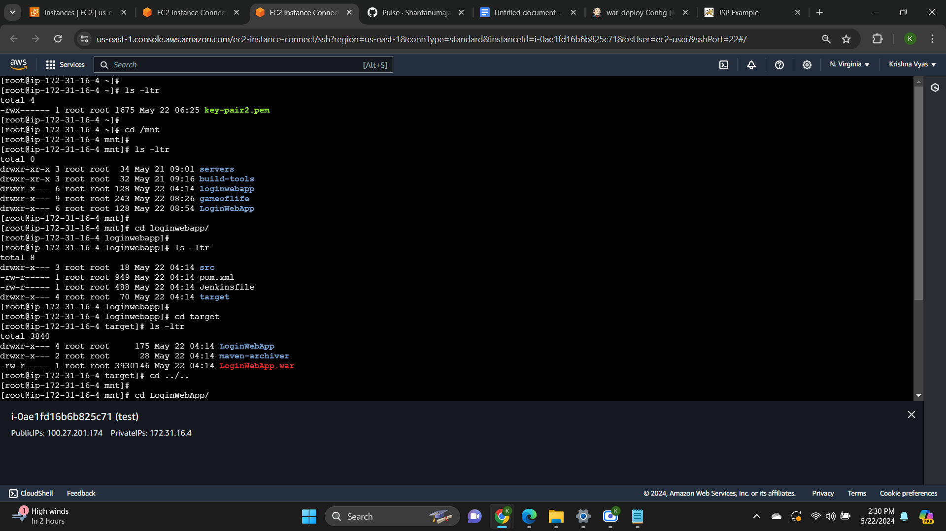

**34.228.70.249**

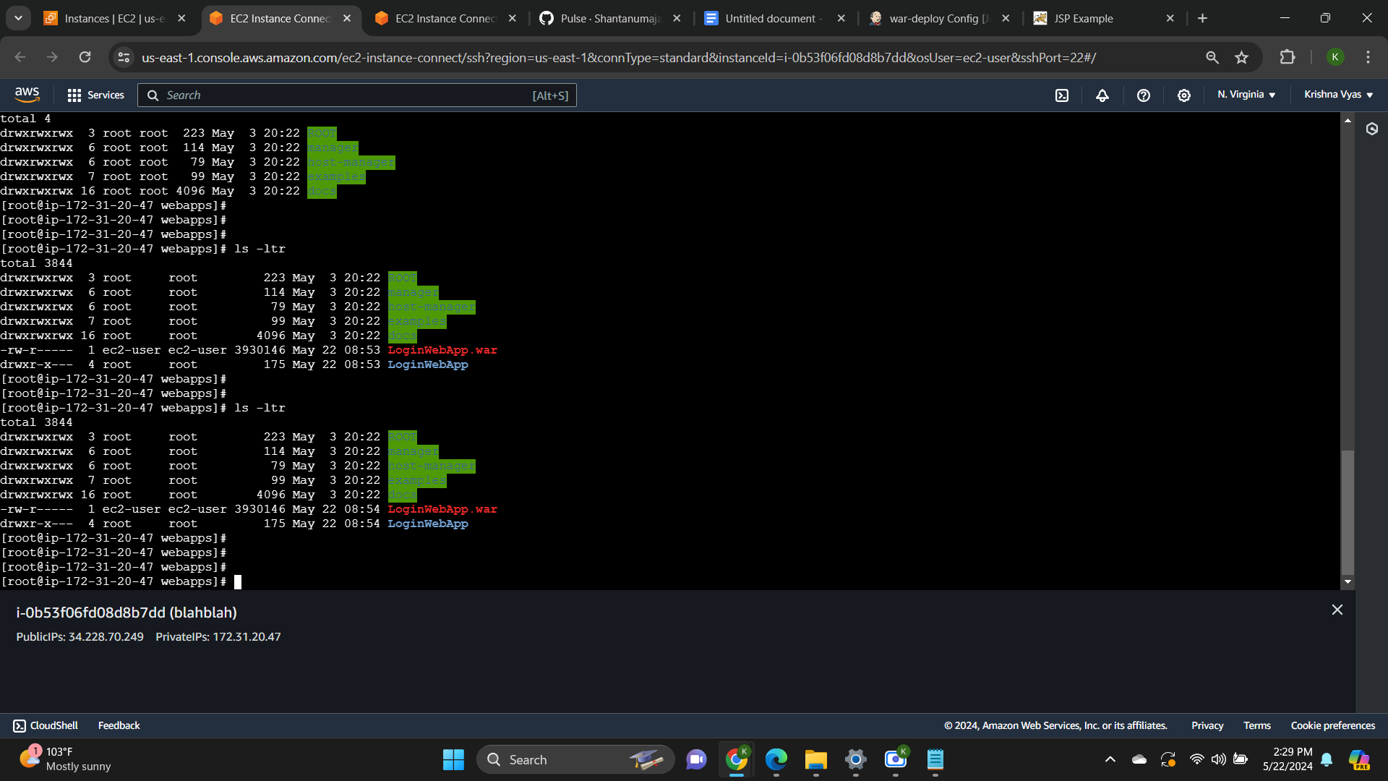

Webpage Access

