**Name : Krishna N. Vyas**

**Assignment 04: Build application war file on master and deploy over apache-tomcat on slaves**

**Prerequisites:**

**On Master**

1. Install java 11

#yum install java-11-amazon-corretto.x86_64

1. Install apache-tomcat-9.0.89

# cd /mnt

# mkdir servers

# cd servers

# wget<https://dlcdn.apache.org/tomcat/tomcat-9/v9.0.89/bin/apache-tomcat-9.0.89.zip>

# unzip apache-tomcat-9.0.89.zip

# rm -rf apache-tomcat-9.0.89.zip

# chmod -R 777 apache-tomcat-9.0.89/

# cd apache-tomcat-9.0.89/

1. Install jenkins stable version

# cd webapps/

# wget https://get.jenkins.io/war-stable/latest/jenkins.war

# ls -ltr

# cd ..

# cd bin

# ./startup.sh

1. Install git

# yum install git -y

1. Install maven

# cd /mnt

# mkdir build-tools

#cd build-tools

# wget <https://dlcdn.apache.org/maven/maven-3/3.9.6/binaries/apache-maven-3.9.6-bin.zip>

**On Slave-1 and Slave-2**

1. Install java 11

#yum install java-11-amazon-corretto.x86_64

1. Install apache-tomcat-9.0.89

# cd /mnt

# mkdir servers

# cd servers

# wget<https://dlcdn.apache.org/tomcat/tomcat-9/v9.0.89/bin/apache-tomcat-9.0.89.zip>

# unzip apache-tomcat-9.0.89.zip

# rm -rf apache-tomcat-9.0.89.zip

# chmod -R 777 apache-tomcat-9.0.89/

# cd apache-tomcat-9.0.89/bin

# ./startup.sh

1. Remote directory : slave home

# cd /mnt

# mkdir slave-home

1. # cd /

# chmod -R 777 /mnt

**Jenkins Management:**

1. Maven tool configuration

Manage Jenkins > Tools

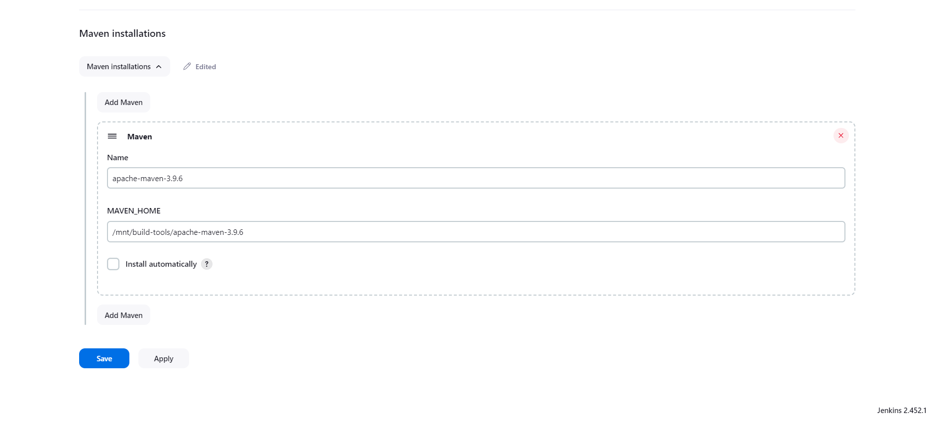

1. Create and connect slave nodes via ssh

Dashboard > Manage Jenkins > Nodes > Add new Node

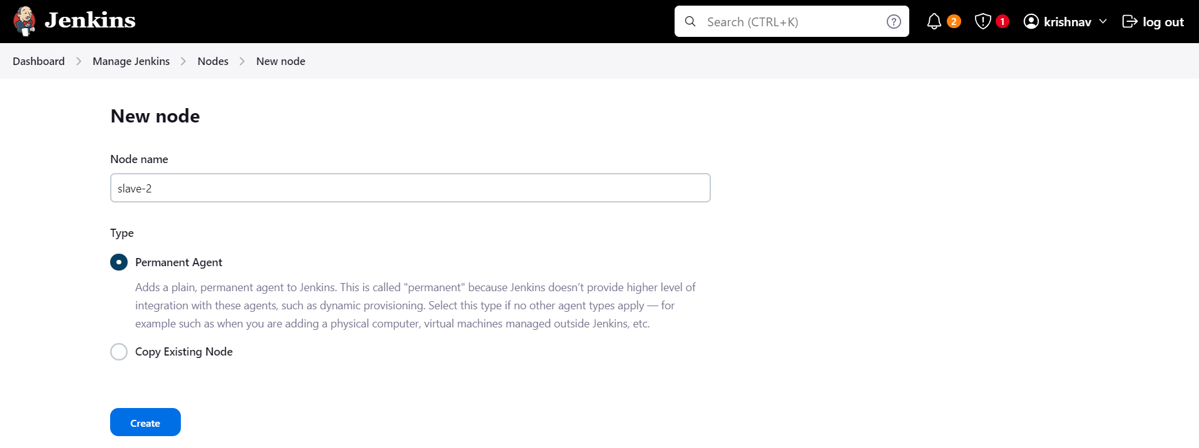

Enter name , description, Number of Executors, Remote root directory > /mnt/slave-home ,Label

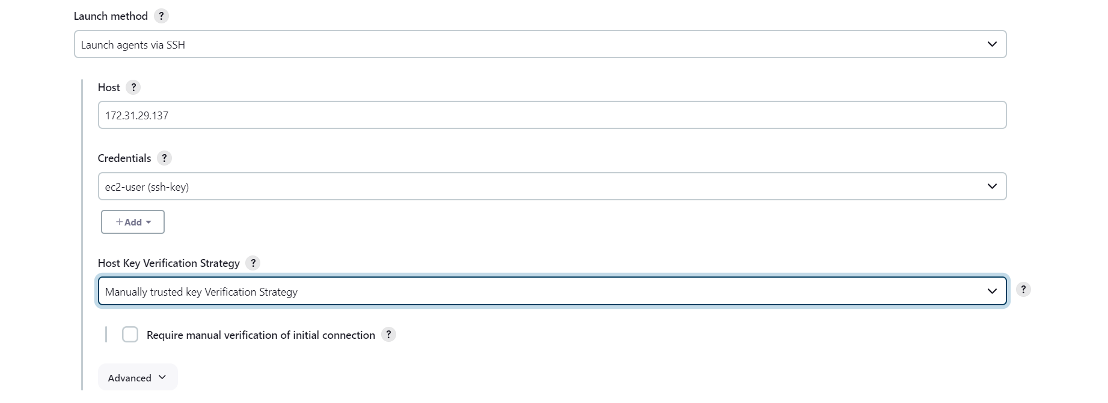

SAVE

> select Node > trust ssh key > yes > relaunch agent

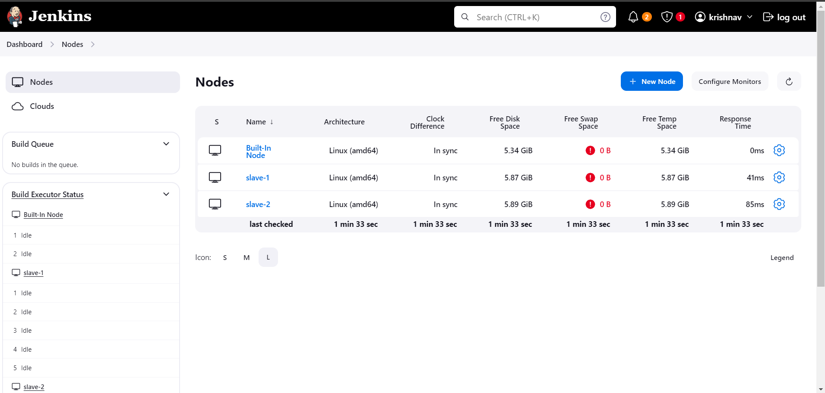

1. Install plugin : copy artifacts

Dashboard > manage jenkins > plugins> available plugins > (search copy artifact ) select and install > restart jenkins or click back to top level page

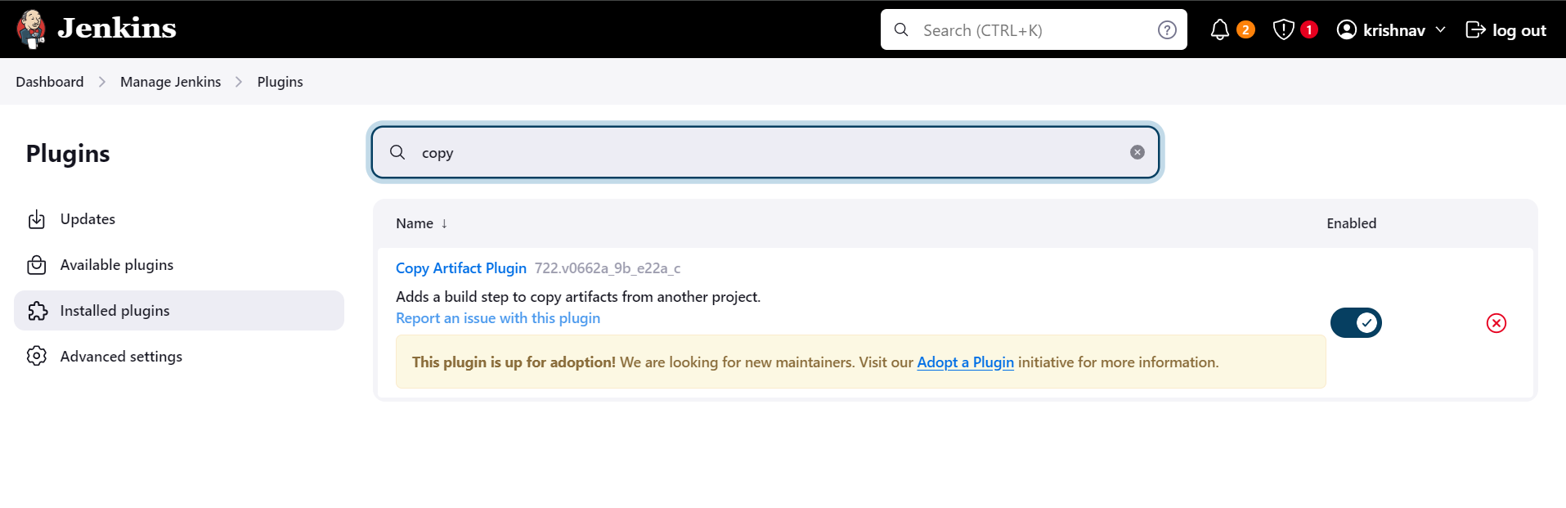

**Jenkins Jobs:**

1. war-deploy

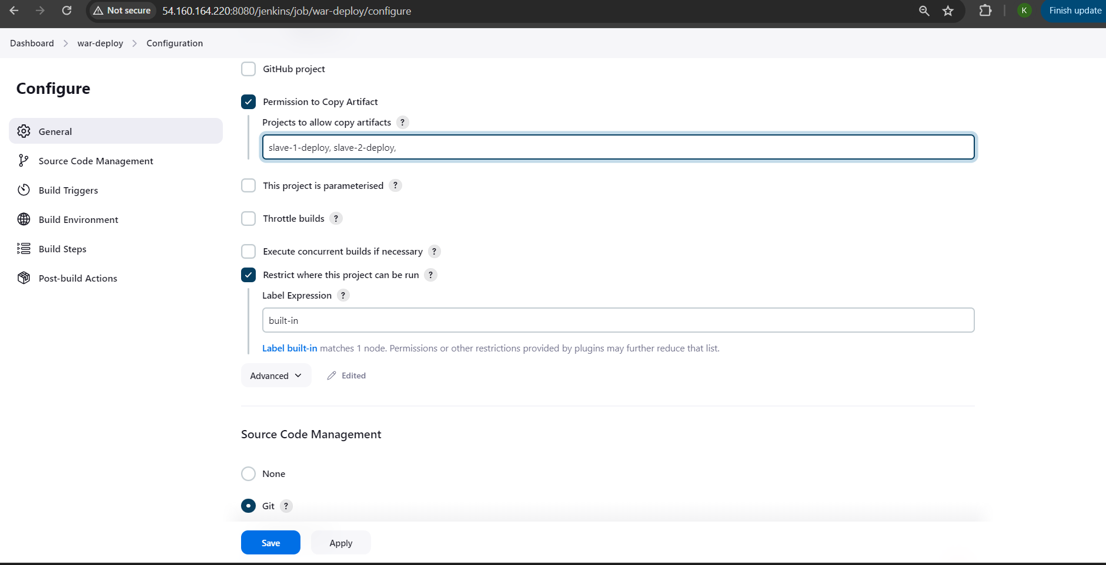

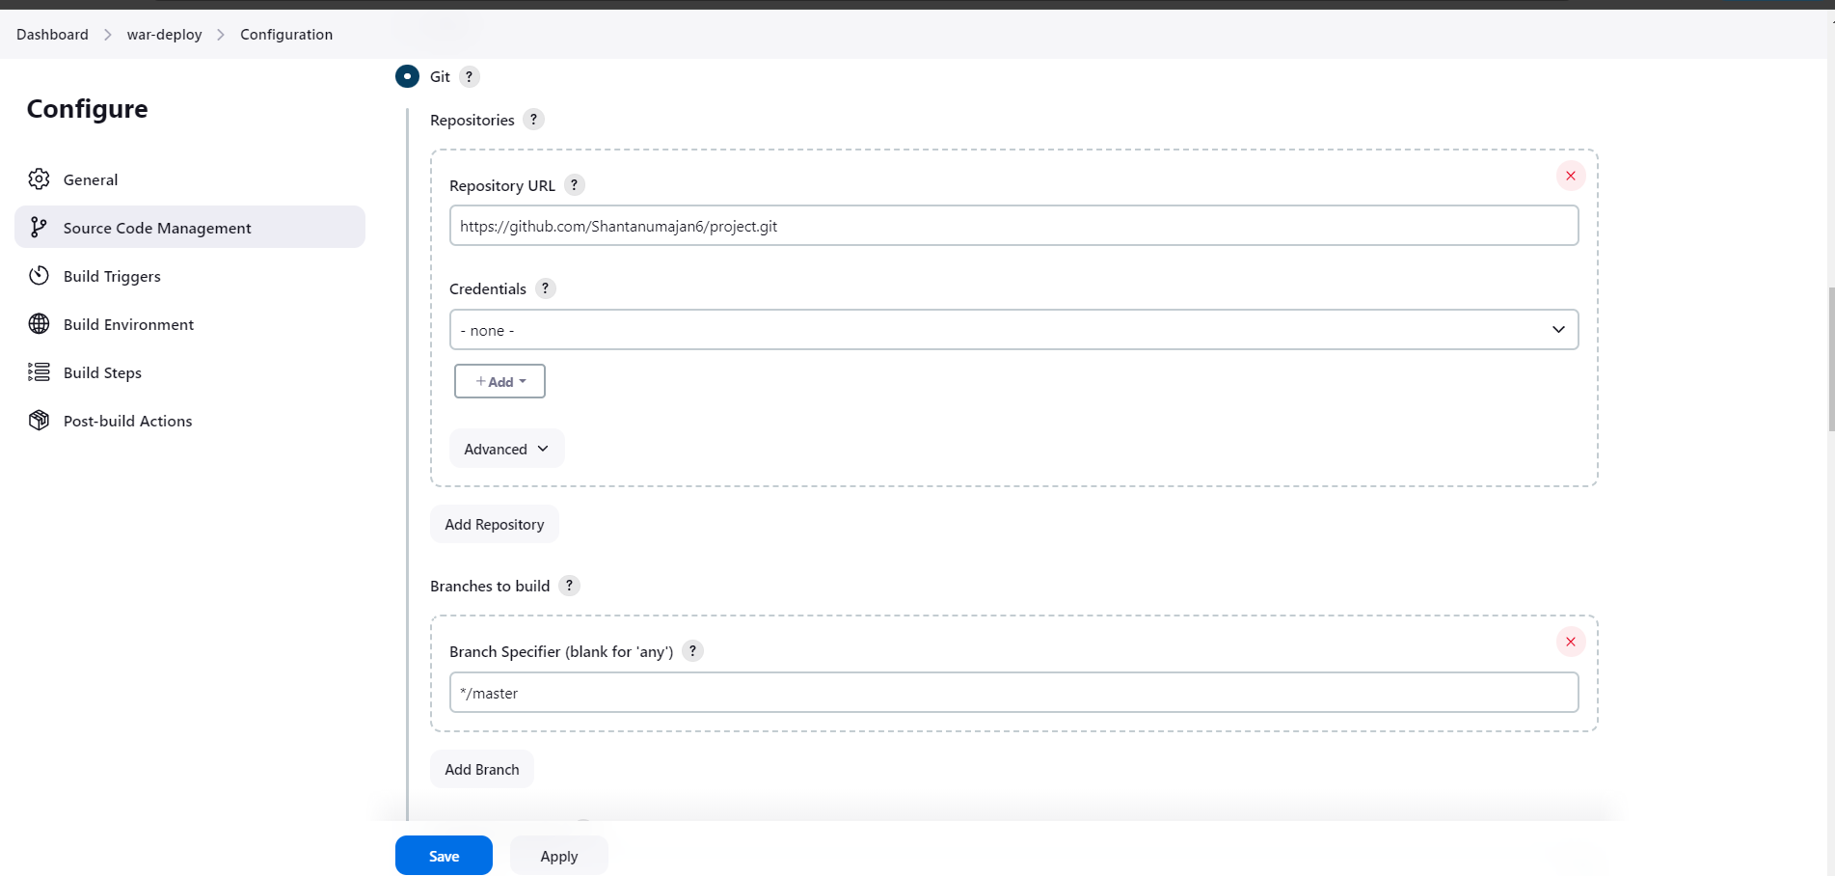

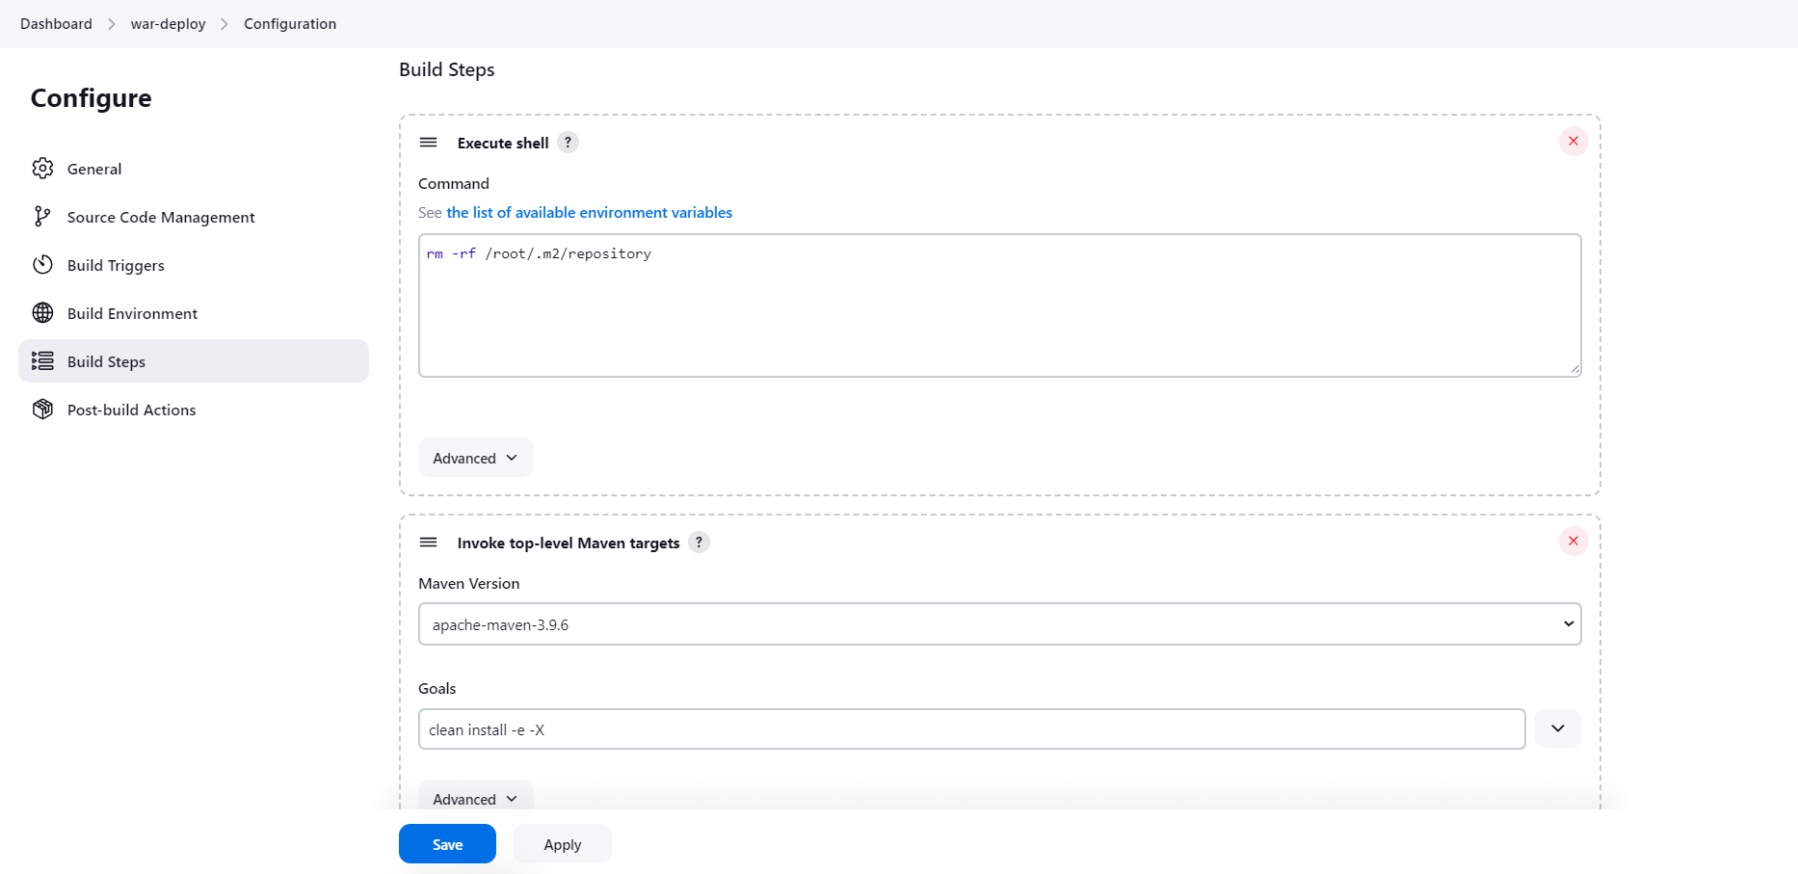

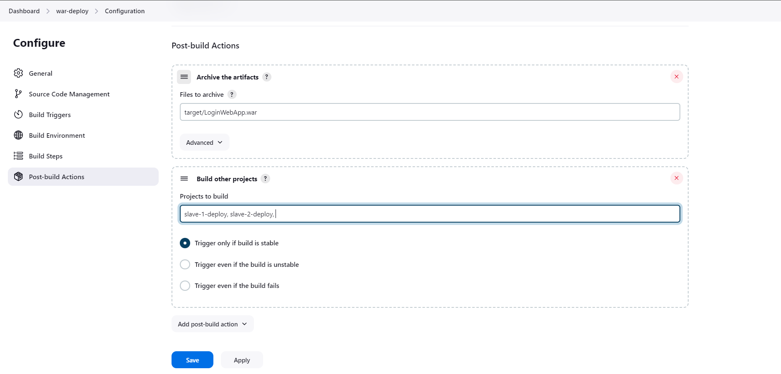

1. slave-1-deploy

New item > freestyle project

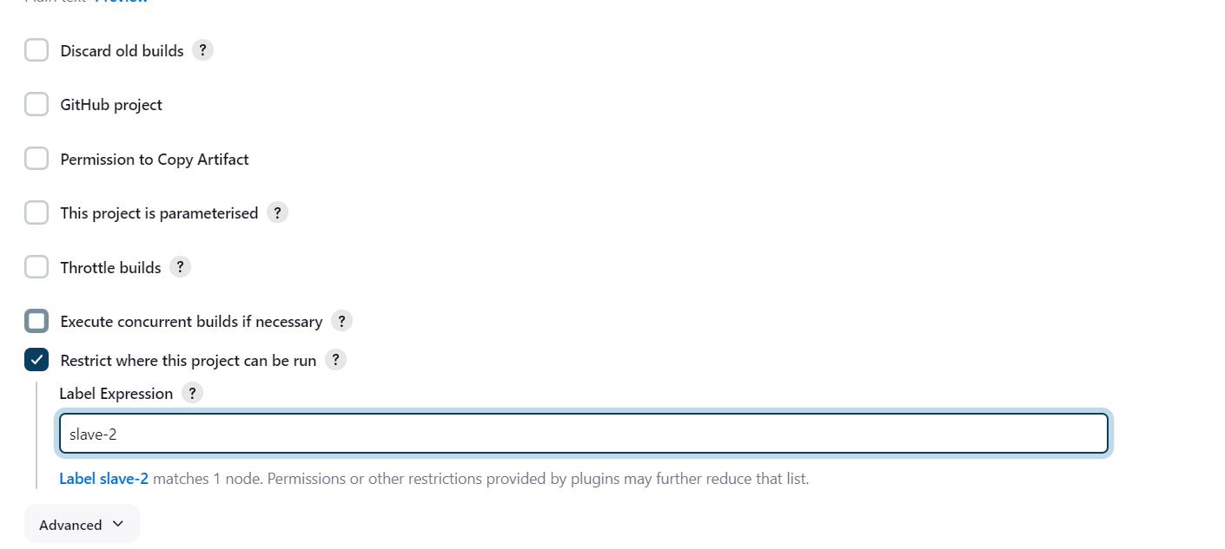

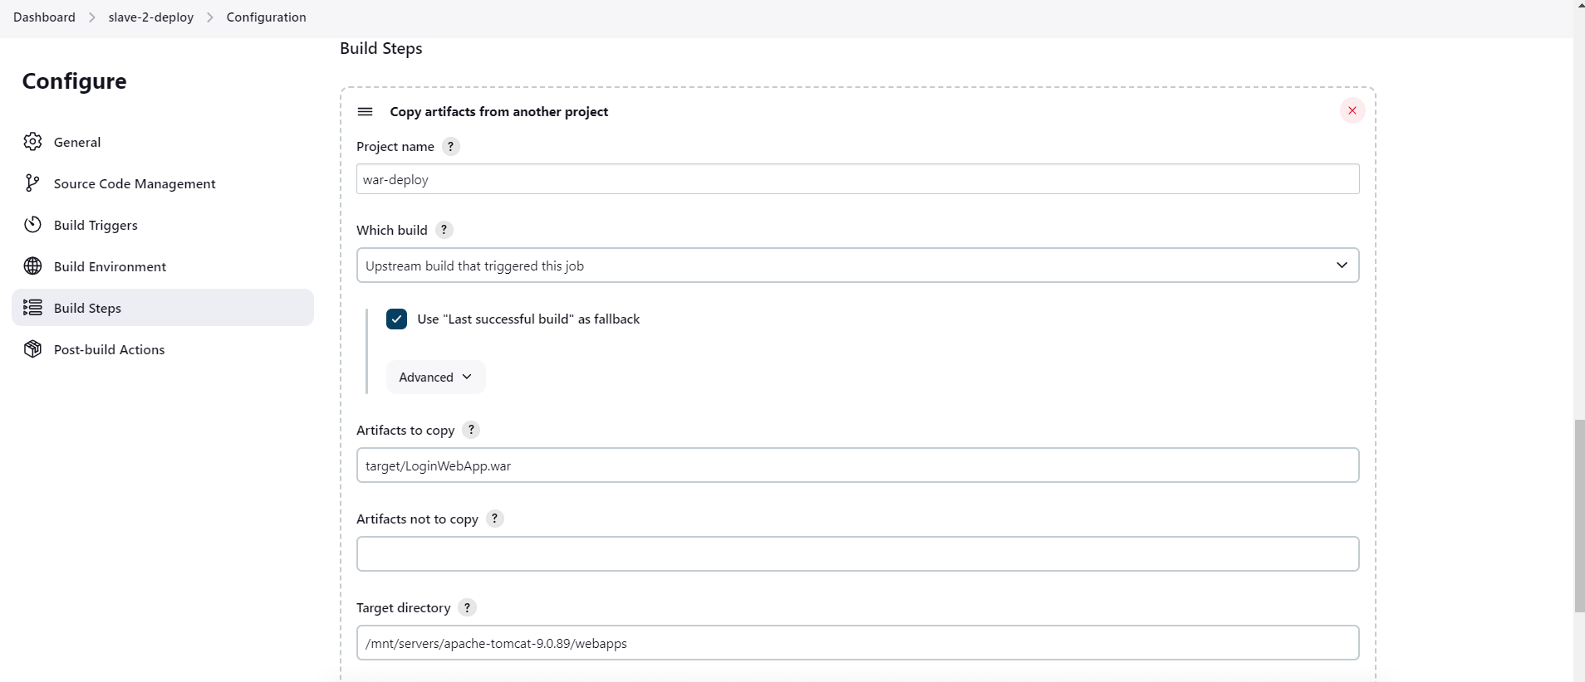

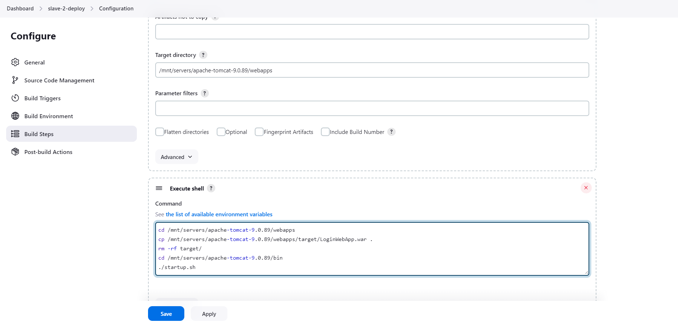

1. Slave-2-deploy : similar as slave-1-deploy

**OUTPUT:**

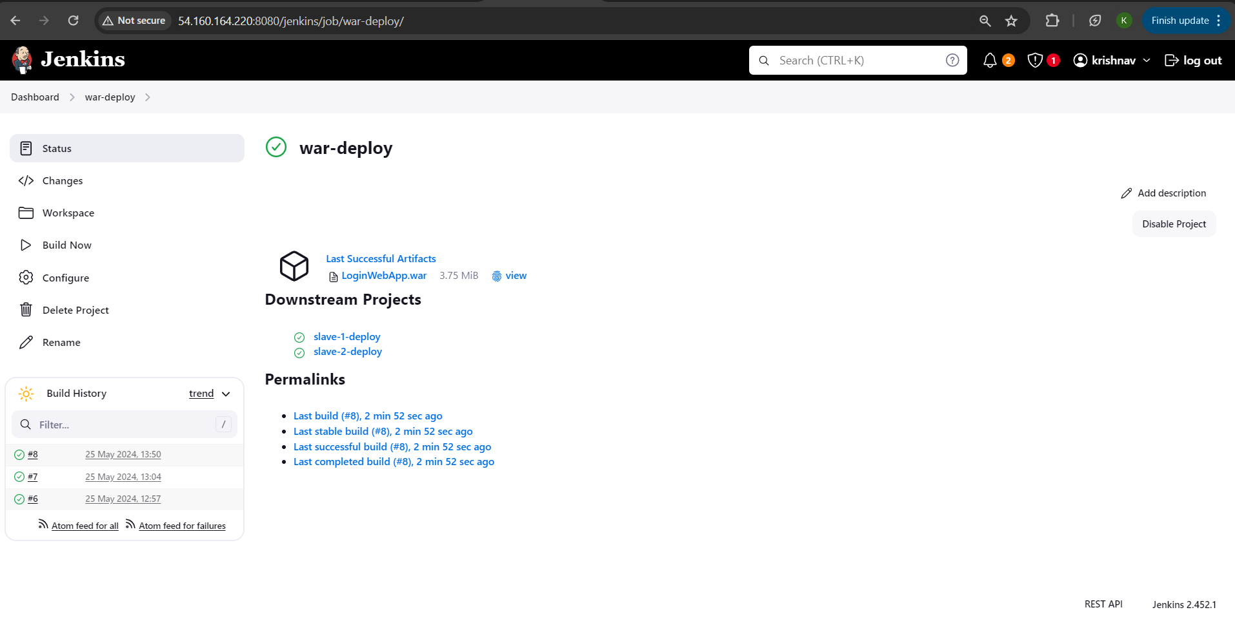

**Webpage hosted on Slave-1 instance**

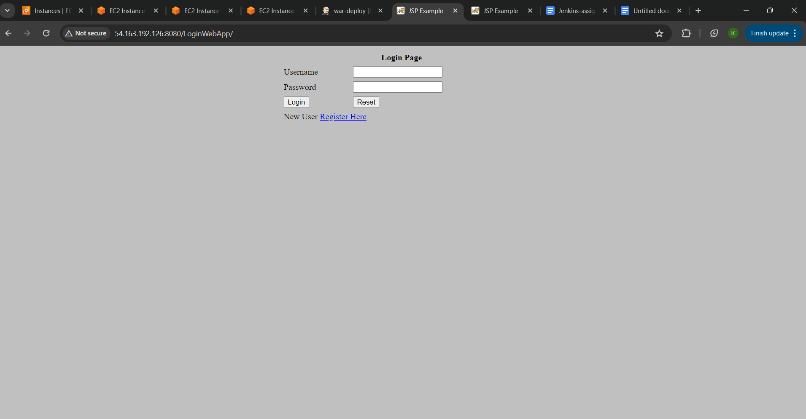

**Webpage hosted on Slave-2 instance** 