**Name : Krishna N. Vyas**

**Assignment 05: Build and deploy application war file on slaves over apache-tomcat**

**Prerequisites:**

**On Master**

1. Install java 11

#yum install java-11-amazon-corretto.x86_64

1. Install apache-tomcat-9.0.89

# cd /mnt

# mkdir servers

# cd servers

# wget<https://dlcdn.apache.org/tomcat/tomcat-9/v9.0.89/bin/apache-tomcat-9.0.89.zip>

# unzip apache-tomcat-9.0.89.zip

# rm -rf apache-tomcat-9.0.89.zip

# chmod -R 777 apache-tomcat-9.0.89/

# cd apache-tomcat-9.0.89/

1. Install jenkins stable version

# cd webapps/

# wget https://get.jenkins.io/war-stable/latest/jenkins.war

# ls -ltr

# cd ..

# cd bin

# ./startup.sh

**On Slave-1 and Slave-2**

1. Install java 11

#yum install java-11-amazon-corretto.x86_64

1. Install apache-tomcat-9.0.89

# cd /mnt

# mkdir servers

# cd servers

# wget<https://dlcdn.apache.org/tomcat/tomcat-9/v9.0.89/bin/apache-tomcat-9.0.89.zip>

# unzip apache-tomcat-9.0.89.zip

# rm -rf apache-tomcat-9.0.89.zip

# chmod -R 777 apache-tomcat-9.0.89/

# cd apache-tomcat-9.0.89/bin

# ./startup.sh

1. Remote directory : slave home

# cd /mnt

# mkdir slave-home

1. # cd /

# chmod -R 777 /mnt

1. Install git

# yum install git -y

1. Install maven

# cd /mnt

# mkdir build-tools

#cd build-tools

# wget <https://dlcdn.apache.org/maven/maven-3/3.9.6/binaries/apache-maven-3.9.6-bin.zip>

1. Set maven home directory environment variable in .bash_profile

**Jenkins Management:**

1. Maven tool configuration

Manage Jenkins > Tools

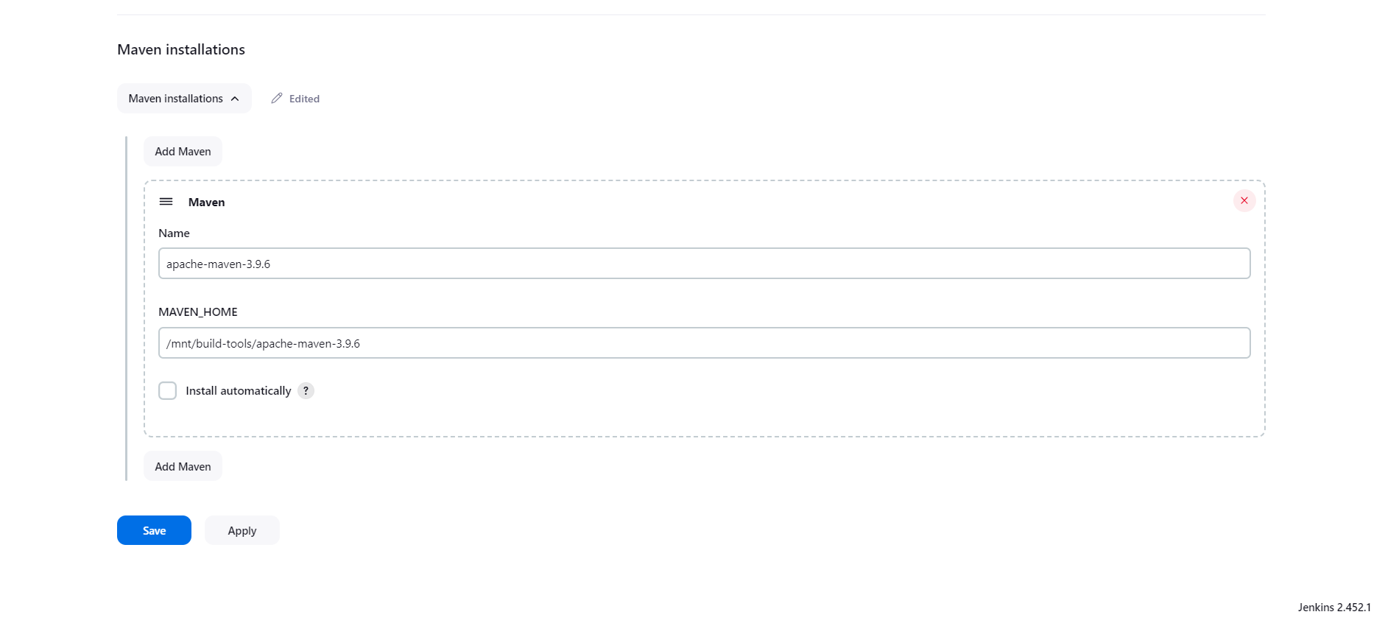

**Jenkins Jobs: similar jobs for slave1, 2: deploy-1 and deploy-2**

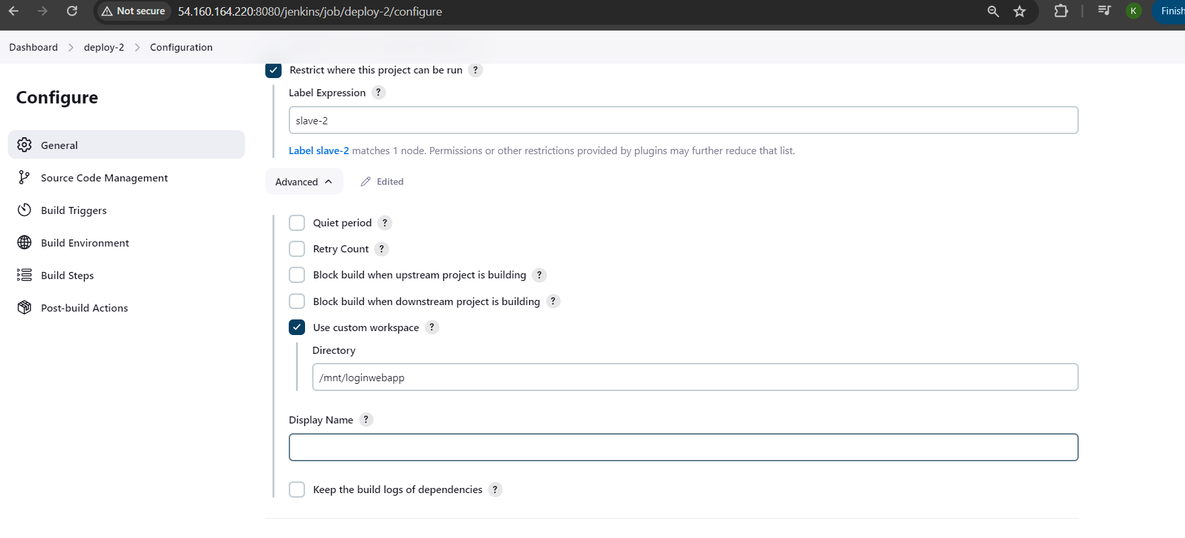

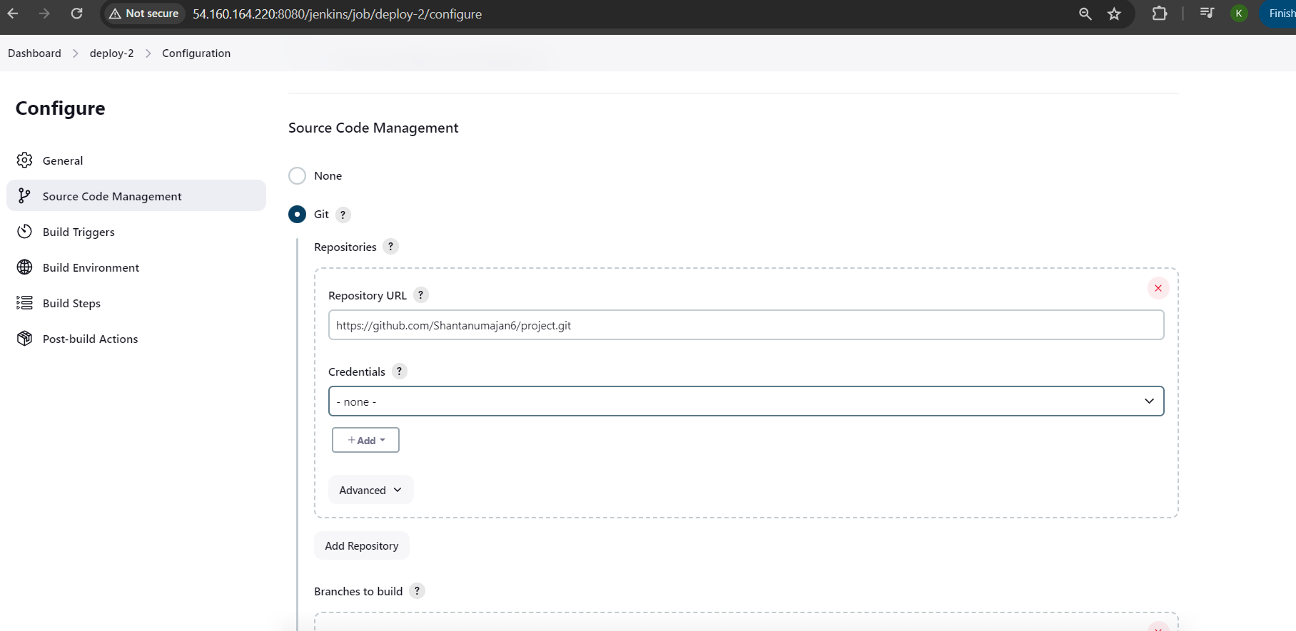

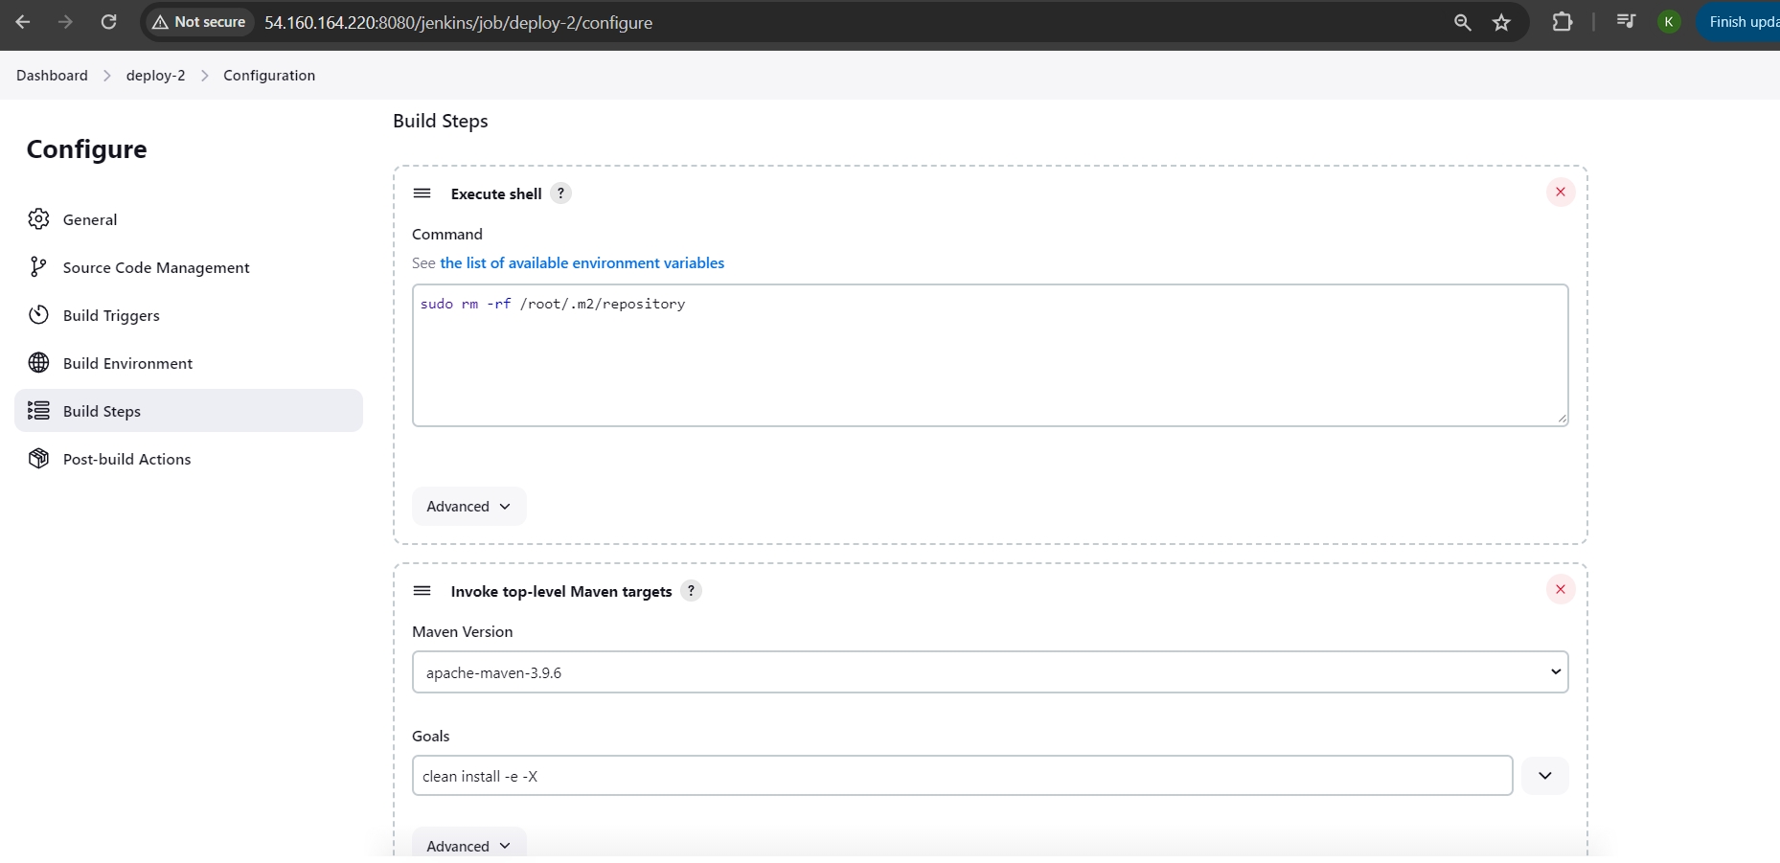

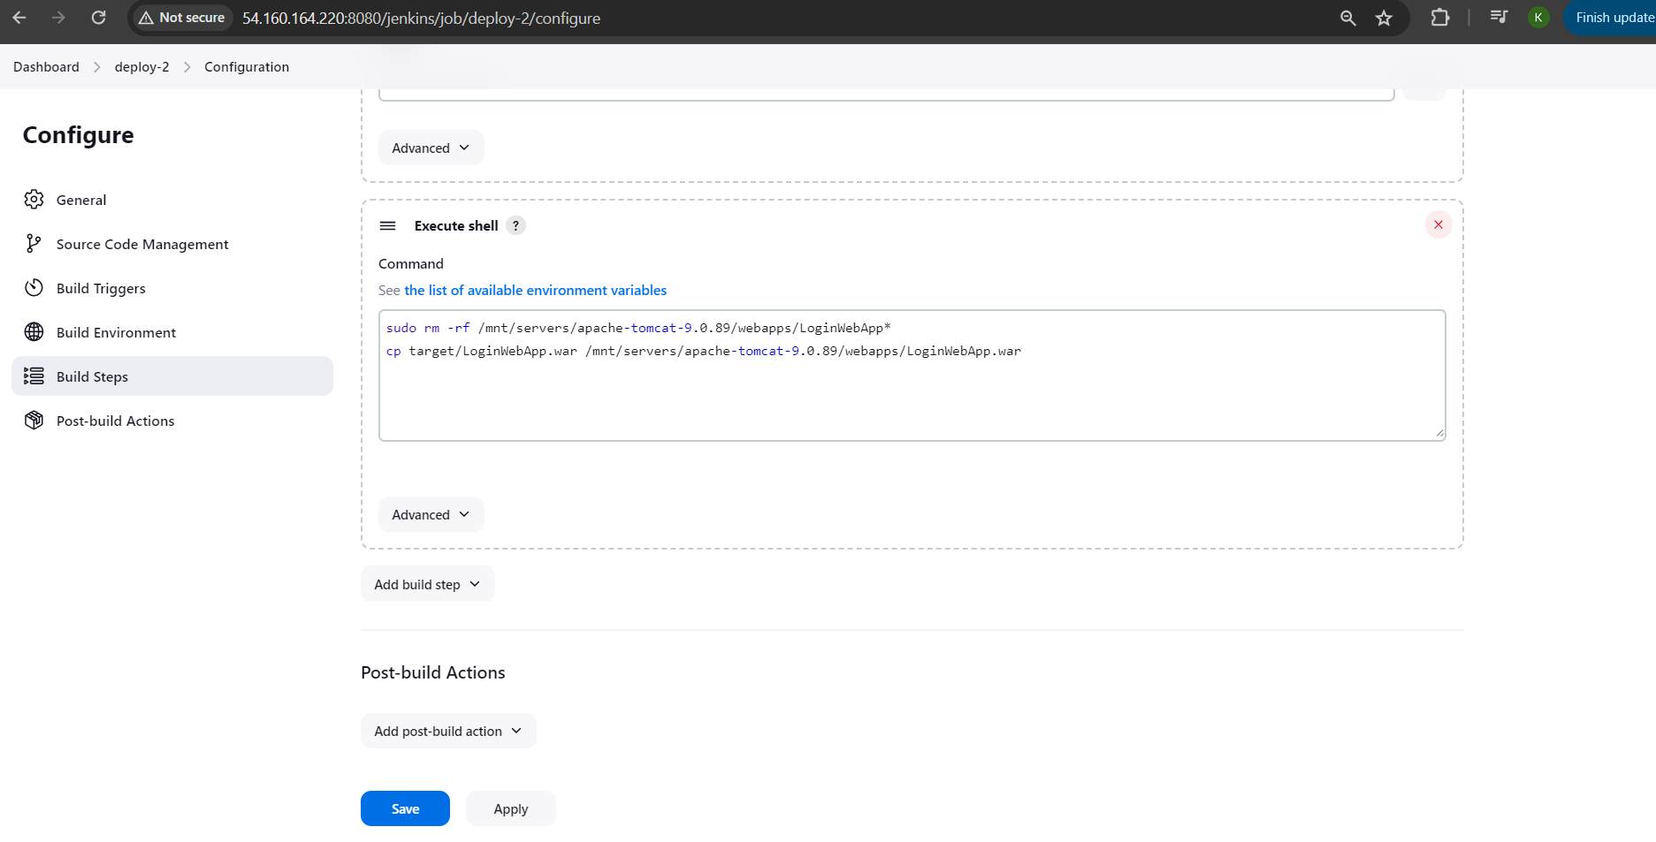

**Outputs**

