**Name : Krishna N. Vyas**

**Assignment 02: Webhooks triggered job**

**Prerequisites:**

1. Install java 11

#yum install java-11-amazon-corretto.x86_64

1. Install httpd

#yum install httpd –y

# systemctl start httpd

# systemctl enable httpd

# systemctl status httpd

1. Install apache-tomcat-9.0.89

# cd /mnt

# mkdir servers

# cd servers

# wget<https://dlcdn.apache.org/tomcat/tomcat-9/v9.0.89/bin/apache-tomcat-9.0.89.zip>

# unzip apache-tomcat-9.0.89.zip

# rm -rf apache-tomcat-9.0.89.zip

# chmod -R 777 apache-tomcat-9.0.89/

# cd apache-tomcat-9.0.89/

1. Install jenkins stable version

# cd webapps/

# wget https://get.jenkins.io/war-stable/latest/jenkins.war

# ls -ltr

# cd ..

# cd bin

# ./startup.sh

1. Install git

# yum install git -y

**Jenkins jobs**

1. **Job1 : Execute shell**

cd /root/.jenkins/workspace/repo1

rm -rf *

git clone https://github.com/C2-80496/git-repo-1.git

cp git-repo-1/index.html /var/www/html/index.html

chmod -R 777 /var/www/html/index.html

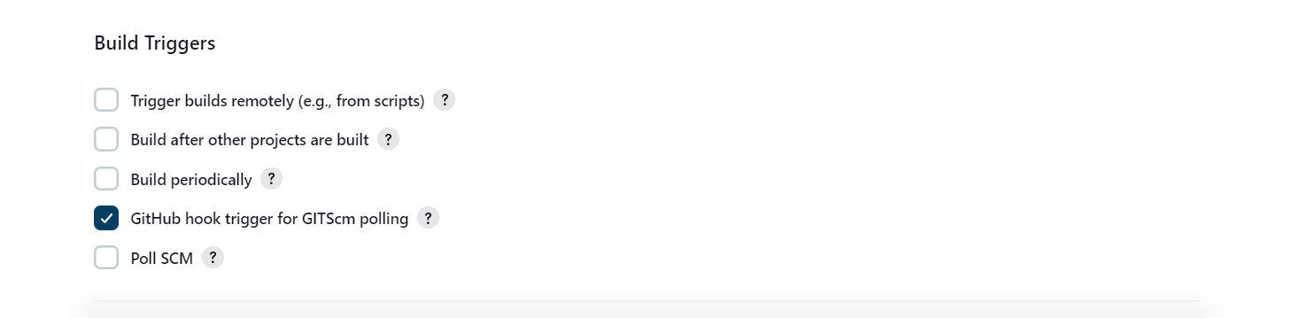

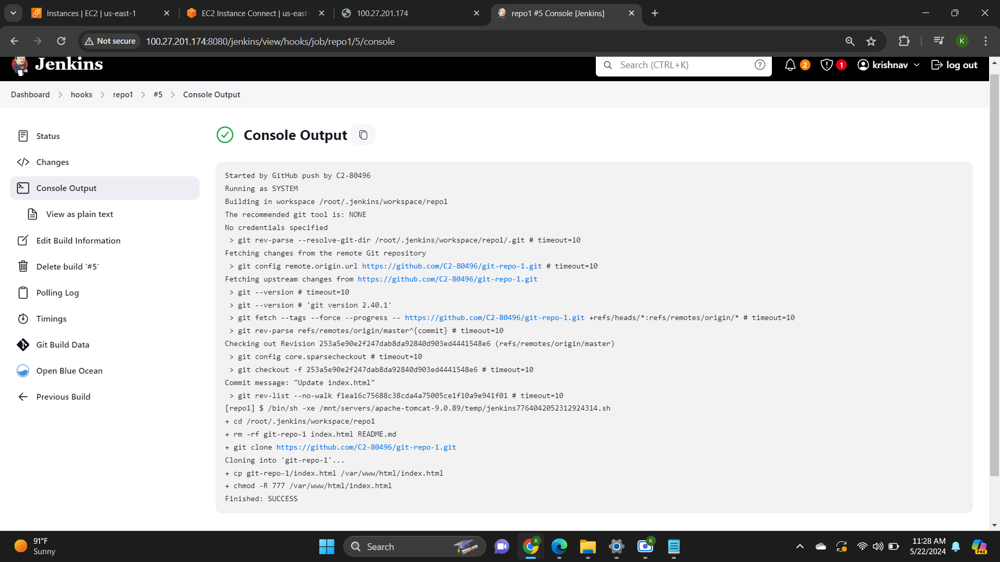

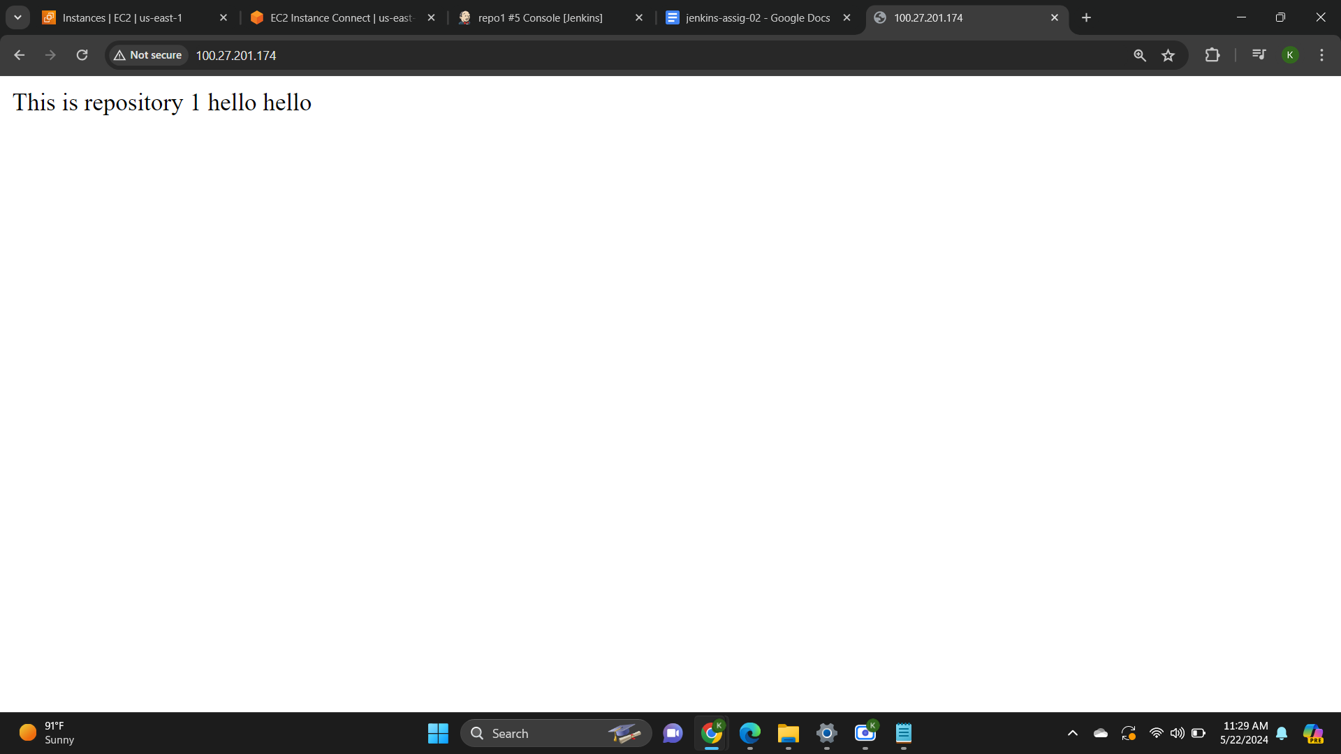

1. **Job 2 : Execute shell**

cd /root/.jenkins/workspace/repo1

rm -rf *

git clone https://github.com/C2-80496/git-repo-1.git

cp git-repo-1/index.html /var/www/html/index.html

chmod -R 777 /var/www/html/index.html



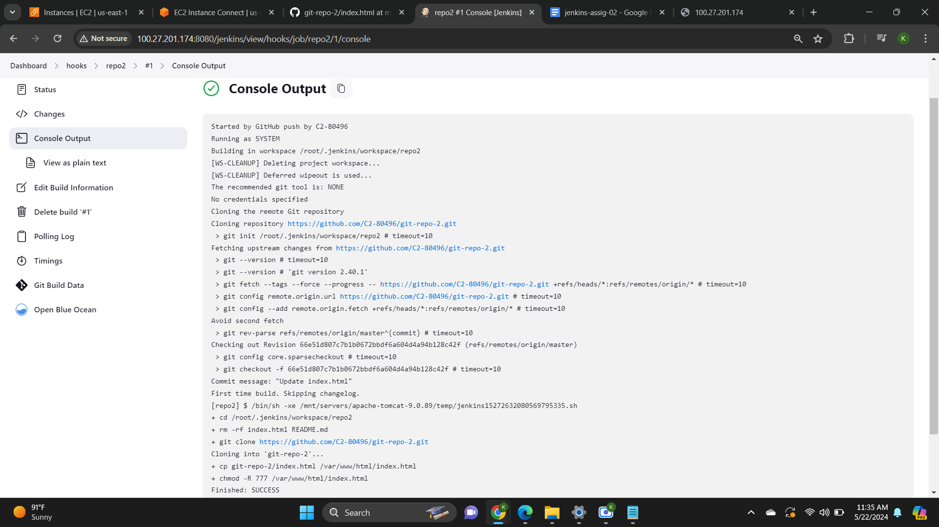

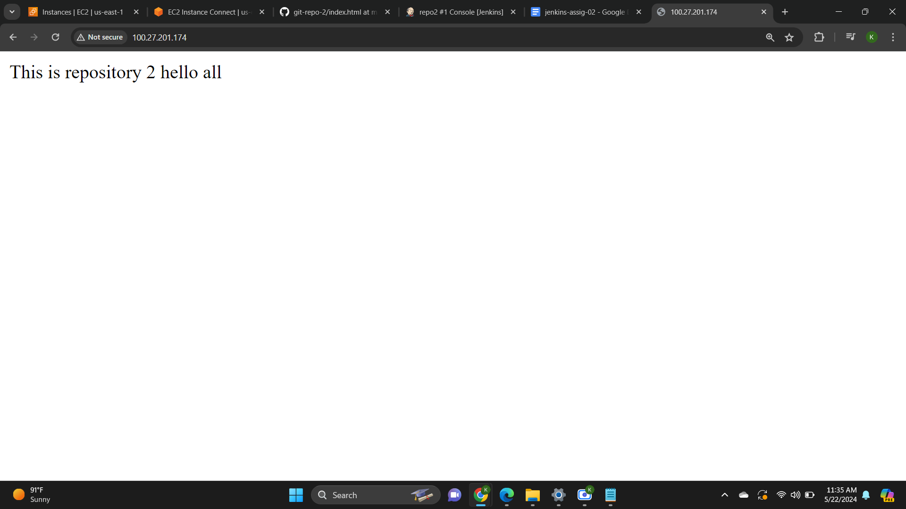

1. **Job 3 : Execute shell**

cd /root/.jenkins/workspace/repo1

rm -rf *

git clone https://github.com/C2-80496/git-repo-1.git

cp git-repo-1/index.html /var/www/html/index.html

chmod -R 777 /var/www/html/index.html



