DROWSY DRIVER DETECTION

Seminar (IT290) Report

Submitted in partial fulfilment of the requirements for the degree of

BACHELOR OF TECHNOLOGY

In

INFORMATION TECHNOLOGY

by

CHINMAYI C. RAMAKRISHNA (181IT113)

KOTLA KARTHIK REDDY (181IT123)

KRISHNA POOJITHA VANTAKULA (181IT223)



DEPARTMENT OF INFORMATION TECHNOLOGY

NATIONAL INSTITUTE OF TECHNOLOGY KARNATAKA

SURATHKAL, MANGALORE -575025

JUNE, 2020

**D E C L A R A T I O N**

I hereby *declare* that the *Seminar (IT290) Report* entitled DROWSY DRIVER DETECTION which is being submitted to the National Institute of Technology Karnataka Surathkal, in partial fulfilment of the requirements for the award of the Degree of Bachelor of Technology in the department of Information Technology, is a ***bonafide report of the work carried out by me***. The material contained in this seminar report has not been submitted to any University or Institution for the award of any degree.

Chinmayi C. Ramakrishna (181IT113)

Kotla Karthik Reddy (181IT123)

Krishna Poojitha Vantakula (181IT223)

Signature of the Student

Place : NITK, Surathkal

Date : 14.06.2020

**CERTIFICATE**

This is to certify that the Seminar entitled “DROWSY DRIVER DETECTION” has been presented by Chinmayi C. Ramakrishna (181IT113), Kotla Karthik Reddy (181IT123) and Krishna Poojitha Vantakula (181IT223) , students of IV semester B.Tech. (IT), Department of Information Technology, National Institute of Technology Karnataka, Surathkal, on 14.06.2020, during the even semester of the academic year 2019 - 2020, in partial fulfillment of the requirements for the award of the degree of Bachelor of Technology in Information Technology.

Mrs. Tanmayee

Signature of the Examiner with Date

Dr. Nagamma Patil

Signature of the Guide with Date

Place : NITK, Surathkal

Date : 14.06.2020

**ABSTRACT**

Studies have suggested that drowsiness and fatigue of drivers are amongst the vital causes of road accidents which are increasing globally. A countless number of people drive on the roads day and night. Taxi drivers, bus drivers, truck drivers and people traveling long-distance suffer from lack of sleep. Due to which it becomes very dangerous to drive when feeling sleepy. Statistics indicate the need for a reliable driver drowsiness detection system which could alert the driver before a mishap happens. The advancement of computing technology has provided the means for building intelligent vehicle systems, thereby providing solutions to many real world problems. This project is an implementation of a safety technology which helps prevent accidents caused by the driver getting drowsy. Through this approach, the detection of drowsiness is performed by applying deep learning concepts and is based on real time eye tracking in the video placed in front of the driver.We conclude that by designing a hybrid drowsiness detection system that include non-intrusive techniques one would accurately determine the drowsiness level of a driver. A number of road accidents might then be avoided if an alert is sent to a driver that is deemed drowsy.

i

**TABLE OF CONTENTS**

|  |  |
| --- | --- |
| **Topic Name** | **Page No** |
| List of Figures | iii |
| **Chapter 1: Introduction** | 1 |
| **Chapter 2: Literature Review** | 4 |
| **Chapter 3: Technical Discussion**   * Methodology * Experimental Results | 6  6  12 |
| **Chapter 4: Conclusions and Future Trends**   * References | 14  15 |

ii

**LIST OF FIGURES**

|  |  |
| --- | --- |
| **Figures** | **Page No.** |
| Figure 1. Flow diagram of Drowsy Detection System | 7 |
| Figure 2. Flow diagram of the CNN | 8 |
| Figure 3. Basic structure of Neural Network | 10 |
| Figure 4. Block diagram of Drowsy Detection System  Figure 5. Screenshot when the eyes are open  Figure 6. Screenshot when the eyes are closed | 11  13  13 |

iii

**CHAPTER-1 INTRODUCTION**

Transportation turned out to be an essential aspect in the daily routine of every individual, without which human progress would not be very effective. Including the travel of people or the movement of goods and other commodities from one place to another, transportation always played a vital role in the diversification of the globe. It also plays a crucial economic role in the world. This is even more so in a global economy where economic opportunities have been increasingly related to the mobility of people and freight, including information and communication technologies. Millions drive as part of their jobs. Some are professionally trained drivers, many are not. If a job does not primarily involve driving, the employee often does not receive the same safety management or engagement in driving safety others may get. Despite being trained or not, there always exists a chance of encountering accidents while driving, which can lead to undesirable consequences. In the 20th century, accidents have taken third place, after cancer and cardiovascular diseases, as a cause of death in the economically developed countries.

Safety is the first priority while travelling or driving. One mistake of the driver can lead to severe physical injuries, deaths and significant economic losses. There are various reasons, especially human errors, which give rise to road accidents. When people drive while they are tired, drowsy or sleepy, this is commonly referred to as driver fatigue or drowsy driving**.** Drowsiness is defined as a decreased level of awareness portrayed by sleepiness and trouble in staying alert but the person awakes with simple excitement by stimuli. It might be caused by an absence of rest, medicine, substance misuse, or a cerebral issue.

It is mostly the result of fatigue which can be both mental and physical. Physical fatigue, or muscle weariness, is the temporary physical failure of a muscle to perform ideally. Mental fatigue is a temporary failure to keep up ideal psychological execution.

1

This is one of the [top causes of car accidents](https://seriousaccidents.com/legal-advice/top-causes-of-car-accidents/), since drowsy drivers are unable to adequately perceive, react and respond to situations on the road. Driver fatigue can also lead to reduced attention to the road as well as slower reaction rates. In extreme cases, a driver may actually fall into microsleep and briefly lose consciousness on the road. Even a few seconds asleep on the road is the perfect formula for a [wrongful death](https://seriousaccidents.com/personal-injury/wrongful-death/) accident.

Drowsy driving is a major problem to be considered all over the world. The risk, danger, and often tragic results of drowsy driving are alarming. Drowsy driving is the dangerous combination of driving and sleepiness or fatigue. A number of symptoms that can suggest driver fatigue, such as the following:

* Yawning
* Tired eyes
* Boredom
* Inability to remember directions
* Restlessness
* Difficulty concentrating

No one knows the exact moment when sleep comes over the driver’s body. Falling asleep at the wheel is clearly dangerous, but being sleepy affects your ability to drive safely even if you do not fall asleep. Drowsiness makes drivers less able to pay attention to the road. It slows reaction time if the driver has to brake or steer suddenly and affects the ability to make good decisions. Based on previous studies, researchers classified drivers as drowsy if their eyes were 80% closed or covering the pupil at least 12% of the time in the minutes before a crash.

2

The major causes for drowsiness of driver in general could be the following:

* Driving patterns, including both time of day and amount of time driven, can increase crash risk.
* Driving for long periods of time, dulls the senses and leads to general lethargy and fatigue. This is especially true for truckers who drive at night because it is biologically more natural to sleep during that time.
* Although the absolute number of crashes is low, crash risk is increased among people with untreated sleep apnea syndrome (SAS) and narcolepsy. The proportion of crashes is higher for people with untreated narcolepsy than it is for people with untreated SAS.
* Short duration of sleep appears to have the greatest negative effects on alertness. Acute sleep loss, even the loss of one night of sleep, results in extreme sleepiness
* Juggling work and family responsibilities, combining work and education, and making time for enjoyable pastimes often leave little time left over for sleeping.

With the rapidly improving technological advancements in various fields, people could come up with solutions to many problems which could affect mankind. Technology would not replace basic measures like getting a good sleep, but it may put a dent in the accidents and fatalities. Drowsy driver detection methods can form the basis of a system to potentially reduce accidents related to drowsy driving.

3

**CHAPTER-2 LITERATURE REVIEW**

Drowsy driving is an extremely serious matter. Experts have found that driving while drowsy is similar to driving while intoxicated or drugged. It is estimated that 30% of all traffic accidents have been caused by drowsiness. It was demonstrated that driving performance deteriorates with increased drowsiness with resulting crashes constituting more than 20% of all vehicle accidents. The main reason occurring from highway accidents is the drowsiness and sleepiness of the driver while driving. Hence there is a considerable demand for a solution that could resolve this major issue of threat to the lives of drivers. It is a necessary step to come up with an efficient technique to detect drowsiness as soon as the driver feels sleepy.

The development of technologies for detecting or preventing drowsiness at the wheel is a major challenge in the field of accident avoidance systems. Because of the hazard that drowsiness presents on the road, methods need to be developed for counteracting its effects. Drowsy driver detection methods can form the basis of a system to potentially reduce the number of crashes related to drowsy driving. This project is the stride that has been made in the development and application of a real-time drowsiness monitor. It is aimed towards developing a prototype of a drowsiness detection system.

Real time drowsy detection has been done using various techniques analysing various types of input data. One approach uses examining the human physiological activities like brain waves, heart rate or pulse rate to determine the drowsiness of the driver. This approach however is not very reliable. It is found that sleep deprivation alone does not influence the brain signals that control the drowsiness whereas the duration of a task has a strong influence in detecting it.

4

There are subjective measures which evaluate the level of drowsiness based on the driver’s personal estimation and several tools have been used to translate this rating to a measure of driver drowsiness. The most commonly used drowsiness scale is the Karolinska Sleepiness Scale (KSS). One limitation is the difficulty in obtaining the feedback from a driver in a real driving situation. Standard Deviation of Lane Position (SDLP) is a vehicle based measure to evaluate drowsiness. This method contains a software to track the position of lanes using an external camera. This technique is purely dependent on external factors like road marking, climatic and lighting conditions. Vehicle based measures are poor predictors of performance error risk due to drowsiness.

Single frames are not sufficient as blinking or micro-sleep can be mistaken for drowsiness and cause the unnecessary alarms. The analysis of single frames cannot identify face movements that are important for drowsiness detection. The duration of the modelled action is therefore an important addition. However, capturing more frames than strictly necessary will hinder real time detection, as both video recording time and model inference time increase.

Our approach is a real time system which captures images continuously and measures the state of the eye according to the specified algorithm and gives warning if required. Though there are several methods for measuring the drowsiness but this approach is completely non-intrusive which does not affect the driver in any way, hence giving the exact condition of the driver. For detection of drowsiness the per closure value of the eye is considered. So when the closure of the eye exceeds a certain amount then the driver is identified to be sleepy. This turns out to be an effective way of detecting an alarming situation.

5

**CHAPTER-3 TECHNICAL DISCUSSION**

**Methodology**

In this project, we intended to develop a drowsiness detecting device that will detect if a person’s eyes are closed or not for some time. This system will alert the driver when drowsiness is detected by ringing an alarm. To prevent these accidents caused by drowsiness, we have built a system using Python, OpenCV, and Keras which will alert the driver when he feels sleepy. We used OpenCV for taking a live video from a webcam. We extract frames from the video and feed them into a deep learning model which will classify whether the person’s eyes are open or closed. The approach used in this project is as follows :

1. Take a live video from a webcam.
2. Extract each frame from the live video.
3. Detect the face in the image and create a Region of Interest (ROI) by using the haarcascade_frontalface_alt file.
4. Detect the eyes from ROI and feed it to the classifier by using haarcascade_lefteye_2splits and haarcascade_righteye_2splits files.
5. Now the image of eyes that is extracted is sent to the CNN model that we built.
6. The CNN Classifier will categorize whether eyes are open or closed.
7. When the eyes are closed then there will be a counter which gets incremented by 1 and it gets decremented when eyes are opened.
8. When the counter value goes above a predetermined value, 15 in our consideration, then the alarm starts ringing.
9. The alarm will stop ringing when the counter goes below 15.
10. Press Q to exit the web-cam.

6

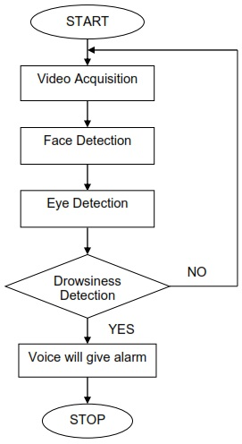

**Figure 1** . Flow Diagram of Drowsy Detection System

The dataset we used in this process for predicting open and closed eyes can downloaded from the below link

(<http://parnec.nuaa.edu.cn/xtan/data/ClosedEyeDatabases.html>)

7

The dataset contains 4 folders namely :

* closedLeftEyes
* closedRightEyes
* openLeftEyes
* openRightEyes

This model Drowsy Driver Detection is built on Convolution Neural Network(CNN) by taking the input as images of eyes.

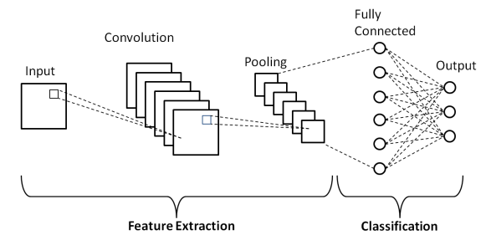

**Figure 2.** Flow of the CNN

8

**Steps in Convolution Neural Network :**

**Step 1 : Convolution Operation**

Convolution has the nice property of being translational invariant. Intuitively, this means that each convolution filter represents a feature of interest (e.g pixels in letters) and the Convolutional Neural Network algorithm learns which features comprise the resulting reference (i.e. alphabet).There are three important items to mention in this process: the input image, the feature detector, and the feature map. The input image is the image being detected. The feature detector is a matrix, usually 3x3 (it could also be 7x7). A feature detector is also referred to as a kernel or a filter.

**Step 1(b) : ReLU Layer**

ReLU is an activation function. Rectified Linear Unit (ReLU) transform function only activates a node if the input is above a certain quantity, while the input is below zero, the output is zero, but when the input rises above a certain threshold, it has a linear relationship with the dependent variable.

**Step 2 : Pooling**

In this layer we shrink the image stack into a smaller size. Pooling is done after passing through the activation layer. Its function is to progressively reduce the spatial size of the representation to reduce the amount of parameters and computation in the network. The most common approach used in pooling is max pooling.

9

**Step 3 : Flattening**

Once the pooled featured map is obtained, the next step is to flatten it.Flattening involves transforming the entire pooled feature map matrix into a single column which is then fed to the neural network for processing.

**Step 4 : Full Connection**

After flattening, the flattened feature map is passed through a neural network. This step is made up of the input layer, the fully connected layer, and the output layer. The fully connected layer is similar to the hidden layer in ANNs but in this case it’s fully connected. The output layer is where we get the predicted classes. The information is passed through the network and the error of prediction is calculated. The error is then back propagated through the system to improve the prediction.

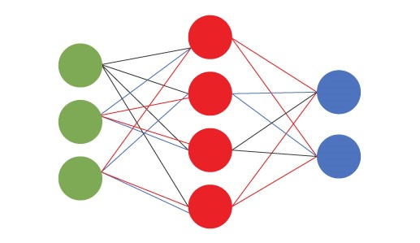

**Figure 3.** Basic structure of Neural Network

10

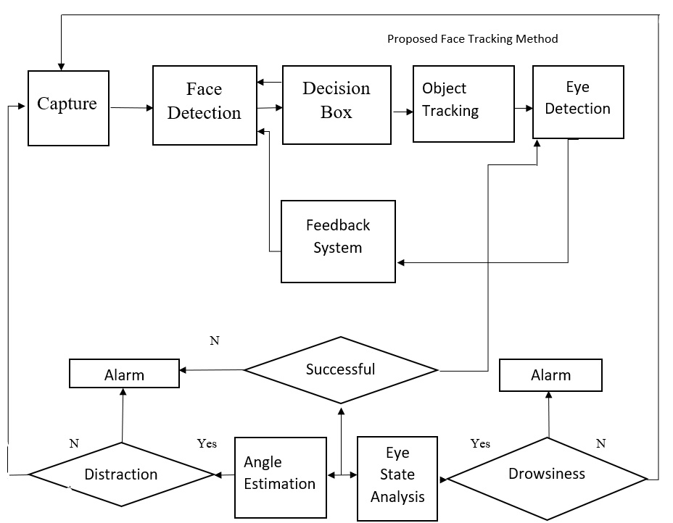

**Figure 4**. Block Diagram of Drowsy Detection System

* The model is convoluted with a 3x3 matrix.
* The activation function used on dense layers is relu.
* The pool_size is (2,2).
* We applied a dropout of 0.25 so that some unimportant nodes will not decide the prediction.
* The activation function used on the output is sigmoid.
* The loss function used is binary_crossentropy.

11

* The optimizer used is sgd.
* The metrics are accuracy.
* The number of epochs are 20
* The batch size is 30
* Once the training of the model gets completed and is ready we save the model and the weights of the neural network in a json format.

**Results :**



When the images are convoluted with a 3x3 matrix, pooled with a pool size of (2,2) and for the model loss function is binary_crossentropy, optimizer as sgd, metrics as accuracy and trained on 20 epochs we got an accuracy of 96.856% and a loss score of 0.108 on test dataset.

The model is able to predict drowsiness very efficiently. When the driver closes his eyes then the count value gets incremented by 1 and when the driver closes his eyes it gets decremented by 1 and when the count value becomes greater than or equal to 15 then the alarm starts ringing and alerts the driver that he is drowsy.

12



**Figure 5.** Screenshot when the eyes are open

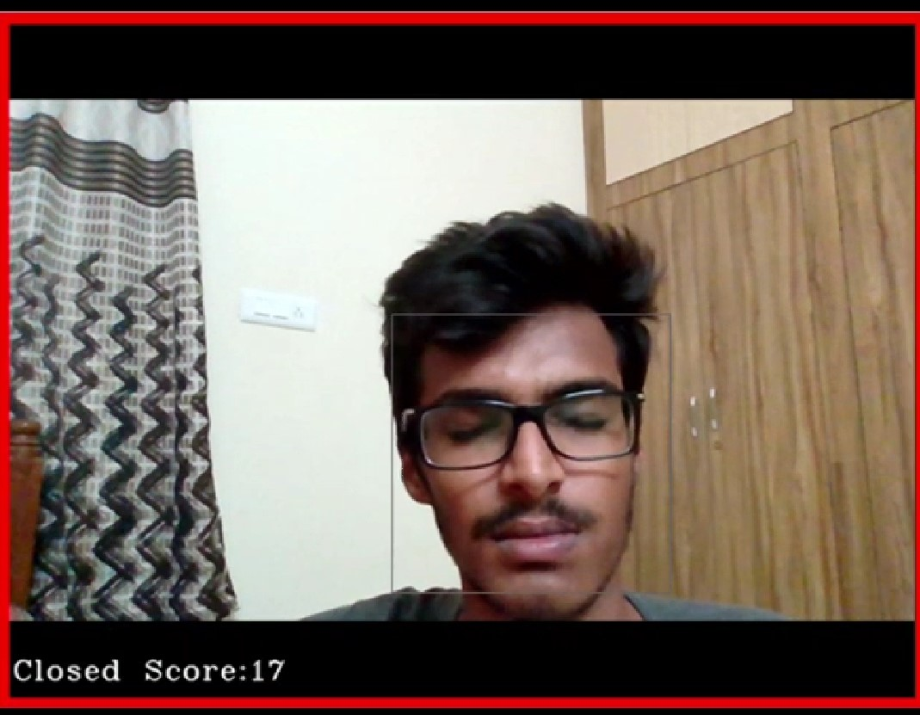

**Figure 6.** Screenshot when the eyes are closed

13

**CHAPTER-4 CONCLUSIONS AND FUTURE TRENDS**

Implementation of drowsiness detection using Python, OpenCV, and Keras was done which includes the following steps: Successful runtime capturing of video using webcam.

Captured video was divided into frames and each frame was analyzed which was put into an infinite loop. Successful detection of face followed by detection of eye from each frame. For each frame having the closure of the eye value of score is incremented by unit value and with open eye decremented the score by unit value. If closure of the eye for successive frames with score greater than or equal to 15 were detected then it is classified as drowsy condition else it is regarded as normal blink and the loop of capturing image and analyzing the state of the driver is carried out again and again. On detection of drowsiness, the alarm is made to ring until the score gets below 15.

**Future Work**

Our model is designed for detection of drowsy state of the eye and gives an alert signal or warning may be in the form of audio. But the response of the driver after being warned may not be sufficient enough to stop causing the accident meaning that if the driver is slow in responding towards the warning signal then an accident may occur. Hence to avoid this we can design and fit a motor driven system and synchronize it with the warning signal so that the vehicle will slow down after getting the warning signal automatically. We also aim to add driver drowsiness monitoring based on yawning detection. Yawning is one of the face gestures that can be used to determine a driver's state. The implementation includes face extraction, mouth localisation and the algorithm proposed in our project for the successful detection. A dataset with the extracted pictures can be fed into the algorithm to train the model. The alarm rings when the mouth remains open for a long time.

14

**REFERENCES**

[1] Hartman, K. and J. Stressor, Saving Lives through Advanced Vehicle Safety Technology: Intelligent Vehicle Initiative Final Report. 2005, Department of Transportation: Washington, DC. p.

[2] Akin; M.; et al., "Estimating vigilance level by using EEG and EMG signals” published in Neural Computing and Applications 2008. 17(3): p. 227-236

[3] X. Li, E. Seignez and P. Loonis, "Vision-based estimation of driver drowsiness with ORD model using evidence theory," 2013 IEEE Intelligent Vehicles Symposium (IV), Gold Coast, QLD, 2013, pp. 666-671

[4] Artem A. Lenskiy and Jong-Soo Lee, "Driver’s Eye Blinking Detection Using Novel Color and Texture Segmentation Algorithms" published in International Journal of Control, Automation, and Systems (2012) 10(2):317-327.

[5] Bradski, G., the OpenCV Library. Dr. Bobb's Journal of Software Tools, 2000.

[6] Shen, L. and L. Bai, AdaBoost Gabor Feature Selection for Classification. 2004.

[7] Freund, Y. and R. Schapiro, A short introduction to Boosting. Japanese Society for Artificial Intelligence, 1999. 14(5): p. 771-780.

[8] Abdelwahab H, Abdel-Aty MA (2002) Artificial neural networks and logit models for traffic safety analysis of toll plazas. Transp Res Rec: J Transp Res Board 1784:02–2270. <https://doi.org/10.3141/1784-15>

15