Lab 6

# C20379081

## Harry O’Donnell

I used azure to deploy the VM using a REST api, I used this as it was easier and I was familiar with azure.

The Json body for the azure VM.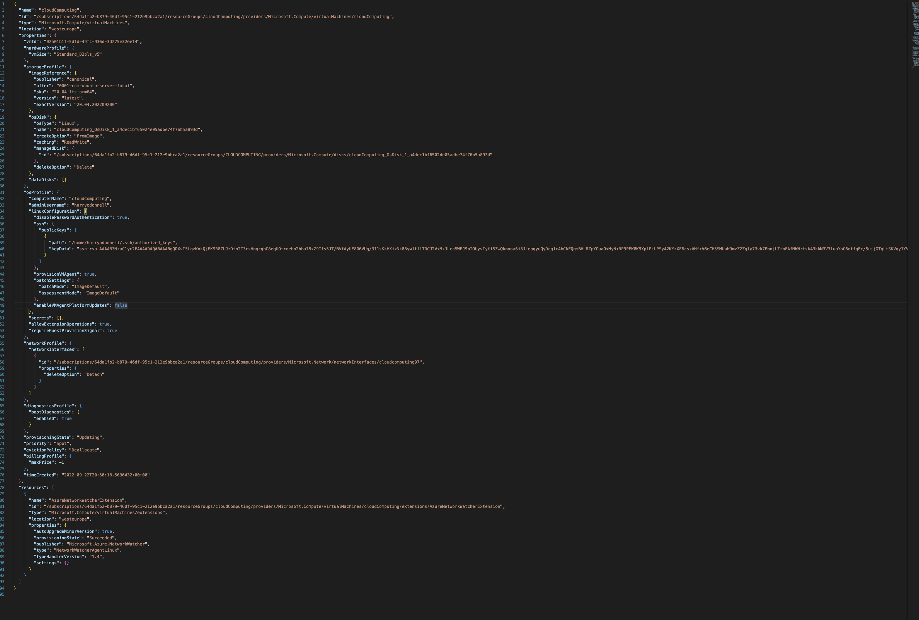

I then used azures equivalent of the cloud secret which is k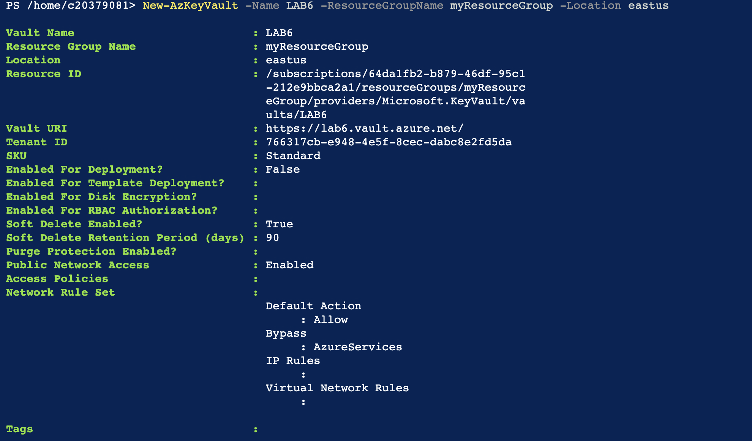ey vault. I did that on the azure power shell.

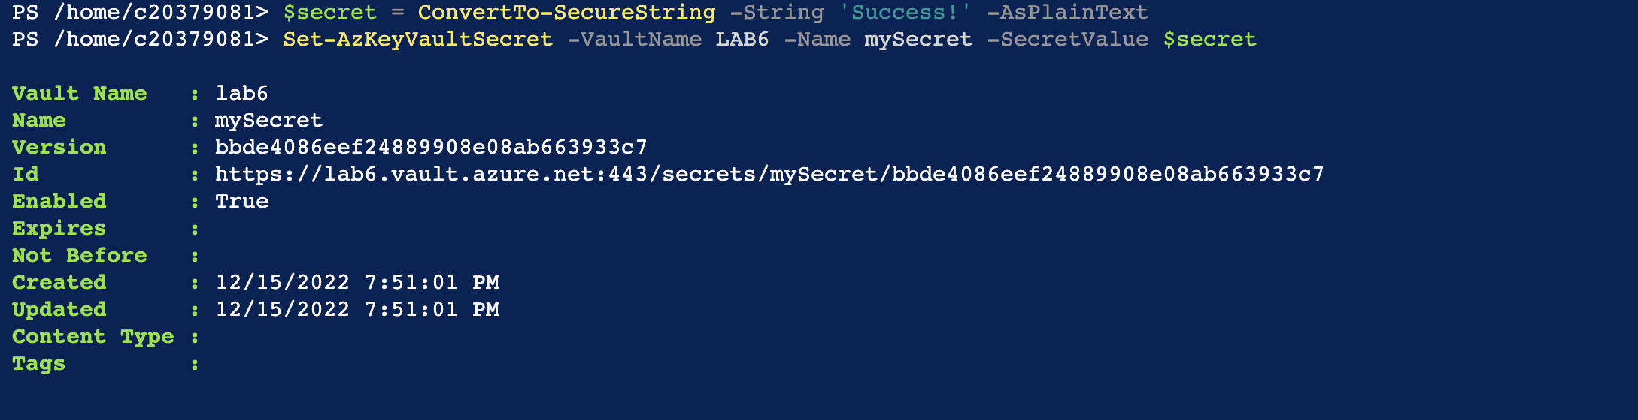

I created a python file which interacts with with the key vault using the virtual machine.

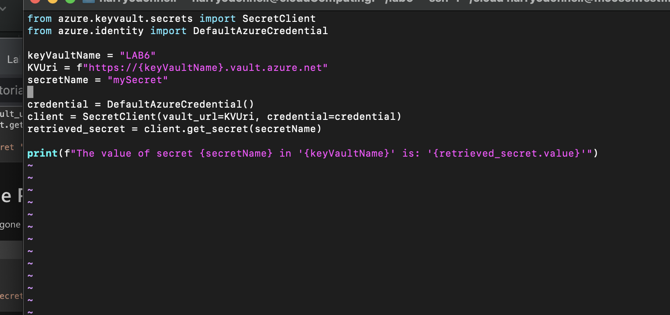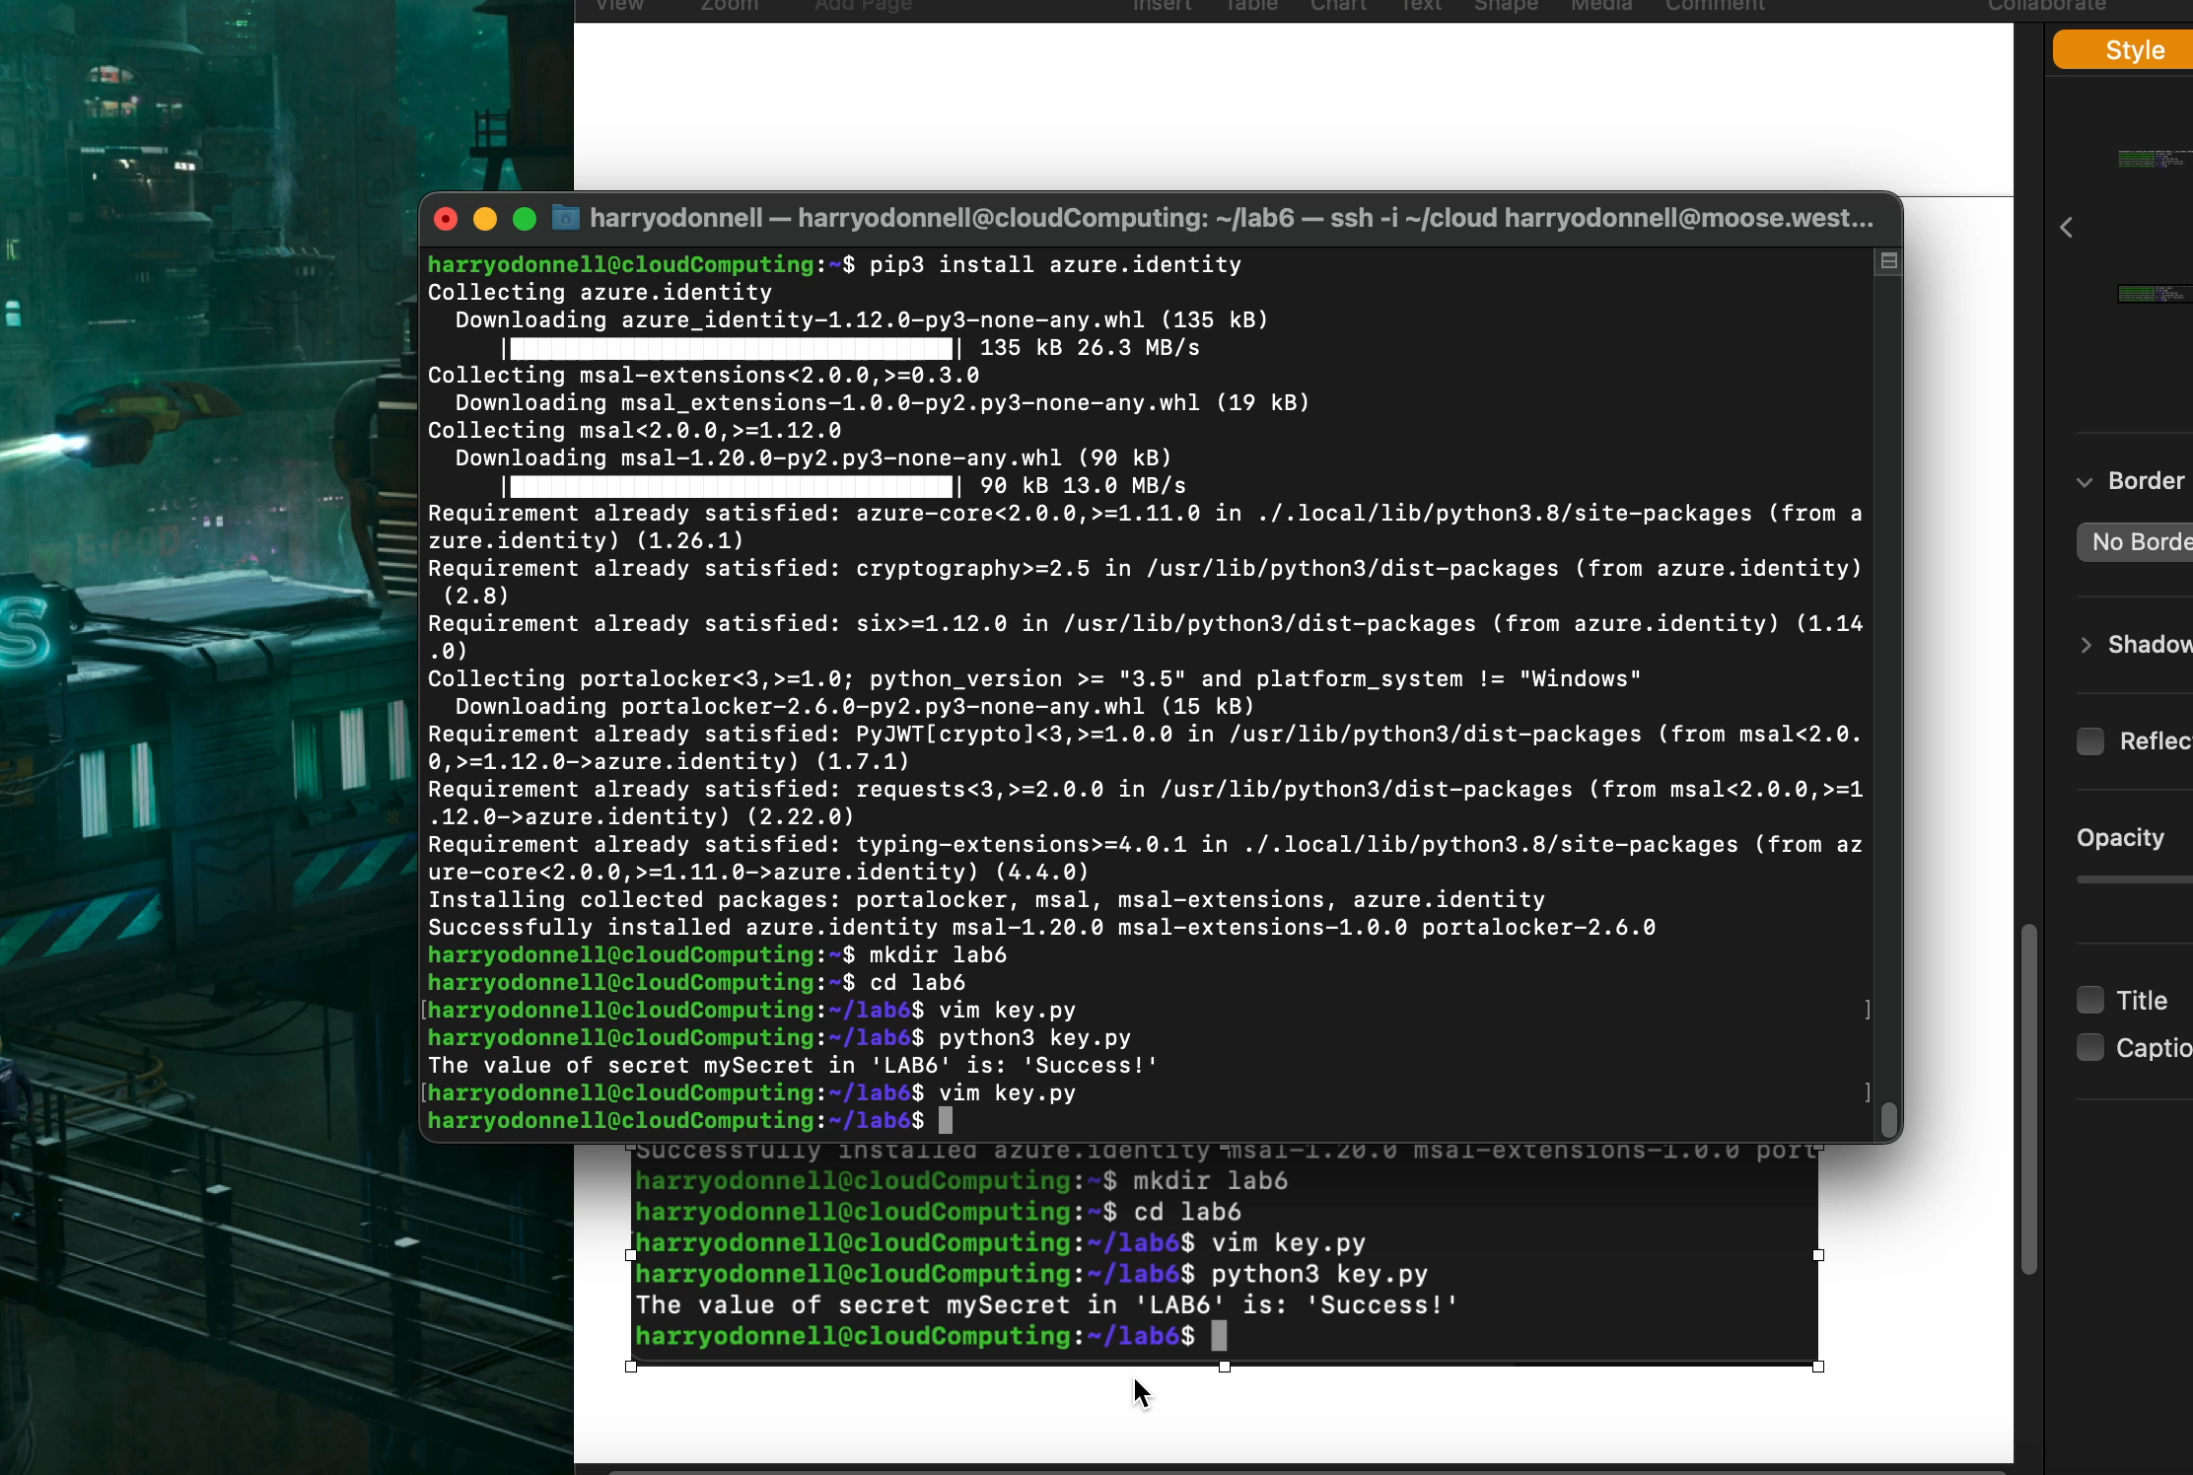I ran the python file on the virtual machine and accessed the secret vault.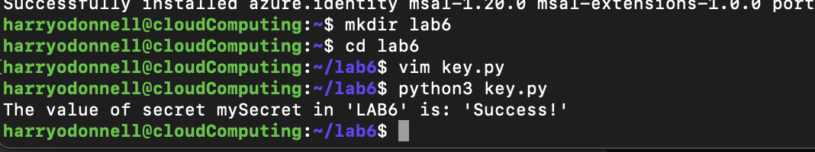

Video of it working: