**Use case 1: Identify potentially lost packages and notify transport managers**

The Transport Manager (user) requests records of potentially lost packages from the system. The system finds all packages that have not been delivered and have had no scans recorded for a set period of time. The records identified are then returned to the user for their inspection. The user can then ascertain the true state of the physical packages outside of the system.

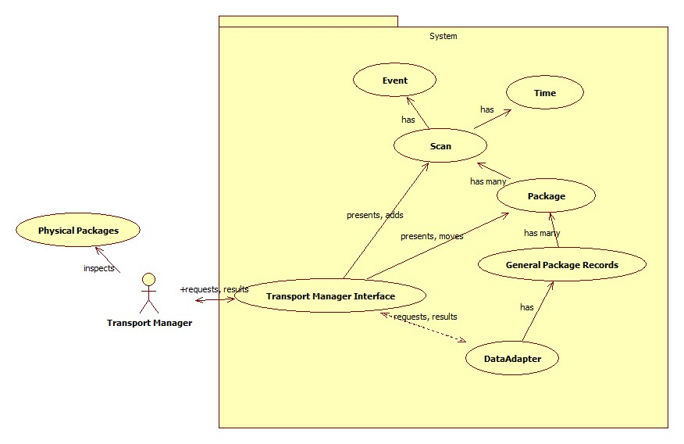

**Function 2: Allow transport managers record lost packages as lost**

The user has previously identified a potentially lost packaged and ascertained that the physical package is lost (through some medium other than the system). The user then returns to the system and indicates the package to record as lost. The system adds a new ‘lost’ status to that package then moves the package record, removing it from the general package records and adding it to the lost package records.

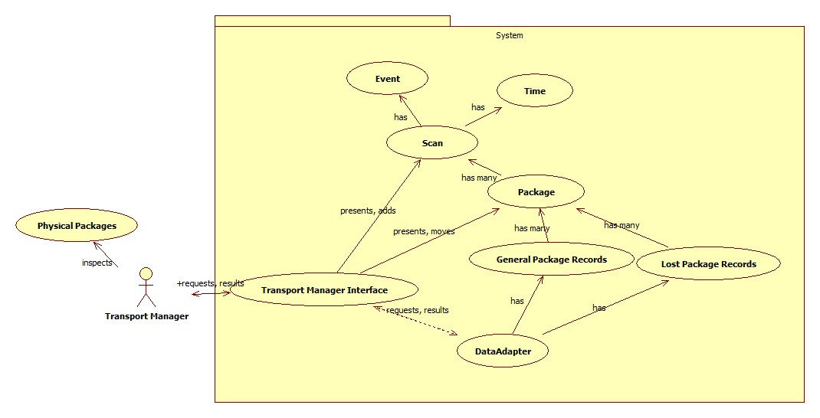

**Function 3: Allow Transport Managers to restore lost packages when found**

The user has previously identified a package recorded as lost has been found (through some medium other than the system). The user sends the system their request to view all packages listed as lost. The system returns collection of lost package records for the user’s inspection. The user indicates the package that has been found. The system adds a new ‘found’ status to that package then restores the package record, removing from the lost records and adding it to the general records.

