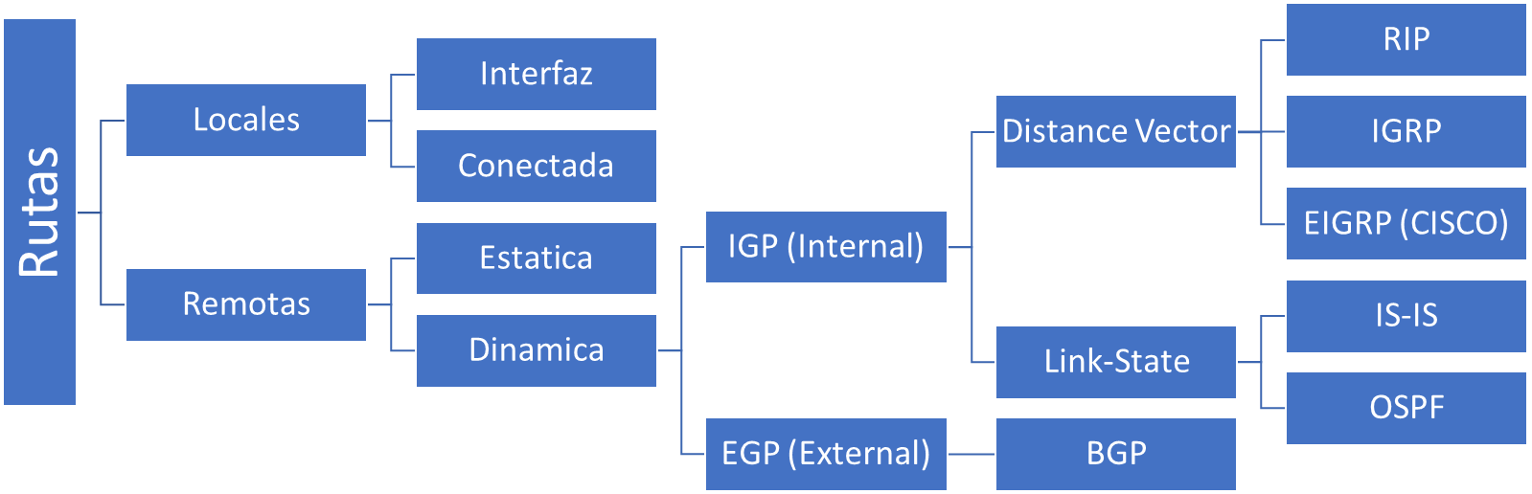

GLOSARIO
- IGP (Internal Gateway Protocol)
- EGP (External Gateway Protocol)
- BGP (Border Gateway Protocol)
- RIP (Router Internet Protocol)
- IGRP (Internal Gateway Routing Protocol) - Protocolo Propietario de CISCO
- EIGRP (Enhaced Internal Gateway Routing Protocol) [CISCO] – Version Mejorada de IGRP
- ISIS (Intermediate System – Intermediate System)
- OSPF (Open Shortest Path First)

