Assets and links
Nested: Bolded (and ita-underlined-lic) content, just to check if the run-level styling was preserved.
This paragraph contains an example of a run (part of a paragraph) that is only visible in the digitalpaper version. Same for hyperlinks to e.g. ebookbook.

Handle assets

Asset for digital
For example, a text relevant only to a publication available online should not necessarily appear in a paper version. Similarly, because of its low resolution, the image below probably should not be included in a paper edition of a book as well. To omit this fragment on paper simply highlight in grey the whole content to leave out.
Figure 1: Drawing of an orange by Franz Eugen Köhler, 1887.
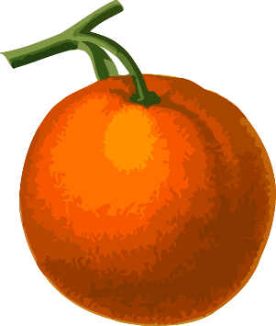
##Digital-input | ./assets/02_assets_and_links/orange_low_resolution.png
##Source | https://web.archive.org/web/20170702171643/https://openclipart.org/detail/237816/orange-low-resolution  Published under Creative Commons Zero 1.0 Public Domain License (https://openclipart.org/share)
##Author | Franz Eugen Köhler
##Alt-text | Low resolution drawing of an orange

Asset for paper
Conversely, an author may wish that some content was published on paper only. To exclude it from being rendered online, highlight it in turquoise. This applies to any content, including an image as shown below.
Figure 2: Image of an orange. Author unknown.
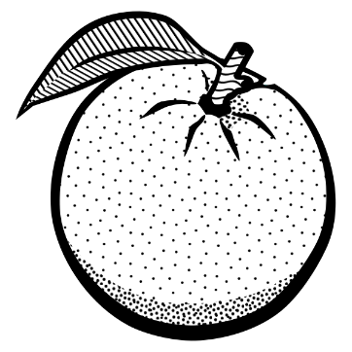
##Paper-input | ./assets/02_assets_and_links/orange_black_and_white.png
##Source | https://web.archive.org/web/20240226071359/https://freesvg.org/drawing-of-an-orange  Published under CC0 1.0 Public Domain (https://creativecommons.org/publicdomain/  https://openclipart.org/share)
##Author | Unknown
##Alt-text | Black and white drawing of an orange

Asset for digital and paper
Content.
Figure 3: An example of an image.

##Digital-input | ./assets/common/uni_logo.png
##Paper-input | ./assets/common/uni_logo.png
##Source | https://en.m.wikipedia.org/wiki/File:University_of_Luxembourg_logo_(fr).svg
##Alt-text | Logo of University of Luxembourg in French pointing to the uni.lu website

Figure numbering
Link to 1st asset (NOT on paper, 1st in digital): cross-ref Figure 1 and link to figForDigital bookmark
Link to 2nd asset (1st on paper, NOT in digital): cross-ref Figure 2 and link to figForPaper bookmark
Link to 3rd asset (2nd on paper, 2nd in digital): cross-ref Figure 3 and link to figForDigitalAndPaper bookmark

Assets Without References
Content.
Figure 4: Target without references. Make sure the numbering is updated as well.
##Digital-input | ./assets/common/uni_logo.png
##Paper-input | ./assets/common/uni_logo.png
##Source | https://en.m.wikipedia.org/wiki/File:University_of_Luxembourg_logo_(fr).svg
##Alt-text | Logo of University of Luxembourg in French pointing to the uni.lu website

