Table 1: An empty table.

Table 2: Not empty table.
Header 1 | Header 2
Row 1, Column 1 | Row 1, Column 2
Row 2, Column 1 | Row 2, Column 2

Nonetheless, he was, like many others since the end of the 19th century, in the "turn-over" movement and went back to Italy during wintertime. At that time Del Nin auditioned to play calcio (football) in the Udine team. He was accepted, with a contract of 20.000 lire per month, of which he gave 10.000 to his parents and took the other half. Because of a fight with the coach, he left the dream job and went to Luxembourg. He gives many details, but a particular story that happened two weeks after his arrival caught my attention, click on the image link to watch the passage:
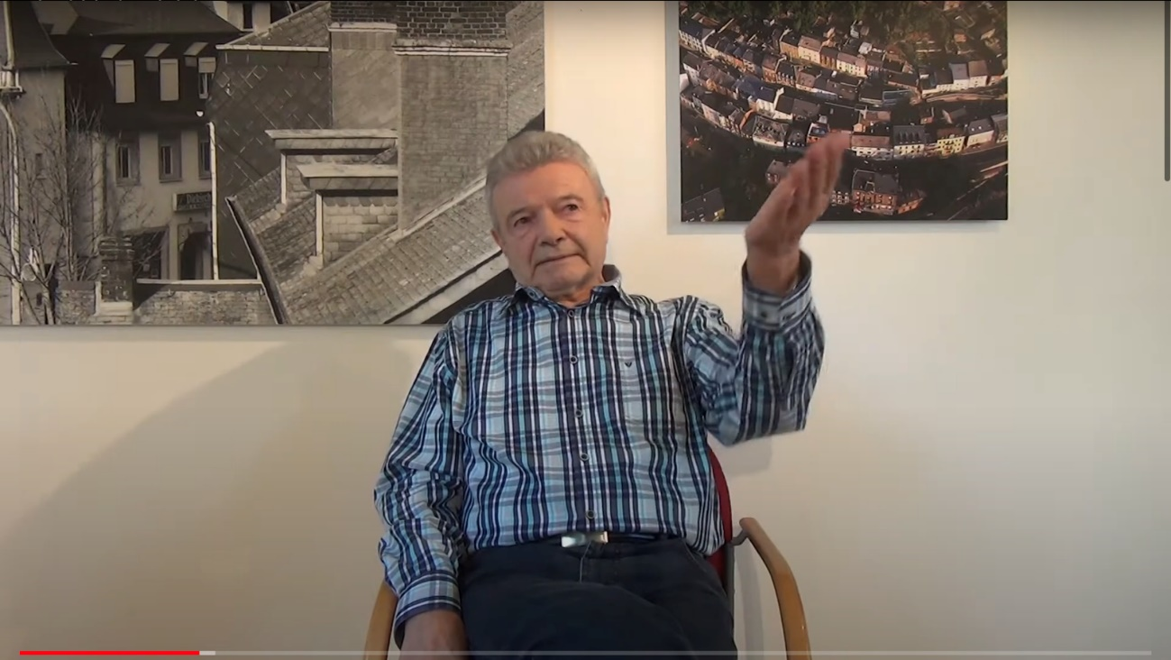
Video 1: Rino Del Nin, Story: “Luxembourgish Italy”, Community >> Friendships >> Neighborhood >> Turning Point >> Places, Dudelange. Story link (00:04:08). | Full video link (00:47:50)

In less than five minutes we got so deep in the colours of the old quartier Italie. After two weeks in Luxembourg, he wanted to visit a friend who lived in France. He asked his brother for directions, who said he should get off at the Dudelange train station, where the train stops, and from there take a bus to France. Instead – and I recalled it happened to me the first time I went to Dudelange as well – he got off at another Dudelange station, at Gare-Usine. When he left the train, he felt confused, and a funny situation unfolds:

As discussed in the section Crowdsourced Memories, scholarship based on oral history sources has long been focused on the text. To take a different approach, in this thesis, all the audiovisual material related to interviews are inserted in the body of text as videos that can be watched with captions in the original language or English subtitles included on the video itself. In this sense, passages of the interview will be quoted only eventually, when more emphasis is needed, and transcriptions will not be added entirely. All the interviews are assembled in the Memorecord Interviews Resource Collection that can be browsed on the electronic version of the thesis on the Manifold digital publishing platform. The collection can be navigated in the order the videos appear or through a range of tags that mirror the coding of the interview by theme and topic. I consider the navigation by tags also offers insights to the readers in terms of how I have interpreted the collection, moreover, by referring to the video passages, readers will also have the option to watch the full video. In this way, I hope, oral history can be reconciled with its aurality and the richness of live discourse and body language that can add so much texture to the contents. Beyond, of course, giving the floor to the interviews, instead of limiting their participation to a few lines of text quoted along with this chapter. An example of the video preview on the Manifold resource collection can be seen on Annex 1. Each video is accompanied by a summary of the interview with the corresponding timestamps, metadata and associated tags. NB: Two interviews were recorded in audio-only, by choice of the participants, that chose not to have their interviews publicised and, for this reason, these two audios were not included in the collection, only their anonymised transcripts.

