Bastian Berle February 11, 2022  
Ron Holzapfel

**AIC Security**

Concept/Design:

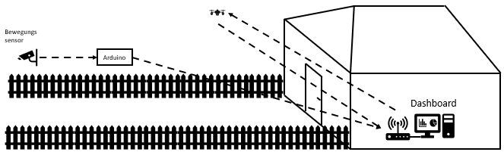

Technical blueprint:

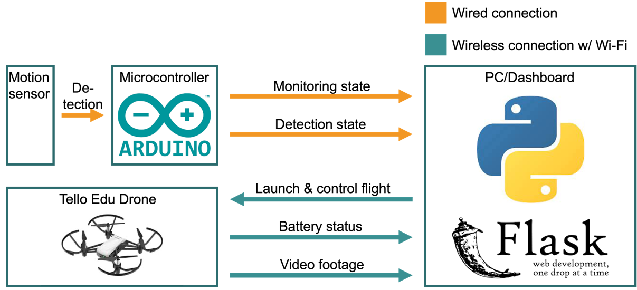

Description:

The motion sensor notifies the Arduino board about any detected movements. The Arduino board then checks whether the owner is at home by monitoring the respective button. The data is then sent to the PC, which determines whether the drone should be launched and whether a video stream should be transmitted. Independently of this, the drone permanently transmits its battery status. All the information is displayed in a dashboard that includes the drone's live video feed, a battery status graph, monitoring status and, if monitoring is enabled, detection status.

