TODO
TO BUY
LINKS
Specifications
Remote
Voltage Rails
Body
Various Parts
Battery
C rating
Brands
Misc
Motor
NX4008
Specs
Misc
Speed Controller (ESC)
HobbyKing SS Series 35-40A
Specs
Computerized battery charger
Frame
V1
Specs
Sensors
Misc
IMU (Inertial Measurement Unit)
Various Info
Ordered Parts

TODO
- Look into mikroquad, aeroquad
- Isolation rubber mounts for the motors

TO BUY
- Props
- Battery charger (with balancer)
- IMUs (Gyros, Accelerometers, Barometers, Magnetometers)
- Esduino Shield board (

LINKS
http://www.instructables.com/id/RC-Quadrotor-Helicopter/
http://arduino.cc/forum/index.php?topic=58048.0
http://www.x-firm.com/?page_id=145
http://www.arduino.cc/cgi-bin/yabb2/YaBB.pl?num=1282384853/0 (PID MOTOR CONTROL)
http://mbed.org/cookbook/IMU (Euler angles FILTER, very good code)

Filtering
http://web.mit.edu/scolton/www/filter.pdf
http://quadcopter.wordpress.com/2009/11/11/data-logging-and-kalman-filtering/

Definitions
http://aeroquad.com/showwiki.php?title=Common+AeroQuad+Terms

Specifications

Remote
- Hand controlled (glove?)
- Regular remote control (console?)
- Wireless protocol (WiFi? Blutooth?)

Voltage Rails

Body
- Which microcontoller? (Arduino? Esduino? Something else?)
- Motors
  - Power Consumption
  - Cost
  - Weight
- Battery
  - 4S or 5S battery?
  - Size the battery based on the frame space
- Camera

Various Parts

Battery

C rating
C rating of a battery is the maximum rate at which you can safely discharge the battery. From people’s experiences, larger mAh batteries perform better.

Brands
Hyperion
Neu
Flightpower
SPC
SMC
Blue Lipo
Gens Ace
G-force
HeCell
Maxamps

Misc
RC LiPo batteries have three main things going for them that make them the perfect battery choice for RC planes and even more so for RC helicopters over conventional rechargeable battery types such as NiCad, or NiMH.

- light weight and can be made in almost any shape and size
- large capacities
- high discharge rates to power the most demanding electric motors

http://www.hobbyking.com/hobbyking/store/__17248__Turnigy_nano_tech_4500mah_4S_35_70C_Lipo_Pack.html

Motor

NX4008
http://www.hobbyking.com/hobbyking/store/__17924__NX_4008_620kv_Brushless_Quadcopter_Motor.html

Specs
Kv: 620rpm/v
Turns: 16T
Resistance: 0.129Rm
Idle Current: 0.8A
Can size: 45mm
Can Length: 14mm
Shaft: 3mm (Includes Prop saver mount for GWS style props)
Suggested ESC: 30A
Rated Watts: 180W/0.241HP (1HP = 746W)
Weight: 79g
Cell count: 3~4S Lipoly
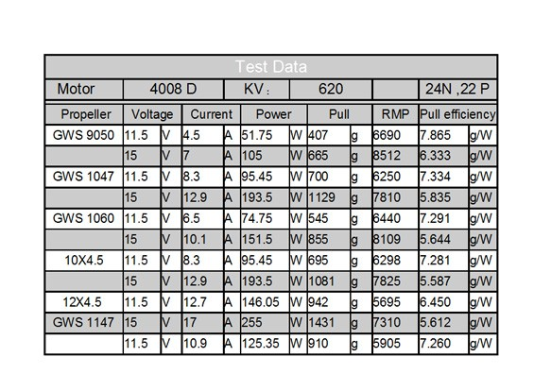

Misc
BLDCs offer more torque per weight, more torque per watt (increased efficiency), increased reliablity, reduced noise, longer lifetime, elimination of ionizing sparks from the commutator and overall reduction in EMI. With no windings on the rotor, they are not subjected to centrifugal forces, and because the windings are supported by the housing, they can be cooled by conduction, requiring no airflow inside the motor for cooling. This in turn means that the motor's internals can be entirely enclosed and protected from dirt or other foreign matter.

The maximum power that can be applied to a BLDC motor is exceptionally high, limited almost exclusively by heat, which can weaken the magnets. (Magnets demagnetize at high temperatures, the Curie point, and for neodymium-iron-boron magnets this temperature is lower than for other types.)

BLDC motors are often more efficient at converting electricity into mechanical power than brushed DC motors. This improvement is largely due to the absence of electrical and friction losses due to brushes. The enhanced efficiency is greatest in the no-load and low-load region of the motor's performance curve. Under high mechanical loads, BLDC motors and high-quality brushed motors are comparable in efficiency.

Speed Controller (ESC)

HobbyKing SS Series 35-40A

Specs
Weight: 27g
Size: 45x24x8mm
Cells: 2-3S (Auto Detect)
Max Current: 35A
Burst: 40A
BEC: 3A
Maximum Kv supported: 2000rpm/v

Computerized battery charger

Frame

V1

Specs
Height: 200mm
Witdh: 550mm
Weight: 195gram (No electonics)
Skid width: 256mm
Ply Wood: 3mm

Clearance:
Underside of main frame: 115mm
Underside of Camera support: 35mm

Sensors

Misc
The gyros are for sensing rotational motion around the three axes (x y z), the accelerometers are for sensing linear acceleration about those same axes, the barometer measures air pressure for supporting the altitude hold feature, and the magnetometer provides an accurate heading measurement.

IMU (Inertial Measurement Unit)
IMU
http://en.wikipedia.org/wiki/Inertial_measurement_unit
http://www.sparkfun.com/products/10121
http://store.diydrones.com/ProductDetails.asp?ProductCode=KT-ArduIMU-30

Various Info
Using Kalman filter to combine accelerometer/gyro signals?

Check for code online.

Ordered Parts

Part | Qty | Price | Source/Link | Note
Motor | 4 | 31.73 | NX_4008_620kv
ESC | 1 | 11.31 | SS_Series_35_40A_ESC | Got this part for FREE
Frame | 1 | 15 | Frame_V1
Battery | 1 | 17.65 | ZIPPY Flightmax 2200mAh 4S1P 40C
ESC | 4 | 30 | Turnigy Super Brain 40A Brushless ESC

