

Web based Application Development (CSM3023)

Lab Report 6  
JSP: JavaBeans & Java Standard Tag Library (JSTL)

Programme

Computer Science (Software Engeenering)

Prepared by

NurSyaza Amira Binti Selamat

Matric No

S62318

**Prepared for**

Sir Arizal

**Task 1: Using JSP Page to Access a Simple MySQL Database**

Step 1: Create a table namely Firsttable using phpMyAdmin

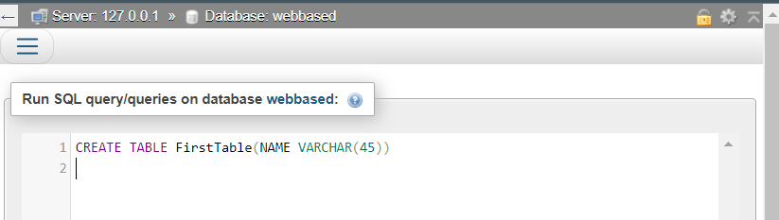

Step 2: Create SampleInsertionRecord.jsp to insert data in FirstTable table

SampleInsertionRecord.jsp

<%@page contentType="text/html" pageEncoding="UTF-8"%>

<%@page language="java"%>

<%@page import="java.sql.*"%>

<!DOCTYPE html>

<html>

<head>

<meta http-equiv="Content-Type" content="text/html; charset=UTF-8">

<title>Lab6</title>

</head>

<body>

<h1>Lab 6 - Task 1 - Sample Insertion records into MySQL through JSP's page</h1>

<%

int result;

// Step 1: Load JDBC driver

Class.forName("com.mysql.cj.jdbc.Driver");

out.println("Step 1: MySQL driver loaded!");

%>

<br>

<%

// Step 2: Establish the connection

String myURL = "jdbc:mysql://localhost:3306/webbased";

Connection myConnection = DriverManager.getConnection(myURL, "admin", "admin01");

out.println("Step 2: Database is connected!");

%>

<br>

<%

// Step 3: Create a PreparedStatement object

out.println("Step 3: Prepared Statement created!");

// Prepared SQL Query as a String

String sInsertQry = "INSERT INTO FirstTable VALUES(?)";

// Call method prepareStatement

PreparedStatement myPS = myConnection.prepareStatement(sInsertQry);

%>

<br>

<%

// Step 4: Perform insertion of record

out.println("Step 4: Perform insertion of record!");

String name = "Welcome to access MySQL database with JSP!";

myPS.setString(1, name);

result = myPS.executeUpdate();

if (result > 0){

%>

<br>

<%

out.println("Step 5: Close database connection!");

out.println("Database connection is closed!");

out.print("<p>The record: (" + name + ") is successfully created!</p>");

}

// Step 5: Close PreparedStatement and database connection

myPS.close();

myConnection.close();

%>

</body>

<footer>

NurSyaza Amira @ 2024

</footer>

</html>

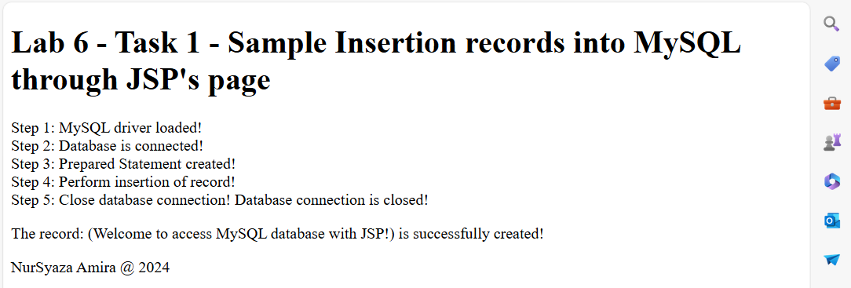

Step 3: Go to the database

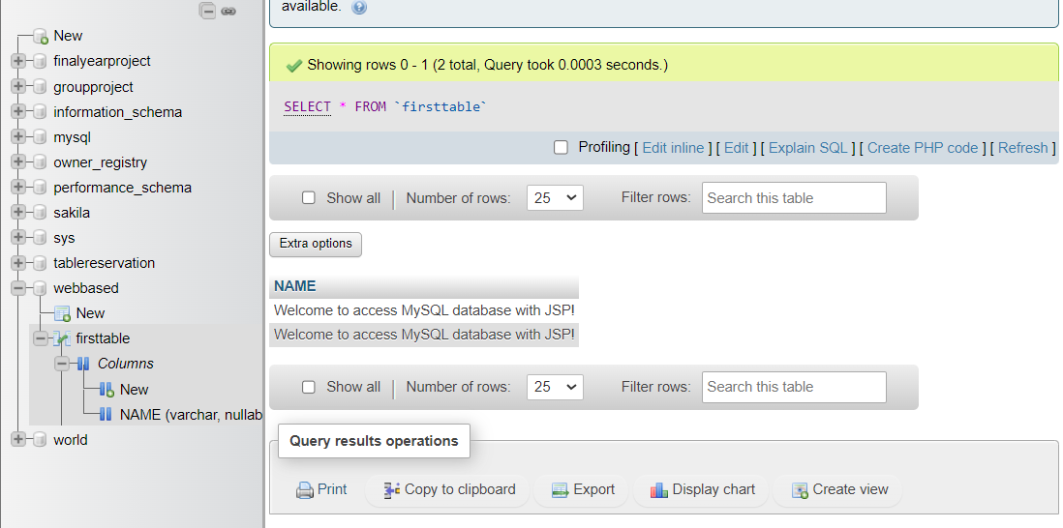

**Task 2: Create Records via JSP Page**

author’s table

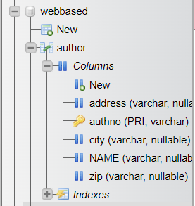

insertAuthor.jsp

<%@page contentType="text/html" pageEncoding="UTF-8"%>

<!DOCTYPE html>

<html>

<head>

<meta http-equiv="Content-Type" content="text/html; charset=UTF-8">

<title>Lab6 - Task 2</title>

</head>

<body>

<h1>Lab6 - Task 2 - Perform creating and retrieving records via JSP page</h1>

<form id="RgstFrm" action="processAuthor.jsp" method="post">

<fieldset>

<legend>Author Registration</legend>

<label for="Authno">Author No</label>

<input type="text" id="authno" name="auth_no" size="35" placeholder="E.g.UKXXXXX"><br/>

<br>

<label for="name">Name</label>

<input type="text" id="name" name="auth_name" size="60"

placeholder="Enter your name"><br/><br>

<label for="AuthAddress">Address</label>

<input type="text" id="authaddress" name="auth_address" size="60"

placeholder="Enter your address"><br/><br>

<label for="AuthCity">City</label>

<input type="text" id="authcity" name="auth_city" size="60"

placeholder="Enter your city"><br/><br>

<label for="AuthZip">Zip</label>

<input type="text" id="authzip" name="auth_zip" size="60"

placeholder="Enter your Zip"><br/><br>

<p><input type="submit" id="btnSubmit" value="Submit"/>

<input type="reset" id="btnCancel" value="Cancel"/>

</p>

</fieldset>

</form>

</body>

<footer>NurSyaza Amira @ 2024</footer>

</html>

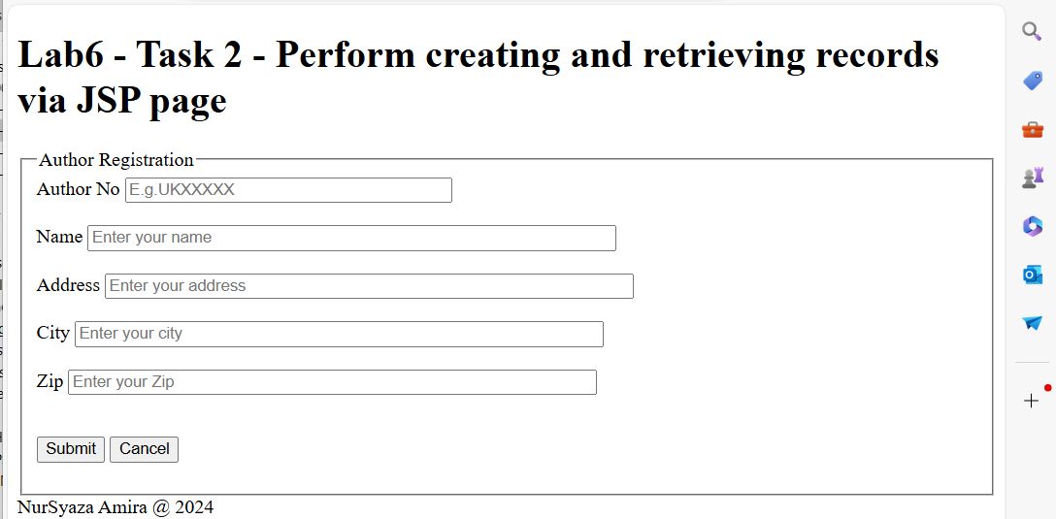

Author.java

/*

* Click nbfs://nbhost/SystemFileSystem/Templates/Licenses/license-default.txt to change this license

* Click nbfs://nbhost/SystemFileSystem/Templates/Classes/Class.java to edit this template

*/

package lab6.com;

/**

*

* @author VivoBook

*/

public class Author {

private String authno;

private String name;

private String address;

private String city;

private String zip;

public String getAuthno() {

return authno;

}

public void setAuthno(String authno) {

this.authno = authno;

}

public String getName() {

return name;

}

public void setName(String name) {

this.name = name;

}

public String getAddress() {

return address;

}

public void setAddress(String address) {

this.address = address;

}

public String getCity() {

return city;

}

public void setCity(String city) {

this.city = city;

}

public String getZip() {

return zip;

}

public void setZip(String zip) {

this.zip = zip;

}

}

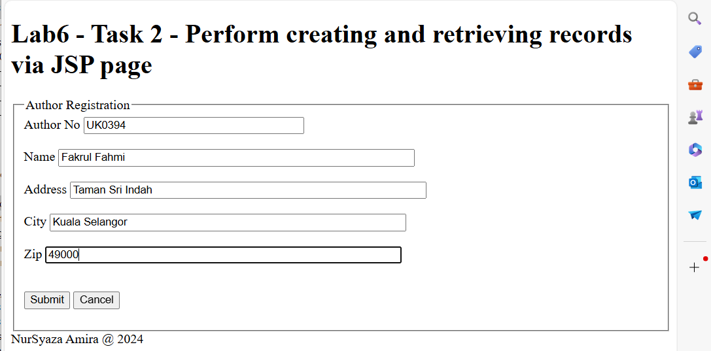

processAuthor.jsp

<%@page contentType="text/html" pageEncoding="UTF-8"%>

<%@page language="java" %>

<%@page import="java.sql.*" %>

<jsp:useBean id="myAuthor" class="lab6.com.Author" scope="request"/>

<!DOCTYPE html>

<html>

<head>

<meta http-equiv="Content-Type" content="text/html; charset=UTF-8">

<title>Lab6 - Task 2</title>

</head>

<body>

<h1>Lab6 - Task 2 - Perform creating and retrieving records via JSP page</h1>

<jsp:setProperty name="myAuthor" property="*"/>

<%

int result;

// Step 1: Load JDBC driver

Class.forName("com.mysql.cj.jdbc.Driver");

// Step 2: Establish the connection

String myURL = "jdbc:mysql://localhost:3306/webbased";

Connection myConnection = DriverManager.getConnection(myURL, "admin", "admin01");

String sInsertQry = "INSERT INTO Author(authno, name, address, city, zip) VALUES(?,?,?,?,?)";

PreparedStatement myPS = myConnection.prepareStatement(sInsertQry);

myPS.setString(1, myAuthor.getAuth_no());

myPS.setString(2, myAuthor.getAuth_name());

myPS.setString(3, myAuthor.getAuth_address());

myPS.setString(4, myAuthor.getAuth_city());

myPS.setString(5, myAuthor.getAuth_zip());

result = myPS.executeUpdate();

if (result > 0) {

out.println("\tRecord successfully added into Author table!");

out.print("<p>Record with author no " + myAuthor.getAuth_no() + " successfully created!</p>");

out.print("<p>Details of record are:</p>");

out.print("<p>Name: " + myAuthor.getAuth_name() + "</p>");

out.print("<p>Address: " + myAuthor.getAuth_address() + "</p>");

out.print("<p>City: " + myAuthor.getAuth_city() + "</p>");

out.print("<p>Zip: " + myAuthor.getAuth_zip() + "</p>");

}

// Step 5: Close database connection

System.out.println("Step 5: Close database connection!");

myConnection.close();

System.out.println(" ");

System.out.println("Database connection is close!");

%>

<br>

</body>

</html>

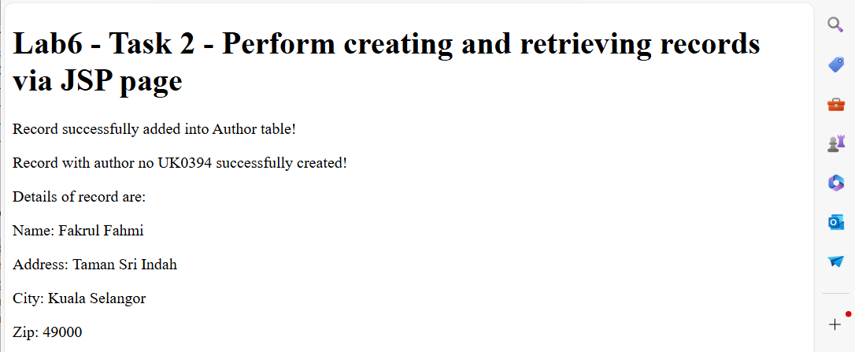

‘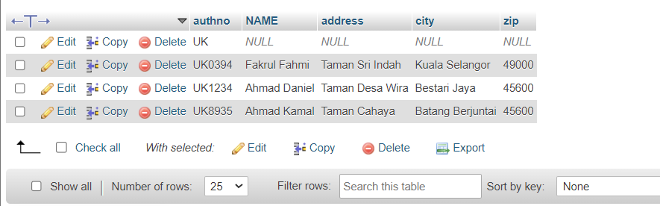

**Reflection:**

1. Define step by step before you successfully perform the transaction in a database.

**Task 3: Create Records Constrained by Regular Expression in JSP**

Step 1: Create a table book using phpMyAdmin

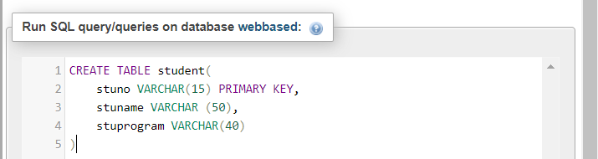

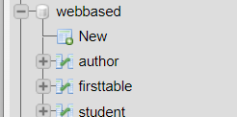

Create insertStudent.jsp as a main interface to register a new student

insertStudent.jsp

<%@page contentType="text/html" pageEncoding="UTF-8"%>

<!DOCTYPE html>

<html>

<head>

<meta http-equiv="Content-Type" content="text/html; charset=UTF-8">

<title>Student Registration</title>

</head>

<body>

<h1>Lab6 - Task 3 - Create Records Constrained by Regular Expression in JSP</h1>

<form id="RgstFrm" action="processAuthor.jsp" method="post">

<fieldset>

<legend>Student Registration</legend>

<label for="StudID">Student ID</label>

<input type="text" id="studid" name="stud_id" size="35" pattern="^[A-Z]+[0-9]+$" placeholder="E.g.UkXXXXX"><br/>

<br>

<label for="name">Name</label>

<input type="text" id="name" name="auth_name" size="60"

placeholder="Enter your name"><br/><br>

<label for="Program">Program:</label>

<select id="Program" name="Program" required>

<option value="BSc. Soft. Eng.">BSc. Soft. Eng.</option>

<option value="BSc. with IM">BSc. with IM</option>

<option value="BSc. in Networking">BSc. in Networking</option>

<option value="BSc. in Robotics">BSc. in Robotics</option>

</select><br><br>

<p><input type="submit" id="btnSubmit" value="Submit"/>

<input type="reset" id="btnCancel" value="Cancel"/>

</p>

</fieldset>

</form>

</body>

<footer>NurSyaza Amira @ 2024</footer>

</html>

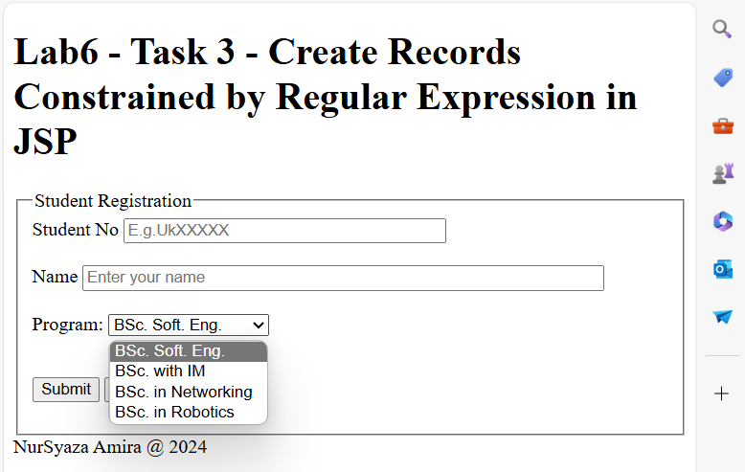

Step 3: Create Book JavaBeans

Book.java