Report of the Meteorological observation taken at Kenilworth Kimberley , during the year 1900

To the Secretary of the MeteorologicalCommission, conducted for the publication in the Annual Report of the Meteorological commission

Kenilworth Kimberley 23rd July 1901

J. R , Sutton , M.A. Camb

* From the beginning of Juneuntil the about the end of September The usual daily routine observation between viii and xvii were mainly continued by Mrs Sutton, and between viii and midnight by Mr H. Neal; the charts being changed and the various instruments kept in order mainly by the latter; so that with one major and a few minor exceptions the various records were maintained without interruptions.
* It is with deep regret that it was found impossible to continue the photo-barographic record. This was closed on June 7 until September 30 to compensate for this hiatus , hourly observations of the Standard Barometer were undertaken from viii to xxiii; the pressure values between midnight and vii being taken, more or less accurately, from the recording aneroids ; as were also the very few interpolations required during the day . an examination of the Standard readings during the four months suggest a slight disparity between Mrs Sutton and Mr Neal in their estimation of when the vernier was truly tangent to the summit of the mercury column : far all the hours at which artificial light had to be used the readings of the former were probably a trifle too low.
* A wholes day’s record from the Jordan Sunshine Recorder was missed on September 4 , for some undiscovered reason , and a day and a half from the Campbell-Stoke’s Sunshine Recorder on July 7 and 8, the supply charts having failed and a new lot arrived. In both cases the missing quantities were estimated for from the sister instrument. The only gap of any magnitude in the Hygrometer elements was the omission to read the wet-bulb temperatures registered at each hour between midnight and vii on September 3 .the spirit column of the grass minimum thermometer was broken , and approximate account taken of the magnitude of the break , from September 11-18, but on the 20-22 , the observations of this instrument were quite untrustworthy , and had to be discarded. Through some misunderstanding of the written instructions left by me, the earth thermometers at depths of 1 and 2 inches were not always read at xxiii; Mr Neal when on duty doing it right, but Mrs Sutton substituting readings for depths of 1 and 2 feet. As the mistake was not discovered until the first week of September , it has not been thought worthwhile to print any monthly values of the 1 and 2 inch temperature at xxiii for this year in appendices.
* Considering the great variety of the instruments , it is I think , to the credit of the observations that , although they had to make the observations in such time as they could spare from their daily occupations , the errors and omissionsshould have been so few. They are only specified here at all to ensure a true understanding of the following tables.
* All the clerical work and computing in connection with the observations taken during my absence of course had to left for me; and such formidable accumulation must be held responsible for the delay in forwarding my report. The matter included in this report is divided into 2 parts, namely ( 1) daily observations arranged into monthly tables, and (2) Appendices giving hourly and monthly summaries.
* Column one gives the daily readings of the Standard Barometer, reduced to 32˚ at viii. The Standard Barometer is by Negretti and Zambra, No. 1.921, with a Kew Verification. In this fine instrument the cistern is fixed, while the scale –which terminates in a fine zero point of ivory -is made to slide up and down the frame by means of a rack and pinion motion on the frame. The inside of the diameter is about 0.7 inch.
* Monthly and annual Pressure values , derived from the indications of the Standard Barometer , are given for 3 different hours (i.e at viii, xiv, and xx) in appendix 2.
* The observation of the Mean Pressure of the day are deduced from the hourly values measured on the Photo-barograms , beginning with midnight ending with xxiii. The Barograph is a very good one of the usual pattern, by Negretti and Zambra. The rays from a paraffin lamp are reflected by a concave spherical mirror through a condenser, passing across the Torricellian vacuum, between the jaws of a long vertical, narrow slit, whence a compound camera objective brings them focus upon a sheet of bromide paper wrapped around a rotating drum. By means of a piece of mechanism attached to the clock a shutter cuts off the light for a few minutes every 2 hours, forming upon the barogram a series of equi-distant narrow white lines at time indicators. Temperature compensation is effected by agency of a delicate system of zinc and glass rods so arranged as to cause the baseline of reference photographed upon the Barograms to undulate proportionally to the temperatures .the charts are changed every second day at a few minutes past xxiii, and developed and measured every 1 or 2 weeks . the hourly ordinates are measured with a metal templet to the nearest .005 inch, and are converted into approximate true pressures in inches after comparison with the regular controlobservations , taken 3 times daily, of the Standard Barometer. Ultimately , therefore, the results may be regarded nearly the same as those would be from hourly observations with the Standard. In case of any temporary break in the photographic record, the Pressures are interpolated from the indications of a recording Aneroid by Ross, or ,as far as possible, from the Standard, according as the break was anticipated or not. Excepting the 4 months June- September this supplementary aid was only required for a few hours in January.
* All the Barometers are mounted in an outside room of raw brick ; floor space 10x8 feet , height 9 feet ; walls nearly a foot thick. It contains no window ventilation. The diurnal range of temperature in this room is about 5̊ .
* Columns giving the observations of the Minimum and Maximum Shade Temperatures of the day , the thermometers from which they are derived are the Standard pattern, by Negretti and Zambra, and Kew-verified. they are:-

Standard Maximum , No. 81, 229, ( carries an index-error of -0˙˚1 at 32˚) , mounted 5 feet 2 inches above ground.

Standard Minimum , . No. 81, 580 ( carries no index – error) ,mounted 4 feet 9 inches above ground.

Standard minimum , No. 81,592 (carries no index-error) . mounted 4 feet 4 inches above ground

* They are mounted in a large , handsome , single-louvred wooden screen of 8x8x8 feet, about two feet from the louvres , and so arranged , consistently with firmness and security , as to be as nearly as possible floating in free air. A board behind and below them serves to cut off possible radiation from the ground. Since all three thermometers continue to agree in their simultaneous indications, there has probably been no material displacement of zero in the Maximum thermometers during the year.
* Comparison observations are taken with Kew-verified Maximum and Minimum Thermometers in a Stevenson Screen (not of the latest pattern adopted by the Royal Meteorological Society). A temperature comparison between this screen and the large screen above mentioned was published in the introduction to the Kenilworth observations of 1898 and 1899.
* Readings of Minimum and Maximum taken at xxiii, and an additional readings of Minimum at viii for the Minimum Shade Temperature of the night hours only. Thus last is for the purposes of comparison with the Grass Minimum. A list of such differences as have occurred during the year between the Minimum Temperature for the whole day of the 24 hours and that for the night hours given in table 1. It will be useful whenever the values of ma-mg are required. Upon only 2 occasions during the year did the Minimum Shade Temperature of the night fail to fall below 70˚, namely January 20 and February 18 with 71˚.1 and 70˚ respectively. In the Stevenson Screen the corresponding Minima were 70˚.7 and 70˚.0 respectively

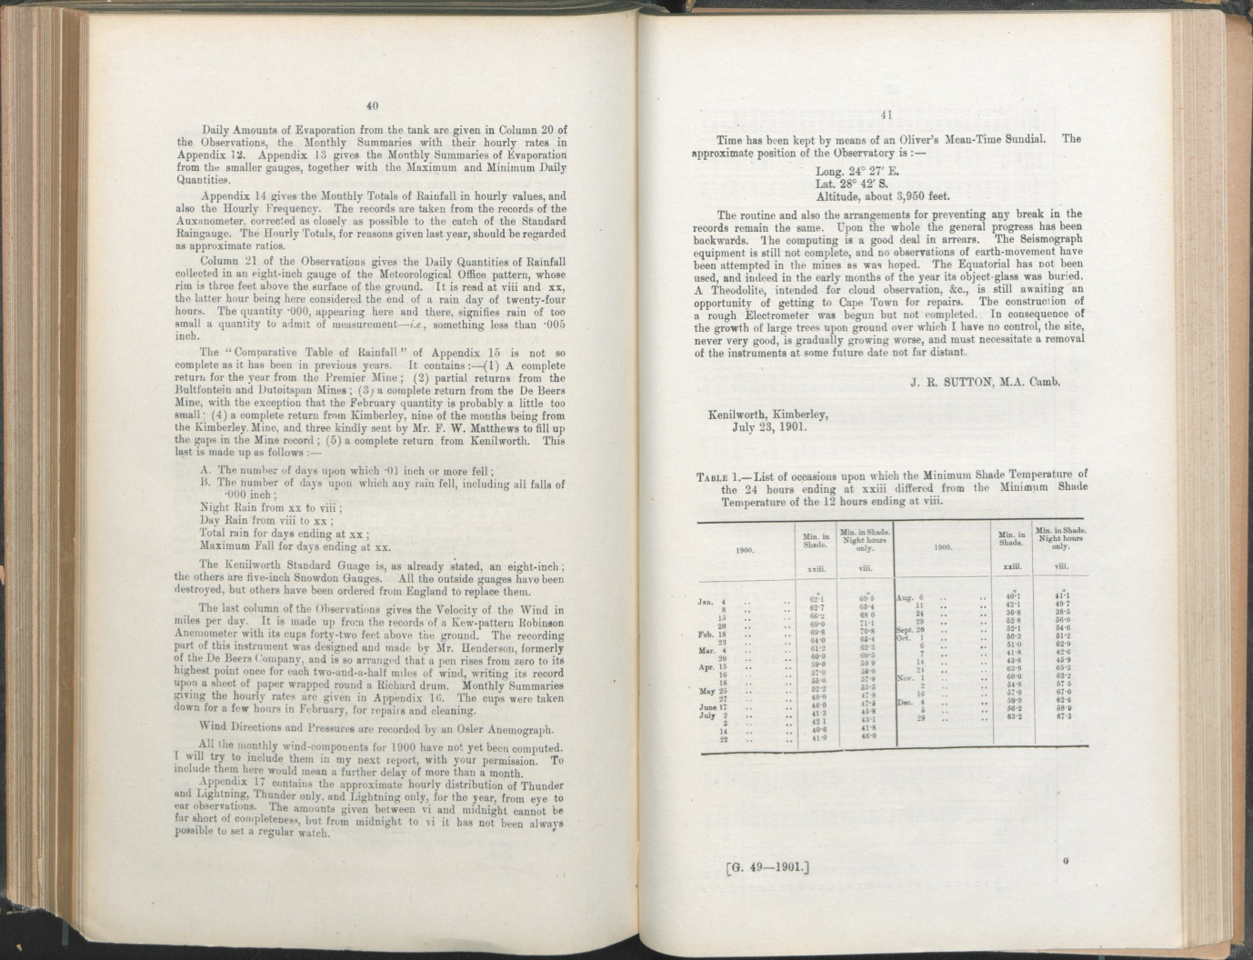

* The columns on the observations of the mean Dry Bulb Temperature and mean Wet Bulb, derived from 24 hourly readings beginning at midnight and ending at xxiii. About 2 thirds of these are from eye-observations of a Standard (including nearly all between viii and midnight , and an occasional 1 between midnight and vii); the others are obtained from the readings of 2 sets , of 12 each, of Negretti and Zambra’s patent Reversing Thermometers with long, slender, cylindrical bulbs, 1 set mounted for Dry-bulb observations, the other for Wet. These Thermometers are in the Large Screen; the clock regulating the apparatus is placed in the Barometer House and joined to the Thermometers ( one Dry and one Wet) whose turn has come to act , releases the hooks supporting them , thus allowing the Thermometers to reverse upon their axes and register their temperatures.
* Each Wet Bulbs are enclosed in a sewn muslin jacket , a loose tuft of which extends below the bulb , serving to collect nearly all the incrustation that would otherwise settle on the end of the bulb. This device has proved so successful that although the jackets are only renewed every two or three weeks , the Bulbs nearly always come quite clean and bright out their old coverings.
* The Standard readings are taken from the Kew- verified Boardof Trade Thermometers with short cylindricalbulbs, by Negretti and Zambra, the Wet Bulb here also having the loose tuft of muslin below the bulb, and partly for the purpose of testing whether different positions in the screen give identical results, a second Dry and Wet pair , but with spherical bulbs, by Casella , is mounted upon a different aspect.

Control Dry and Wet Bulb observations are secured by :-

1. A small reversing apparatus of one pair, with spherical bulbs, which can be set to act at any assigned hour;
2. A Richard Thermograph ; and
3. A Richard Hair Hygrograph.

Each of these 2 last marks are continuous record upon a drum rotating in 24 hours.

* To collect the incrustation that would otherwise settle upon the spherical Wet Bulbs 2 strands of wick-cotton ( No. 10 ‘knitting’) are threaded through the lowest weft and warp of each jacket and left to hang. This arrangement almost obviates the use of a vinegar bath , which is excellent for cleaning and incrusted bulb.
* The column on the observations of the Daily Mean Dew- Points are deduced from the hourly values of Dry and Wet Bulbs by the aid of the Greenwich Factors. The series of comparisons hoped to make between the Dew points obtained with a Dines Hygrometer , and those calculated from the Dry and Wet-bulb readings by means of the factors had again to be postponed, in company with a number of other equally interesting enquiries.
* The column on the observations of Rainfall, gives the Daily quantities of Rainfall collected in an 8 inch gauge of the MeteorologicalOffice pattern , whose rim is 3 feet above the surface of the ground. it is read at viii and xx, the latter hour being here considered the end of a rain day of 24 hours. The quantity .000, appearing here and there , signifies rain of too small a quantity to admit of measurement – *i.e*, something less than .005 inch.
* The Kenilworth gauge is, as already stated , an 8 inch ; the others are 5 inch Snowdon Gauges. All the outside gauges have been destroyed, but others have been ordered from England to replace them.
* The last column on the observations gives the Velocity of the Wind in mile per day. It is made up from records of a Kew-pattern Robinson Anemometer with its cups 42 feet above the ground. the recording part of the instrument was designed and made by Mr Henderson, formerly of the De Beers Company, and is so arranged that a pen rises from zero to its highest point for each 2 and a half miles of wind, writing its record upon a sheet of paper wrapped round a Richard drum, the cups were taken down for a few hours in February , for repairs and cleaning.
* Wind direction and pressure are recorded by and Osler Anemograph.
* Time has been kept by means of an Oliver’s Mean-Time Sundial. The approximate position of the observatory is:-

Longitude 24˚ 27’E.

Latitude 28˚42’S.

Altitude about 3,950 feet.

* The routine and also the arrangements for preventing any break in the records remain the same. Upon the whole the general progress has been backwards. The computing is a good deal in arrears. The Seismograph equipment is still not complete, and no observations of earth movement have been attempted in the mines as was hoped. The Equatorial has not been used, and indeed in the early months of the year its object-glass was buried. A Theodolite, intended for cloud observations , and , is still awaiting an opportunity of getting to Cape Town for repairs. The construction of a rough Electrometer was begun but not completed. In consequences of the growth of large trees upon ground over which I have no control , the site , never very good, is gradually growing worse, and must necessitate a removal of instruments at some future date not far distant.