3D Mapping Drone

**3D Mapping Drone**

Author: Josiah Bennett

Creation Date: 12/6/13

Last Revised: N/A

Version: 1.0

INTRODUCTION

Purpose of Plan

**The Project Plan defines the following:**

1. Project purpose
2. Business and project goals and objectives
3. Scope and expectations
4. Roles and responsibilities
5. Assumptions and constraints
6. Project management approach
7. Ground rules for the project
8. Project budget
9. Project timeline

Background Information/Available Alternatives

Project Approach

This section should outline the way you will move to complete the project including the highest-level summary tasks

For example:

Phase I: Planning

Phase II: Research

Phase III: Design

Phase IV: Material Gathering

Phase V: Production / Programming

Phase VI: Testing

Phase VII: Deployment

Phase I: Planning

The planning phase will consist of determining what will be included and excluded. With the amount of features that could be desired this project will have to determine which features will get the most attention and which features will be put on the back burner for awhile. During this phase, a SWOT matrix will be completed to determine: strengths, weaknesses, opportunities, and threats of the project. By using the SWOT analysis we will find what could potentially put the project behind. We will use the SWOT analysis to help strengthen possible weaknesses and minimalize the threats to the project.

Phase II: Research

During the research phase all of the major research about what is needed will be performed. The research will centralize around the factors that will be needed to get the drone off of the ground. The drone will never be able to perform its desired job if it can’t get it in the air, so the research will focus on that. The second most important research performed will be determining what the complete programming portion will contain. There will be a large portion of programming to provide the gyrocopter the ability to fly independently, and take pictures for the 3D map. Many completed gyrocopters will be looked at during this stage to study the different variations that have already been completed successfully.

Phase III: Design

During the design phase the project will finally start to take shape. After studying the previously completed successful designs a decision will be made. This phase will also discuss what the end project design should look like at completion.

Phase IV: Material Gathering

Material gathering is the phase where the 3D printer to print the parts, resin, and printing file will be gathered. All of the parts required will also be printed to build the quad copter.

Phase V: Production / Programming

Phase four is the building and programming phase. All of the parts are printed and are in the process of being assembled. The programming for the quad copter will also be done during this phase. The programming will be done using python scripts and code. By using Python the project gains a more adaptive ability. After all of the coding and assembling of the drone is completed the next step is the testing phase.

Phase VI: Testing

During the testing phase the drone has been assembled and is ready to make its very first flight. The drone will go through hundreds of tests to make sure that it will be safe to fly overhead. The quad copter will need to primarily need to be tested for battery life, function ability, and distance limitations.

Phase VII: Deployment

The Deployment phase is the final phase for the quad copter. The quad copter will be deemed ready to fly with a demonstration to the administration. The quad copter will now be turned over to the customer for full ownership transfer.

GOALS AND OBJECTIVES

Business Goals and Objectives

The business goal for this project is to provide a 3D mapping drone that will provide new perspectives. By providing new perspectives of campus it allows them to take a full digital 3D tour of campus remotely. By having the drone it will also increase campus appeal to perspective students.

Project Goals and Objectives

1. Give the technology depart of the university the chance to provide input into the design.
2. Build a drone that allows the 3D mapping of the campus.
3. Minimize impact to standard operations budget for the Computer Technology and Media department.
4. Improve the visibility of the technology department to bring more perspective students.
5. Give the university a street view of the campus
6. Give the university take a picture of a crowd from the air to use in advertisement and marketing
7. Expand the ability to provide remote campus tours

SCOPE

Scope Definition

To provide the University of Pittsburgh at Bradford with 3D mapping drone. The drone will allow the university to create a 3D map of the campus.

**Desired Enhancements**

1. None

Items Beyond Scope

Examples of…The project does not include the following:

1. Creating the 3D Map of the campus
2. Printing of spare parts
3. Rebuilding the drone due to damage

Projected Budget

Employees: $65,000

Supplies: $5,000

Total Expenses: $70,000

Risk Assessment

The initial **Risk Assessment** (following page) attempts to identify, characterize, prioritize and document a mitigation approach relative to those risks, which can be identified prior to the start of the project.

The **Risk Assessment** will be continuously monitored and updated throughout the life of the project, with monthly assessments included in the status report (see **Communications Plan**) and open to amendment by the Project Manager.

Because mitigation approaches must be agreed upon by project leadership (based on the assessed impact of the risk, the project’s ability to accept the risk, and the feasibility of mitigating the risk), it is necessary to allocate time into each Steering Committee meeting, dedicated to identifying new risks and discussing mitigation strategies.

The Project Manager will convey amendments and recommended contingencies to the Steering Committee monthly, or more frequently, as conditions may warrant.

Initial Project Risk Assessment

| **Risk** | **Risk Level**  **L/M/H** | **Likelihood of Event** | **Mitigation Strategy** |
| --- | --- | --- | --- |
| **Project Size** |  |  |  |
| Person Hours | **H:** Over 20,000 | **Certainty** | Assigned Project Manager, engaged consultant, comprehensive project management approach and communications plan |
| Estimated Project Schedule | **H:** Over 12 months | **Certainty** | Created comprehensive project timeline with frequent baseline reviews |
| Team Size at Peak | **H:** Over 15 members | **Certainty** | Comprehensive communications plan, frequent meetings, tight project management oversight |
| Number of Interfaces to Existing Systems Affected | **H:** Over 3 | **Certainty** | Develop interface control document immediately |
| **Project Definition** |  |  |  |
| Narrow Knowledge Level of Users | **M:** Knowledgeable of user area only | **Likely** | Assigned Project Manager(s) to assess global implications |
| Available documentation clouds establishment of baseline | **M:** More than 75% complete/current | **Likely** | Balance of information to be gathered by consultant |
| Project Scope Creep | **L:** Scope generally defined, subject to revision | **Unlikely** | Scope intially defined in project plan, reviewed monthly by three groups (Project Manager and Steering Committee) to prevent undetected scope creep |
| **Project Importance** |  |  |  |
| Funding may be removed from the project | **L:** Low funding required | **Unlikely** | Money budgeted for previously and assured full budget approval |
| Interest in the project may decrease once the initial excitement dies down | **L:** Adds an asset to the university that can bring potential new students | **Unlikely** | Designed to improve the visability of the University of Pittsburgh campus. |
|  |  |  |  |
|  |  |  |  |
|  |  |  |  |
|  |  |  |  |
|  |  |  |  |
|  |  |  |  |
|  |  |  |  |
|  |  |  |  |
|  |  |  |  |
|  |  |  |  |
|  |  |  |  |
|  |  |  |  |
|  |  |  |  |
|  |  |  |  |
|  |  |  |  |
|  |  |  |  |
|  |  |  |  |
|  |  |  |  |
|  |  |  |  |
|  |  |  |  |
|  |  |  |  |
|  |  |  |  |

Milestones

The following represent key project milestones, with estimated completion dates:

**Milestone Estimated Completion Date**

**Phase I: Planning**

Initial Steering Committee Meeting 1/6/2014

**Phase II: Research**

End of research Meeting 1/20/2014

**Phase III: Design**

End of design Meeting 2/3/2014

**Phase IV: Programming/Production**

End of Production Meeting 2/24/2014

**Phase V: Testing**

End of testing Meeting 3/3/2014

**Phase VI: Deployment**

End of project party 3/10/2014

ASSUMPTIONS

Project Assumptions

The following assumptions were made in preparing the Project Plan:

1. Management will ensure that project team members are available as needed to complete project tasks and objectives.
2. Failure to identify changes to draft deliverables within the time specified in the project timeline will result in project delays.
3. The parts will be able to be produced without 3D printer malfunction.
4. Employees will be knowledgeable about engineering and aeronautics.
5. A new design will not need to be chosen after work begins.
6. At least four employees will be able to program at one time in a team.
7. Coding will be documented as the project progresses.
8. The employees will be able to work without needing to be interrupted for other projects.
9. Code reviews will be performed between members of the programming team to hold each member accountable.
10. Certain key employees will be able to work overtime if the project slips to make the deadline.

CONSTRAINTS

Project Constraints

The following represent known project constraints:

1. Project funding sources are limited, with no contingency.
2. Due to the nature of law enforcement, resource availability is inconsistent.
3. Precompiled quad copter plans may become unavailable.
4. 3D printer resin can get to be expensive and too many faulty parts could decimate our supplies.
5. Changing of weather especially during winter could jeopardize our power source.

Related Projects

None known.

Critical Project Barriers

Unlike risks, critical project barriers are insurmountable issues that can be destructive to a project’s initiative. In this project, the following are possible critical barriers:

1. Removal of project funding
2. Natural disasters or acts of war

Should any of these events occur, the Project Plan would become invalid.

PROJECT MANAGEMENT APPROACH

Project Timeline

See appendix (insert Gantt chart

Project Roles and Responsibilities Matrix

| **Role** | **Responsibilities** | **Participant(s)** |
| --- | --- | --- |
| Project Sponsor | 1. Ultimate decision-maker and tie-breaker 2. Provide project oversight and guidance 3. Review/approve some project elements | Don Lewicki |
| Steering Committee | 1. Commits department resources | James Baldwin, Bill Kline, Don Lewicki |
| Project Manager | 1. Request resources needed 2. Follow up with team members weekly 3. Make sure progress is being made continuously. | Josiah Bennett |
| Project Participants | 1. Employees that will perform the majority of the work 2. Provide project ideas and input every step of the way | Eric Jameson, Matt Kendrick, Thomas Brown, Robert Smith, Steven Jobson, Michael McKintrick, Christopher Birdsell, Bill Fences |
| Subject Matter Experts | 1. Eric Jameson, Matt Kendrick, Thomas Brown, Robert Smith | Steven Jobson, Michael McKintrick, Christopher Birdsell, Bill Fences |

Issue Management

The information contained within the Project Plan will likely change as the project progresses. While change is both certain and required, it is important to note that any changes to the Project Plan will impact at least one of three critical success factors: Available Time, Available Resources (Financial, Personnel), or Project Quality. The decision by which to make modifications to the Project Plan (including project scope and resources) should be coordinated using the following process:

**Step 1:** As soon as a change which impacts project scope, schedule, staffing or spending is identified, the Project Manager will document the issue.

**Step 2:** The Project Manager will review the change and determine the associated impact to the project and will forward the issue, along with a recommendation, to the Steering Committee for review and decision.

**Step 3:** Upon receipt, the Steering Committee should reach a consensus opinion on whether to approve, reject or modify the request based upon the information contained within the project website, the Project Manager’s recommendation and their own judgment. Should the Steering Committee be unable to reach consensus on the approval or denial of a change, the issue will be forwarded to the Project Sponsor, with a written summation of the issue, for ultimate resolution.

**Step 4:** If required under the decision matrix or due to a lack of consensus, the Project Sponsor shall review the issue(s) and render a final decision on the approval or denial of a change.

**Step 5:** Following an approval or denial (by the Steering Committee or Project Sponsor), the Project Manager will notify the original requestor of the action taken. There is no appeal process.

Communications Plan

Disseminating knowledge about the project is essential to the project’s success. Project participants desire knowledge of what the status of the project is and how they are affected. Furthermore, they are anxious to participate. The more that people are educated about the progress of the project and how it will help them in the future, the more they are likely to participate and benefit.

This plan provides a framework for informing, involving, and obtaining buy-in from all participants throughout the duration of the project.

**Audience** This communication plan is for the following audiences:

1. Project Sponsor
2. Steering Committee
3. Project Manager
4. User Group Participants
5. Subject Matter Experts

**Communications Methodology** The communications methodology utilizes three directions for effective communication:

### **Top-Down** It is absolutely crucial that all participants in this project sense the executive support and guidance for this effort. The executive leadership of the organization needs to speak with a unified, enthusiastic voice about the project and what it holds for everyone involved. This will be 'hands-on' change management, if it is to be successful. Not only will the executives need to speak directly to all levels of the organization, they will also need to listen directly to all levels of the organization, as well.

The transition from the project management practices of today to the practices envisioned for tomorrow will be driven by a sure and convinced leadership focused on a vision and guided by clearly defined, strategic, measurable goals.

### **Bottom-Up** To ensure the buy-in and confidence of the personnel involved in bringing the proposed changes to reality, it will be important to communicate the way in which the solutions were created. If the perception in the organization is that only the Steering Committee created the proposed changes, resistance is likely to occur. However, if it is understood that all participants were consulted, acceptance seems more promising.

### **Middle-Out** Full support at all levels, where the changes will have to be implemented, is important to sustainable improvement. At this level (as with all levels), there must be an effort to find and communicate the specific benefits of the changes. People need a personal stake in the success of the project management practices.

**Communications Outreach** The following is a list of communication events that are established for this project:

### **Monthly Status Reports** The Project Manager shall provide monthly written status reports to the Steering Committee. The reports shall include the following information tracked against the Project Plan:

1. Summary of tasks completed in previous month
2. Summary of tasks scheduled for completion in the next month
3. Summary of issue status and resolutions

### **Monthly Steering Committee Meeting** These status meetings are held at least once per month and are coordinated by the Project Manager. Every member of the Steering Committee participates in the meeting. The Project Manager sends the status report to each member of the team prior to the meeting time so everyone can review it in advance.

### **Bi-Monthly Project Team Status Meeting** These status meetings are held every other month. Every member of the Project Team will be invited to participate in the meeting. Project Manager sends the status report to each member of the team prior to the meeting so everyone can review it in advance.

### **Website Use** User Group Participants and Subject Matter Experts may be updated monthly at the discretion of the Project Manager. Information will be posted to the project’s website.

ATTACHMENTS/APPENDICES

***Appendices/Attachments***

**WBS Chart PRO or VISIO WBS**

**MS Project gantt CHART ON SINGLE PAGE**

**MS EXCEL PLANNED VALUE PROGRESS CHART for entire project**

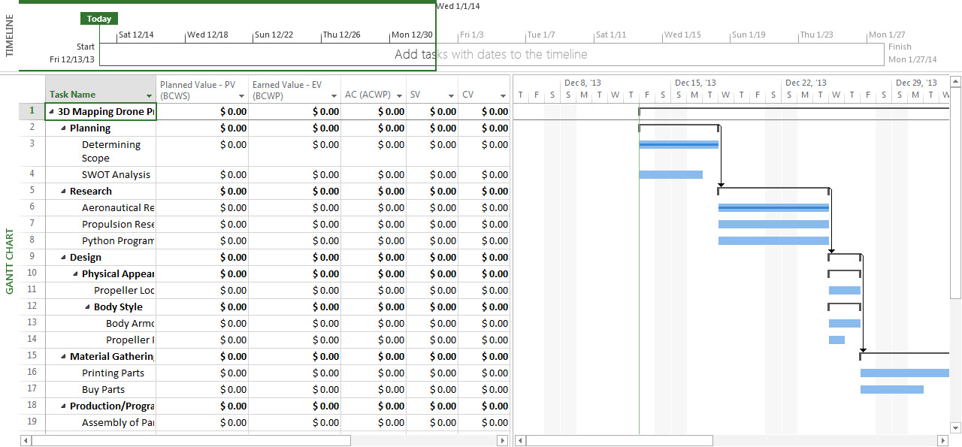

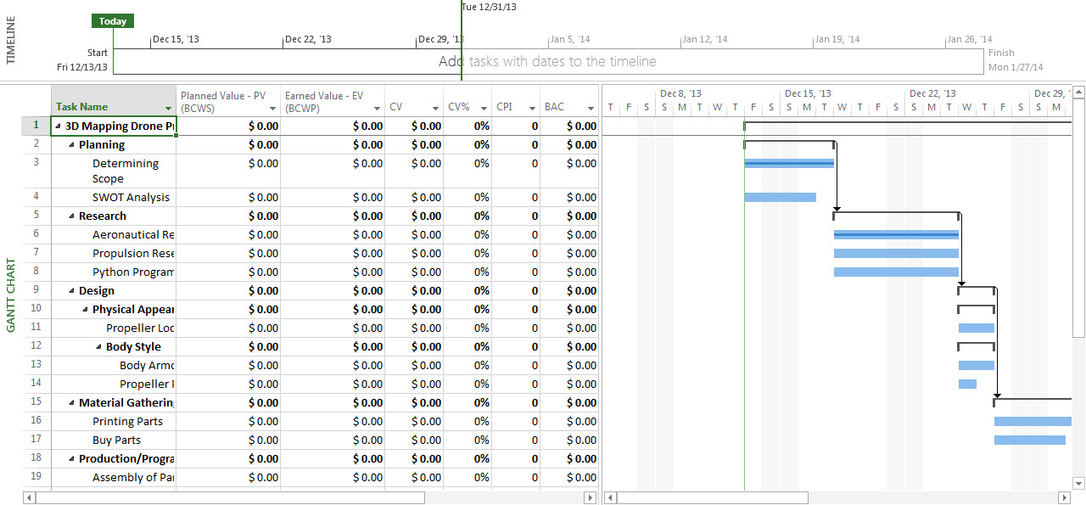

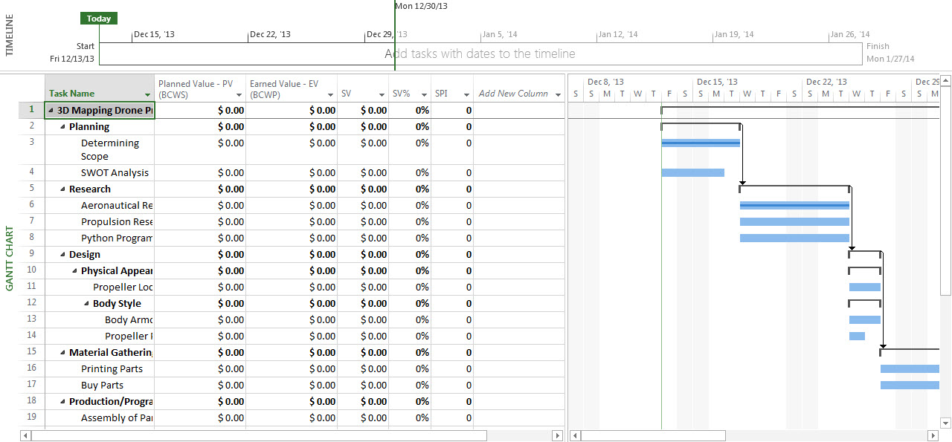

APPROVALS

Sign-off Sheet

***I have read the above Project Plan and will abide by its terms and conditions and pledge my full commitment and support for the Project Plan.***

**Project Sponsor:**

Date

**Project Manager:**

Date

**Steering Committee:**

Date

**Steering Committee:**

Date

**Steering Committee:**

Date

**Steering Committee:**

Date

**Steering Committee:**

Date

**Steering Committee:**

Date

**Steering Committee:**

Date

**Steering Committee:**

Date

**Steering Committee:**

Date

**Steering Committee:**

Date

**Steering Committee:**

Date

**Steering Committee:**

Date

**Steering Committee:**

Date

**Steering Committee:**

Date

**Steering Committee:**

Date