Computer Science April 2018

Computing for Medicine University of Toronto

**Computing for Medicine, Phase 3, Project #6**

**Visualizing Information on Nutrition Labels**

This assignment will give you experience with visualization and Python programming. Your task is to allow the user to query a collection of nutrition facts about various foods from a JSON file, and plot the result in a visual representation.

⎼⎼⎼⎼⎼⎼⎼⎼ ⬧ ⎼⎼⎼⎼⎼⎼⎼⎼

Nutrition labels on food products are a major resource for people to make informed decisions about the foods they consume. In their current tabular format (see Figure 1), nutrition facts labels are difficult to navigate and understand without training [1]. Many experts believe it’s because of information overload, and a lack of a clear, simple message. For the average consumer, “is 6g of fat too much for 1 serving of cheese?” and “is 1g of protein a good amount?” are difficult questions to answer, due to an undeveloped sense of scale regarding nutrients[1] and one’s personal needs.

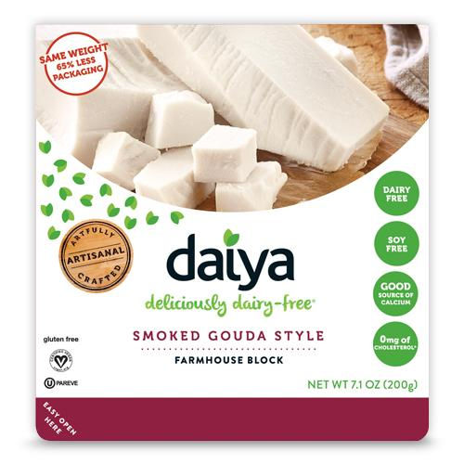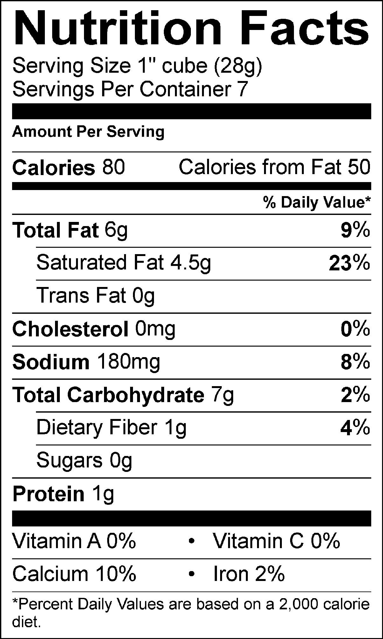

**Figure 1 - Nutrition labels are currently displayed as a large textual table on food packages. Additional quick facts are presented as front-of-package labels, mostly for marketing purposes**.

The difficulty in interpreting the information conveyed on food packages is one of the reasons why most consumers ignore or misunderstand these labels [2]. Front-of-package labels have been introduced to provide easy-to-understand nutritional facts, such as “good source of calcium”, or “rich in fiber” (see Figure 1). While more accessible to the layman consumer, these labels are loosely regulated and typically designed for marketing purposes, rather than aimed at better informing consumers. Not a single food package ever advertises that it contains a lot of sugar or a lot of fat!

Another problem is the somewhat deceptive practice of arbitrarily choosing the number of servings per package—often with the goal of lowering the number of calories that appear. Even for a consumer with a fair understanding of nutrition, it remains difficult to assess how much nutrients they truly consume, because serving sizes on labels rarely correspond to their actual intake. A typical example is bottles of a sweetened beverage, listing calories and sugar for ‘about half’ of the bottle. Many consumers look at the number and mistakenly assume it refers to the entire contents, adding to the confusion. The lack of consistency across packages also makes it tedious to compare the nutritional values of similar foods.

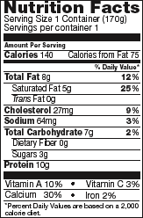 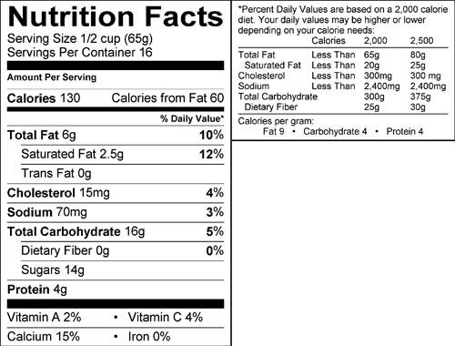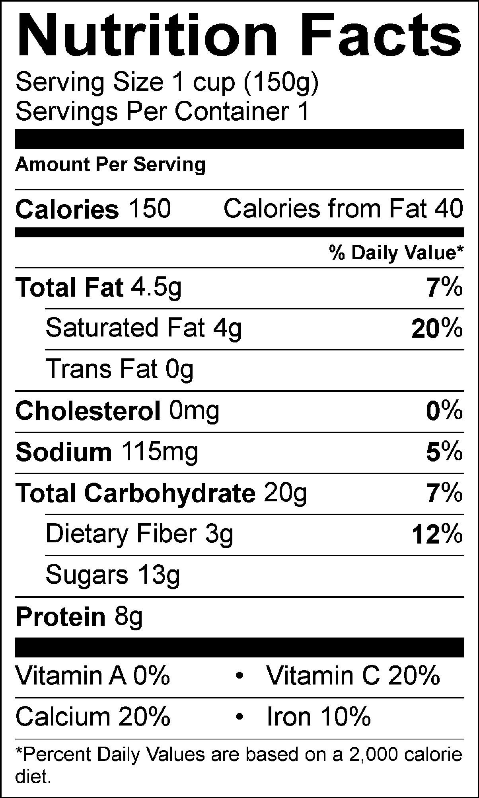 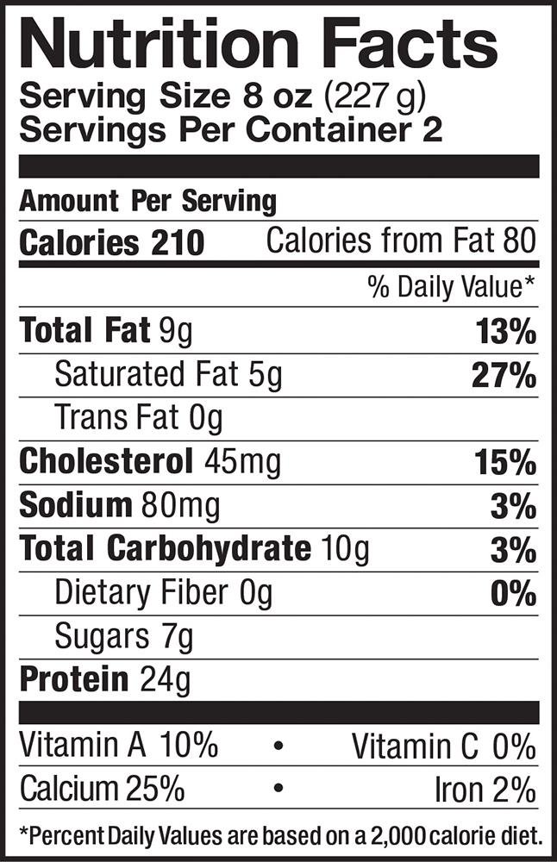

**Figure 2 - A series of nutrition facts labels found on various yogourts. Note the inconsistencies in serving size across products**.

Together, the ineffective representation of nutritional contents and the lack of standards regarding serving size are major barriers to nutrition literacy. While there is a drive to improve food labels, in practice change takes time due to the various government agencies involved in ensuring the quality of any new labeling.

⎼⎼⎼⎼⎼⎼⎼⎼ ⬧ ⎼⎼⎼⎼⎼⎼⎼⎼

The goal of this project is to develop an interactive visualization that conveys nutritional contents of food in a more accessible and engaging way, with an ultimate goal of promoting healthier lifestyles.

**REFERENCES**

[1] Peter Helfer, Thomas R. Shultz. The effects of nutrition labeling on consumer food choice: a

psychological experiment and computational model. Annals of the New York Academy of

Sciences, 2014; 1331 (1): 174.

[2] Graham, D.J., Hodgin, K., & Heidrick, C. (2015). Nutrition label viewing during a food selection

task: Front-of-package labels vs. Nutrition Facts Panels. Journal of the Academy of Nutrition

and Dietetics, 115(10), 1636-1646.

[3] Graham, D.J., Mohr, G.S. (2014). When zero is greater than one: Consumer misinterpretations

of nutrition labels. Health Psychology, 33(12) 1579-1587.

**PART I : Load and visualize the nutritional information of a food item.**

This first part consists of 1) loading data in a structured data format, 2) selecting relevant information from this file (i.e. food item and specific nutritional facts), and 3) plotting this information in a bar chart showing daily percentage value.

**1. Read and display the data**

In this project, we will work with food labels stored in a JSON format since most APIs (e.g. Open Food Facts, MyNetDiary, Spoonacular’s food API) provide detailed information in this format.

* 1. Open the foodfacts.json file in a text editor, and observe its structure.

How are each of the food items characterized?

Draw the corresponding hierarchical data representation of the JSON file.

* 1. In a file named seminar6_part1.py, begin by importing the json module. Next, write a load_file function that loads the JSON file, given a file name. Include the following code snippet in your script:

|  |
| --- |
| with open(filename, 'r') as open_file:  json_data = json.load(open_file) |

In the main block of your script, call your newly defined load_file function and store the result in a variable named data.

* 1. We will now display the object that data refers to.
* Display the data object using print. Note how difficult it is to parse the hierarchical structure of the data with the basic print function.

To make this more readable, we will use prettyprint[2], the “data pretty printer” module that prints the *formatted* representation of an object on the stream.

* Import the pprint function from the pprint module as pp

|  |
| --- |
| from pprint import pprint as pp |

* Use pretty print to display the hierarchical data contained in the JSON file that you loaded.

|  |
| --- |
| pp(data) |

Note the difference with print.

**2. Select and display the nutritional information of one ingredient**

The data you loaded contains a lot of information, for numerous food items. We are interested in a subset of this information (e.g., major nutrients), for a single food item. We will now filter the data of interest and plot it in a chart.

* 1. We will first select the food item the user is interested in.
* Define a new select_food function with two parameters representing the JSON data and the name of a food, respectively. Return the JSON data for that food as a dictionary.
* In the main block, prompt the user to enter a food, call the select_food function to get the data for that food, and then pretty print the JSON data for that food.
  1. We will now select the nutrition facts that the user is interested in.
* Define a select_facts function which takes the JSON data for a food and a list of nutrients, and returns a list of dictionaries with the data for those nutrients.
* Update the main block to repeatedly prompt the user to enter nutrients. Once the user types quit, stop prompting. Call the select_facts function to get the JSON data for those nutrients and pretty print it.

Here is an example interaction:

|  |
| --- |
| Enter the food item you want: Carrot juice  Enter a nutrient or type 'quit' to exit: Protein  Enter a nutrient or type 'quit' to exit: Fiber  Enter a nutrient or type 'quit' to exit: Calcium  Enter a nutrient or type 'quit' to exit: quit  [{'amount': 1.7, 'fact': 'Protein', 'percent': 3.4},  {'amount': 2.5, 'fact': 'Fiber', 'percent': 10},  {'amount': 44, 'fact': 'Calcium', 'percent': 4.4}] |

**3. Plot the data in a bar chart.**

Now that we have the nutritional information for the food item of our interest, the next step will consist of visualizing this information in the form of a bar plot, where each bar corresponds to a nutrient, and its size corresponds to the percent of the recommended daily value. This way, a consumer can better evaluate, out of 100%, whether a food contains a lot, or too little of a specific nutrient.

To do so, we will use the pyplot[3] interface of the matplotlib[4] module, a popular Python 2D plotting library similar to MATLAB.

We want to plot the data in a horizontal bar chart as follows (the order in which nutrients are displayed is arbitrary here):

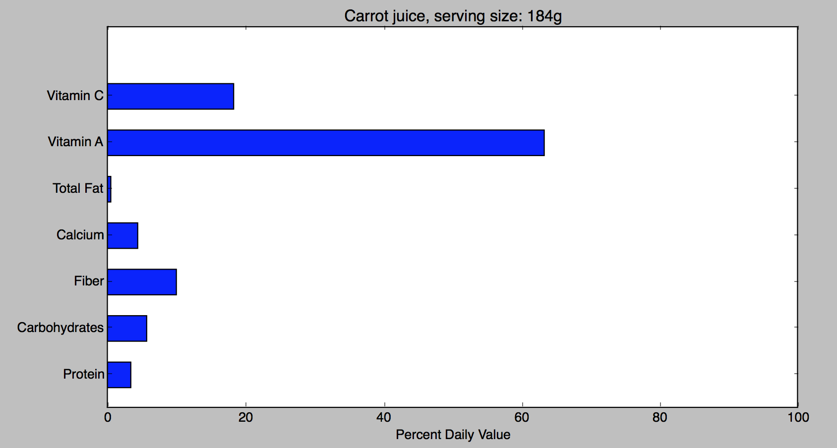

**Figure 3 - A horizontal bar chart showing the percent daily value of a series of nutrients, for the 'Carrot juice' food item.**

* 1. Search the matplotlib documentation for which function of pyplot displays a *horizontal bar chart*, and identify the data structure this function needs to build the bars.

A typical task in Python is to *prepare* and *format* the data to pass it to other functions. Here, we will build two tuples: the first tuple containing the nutrients names, and the second containing the daily percentage for these nutrients.

* Using an iterator, build the tuple of nutrient names in a variable named names and the tuple of percent daily values in a variable named values.
  1. Now that you have the data at hand in a practical format, plot the horizontal bar chart for the food item and list of nutrients of your choice, as shown in Figure 3. Complete the following steps in order:
* Build a simple horizontal bar chart where each bar corresponds to a nutrient
* Add the yticks in your chart, for the viewer to be able to associate the bars with the corresponding nutrient
* Change the xlimit of your chart so that one can better read the values out of 100%
* Add a label to the x axis, to specify that the data corresponds to the Percentage Daily Value
* Add a title to your chart so that the viewer knows which food item he/she visualizes the data of, and the corresponding serving size

**Part II. Show the data of two different foods for comparison.**

In this part, we aim to facilitate comparison of two food items by plotting the nutrition facts concurrently, in the same plot.

In a file named seminar6_part2.py, begin by importing seminar6_part1. This will allow you to use the functions you defined in that module without duplicating code.

For foods ‘Yogurt lowfat fruit added’ and ‘Yogurt whole milk’ and nutrients *Total Fat, Carbohydrates, Cholesterol, Sodium, Protein, Magnesium* and *Fiber,* the expected result is shown in Figure 4.

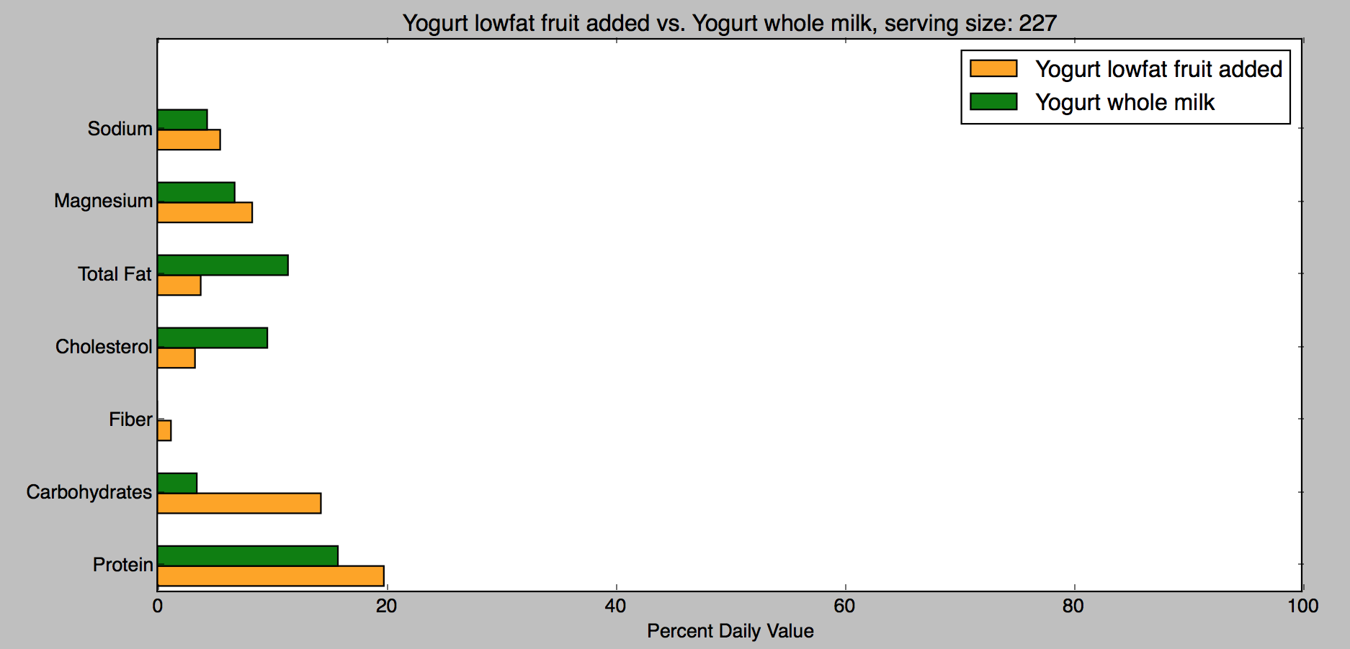

**Figure 4 - Comparison of the percent daily value of a series of nutrients**

**for the** ‘Yogurt lowfat fruit added’ **and** ‘Yogurt whole milk’ **food items**

**1. Normalize the data**

Prompt the user for two food items to compare and for nutrients to compare, and load the raw data for those two food items.

Since we are comparing two food items of possibly different serving size, it is necessary to normalize the values to enable comparison. Create a function normalize_nutrients which takes the nutrients data (list of dictionaries) and a normalization factor, and returns the same list of dictionaries where the values for 'amount' and 'percent' are multiplied by the normalization factor.

Here is an example of the data before and after normalization:

|  |
| --- |
| Enter the first food item you want: Yogurt lowfat fruit added  Enter the second food item you want: Yogurt whole milk  Enter a nutrient or type 'quit' to exit: Carbohydrates  Enter a nutrient or type 'quit' to exit: Sodium  Enter a nutrient or type 'quit' to exit: Protein  Enter a nutrient or type 'quit' to exit: quit  ------- Values for Yogurt lowfat fruit added, serving size: 227  [{'amount': 9.9, 'fact': 'Protein', 'percent': 19.8},  {'amount': 43, 'fact': 'Carbohydrates', 'percent': 14.3},  {'amount': 133, 'fact': 'Sodium', 'percent': 5.5}]  ------- Values for Yogurt whole milk, serving size: 151  [{'amount': 5.3, 'fact': 'Protein', 'percent': 10.5},  {'amount': 7.0, 'fact': 'Carbohydrates', 'percent': 2.3},  {'amount': 69.2, 'fact': 'Sodium', 'percent': 2.9}]  ------- After normalization: Values for Yogurt lowfat fruit added, serving size: 227  [{'amount': 9.9, 'fact': 'Protein', 'percent': 19.8},  {'amount': 43, 'fact': 'Carbohydrates', 'percent': 14.3},  {'amount': 133, 'fact': 'Sodium', 'percent': 5.5}]  ------- After normalization: Values for Yogurt whole milk, serving size: 227  [{'amount': 7.967549668874171,  'fact': 'Protein',  'percent': 15.784768211920529},  {'amount': 10.52317880794702,  'fact': 'Carbohydrates',  'percent': 3.457615894039735},  {'amount': 104.02913907284768,  'fact': 'Sodium',  'percent': 4.359602649006622}] |

**2. Plot the data**

Plot the data for the two food items in the same chart as shown in Figure 3, including the title, the different colors for the bars, and the legend.

**Part III. Personalized visualization.**

In this part, our goal is to plot the data for one or two food items, this time with values corresponding to one's personal needs.

⎼⎼⎼⎼⎼⎼⎼⎼ ⬧ ⎼⎼⎼⎼⎼⎼⎼⎼

**BACKGROUND**

The daily values shown on food packages are based on a 2,000-kilocalorie diet for healthy adults. However, depending on one's sex, age, weight and activity level, the 2,000-kilocalorie reference might be quite off. Energy requirements are based on multiple factors including body composition, training and goals (i.e. weight loss, muscle building). While the formulas to compute the recommended intake are not set in the stone, they constitute a more accurate model to convey percent daily values than the traditional 2,000-kilocalorie per day reference.

In this work, we will use the Harris-Benedict principle [1] to compute an estimate of an individual's basal metabolic rate (BMR) and daily kilocalorie requirements, considering Mifflin and St Jeor equation for BMR [2], which provides a better prediction for modern lifestyles than the original equation.

The BMR Harris–Benedict equations revised by Mifflin and St Jeor in 1990 are:

**Men**: BMR = (10 × weight in kg) + (6.25 × height in cm) - (5 × age in years) + 5

**Women**: BMR = (10 × weight in kg) + (6.25 × height in cm) - (5 × age in years) - 161

An individual's recommended daily kilocalorie intake to maintain current weight depending on activity is computed as follows:

|  |  |
| --- | --- |
| **Activity level**  Little to no exercise :  Light exercise (1-3 days per week):  Moderate exercise (3-5 days per week):  Heavy exercise (6-7 days per week):  Very heavy exercise (twice per day, extra heavy workouts) | **Daily kilocalories needed**  BMR x 1.2  BMR x 1.375  BMR x 1.55  BMR x 1.725  BMR x 1.9 |

**REFERENCES**

[1] Harris JA, Benedict FG (1918). "A Biometric Study of Human Basal Metabolism". Proceedings

of the National Academy of Sciences of the United States of America. 4 (12): 370–3..

[2] Mifflin MD, St Jeor ST, Hill LA, Scott BJ, Daugherty SA, Koh YO (1990). "A new predictive

equation for resting energy expenditure in healthy individuals". The American Journal of

Clinical Nutrition. 51 (2): 241–7.

⎼⎼⎼⎼⎼⎼⎼⎼ ⬧ ⎼⎼⎼⎼⎼⎼⎼⎼

**1. Compute the user's recommended daily kilocalorie intake**

In a file named seminar6_part3.py, begin by prompting the user for their personal information (sex, height, weight, age and activity level), and use the above formulas to compute their recommended daily kilocalorie intake.

An example of interaction is as follows:

|  |
| --- |
| Enter your sex (F-M): F  Enter your age (in years): 32  Enter your weight (in kg): 62  Enter your height (in cm): 163  Activity levels:  1. Little to no exercise  2. Light exercise (1-3 days per week)  3. Moderate exercise (3-5 days per week)  4. Heavy exercise (6-7 days per week)  5. Very heavy exercise (twice per day, extra heavy workouts)  Enter your level of activity (1-5): 2  'BMR: 1317.75'  'Recommended intake (kcal): 2503.725' |

**2. Compute personalized daily values**

We will now use the recommended intake information to improve the visualization of Part I.

* Begin by importing seminar6_part1 to be able to reuse functions from your previous code.
* Prompt the user for the food item and nutrients they want to visualize, and load the corresponding data.

The next step consists of computing the personalized daily value for each nutrient, using the recommended intake computed before.

* The 'percentage' value in your data must be updated according to the recommended intake. Is it the case for the 'amount' value as well? Why?
* Let us call reference_intake the traditional 2000 kcal reference, recommended_intake one's personal recommended intake as computed above, and reference_value the daily percent value of a nutrient, based on the 2,000kcal diet. What is the formula to compute the personalized daily percent value of a nutrient?
* In your code, create a personalized_nutrients function that takes the list of nutrients and the personalization factor of the precedent question and returns the same list of dictionaries with updated daily percent values.

An example of the expected result is as follows:

|  |
| --- |
| [...]  'Recommended intake (kcal): 2755.0'  Enter the food item you want: Chocolate Chip cookies commercial  Enter a nutrient or type 'quit' to exit: Iron  Enter a nutrient or type 'quit' to exit: Protein  Enter a nutrient or type 'quit' to exit: Total Fat  Enter a nutrient or type 'quit' to exit: quit  selected nutrients: ['Iron', 'Protein', 'Total Fat']  [{'amount': 2.3, 'fact': 'Protein', 'percent': 4.6},  {'amount': 8.8, 'fact': 'Total Fat', 'percent': 13.5},  {'amount': 0.8, 'fact': 'Iron', 'percent': 4.4}]  --- Personalized values ---  [{'amount': 2.3, 'fact': 'Protein', 'percent': 3.3393829401088926},  {'amount': 8.8, 'fact': 'Total Fat', 'percent': 9.800362976406534},  {'amount': 0.8, 'fact': 'Iron', 'percent': 3.194192377495463}] |

Finally, call the plot_nutrients function from Part I to plot the data.

**3. Extend your code to support food comparison, using personalized data**

In this last step we will extend the code so as to consolidate Part I, Part II and Part III in a single program.

* Modify your code to prompt the user for the choice of visualizing a single food item, or compare two food items, after computing the BMR and recommended intake.
* Add the corresponding if statement to either display the information for one food item (i.e. the code of part III.2), or compare two food items (code to add, based on part II, and the personalized_nutrients function of part III.2)

An example of the expected result is as follows:

|  |
| --- |
| Enter your sex (F-M): F  Enter your age (in years): 32  Enter your weight (in kg): 61  Enter your height (in cm): 167  Activity levels:  1. Little to no exercise  2. Light exercise (1-3 days per week)  3. Moderate exercise (3-5 days per week)  4. Heavy exercise (6-7 days per week)  5. Very heavy exercise (twice per day, extra heavy workouts)  Enter your level of activity (1-5): 3  'BMR: 1332.75'  'Recommended intake (kcal): 2532.225'  Do you want to visualize  1. one food item  2. two food items  Answer:2  Enter the first food item you want: French fries oven heated  Enter the second food item you want: French fries fried in veg oil  Enter a nutrient or type 'quit' to exit: Total Fat  Enter a nutrient or type 'quit' to exit: Protein  Enter a nutrient or type 'quit' to exit: Calcium  Enter a nutrient or type 'quit' to exit: Fiber  Enter a nutrient or type 'quit' to exit: Iron  Enter a nutrient or type 'quit' to exit: Vitamin A  Enter a nutrient or type 'quit' to exit: quit  ------- After normalization: Values for French fries oven heated, serving size: 50  [{'amount': 1.7, 'fact': 'Protein', 'percent': 2.6853853824205984},  {'amount': 1.6, 'fact': 'Fiber', 'percent': 5.054843072791716},  {'amount': 4, 'fact': 'Calcium', 'percent': 0.31592769204948223},  {'amount': 4.4, 'fact': 'Total Fat', 'percent': 5.370770764841197},  {'amount': 0.7, 'fact': 'Iron', 'percent': 3.080294997482451},  {'amount': 0, 'fact': 'Vitamin A', 'percent': 0.0}]  ------- After normalization: Values for French fries fried in veg oil, serving size: 50  [{'amount': 2.0, 'fact': 'Protein', 'percent': 3.159276920494822},  {'amount': 1.6, 'fact': 'Fiber', 'percent': 5.054843072791716},  {'amount': 10.0, 'fact': 'Calcium', 'percent': 0.7898192301237055},  {'amount': 8.3, 'fact': 'Total Fat', 'percent': 10.109686145583431},  {'amount': 0.4, 'fact': 'Iron', 'percent': 1.7376023062721522},  {'amount': 0.0, 'fact': 'Vitamin A', 'percent': 0.0}] |

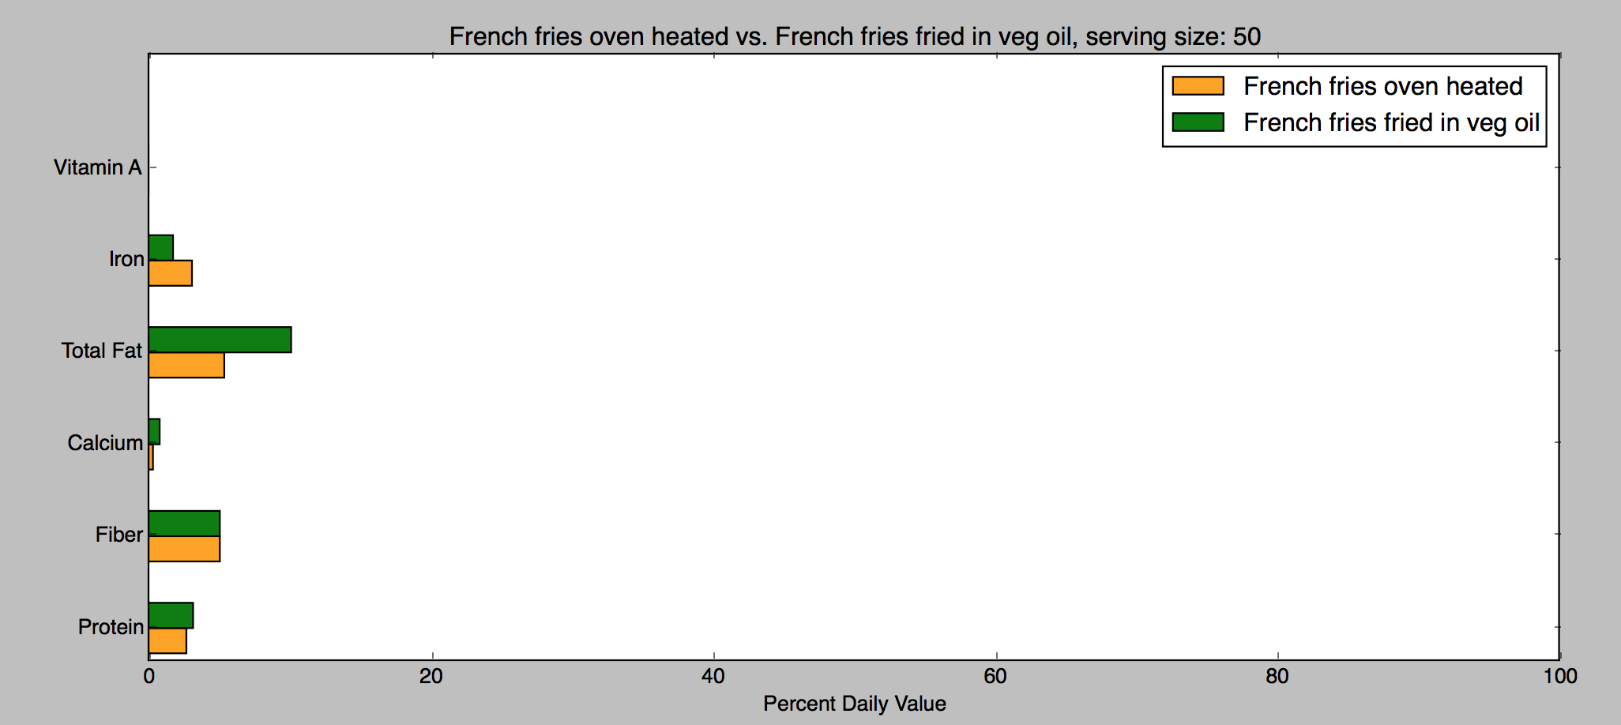

**APPENDIX**

List of foods contained in the foodfacts.json file, by category

|  |  |  |  |
| --- | --- | --- | --- |
| **. Baked goods**  Apple pie  Bagel, plain  Bread crumbs, dry grated  Carrot cake, cream cheese  Cheese crackers  Chocolate Chip cookies commercial  Corn Chips  Croissant 4 1/2 x 4 x 1 3/4 in  English muffin, plain  Gingerbread  Graham crackers  Melba toast, plain  Mixed grain toasted  Muffins Blueberry, commercial  Peach pie, piece  Pretzels, thin sticks  Raisin bread slice  Rye wafers, whole grain  Rye, sliced  Saltine crackers  Snack cakes, chocolate  Wheat bread, sliced  Wheat cracker, thin  White bread, sliced  Yellow cake  **. Fruits**  Apple juice  Apples raw with peel 2 3/4 diam  Apricot nectar canned  Avocado Calif 1/2 lb with refuse  Banana raw without peel  Blackberries raw  Blueberries raw  Cantaloupe  Cherries sweet raw without pits  Dates whole without pits  Honeydew  Mango raw edible part  Nectarines raw without pits  Orange juice  Peaches juice pack  Peaches raw whole  Pears raw Bartlett  Pineapple raw chunks, dices  Pineapple, juice canned  Plantains, cooked, boiled,sliced  Plums  Prune juice bottled or canned  Raisins, seedless  Rhubarb cooked added sugar  Strawberries thawed measure | **. Beverages**  Beer Light (12 fl oz)  Beer Regular (12 fl oz)  Carbonated Cola (12 fl oz)  Carbonated Diet Cola (12 fl oz)  Coffee Brewed  Coffee Instant  Gin, Rum, Vodka, Whiskey 80 proof  Grape Drink Canned  Lemonade concentrate  Orange (12 fl oz)  Root Beer (12 fl oz)  Tea Brewed  **. Eggs**  Raw white  Raw whole without shell  Raw Yolk  Scrambled with milk and butter  **. Grain products**  Egg noodles, cooked  Grape Nuts cereal  Lucky Charms cereal  Macaroni, cooked firm stage hot  Popcorn, air popped plain  Rice, brown cooked  Spaghetti, cooked firm stage hot  Trix cereal  White rice, raw dry  **. Meat**  Beef - Liver  Beef - Steak lean and fat  Beef dried chipped  Canadian style Bacon  Ground beef lean  Ground beef regular  Ham luncheon meat canned  Lamb - Chops lean and fat  Lamb leg roasted lean and fat  Pork - Chops, Broiled lean & fat  Pork, Bacon medium slices  Pork, rib roasted lean and fat  Veal cutlet braised or broiled  **. Misc**  Chili powder  Pepper black  Pickles dill medium | **. Dairy**  Buttermilk  Cheese - Blue  Cheese - Cheddar cut pieces  Cheese - Cream  Cheese - Monterey Jack  Cheese - Swiss  Cheese Gouda  Cheese Mozzarella whole milk  Cottage Creamed small curd  Cream sour cultured  Custard baked  Egg Nog commercial  Ice Cream Vanilla  Ice Milk Vanilla  Kefir  Milk - 2% Low Fat  Milk - Whole  Pudding canned Chocolate  Sherbert (2% fat)  Skim Milk  Yogurt lowfat fruit added  Yogurt whole milk  **. Mixed dishes and fast food**  Burrito, beef and bean  Cole slaw  Corn dog  Enchilada  Spaghetti in sauce w/cheese  **. Nuts, seeds and products**  English walnuts, chopped  Peanut Butter  Pine nuts/pinyon dried  **. Poultry**  Chicken - Roasted whole  Chicken breast fried w/batter  Duck meat only roasted  Turkey - Roasted whole, slices  **. Sausages and lunchmeat**  Frankfurter, beef and pork  Frankfurter, turkey  **. Soups, sauces and gravies**  Beef gravy canned  Bouillon  **. Sweets**  Marshmallows | **. Fats and oils**  Butter - Stick  Lard  Margarine - Regular, hard  Margarine Spread (60% fat) hard  Oil - Corn  Oil - Olive  Oil - Peanut  Safflower  Salad Dressing - Blue Cheese  Salad Dressing - French Regular  Salad Dressing - Italian Regular  Salad Dressing 1000 Island  Salad Dressing Mayonnaise  Soybean  **. Fish and shellfish**  Fishsticks  Oysters Eastern raw  Salmon, canned pink solids  Trout broiled w/butter & lemon  Tuna, oil packed  Clams - raw  Oysters - raw Pacific  Salmon - Broiled or baked  **. Vegetables and legumes**  Dandelion greens (raw)  Asparagus, raw cuts and tips  Bamboo shoots, canned and sliced  Beets cooked sliced or diced  Blackeyed peas frozen drained  Broccoli - Cooked, raw, spears  Brussel sprouts cooked raw  Carrot juice  Carrots whole raw  Cauliflower - Cooked, raw  Celery, pascal large stalk  Corn cooked raw on cob  Cucumber with peel  Eggplant cooked  French fries fried in veg oil  French fries oven heated  Lettuce Butterhead/Boston  Lima Beans, thick seeded  Mushrooms raw sliced  Onions raw chopped  Peas, green canned drained  Pinto Beans cooked from dry  Potato chips  Potatoes mashed  Spinach raw chopped  Tomatoes raw whole  Vegetable juice cocktail canned  Water chestnuts canned sliced |

1. See for instance, how much 39g of sugar (contained in a can of coke) represents in terms of sugar cubes: <http://www.sugarstacks.com/beverages.htm>
2. https://docs.python.org/2/library/pprint.html
3. http://matplotlib.org/api/pyplot_api.html
4. http://matplotlib.org/