Assignment 2 – Food Delivery

Somfalean Denis

30431

1.DB diagram

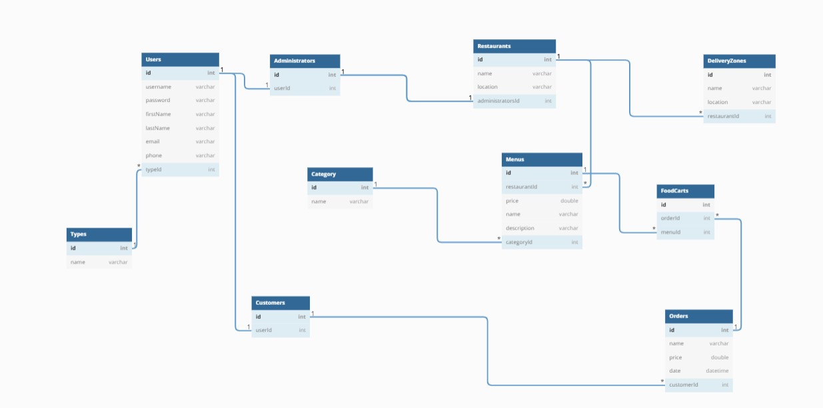

2. Class Diagram

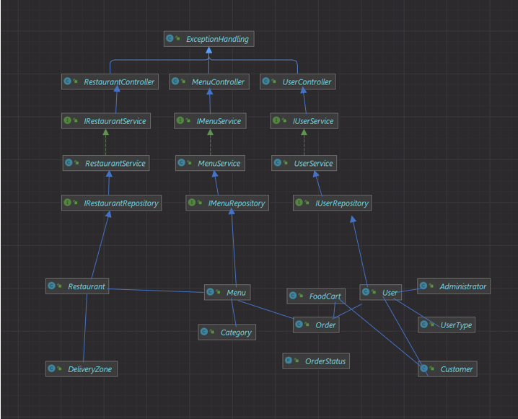

3.Use Case Diagram

