Zarchan pg 373

Theory

Model

Dynamics

$$\dot{z}=v_{z}$$

$${\dot{v}}_{z}=\frac{0.0034⋅g⋅e^{-\frac{z}{22000}}}{2⋅β}⋅v_{z}^{2}-g$$

$$\dot{β} =u_{s}$$

$$Z=z+v_{k}$$

$u_{s}$ is a white process noise with spectral density $Φ_{s}$.

$v_{k}$ is the variance of noise in the position measurement.

$R_{k}=E\left(v_{k}⋅v_{k}^{T}\right)=σ_{k}^{2}$

$$→H=[\begin{matrix}1 & 0 & 0\end{matrix}]$$

Derivation

$$a_{z}=\frac{F_{z}}{m}=\frac{F_{d}-F_{gravity}}{m}=\frac{\frac{1}{2}⋅ρ⋅v_{z}^{2}⋅c_{d}}{m}-g→\vec{ρ=0.0034⋅e^{-\frac{z}{22000}}}=\frac{0.0034⋅e^{-\frac{z}{22000}}}{2⋅m}⋅v_{z}^{2}⋅c_{d}-g→\vec{m⋅g=W}=\frac{0.0034⋅g⋅e^{-\frac{z}{22000}}}{2⋅W}⋅v_{z}^{2}⋅c_{d}-g→\vec{\frac{W}{c_{d}}=β}=\frac{0.0034⋅g⋅e^{-\frac{z}{22000}}}{2⋅β}⋅v_{z}^{2}-g$$

Linearization

nominal solution: constant velocity.

$$z_{n}(t)=\int{{v_{z}}_{n}}⋅dt$$

$${v_{z}}_{n}(t)=\frac{0.0034⋅g⋅e^{-\frac{z_{n}\left(t\right)}{22000}}}{2⋅β_{n}}⋅v_{z_{n}}^{2}(t)-g$$

$$β(t)=β_{n}$$

Assume the point confirmed and the system after lijneaizaiton is geiven by:

$$A=\left[\begin{matrix}0 & 1 & 0 \\ -\frac{ρ_{n}⋅g⋅v_{z_{n}}^{2}}{44000⋅β_{n}} & \frac{ρ_{n}⋅g⋅v_{z_{n}}}{β_{n}} & -\frac{ρ_{n}⋅g⋅v_{z_{n}}^{2}}{2⋅β_{n}^{2}} \\ 0 & 0 & 0\end{matrix}\right]$$

Where $ρ_{n}=0.0034⋅e^{-\frac{z_{n}}{22000}}$

Initial conditions

$$x_{0}=\left[\begin{matrix}100000 \\ 6000 \\ 500\end{matrix}\right]+\left[\begin{matrix}25 \\ 150 \\ 300\end{matrix}\right]$$

$$P_{0}=\left[\begin{matrix}500 & 0 & 0 \\ 0 & {150}^{2} & 0 \\ 0 & 0 & {300}^{2}\end{matrix}\right]$$

Predict

$$\dot{x}=f\left(x\right)$$

$$P=F⋅P⋅F^{T}+Q$$

Correct

$$K=P⋅H^{T}⋅{\left(H⋅P⋅H^{T}+R\right)}^{-1}$$

$$\dot{x}=f\left(x\right)+K⋅\left(z-H\left(x\right)\right)$$

$$P=P-K⋅H⋅P$$

Results

…

Summary

Ballistic coefficient est. with ekf with c4d.

One dimensional (z) dynamic equations with uncertainty in beta.

Seeker measures the altitude position with a noise of 500 ft^2 a rate of 50msec.

Errors in intital conditions are introduced in P.

Up to 150kft and 300lb/ft2 good estimation and match between the theoretical and actual errors.

Even though beta0 error is introduced in P0 the absence of values in the process noise matrix make the filter rely too much on the model fail to estimate beta when beta0 error is too high. \\ but why? Bad x0 doesn’t mean the process is noisy but just a large initial covariance error.

Results

1. Nominal case

z0 = 100kft

Beta0 err = 300 lb/ft^2

P33 = 300^2

Qs = 0

---

* improving as alt descends.
* results agree with the covariance matrix.
* High rate predicts don’t matter.

1. 200kft

z0 = 200kft

Beta0 err = 300 lb/ft^2

P33 = 300^2

Qs = 0

---

* not observable where no drag.
* High rate predictions are slightly better.

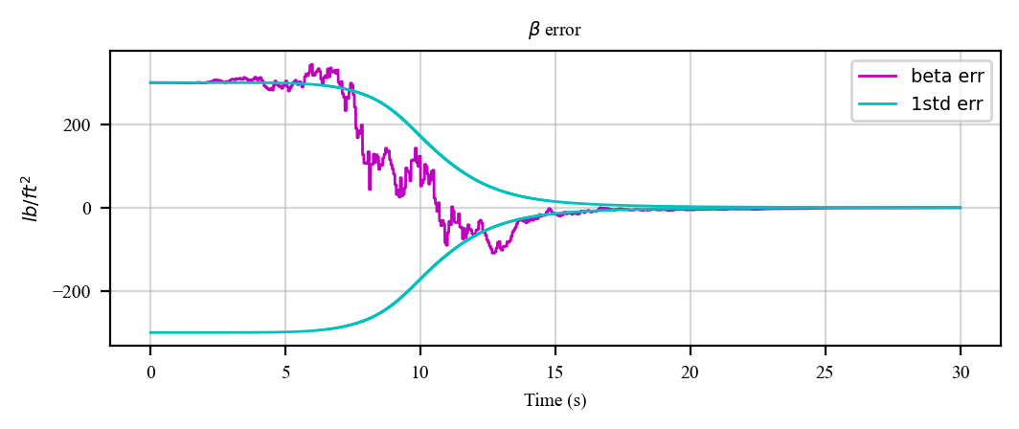

1. High error

z0 = 100kft

Beta0 err = 1000 lb/ft^2

P33 = 1000^2

Qs = 0

---

* Doesn’t converge.
* highly depends on initial conditions!
* the filter does not even realize when it is broken!
* High rate predicts are helpful to estimate before hitting the ground.
* -> if our initial guess is bad high rate predictions help to converge faster the solution

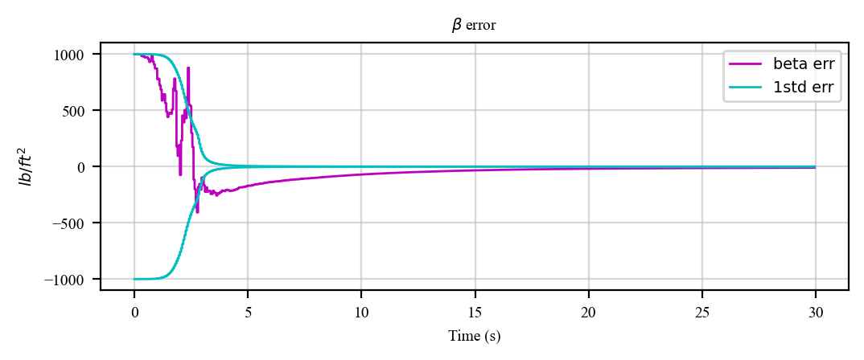

1. Process noise

z0 = 100kft

Beta0 err = 1000 lb/ft^2

P33 = 1000^2

Qs = 1000^2/30

* fairly quick convergence.
* results agree with the covariance matrix
* High rate predicts almost don’t matter

---

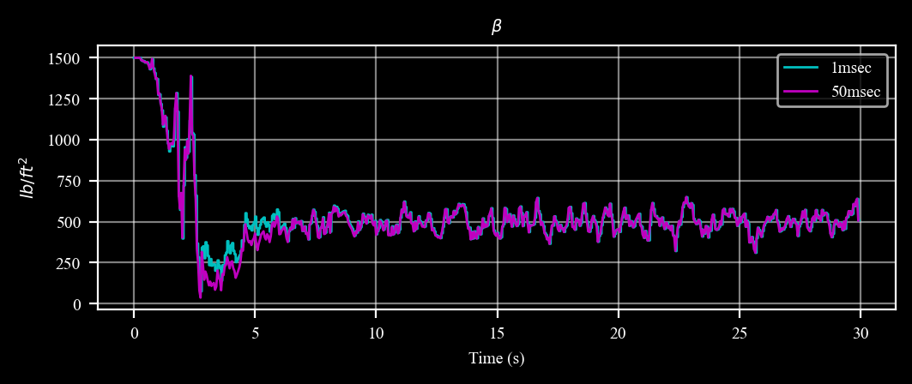

1. Nominal + process noise

z0 = 100kft

Beta0 err = 300 lb/ft^2

P33 = 300^2

Qs = 300^2/30

* Non accurate steady state error.
* The uncertainty reduced from 300 lb/ft2 to about 100 lb/ft2 of error.
* more robust to initialization errors filter
* no difference between prediction rates

---

