**PRACTICAL NO.02**

**Sample Calculations (can match with simulator):**

Effort=3.0×(50)1.12= 259 PM

Tdev=2.5×(259)0.35= 19.5 months

Tdev=2.5×(259)0.35= 19.5 months

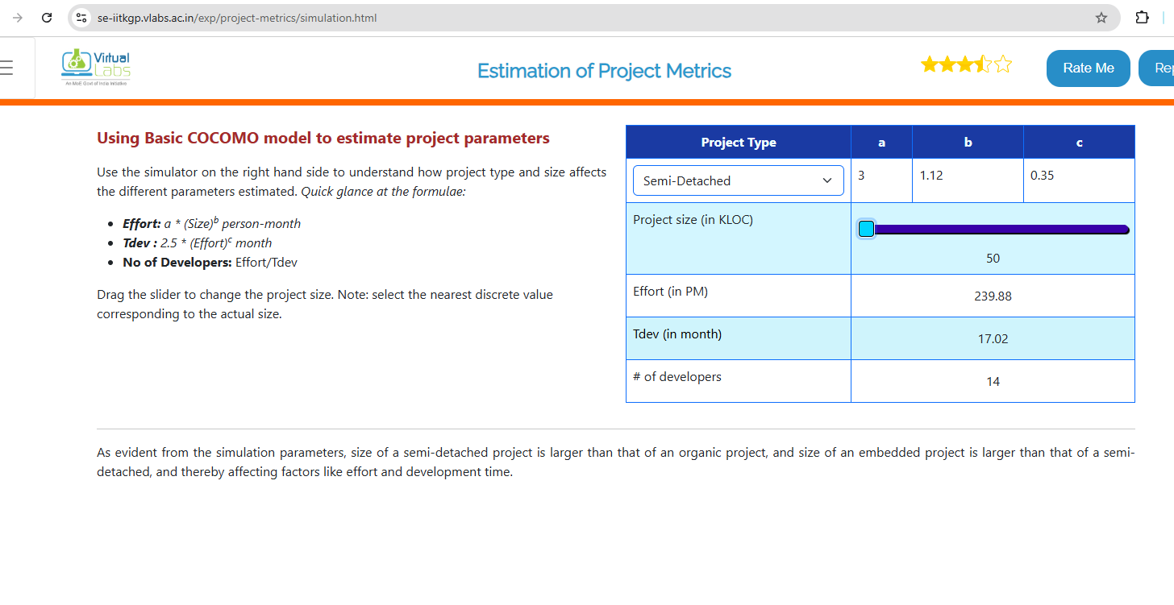

**Calculations:**

Effort = 2.4 × (2)^1.05 ≈ 2.4 × 2.07 = **4.97 PM**

Tdev = 2.5 × (4.97)^0.38 ≈ 2.5 × 1.87 = **4.68 months**

Developers = 4.97 / 4.68 ≈ **1.06 ≈ 1 developer**

