Java Programming Assignment Submission

Name of the Student: Chinmayakumar Shegokar
Date of Submission: 4th November 2025
Number of Programs Completed (out of 50): 25
Uploaded on (GitHub / Google Drive): GitHub
Link to Repository / Folder:

- Develop a Java program to take user input for name and age and display a welcome message.
import java.util.Scanner;
public class WelcomeUser {
public static void main(String[] args) {
// Scanner object to read input
Scanner scanner = new Scanner(System.in);
// For the user's name
System.out.print("Enter your name: ");
String name = scanner.nextLine();
// For the user's age
System.out.print("Enter your age: ");
int age = scanner.nextInt();
// Display welcome message
System.out.println("\nWelcome, " + name + "! You are " + age + " years old.");
scanner.close();
}
}
OUTPUT:
Enter your name: Chinmay
Enter your age: 20
Welcome, Chinmay! You are 20 years old.

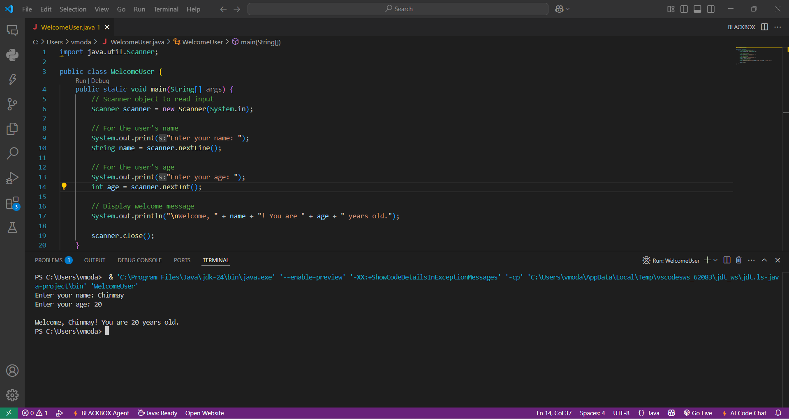
- Write a Java program that takes two numbers and performs basic arithmetic operations (+, –, , /).

import java.util.Scanner;
public class BasicArithmetic {
public static void main(String[] args) {
// Create a Scanner object to read input
Scanner scanner = new Scanner(System.in);
// Ask for two numbers
System.out.print("Enter the first number: ");
double num1 = scanner.nextDouble();
System.out.print("Enter the second number: ");
double num2 = scanner.nextDouble();
// Perform arithmetic operations
double sum = num1 + num2;
double difference = num1 - num2;
double product = num1 * num2;
// Handle division carefully to avoid dividing by zero
double quotient = (num2 != 0) ? num1 / num2 : Double.NaN;
// Display the results
System.out.println("\n Results ");
System.out.println("Sum: " + sum);
System.out.println("Difference: " + difference);
System.out.println("Product: " + product);
if (num2 != 0)
System.out.println("Quotient: " + quotient);
else
System.out.println("Quotient: Undefined (division by zero not allowed)")

scanner.close();
}
}

OUTPUT:
Enter the first number: 2
Enter the second number: 8
Results
Sum: 10.0
Difference: -6.0
Product: 16.0
Quotient: 0.25
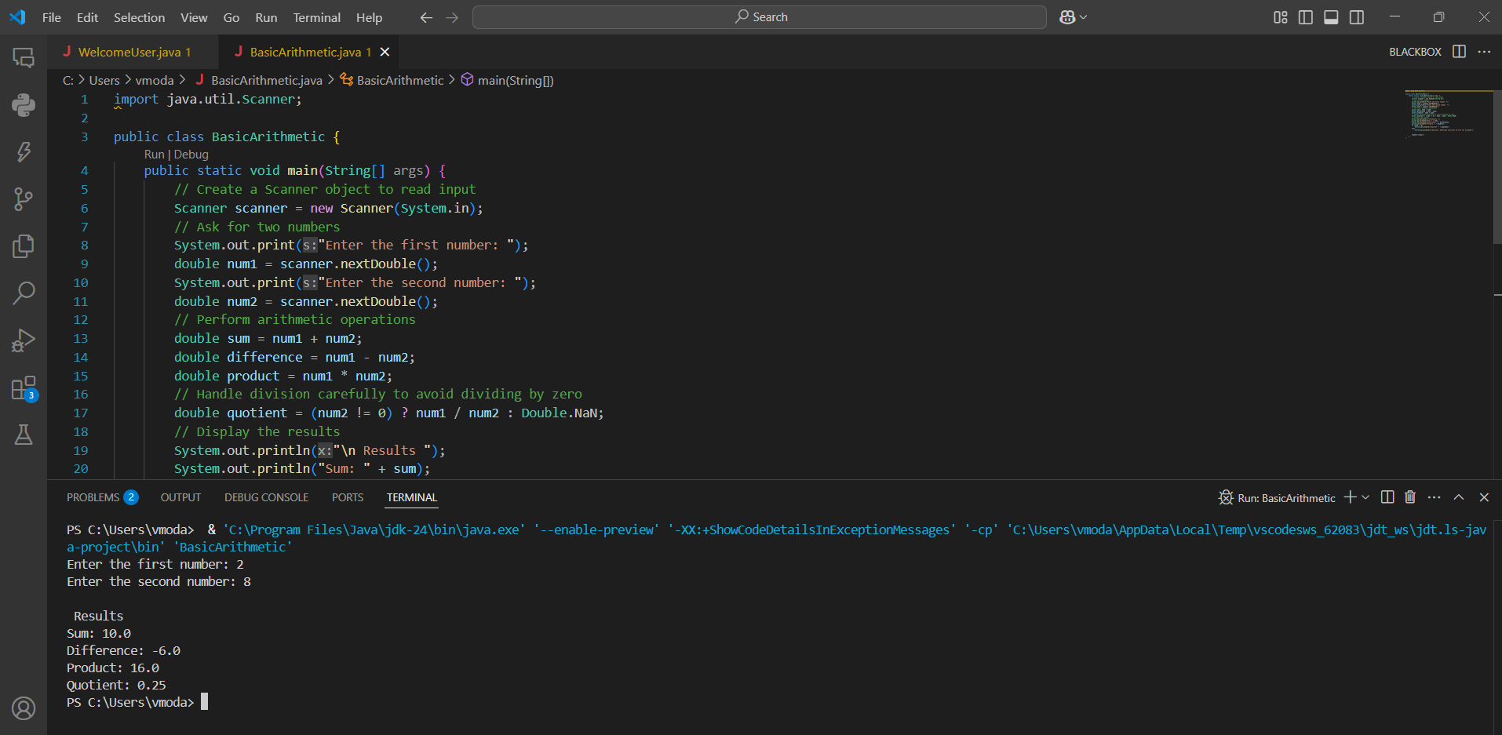
- Create a program to convert temperature from Fahrenheit to Celsius.

import java.util.Scanner;
public class FahrenheitToCelsius {
public static void main(String[] args) {
// Create Scanner object to take user input
Scanner scanner = new Scanner(System.in);

// Ask for the temperature in Fahrenheit
System.out.print("Enter temperature in Fahrenheit: ");
double fahrenheit = scanner.nextDouble();

// Convert Fahrenheit to Celsius
double celsius = (fahrenheit - 32) * 5 / 9;

// Display the result
System.out.println("\nTemperature in Celsius: " + celsius + "C");

// Close the scanner
scanner.close();
}
}

OUTPUT:
Enter temperature in Fahrenheit: 27
Temperature in Celsius: -2.7777777777777777C

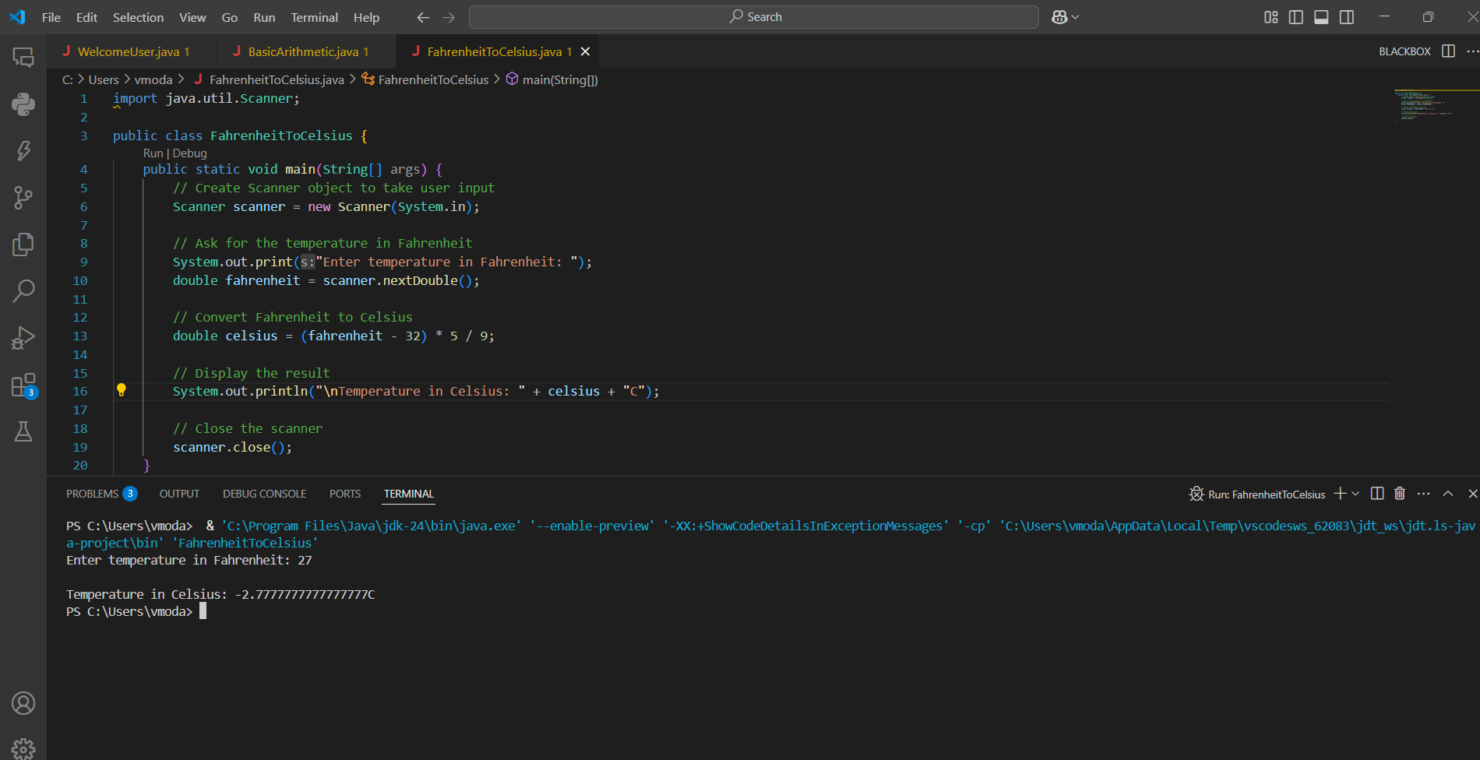

- Design a Java application to calculate simple interest using the formula: SI = (P × R × T) / 100.

import java.util.Scanner;

public class SimpleInterestCalculator {
public static void main(String[] args) {
// Create Scanner object to take user input
Scanner scanner = new Scanner(System.in);

// Ask for principal amount
System.out.print("Enter Principal amount (P): ");
double principal = scanner.nextDouble();

// Ask for rate of interest
System.out.print("Enter Rate of interest (R): ");
double rate = scanner.nextDouble();

// Ask for time period in years
System.out.print("Enter Time (T) in years: ");
double time = scanner.nextDouble();

// Calculate Simple Interest
double simpleInterest = (principal * rate * time) / 100;

// Display the result
System.out.println("\n💰 Simple Interest: " + simpleInterest);

// Optionally show total amount
double totalAmount = principal + simpleInterest;
System.out.println("Total Amount after " + time + " years: " + totalAmount);

// Close scanner
scanner.close();
}
}

OUTPUT:
Enter Principal amount (P): 8000
Enter Rate of interest (R): 50
Enter Time (T) in years: 1

Simple Interest: 4000.0
Total Amount after 1.0 years: 12000.0
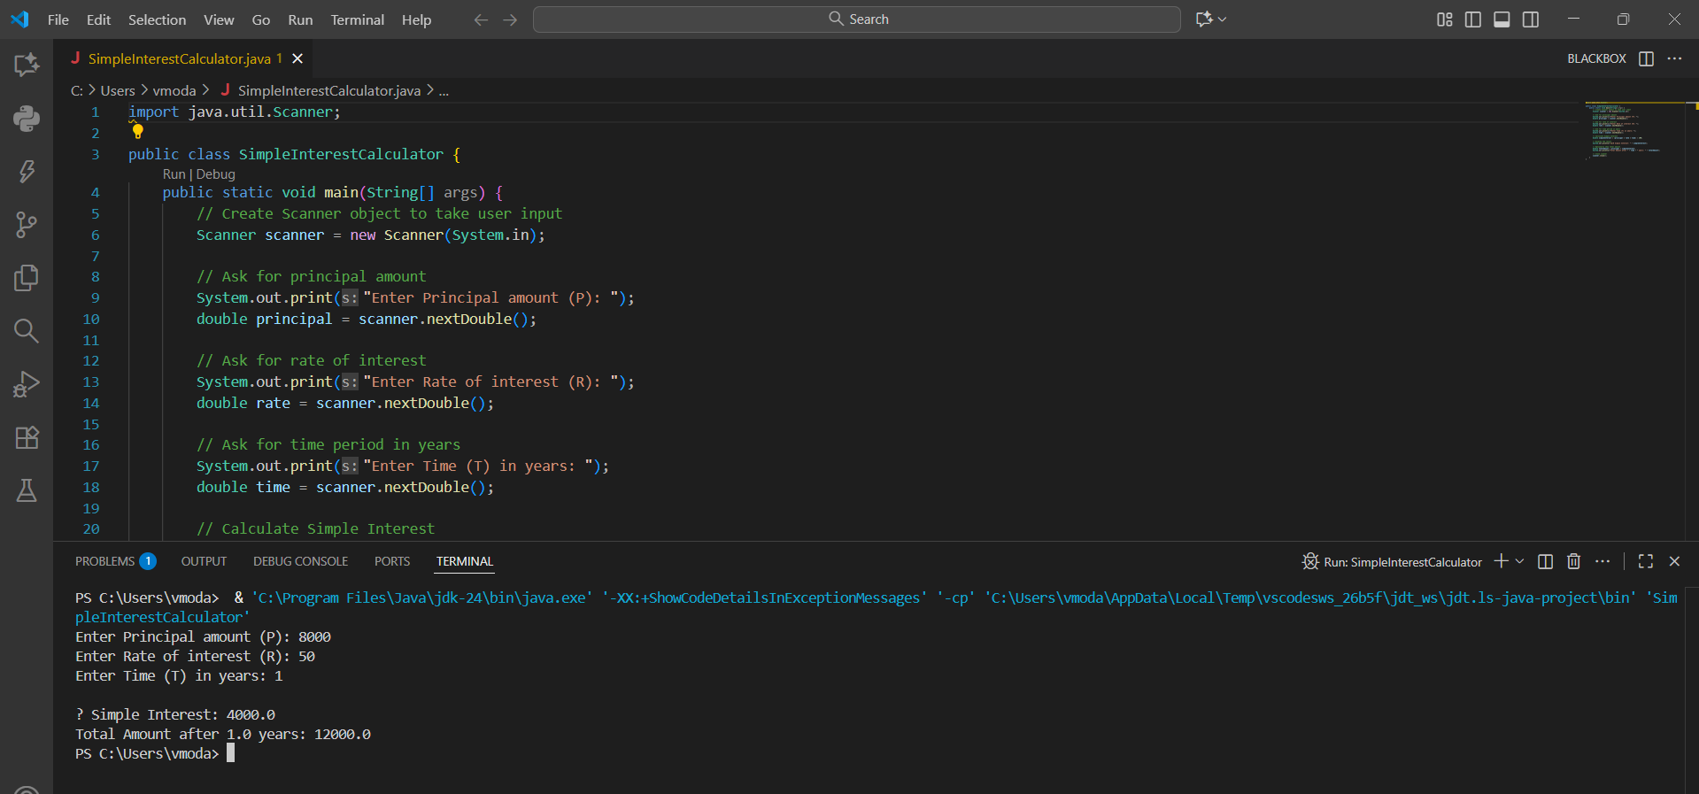

- Write a Java program to determine whether a given year is a leap year.

import java.util.Scanner;

public class LeapYearChecker {
public static void main(String[] args) {
// Create Scanner object for user input
Scanner scanner = new Scanner(System.in);

// Ask for the year
System.out.print("Enter a year: ");
int year = scanner.nextInt();

// Check if the year is a leap year
boolean isLeap = false;

if (year % 400 == 0) {
isLeap = true; // Divisible by 400 → leap year
} else if (year % 100 == 0) {
isLeap = false; // Divisible by 100 but not 400 → not a leap year
} else if (year % 4 == 0) {
isLeap = true; // Divisible by 4 → leap year
} else {
isLeap = false; // All other years → not a leap year
}

// Display the result
if (isLeap) {
System.out.println(year + " is a Leap Year! ");
} else {
System.out.println(year + " is NOT a Leap Year. ");
}

// Close the scanner
scanner.close();
}
}
OUTPUT:
Enter a year: 3032
3032 is a Leap Year.

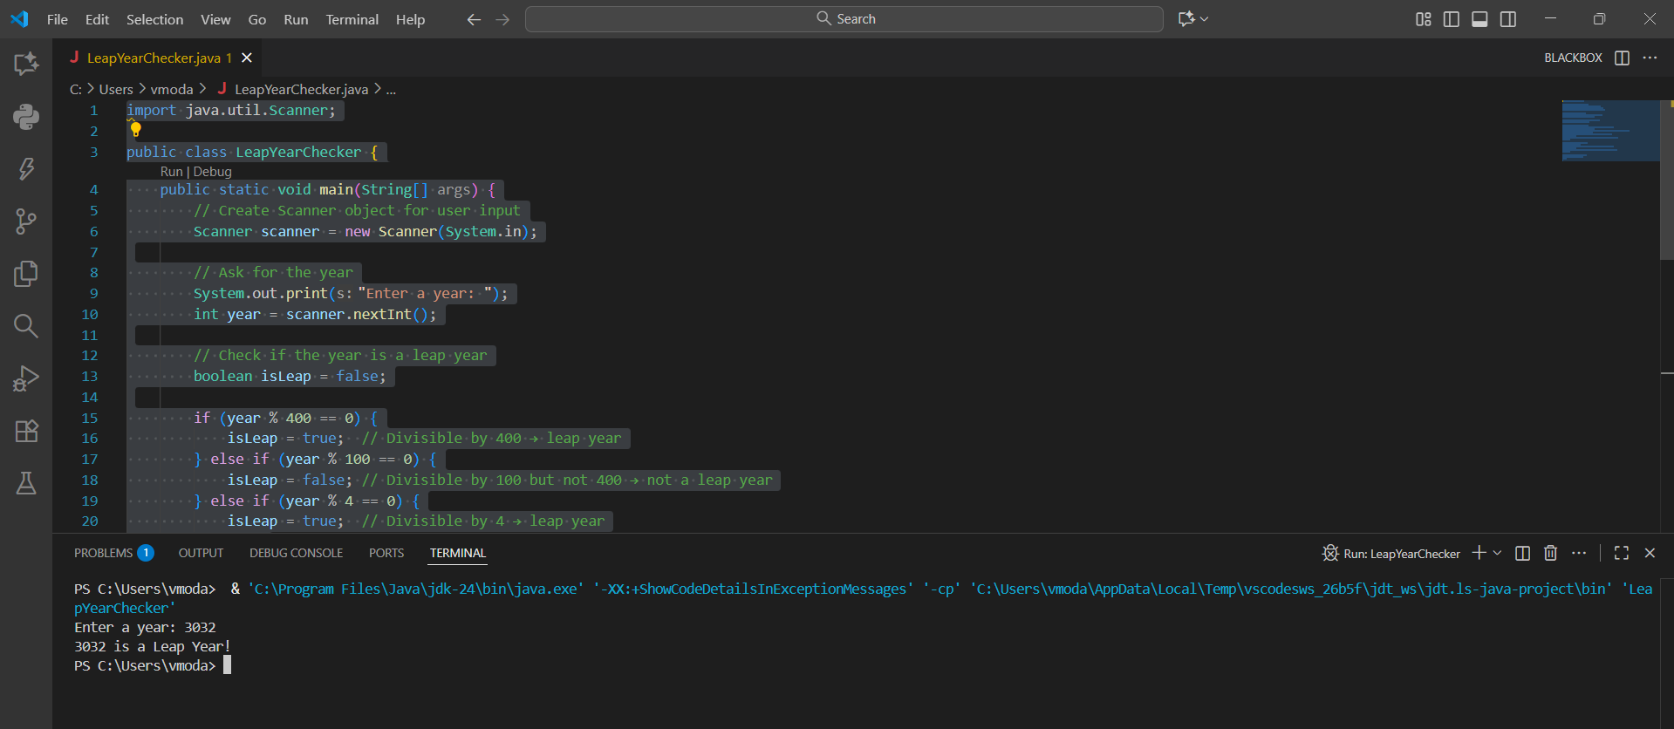
- Develop a program to check whether an input number is prime or not using for loop..
import java.util.Scanner;

public class PrimeNumberChecker {
public static void main(String[] args) {
// Create Scanner object to take user input
Scanner scanner = new Scanner(System.in);

// Ask user for a number
System.out.print("Enter a number: ");
int num = scanner.nextInt();

boolean isPrime = true;

// Handle edge cases
if (num <= 1) {
isPrime = false; // 0 and 1 are not prime
} else {
// Check divisibility using a for loop
for (int i = 2; i <= num / 2; i++) {
if (num % i == 0) {
isPrime = false;
break; // no need to check further
}
}
}

// Display the result
if (isPrime) {
System.out.println(num + " is a Prime Number! ");
} else {
System.out.println(num + " is NOT a Prime Number. ");
}

// Close the scanner
scanner.close();
}
}
OUTPUT:
Enter a number: 17
17 is a Prime Number!

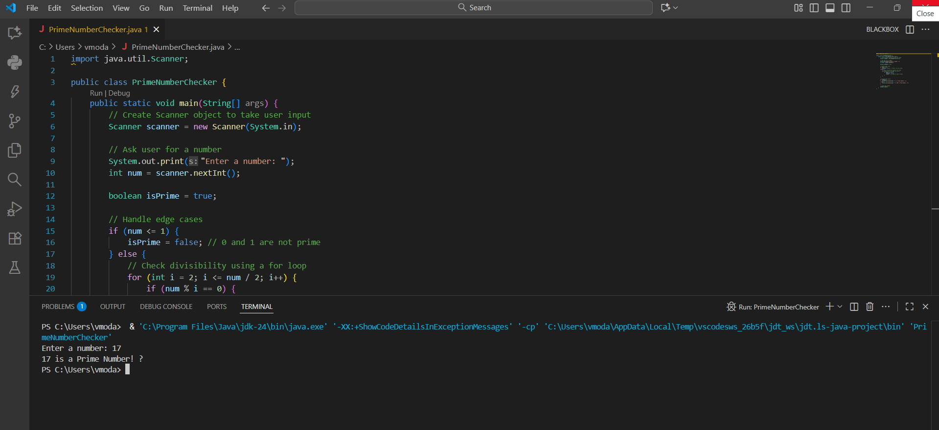

- Write a program to reverse a number using a while loop.
import java.util.Scanner;

public class ReverseNumber {
public static void main(String[] args) {
// Create Scanner object to take user input
Scanner scanner = new Scanner(System.in);

// Ask user for a number
System.out.print("Enter a number: ");
int number = scanner.nextInt();

int reversed = 0; // variable to store the reversed number

// Use while loop to reverse the number
while (number != 0) {
int digit = number % 10; // get last digit
reversed = reversed * 10 + digit; // build reversed number
number = number / 10; // remove last digit
}

// Display the reversed number
System.out.println("Reversed Number: " + reversed);

// Close the scanner
scanner.close();
}
}
OUTPUT:
Enter a number: 4896
Reversed Number: 6984
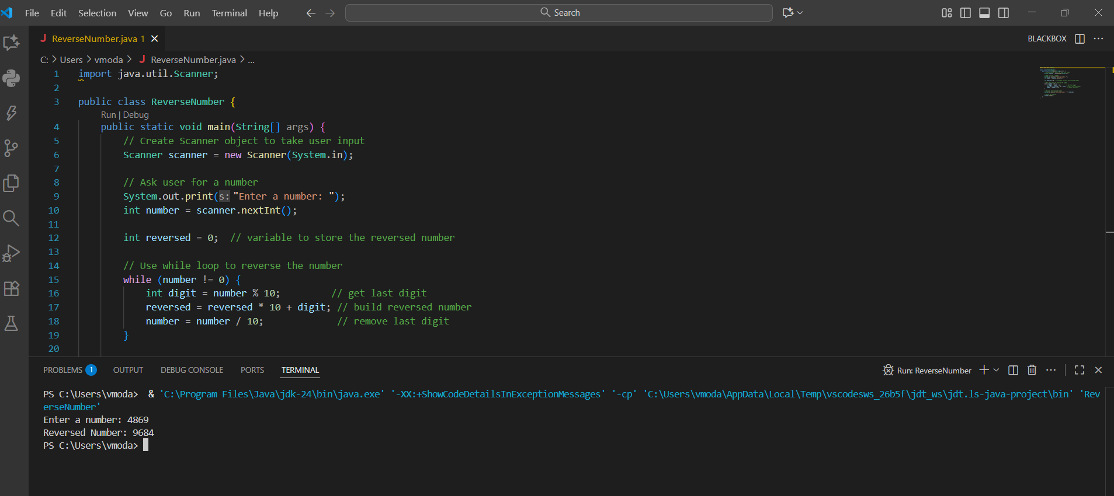

- Create a Java application to generate Fibonacci series up to a given number using do-while loop..

import java.util.Scanner;

public class FibonacciSeries {
public static void main(String[] args) {
// Create Scanner to take user input
Scanner scanner = new Scanner(System.in);

System.out.print("Enter the limit (up to which Fibonacci series should be generated): ");
int limit = scanner.nextInt();

int first = 0, second = 1; // first two numbers of Fibonacci series
int next = 0;

System.out.print("\nFibonacci Series up to " + limit + ": ");

// Display first two terms
System.out.print(first + " " + second);

// Use do-while loop to generate next numbers
do {
next = first + second;
if (next > limit)
break; // stop if next number exceeds limit

System.out.print(" " + next);

// move ahead in the series
first = second;
second = next;

} while (next <= limit);

// close the scanner
scanner.close();
}
}

OUTPUT:

Enter the limit (up to which Fibonacci series should be generated): 10

Fibonacci Series up to 10:
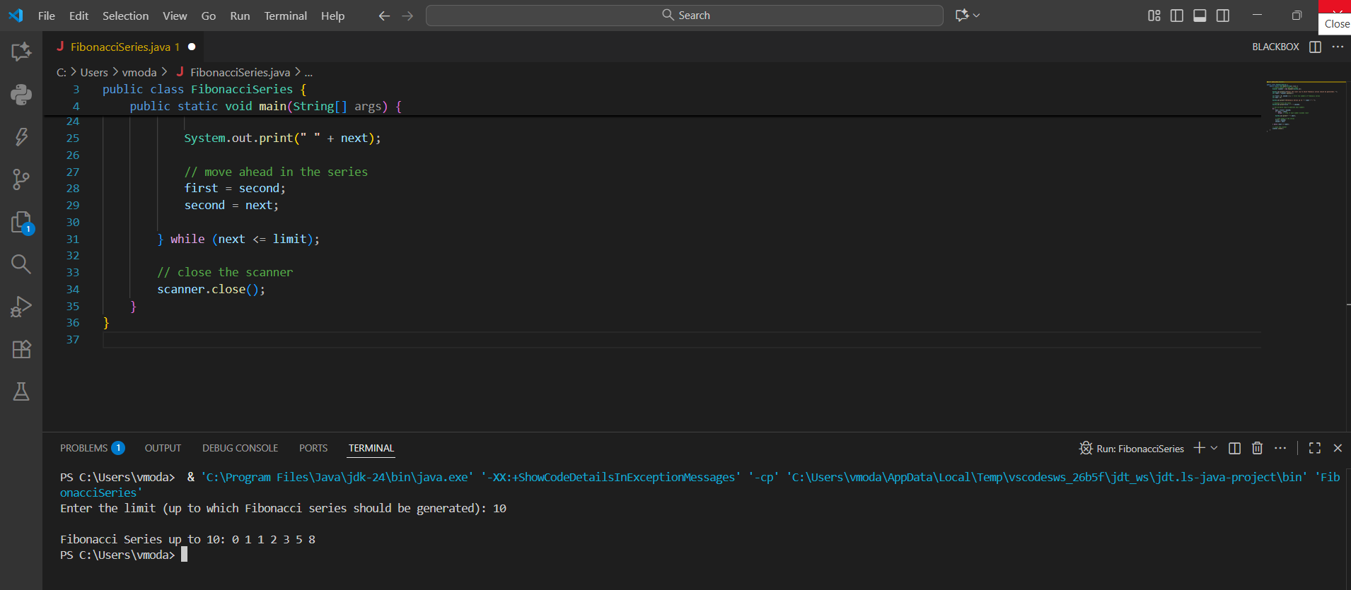

- Design a recursive program to compute the factorial of a number using function.
import java.util.Scanner;

public class FactorialRecursive {

// Recursive function to compute factorial
static long factorial(int n) {
if (n == 0 || n == 1) {
return 1; // Base case
} else {
return n * factorial(n - 1); // Recursive call
}
}

public static void main(String[] args) {
Scanner scanner = new Scanner(System.in);

// Ask user for input
System.out.print("Enter a number to find its factorial: ");
int number = scanner.nextInt();

// Validate input
if (number < 0) {
System.out.println("Factorial is not defined for negative numbers ❌");
} else {
long result = factorial(number);
System.out.println("Factorial of " + number + " is: " + result + " ✨");
}

scanner.close();
}
}
OUTPUT :
Enter a number to find its factorial: 85
Factorial of 85 is: 0
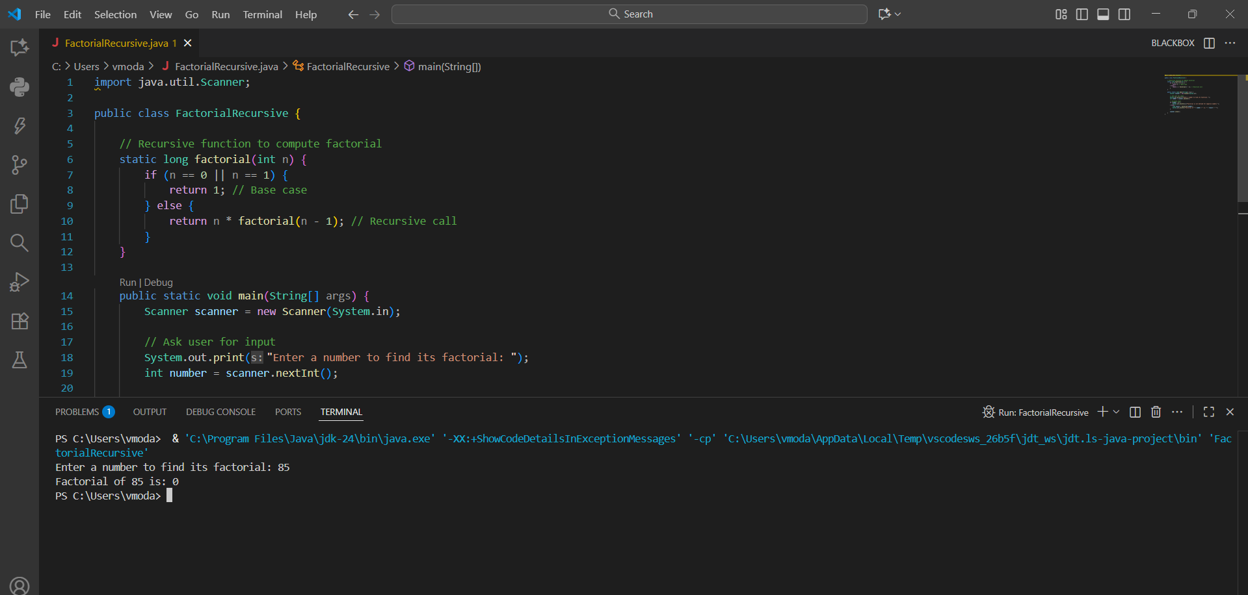
- Implement a program to check whether a given number is an Armstrong number.

import java.util.Scanner;

public class ArmstrongNumberChecker {
public static void main(String[] args) {
Scanner scanner = new Scanner(System.in);

// Ask user for input
System.out.print("Enter a number: ");
int number = scanner.nextInt();

int originalNumber = number;
int result = 0;
int n = 0;

// Find number of digits
int temp = number;
while (temp != 0) {
temp /= 10;
n++;
}

// Calculate sum of powers of digits
temp = number;
while (temp != 0) {
int digit = temp % 10;
result += Math.pow(digit, n);
temp /= 10;
}

// Check if Armstrong number
if (result == originalNumber) {
System.out.println(originalNumber + " is an Armstrong Number! ");
} else {
System.out.println(originalNumber + " is NOT an Armstrong Number. ");
}

scanner.close();
}
}
OUTPUT:
Enter a number: 370
370 is an Armstrong Number.

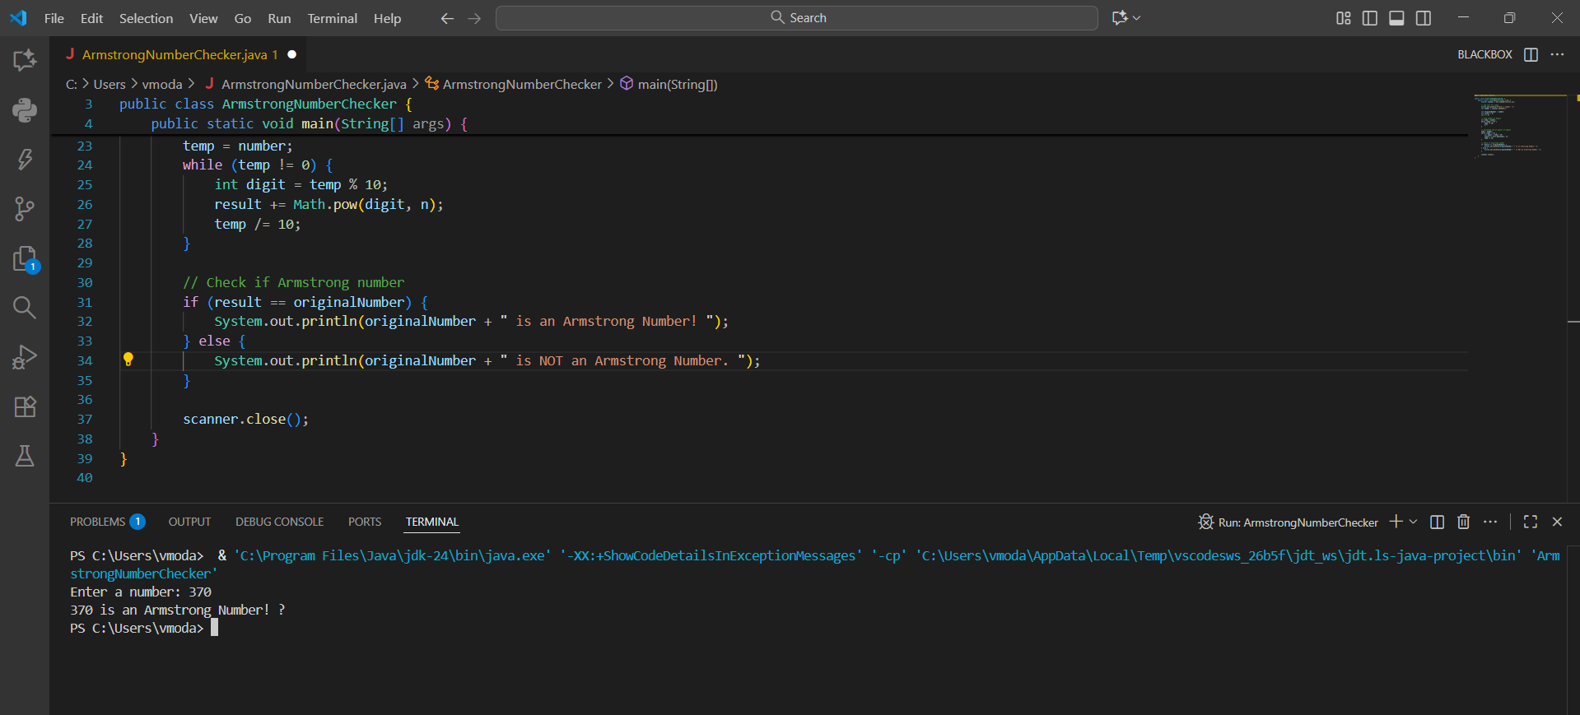

- Count the number of vowels, consonants, digits, and special characters in a string.
import java.util.Scanner;
public class CountCharacters {
public static void main(String[] args) {
Scanner scanner = new Scanner(System.in);

// Take input from user
System.out.print("Enter a string: ");
String input = scanner.nextLine();

// Convert the string to lowercase for easier comparison
input = input.toLowerCase();

int vowels = 0, consonants = 0, digits = 0, specialChars = 0;

// Loop through each character
for (int i = 0; i < input.length(); i++) {
char ch = input.charAt(i);

if (ch >= 'a' && ch <= 'z') {
// Check if it's a vowel or consonant
if (ch == 'a' || ch == 'e' || ch == 'i' || ch == 'o' || ch == 'u') {
vowels++;
} else {
consonants++;
}
} else if (ch >= '0' && ch <= '9') {
digits++;
} else if (ch != ' ') { // Ignore spaces
specialChars++;
}
}

// Display results
System.out.println("\nVowels: " + vowels);
System.out.println("Consonants: " + consonants);
System.out.println("Digits: " + digits);
System.out.println("Special Characters: " + specialChars);

scanner.close();
}
}
OUTPUT:
Enter a string: chinmay
Vowels: 2
Consonants: 5
Digits: 0
Special Characters: 0
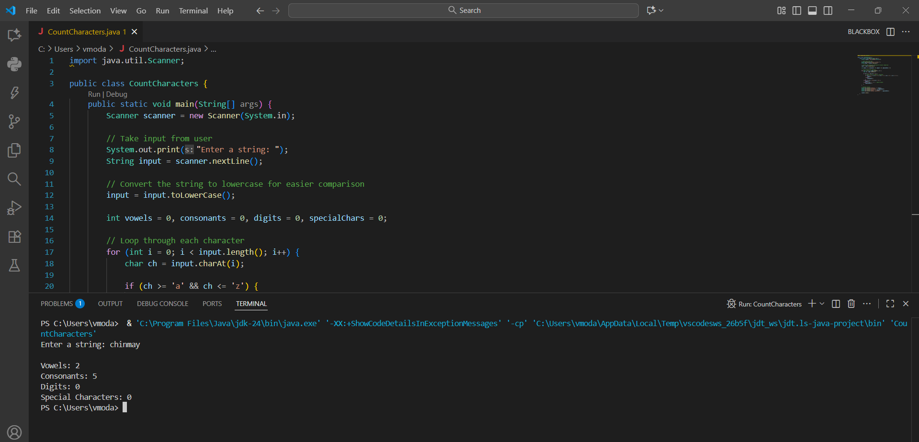

- Program to reverse the string using predefined methods in String class.
import java.util.Scanner;

public class ReverseString {
public static void main(String[] args) {
Scanner scanner = new Scanner(System.in);

// Ask the user for input
System.out.print("Enter a string to reverse: ");
String input = scanner.nextLine();

// Use StringBuilder's reverse() method
String reversed = new StringBuilder(input).reverse().toString();

// Display the result
System.out.println("Reversed string: " + reversed);

scanner.close();
}
}
OUTPUT:
Enter a string to reverse: pallotti college
Reversed string: egelloc ittollap
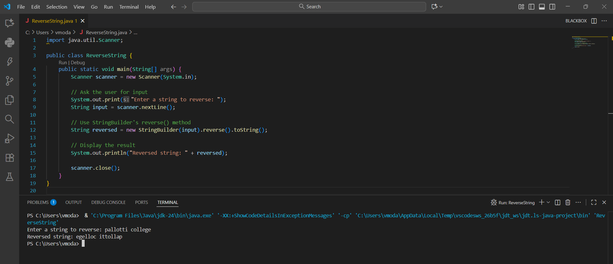

- Write a program to remove duplicate characters from a string.
import java.util.LinkedHashSet;
import java.util.Scanner;

public class RemoveDuplicates {
public static void main(String[] args) {
Scanner scanner = new Scanner(System.in);

// Ask the user for input
System.out.print("Enter a string: ");
String input = scanner.nextLine();

// Use LinkedHashSet to maintain order and remove duplicates
LinkedHashSet<Character> set = new LinkedHashSet<>();

for (char c : input.toCharArray()) {
set.add(c);
}

// Build the result string from the set
StringBuilder result = new StringBuilder();
for (char c : set) {
result.append(c);
}

System.out.println("String after removing duplicates: " + result);

scanner.close();
}
}
OUTPUT:
Enter a string: data science
String after removing duplicates: dat scien
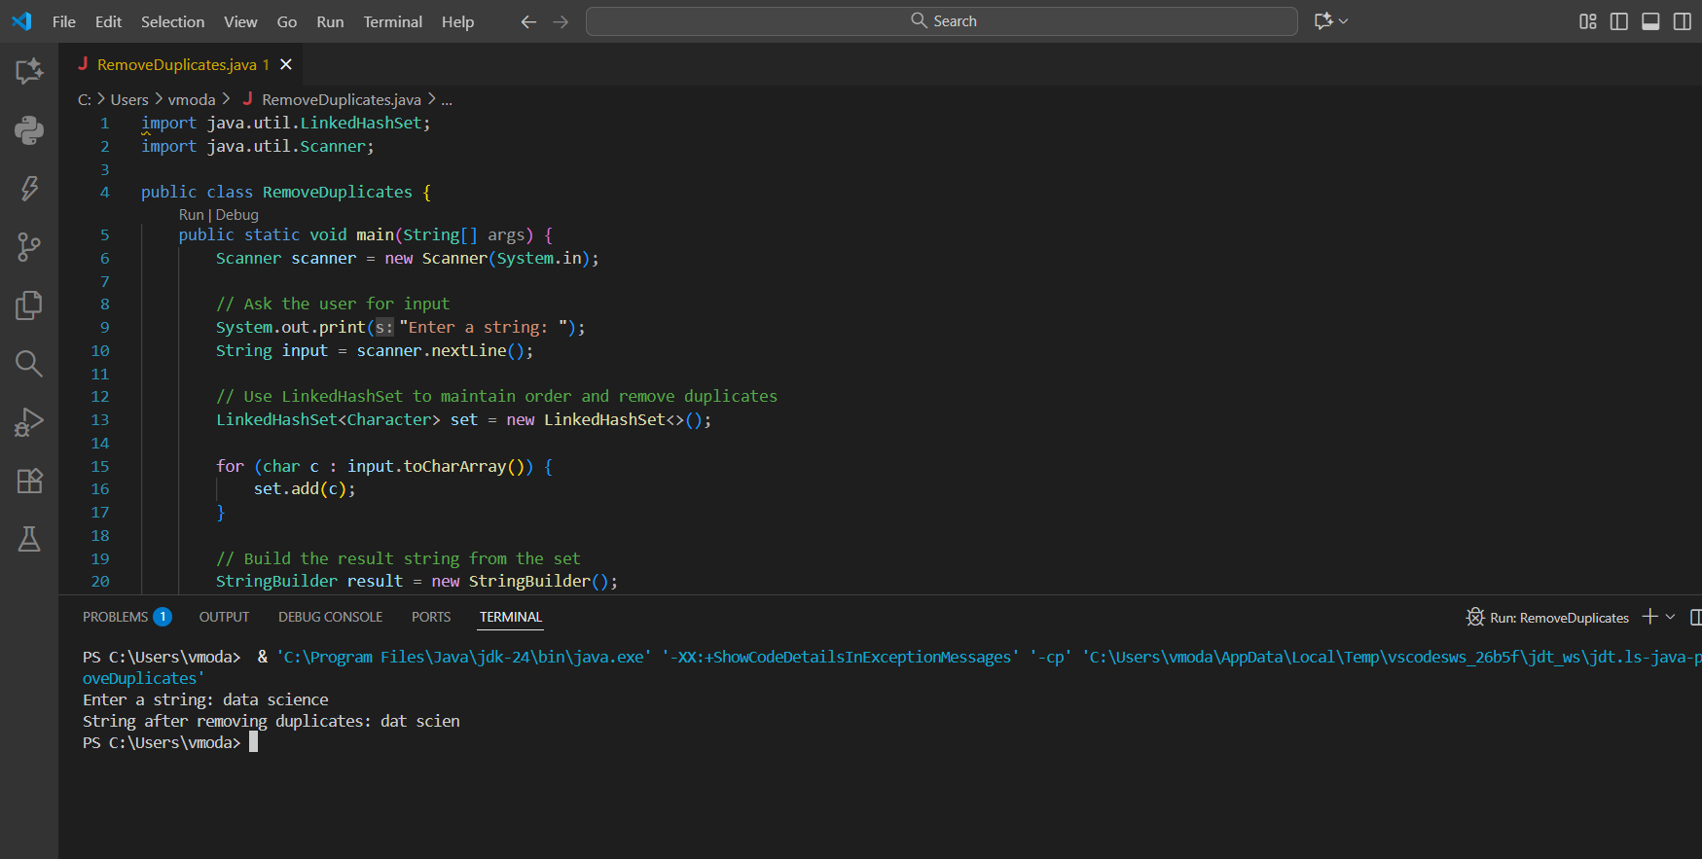

- Develop a Java program to count the frequency of each word in a sentence.

import java.util.HashMap;
import java.util.Scanner;

public class WordFrequencyCounter {
public static void main(String[] args) {
Scanner scanner = new Scanner(System.in);

// Ask the user for a sentence
System.out.print("Enter a sentence: ");
String sentence = scanner.nextLine();

// Convert to lowercase and split into words
String[] words = sentence.toLowerCase().split("\\s+");

// Use a HashMap to store word frequencies
HashMap<String, Integer> wordCount = new HashMap<>();

for (String word : words) {
// Remove punctuation (optional)
word = word.replaceAll("[^a-zA-Z0-9]", "");

if (!word.isEmpty()) {
wordCount.put(word, wordCount.getOrDefault(word, 0) + 1);
}
}

// Display the results
System.out.println("\nWord Frequencies:");
for (String word : wordCount.keySet()) {
System.out.println(word + ": " + wordCount.get(word));
}

scanner.close();
}
}

OUTPUT:
Enter a sentence: word frequencies

Word Frequencies:
word: 1
frequencies: 1
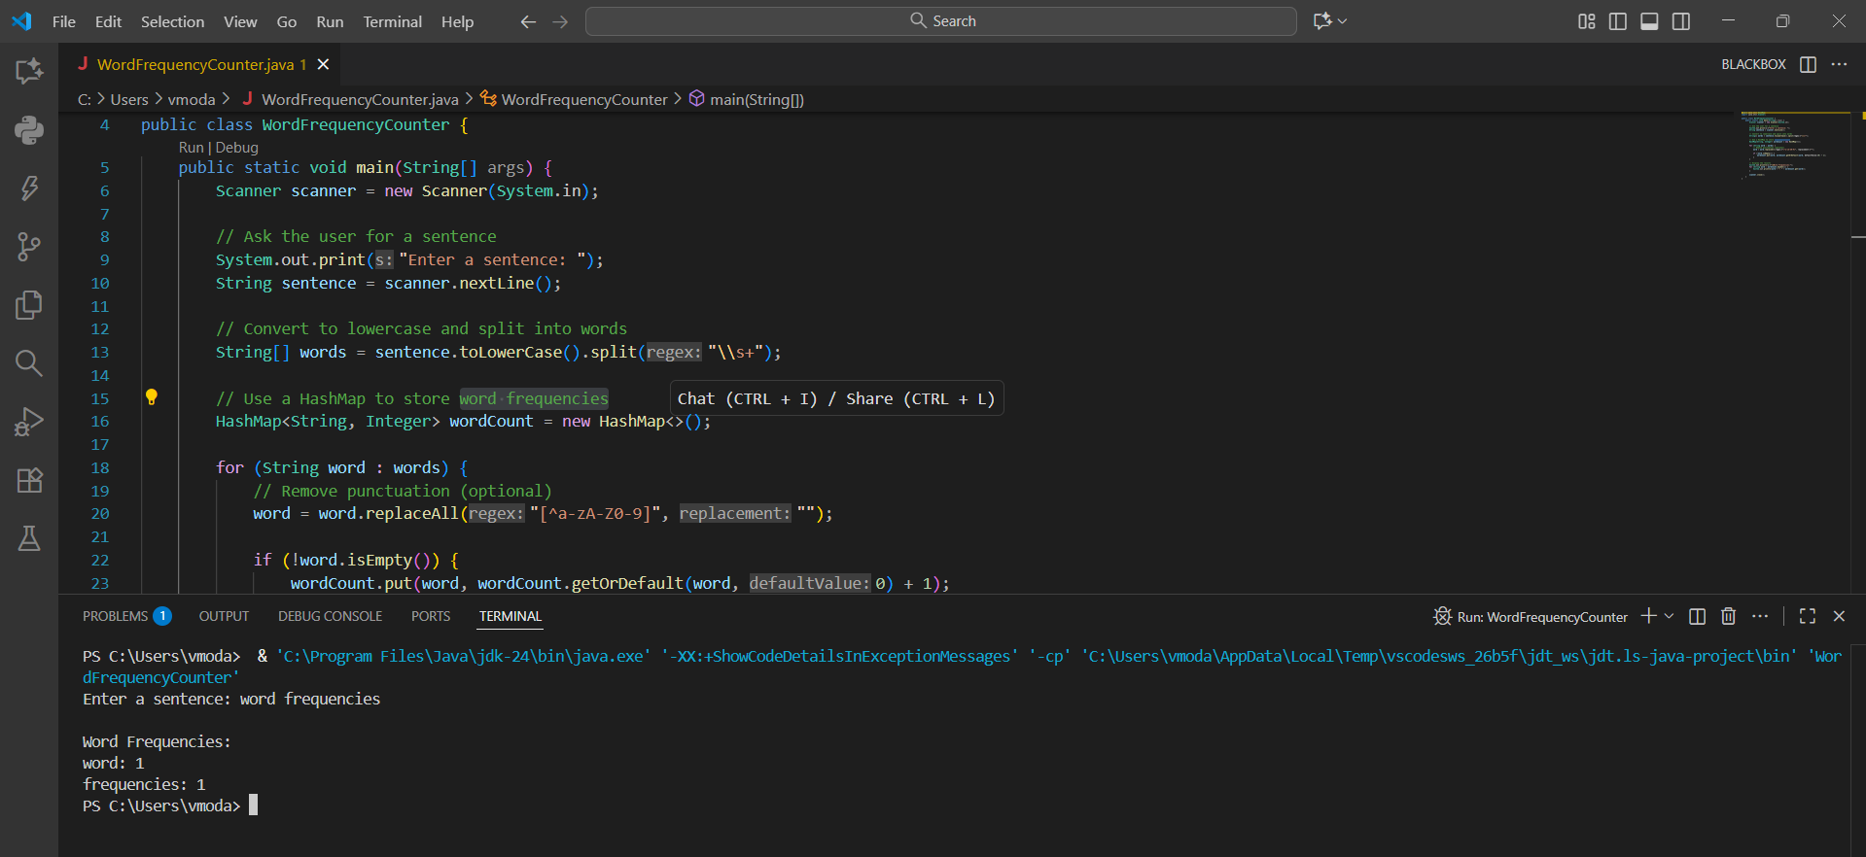
- Implement linear search to find an element in an array.
import java.util.Scanner;

public class LinearSearch {
public static void main(String[] args) {
Scanner scanner = new Scanner(System.in);

// Take array size from user
System.out.print("Enter the number of elements in the array: ");
int size = scanner.nextInt();

int[] arr = new int[size];

// Input array elements
System.out.println("Enter " + size + " elements:");
for (int i = 0; i < size; i++) {
arr[i] = scanner.nextInt();
}

// Ask for the element to search
System.out.print("Enter the element to search: ");
int key = scanner.nextInt();

// Perform linear search
boolean found = false;
int position = -1;

for (int i = 0; i < size; i++) {
if (arr[i] == key) {
found = true;
position = i; // store the index
break;
}
}

// Display result
if (found) {
System.out.println("\nElement " + key + " found at position: " + (position + 1));
} else {
System.out.println("\nElement " + key + " not found in the array.");
}

scanner.close();
}
}
OUTPUT :
Enter the number of elements in the array: 4
Enter 4 elements:
54
23
78
08
Enter the element to search: 08
Element 8 found at position: 4
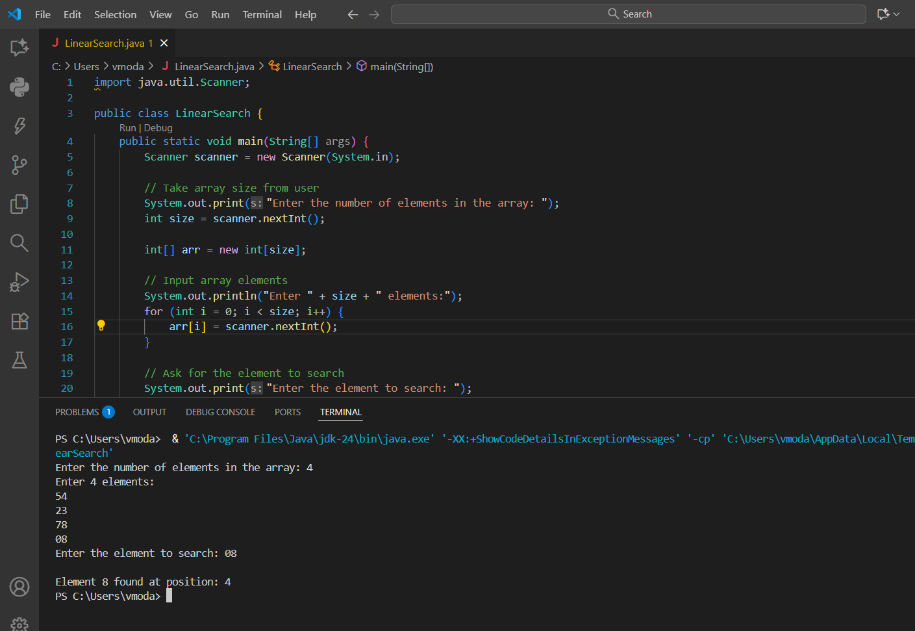

- Implement binary search to find an element in an array.
import java.util.Arrays;
import java.util.Scanner;
public class BinarySearch {
public static void main(String[] args) {
Scanner scanner = new Scanner(System.in);
// Take array size from user
System.out.print("Enter the number of elements in the array: ");
int size = scanner.nextInt();

int[] arr = new int[size];

// Input array elements
System.out.println("Enter " + size + " elements (in any order):");
for (int i = 0; i < size; i++) {
arr[i] = scanner.nextInt();
}
// Sort the array (binary search requires sorted data)
Arrays.sort(arr);
System.out.println("\nSorted Array: " + Arrays.toString(arr));

// Ask for the element to search
System.out.print("Enter the element to search: ");
int key = scanner.nextInt();

// Perform binary search
int low = 0, high = size - 1;
boolean found = false;
int position = -1;
while (low <= high) {
int mid = (low + high) / 2;

if (arr[mid] == key) {
found = true;
position = mid;
break;
} else if (arr[mid] < key) {
low = mid + 1;
} else {
high = mid - 1;
}
}
// Display result
if (found) {
System.out.println("\nElement " + key + " found at position: " + (position + 1));
} else {
System.out.println("\nElement " + key + " not found in the array.");
}

scanner.close();
}
}
OUTPUT:
Enter the number of elements in the array: 4
Enter 4 elements (in any order):
34
67
13
55
Sorted Array: [13, 34, 55, 67]
Enter the element to search: 55
Element 55 found at position: 3
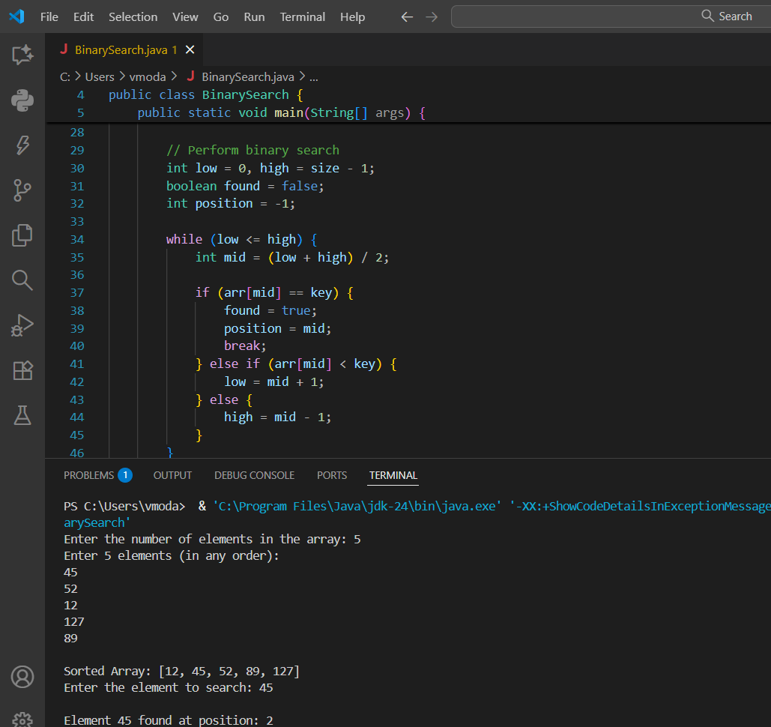

- Develop a program to sort an array using bubble sort algorithm.
import java.util.Scanner;

public class BubbleSort {
public static void main(String[] args) {
Scanner scanner = new Scanner(System.in);

// Ask for array size
System.out.print("Enter the number of elements in the array: ");
int size = scanner.nextInt();

int[] arr = new int[size];

// Input array elements
System.out.println("Enter " + size + " elements:");
for (int i = 0; i < size; i++) {
arr[i] = scanner.nextInt();
}

// Bubble sort logic
for (int i = 0; i < size - 1; i++) {
for (int j = 0; j < size - i - 1; j++) {
if (arr[j] > arr[j + 1]) {
// Swap elements
int temp = arr[j];
arr[j] = arr[j + 1];
arr[j + 1] = temp;
}
}
}

// Display sorted array
System.out.println("\nSorted array in ascending order:");
for (int num : arr) {
System.out.print(num + " ");
}

scanner.close();
}
}
OUTPUT:
Enter the number of elements in the array: 5
Enter 5 elements:
34
56
78
76
55

Sorted array in ascending order:
34 55 56 76 78
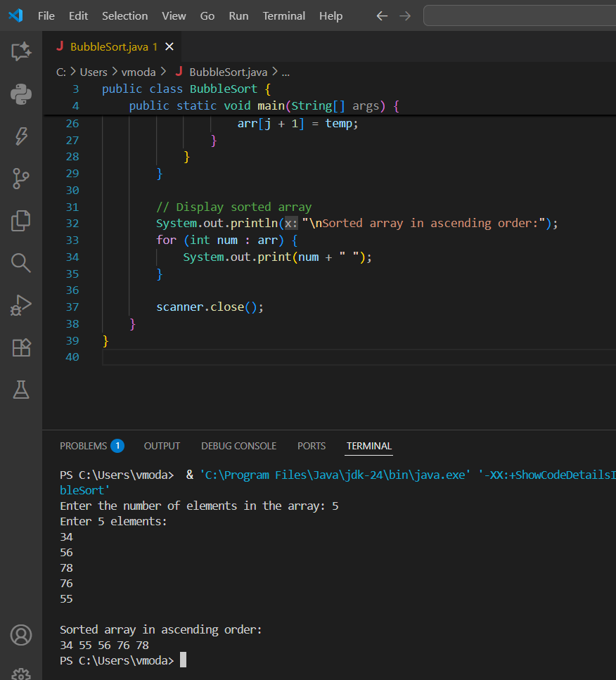

- Check whether a given string is a palindrome.
import java.util.Scanner;

public class PalindromeCheck {
public static void main(String[] args) {
Scanner scanner = new Scanner(System.in);

// Ask the user for a string
System.out.print("Enter a string: ");
String str = scanner.nextLine();

// Normalize the string: remove spaces and convert to lowercase
str = str.replaceAll("\\s+", "").toLowerCase();

// Reverse the string using StringBuilder
String reversed = new StringBuilder(str).reverse().toString();

// Check if palindrome
if (str.equals(reversed)) {
System.out.println(" The string is a palindrome!");
} else {
System.out.println("The string is not a palindrome.");
}

scanner.close();
}
}
OUTPUT:
Enter a string: madam
The string is a palindrome!

- Create a Student class with marks in 3 subjects and compute the result with percentage.
import java.util.Scanner;
class Student {
private String name;
private int mark1, mark2, mark3;

// Constructor
public Student(String name, int mark1, int mark2, int mark3) {
this.name = name;
this.mark1 = mark1;
this.mark2 = mark2;
this.mark3 = mark3;
}

// Method to calculate total
public int getTotal() {
return mark1 + mark2 + mark3;
}

// Method to calculate percentage
public double getPercentage() {
return getTotal() / 3.0;
}

// Method to display result
public void displayResult() {
double percentage = getPercentage();
System.out.println("\n🎓 Student Name: " + name);
System.out.println("Marks: " + mark1 + ", " + mark2 + ", " + mark3);
System.out.println("Total Marks: " + getTotal());
System.out.printf("Percentage: %.2f%%\n", percentage);

// Optional: Grade based on percentage
if (percentage >= 90) {
System.out.println("Grade: A+ ");
} else if (percentage >= 75) {
System.out.println("Grade: A");
} else if (percentage >= 60) {
System.out.println("Grade: B");
} else if (percentage >= 50) {
System.out.println("Grade: C");
} else {
System.out.println("Grade: F ");
}
}
}

public class StudentResult {
public static void main(String[] args) {
Scanner scanner = new Scanner(System.in);

// Input student details
System.out.print("Enter student name: ");
String name = scanner.nextLine();

System.out.print("Enter marks in 3 subjects (out of 100): ");
int mark1 = scanner.nextInt();
int mark2 = scanner.nextInt();
int mark3 = scanner.nextInt();

// Create student object and show result
Student student = new Student(name, mark1, mark2, mark3);
student.displayResult();

scanner.close();
}
}
OUTPUT:
Enter student name: Alice
Enter marks in 3 subjects (out of 100): 90
78
82

Student Name: Alice
Marks: 90, 78, 82
Total Marks: 250
Percentage: 83.33%
Grade: A
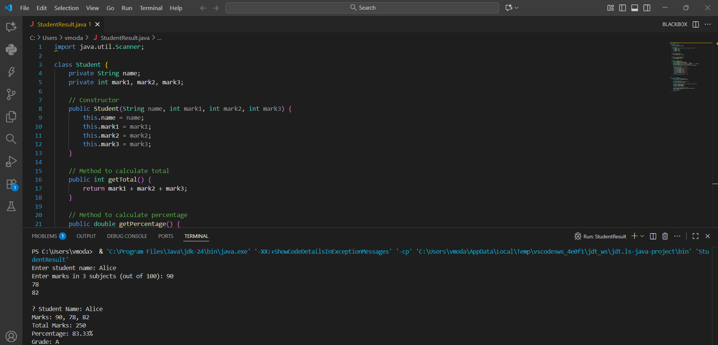

- Write a Java program to perform matrix addition using for loop.
import java.util.Scanner;

public class MatrixAddition {
public static void main(String[] args) {
Scanner scanner = new Scanner(System.in);

// Step 1: Get matrix size
System.out.print("Enter number of rows: ");
int rows = scanner.nextInt();
System.out.print("Enter number of columns: ");
int cols = scanner.nextInt();

// Step 2: Declare matrices
int[][] matrix1 = new int[rows][cols];
int[][] matrix2 = new int[rows][cols];
int[][] sum = new int[rows][cols];

// Step 3: Input first matrix
System.out.println("\nEnter elements of Matrix 1:");
for (int i = 0; i < rows; i++) {
for (int j = 0; j < cols; j++) {
matrix1[i][j] = scanner.nextInt();
}
}

// Step 4: Input second matrix
System.out.println("\nEnter elements of Matrix 2:");
for (int i = 0; i < rows; i++) {
for (int j = 0; j < cols; j++) {
matrix2[i][j] = scanner.nextInt();
}
}

// Step 5: Perform addition
for (int i = 0; i < rows; i++) {
for (int j = 0; j < cols; j++) {
sum[i][j] = matrix1[i][j] + matrix2[i][j];
}
}

// Step 6: Display result
System.out.println("\n🧮 Resultant Matrix (Matrix 1 + Matrix 2):");
for (int i = 0; i < rows; i++) {
for (int j = 0; j < cols; j++) {
System.out.print(sum[i][j] + "\t");
}
System.out.println();
}

scanner.close();
}
}
OUTPUT:
Enter number of rows: 2
Enter number of columns: 2
Enter elements of Matrix 1:
1
4
7
8
Enter elements of Matrix 2:
2
5
9
8
Resultant Matrix (Matrix 1 + Matrix 2):
3 9
16 16

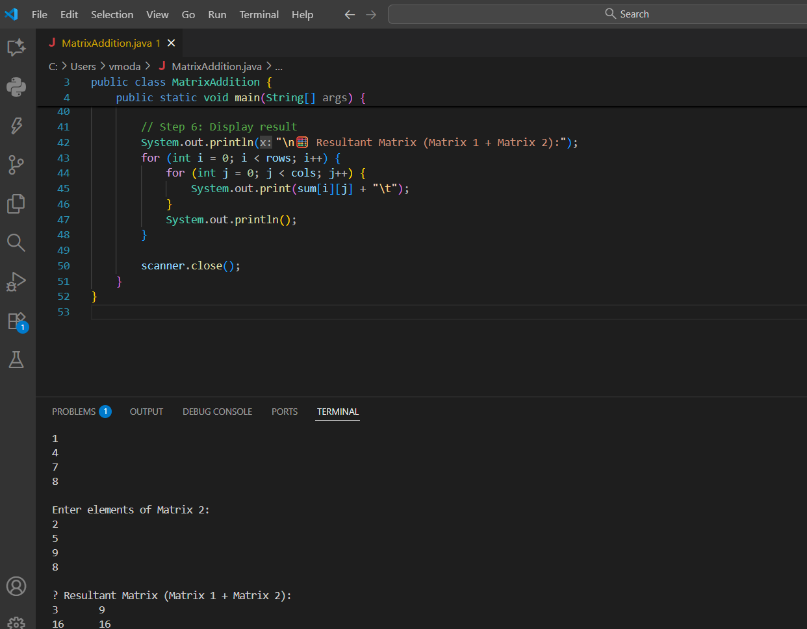

- Write a java program to find the sum of diagonal elements in an array.

import java.util.Scanner;

public class DiagonalSum {
public static void main(String[] args) {
Scanner scanner = new Scanner(System.in);

// Step 1: Get matrix size
System.out.print("Enter the size of the square matrix: ");
int n = scanner.nextInt();

int[][] matrix = new int[n][n];

// Step 2: Input matrix elements
System.out.println("\nEnter elements of the matrix:");
for (int i = 0; i < n; i++) {
for (int j = 0; j < n; j++) {
matrix[i][j] = scanner.nextInt();
}
}

// Step 3: Display matrix
System.out.println("\nThe Matrix:");
for (int i = 0; i < n; i++) {
for (int j = 0; j < n; j++) {
System.out.print(matrix[i][j] + "\t");
}
System.out.println();
}

// Step 4: Find sum of diagonal elements
int sum = 0;
for (int i = 0; i < n; i++) {
sum += matrix[i][i];
}

// Step 5: Display result
System.out.println("\n Sum of Diagonal Elements = " + sum);

scanner.close();
}
}
OUTPUT:
Enter the size of the square matrix: 3

Enter elements of the matrix:
1
2
3
4
5
6
7
8
9
The Matrix:
1 2 3
4 5 6
7 8 9
Sum of Diagonal Elements = 15
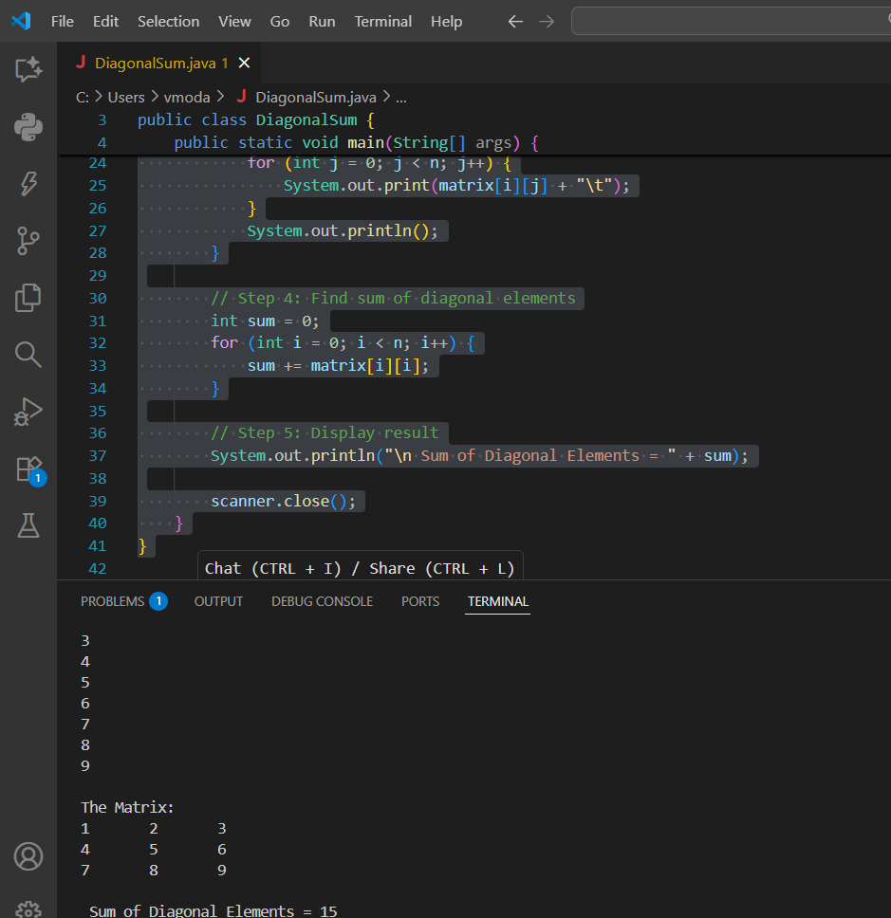

- Design a class BankAccount with methods for deposit, withdraw, and balance inquiry
import java.util.Scanner;

class BankAccount {
private String accountHolder;
private double balance;

// Constructor
public BankAccount(String accountHolder, double initialBalance) {
this.accountHolder = accountHolder;
this.balance = initialBalance;
}

// Method to deposit money
public void deposit(double amount) {
if (amount > 0) {
balance += amount;
System.out.println(" Deposited: ₹" + amount);
} else {
System.out.println(" Invalid deposit amount.");
}
}

// Method to withdraw money
public void withdraw(double amount) {
if (amount > 0 && amount <= balance) {
balance -= amount;
System.out.println("Withdrawn: ₹" + amount);
} else if (amount > balance) {
System.out.println(" Insufficient balance.");
} else {
System.out.println(" Invalid withdrawal amount.");
}
}

// Method to check balance
public void checkBalance() {
System.out.println(" Current Balance: ₹" + balance);
}
}

public class BankApp {
public static void main(String[] args) {
Scanner scanner = new Scanner(System.in);

// Create an account
System.out.print("Enter account holder name: ");
String name = scanner.nextLine();

System.out.print("Enter initial balance: ");
double initialBalance = scanner.nextDouble();

BankAccount account = new BankAccount(name, initialBalance);

int choice;
do {
System.out.println("\n--- Bank Menu ---");
System.out.println("1. Deposit");
System.out.println("2. Withdraw");
System.out.println("3. Check Balance");
System.out.println("4. Exit");
System.out.print("Enter your choice: ");
choice = scanner.nextInt();

switch (choice) {
case 1:
System.out.print("Enter amount to deposit: ");
double depositAmount = scanner.nextDouble();
account.deposit(depositAmount);
break;
case 2:
System.out.print("Enter amount to withdraw: ");
double withdrawAmount = scanner.nextDouble();
account.withdraw(withdrawAmount);
break;
case 3:
account.checkBalance();
break;
case 4:
System.out.println("Thank you !");
break;
default:
System.out.println(" Invalid, Try again.");
}
} while (choice != 4);

scanner.close();
}
}
OUTPUT:
Enter account holder name: Chinmay
Enter initial balance: 50000

--- Bank Menu ---
1. Deposit
2. Withdraw
3. Check Balance
4. Exit
Enter your choice: 2
Enter amount to withdraw: 5000
Withdrawn: 5000.0

--- Bank Menu ---
1. Deposit
2. Withdraw
3. Check Balance
4. Exit
Enter your choice: 3
Current Balance: 45000

--- Bank Menu ---
1. Deposit
2. Withdraw
3. Check Balance
4. Exit
Enter your choice: 4
Thank you !
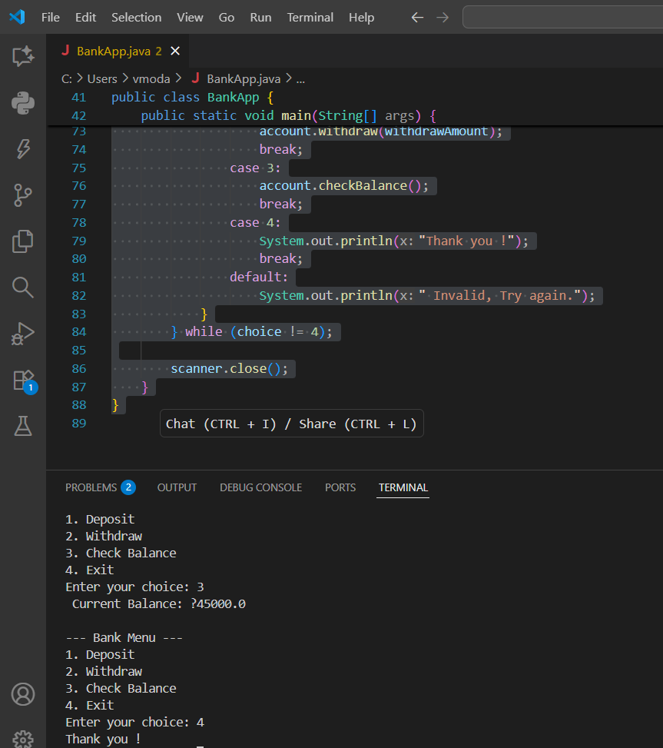

- Write a Java program to find the largest and smallest number in an array.

import java.util.Scanner;
public class LargestSmallest {
public static void main(String[] args) {
Scanner scanner = new Scanner(System.in);

// Step 1: Get array size
System.out.print("Enter the number of elements in the array: ");
int n = scanner.nextInt();

int[] arr = new int[n];

// Step 2: Input array elements
System.out.println("Enter " + n + " elements:");
for (int i = 0; i < n; i++) {
arr[i] = scanner.nextInt();
}

// Step 3: Initialize min and max
int largest = arr[0];
int smallest = arr[0];

// Step 4: Loop to find largest and smallest
for (int i = 1; i < n; i++) {
if (arr[i] > largest) {
largest = arr[i];
}
if (arr[i] < smallest) {
smallest = arr[i];
}
}

// Step 5: Display results
System.out.println("\n Largest number = " + largest);
System.out.println(" Smallest number = " + smallest);

scanner.close();
}
}
OUTPUT:
Enter the number of elements in the array: 5
Enter 5 elements:
89
100
58
62
45
Largest number = 100
Smallest number = 45
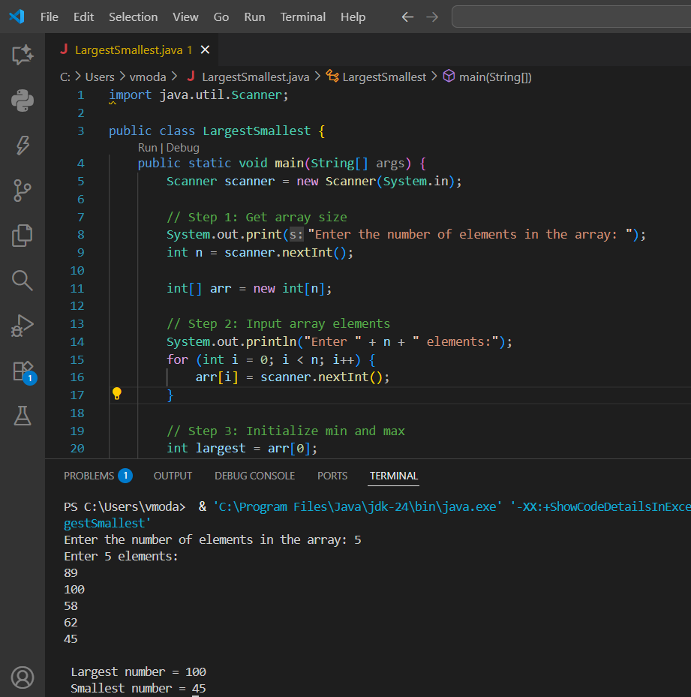

- Design a Java class Employee with the following:A method empDetails() to accept and display employee details.A method salary() to compute basic salary components.A method total() to calculate the total salary (including allowances/deductions)

import java.util.Scanner;

class Employee {
String name, designation;
int empId;
double basicSalary, hra, da, pf, totalSalary;

// Method to accept and display employee details
void empDetails() {
Scanner sc = new Scanner(System.in);

System.out.print("Enter Employee ID: ");
empId = sc.nextInt();
sc.nextLine(); // consume leftover newline

System.out.print("Enter Employee Name: ");
name = sc.nextLine();

System.out.print("Enter Designation: ");
designation = sc.nextLine();

System.out.print("Enter Basic Salary: ");
basicSalary = sc.nextDouble();

System.out.println("\n Employee Details:");
System.out.println("ID: " + empId);
System.out.println("Name: " + name);
System.out.println("Designation: " + designation);
System.out.println("Basic Salary: ₹" + basicSalary);
}

// Method to compute basic salary components
void salary() {
hra = 0.20 * basicSalary; // House Rent Allowance = 20%
da = 0.10 * basicSalary; // Dearness Allowance = 10%
pf = 0.08 * basicSalary; // Provident Fund = 8%

System.out.println("\n Salary Breakdown:");
System.out.println("HRA (20%): ₹" + hra);
System.out.println("DA (10%): ₹" + da);
System.out.println("PF (8%): ₹" + pf);
}

// Method to compute total salary
void total() {
totalSalary = basicSalary + hra + da - pf;
System.out.println("\n Total Salary (after deductions): ₹" + totalSalary);
}
}

public class EmployeeMain {
public static void main(String[] args) {
Employee emp = new Employee();

emp.empDetails(); // Accept & show details
emp.salary(); // Calculate components
emp.total();
}
}
OUTPUT:
Enter Employee ID: 1
Enter Employee Name: Manoj
Enter Designation: Manager
Enter Basic Salary: 40000

Employee Details:
ID: 1
Name: Manoj
Designation: Manager
Basic Salary: 40000.0

Salary Breakdown:
HRA (20%): 8000.0
DA (10%): 4000.0
PF (8%): 3200.0
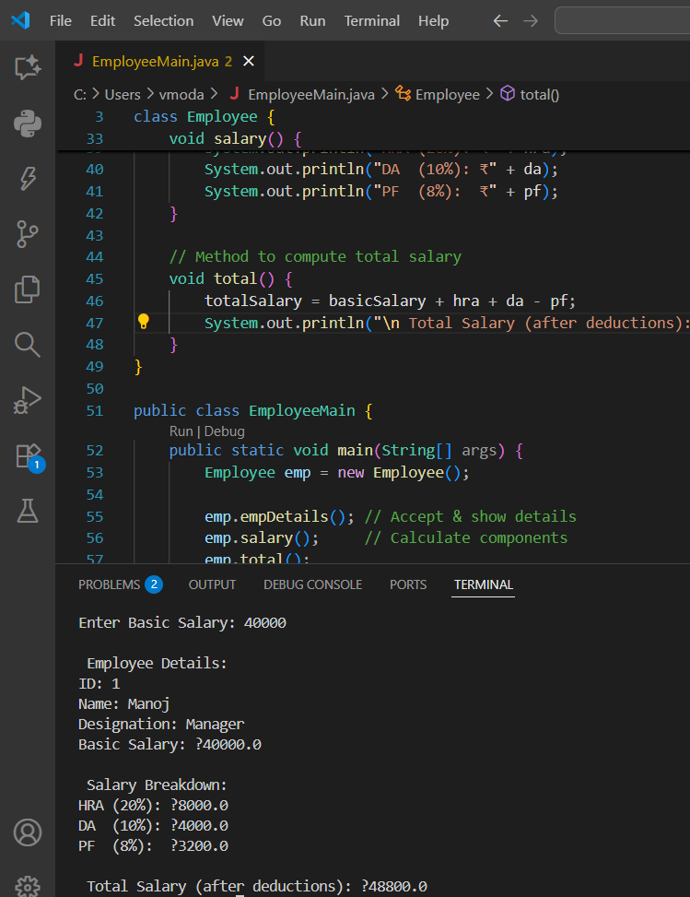

- Create a class Volume and create three constructor with one arg,two arg and three arg with the help of constructor overloading concept.

// Class to demonstrate constructor overloading
class Volume {
double volume;

// Constructor with one argument (Cube)
Volume(double side) {
volume = side * side * side;
System.out.println("Volume of Cube: " + volume);
}

// Constructor with two arguments (Cylinder)
Volume(double radius, int height) {
volume = 3.1416 * radius * radius * height;
System.out.println("Volume of Cylinder: " + volume);
}

// Constructor with three arguments (Cuboid)
Volume(double length, double breadth, double height) {
volume = length * breadth * height;
System.out.println("Volume of Cuboid: " + volume);
}
}

// Main class
public class VolumeDemo {
public static void main(String[] args) {
System.out.println("Volume Calculation Using Constructor Overloading \n");

Volume cube = new Volume(5); // One argument
Volume cylinder = new Volume(3.5, 10); // Two arguments
Volume cuboid = new Volume(4.2, 3.1, 6.5); // Three arguments
}
}
OUTPUT:
? Volume Calculation Using Constructor Overloading ?

Volume of Cube: 125.0
Volume of Cylinder: 384.846
Volume of Cuboid: 84.63000000000001

