**EN210305+08_Mediation + Diary**

1. In preparation of an international youth conference on global migration issues you have come across this article that inspires you to start a **blog**.

**Summarize** the information on the life and situation of “DREAMERS” in the USA. Write this entry.

> If you need help, study the material “*Selbständiges Lernen*”.

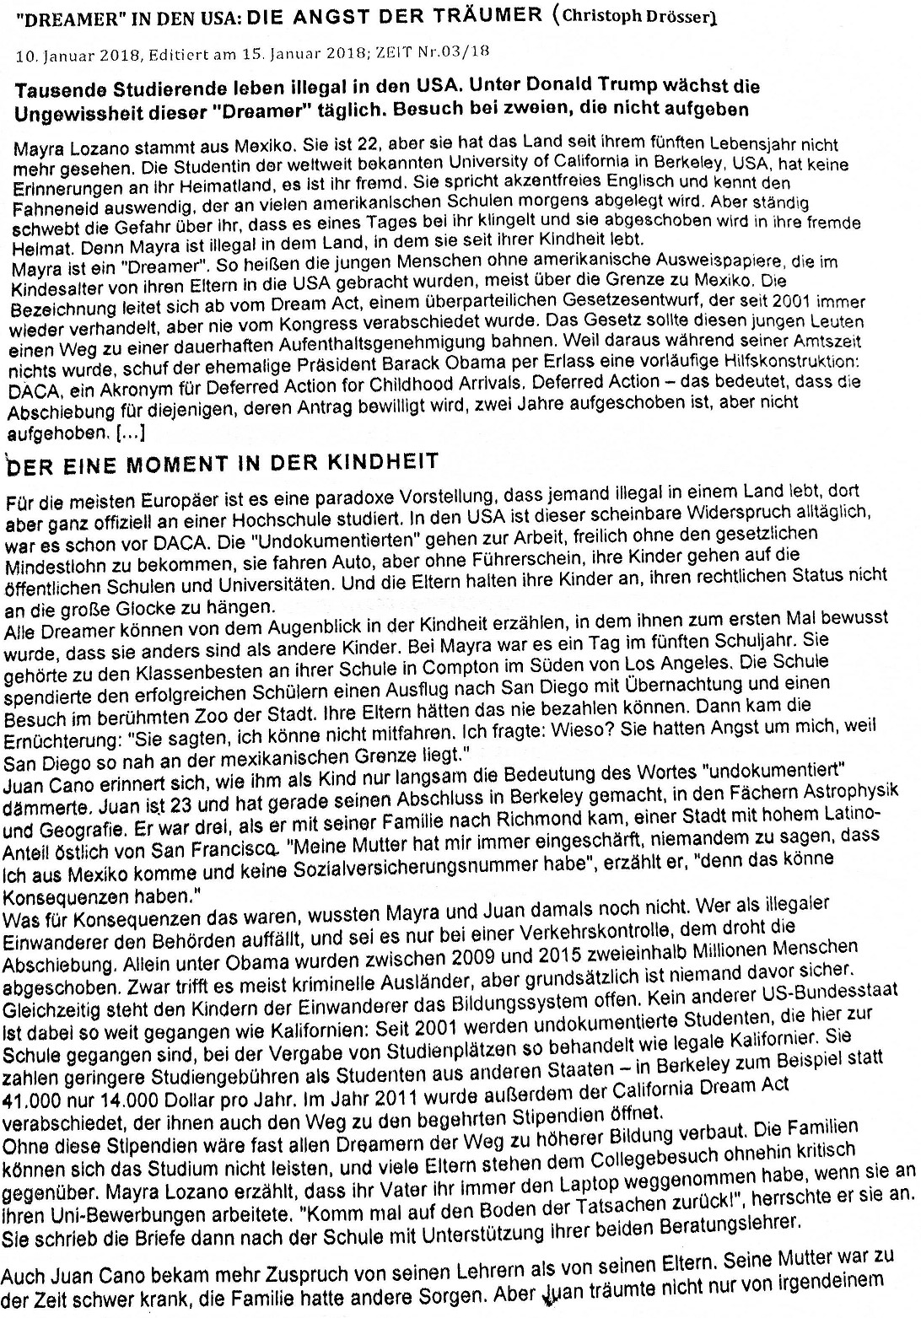

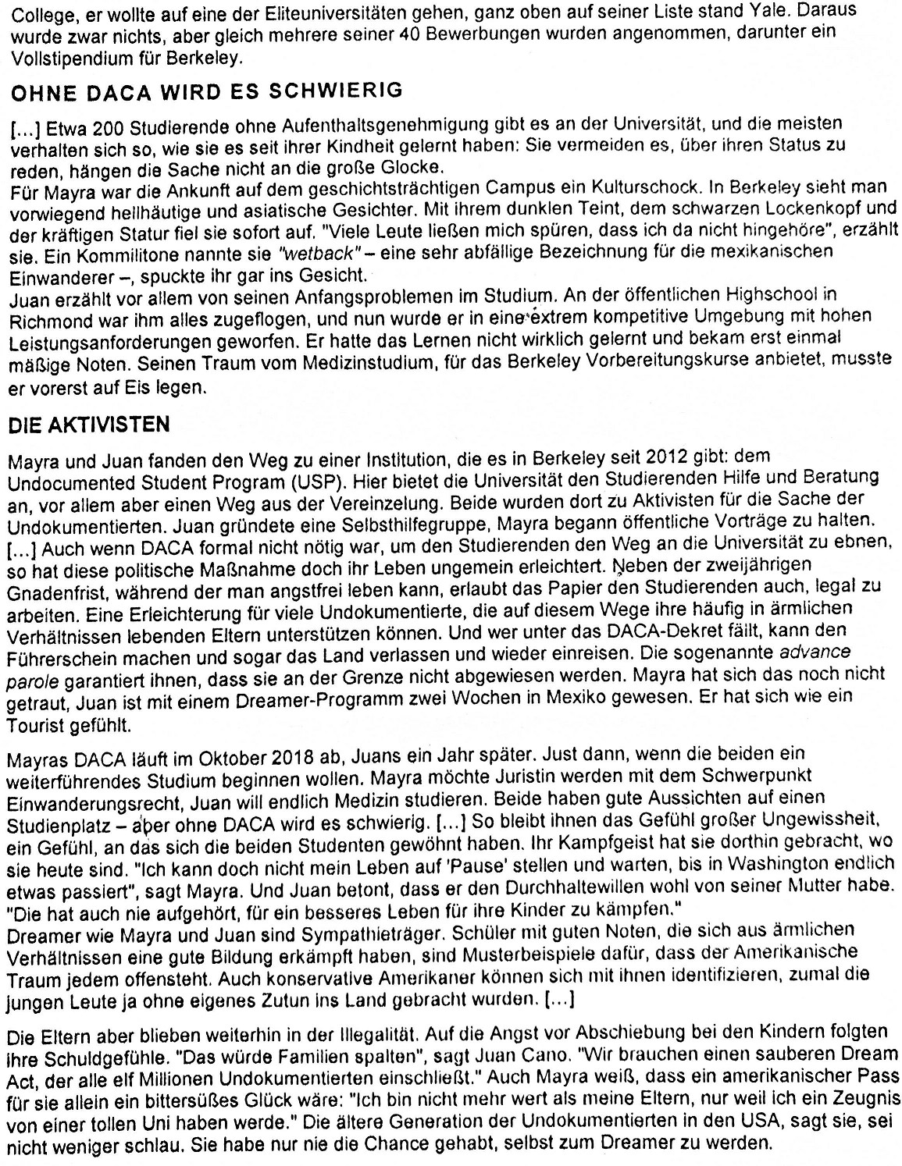

2. You have learned a bit about people called ‘Dreamers’ and the situation they find themselves in.

Choose one of the people, either Keyla (cf. material from March 1) or someone from today’s material (see above) and write a **diary entry** for one day when something positive but also negative happens in their life. (Write at least 300 words.)

> If you need help, study the material “*Selbständiges Lernen*”.

You are supposed to **do both assignments** written but you can decide which of these 2 texts, which will be graded, you upload to the cloud.

For the text to be handed in:

**Write this text on a computer. (double line spacing, font size 12)**

*For those who didn’t do it last time, write your name at the top or bottom of your text file.*

**Deadline: March 08, 11.30 a.m.**

Put the other text in your material. I might ask you to present it in our next videoconference on March 9.