How To Bind a Macro in IBM iAccess Client Solutions

1. Popup Keypad
   1. Binding the Macro to a Button
      1. On the menu bar click, Edit -> Preferences -> Popup Keypad -> Customize.
      2. Click on “Macro” in the white box on the left of the “Customize Popup Keypad” window.
      3. Select the file location of where you saved the macros under the “Macro Location” section.
      4. Select the macro that you want to bind from the “Macro List”.
      5. A screenshot of a computer

         Description automatically generatedClick which button you want to bind the macro.
   2. Configuration
      1. On the menu bar click, Edit -> Preferences -> Popup Keypad -> Customize.
      2. Sticky Popup Keypad = TRUE
      3. Focus Back to Terminal = TRUE
      4. Scroll bar = TRUE
   3. Displaying Keypad
      1. On the menu bar click, Actions -> Popup Keypad
   4. Running the macro
      1. On the popup keypad press the button you have selected for the macro
2. Keyboard
   1. Binding the macro to keys
      1. On the menu bar click, Edit -> Preferences -> Keyboard.
      2. In the “Keyboard” window, Under the “Key Assignment” tab, in the “Category” combo box select “Macros.”
      3. Select the macro you want to bind.
      4. Click the “Assign a Key” button.
      5. The box above it will say “Press a key” and you will press the key binding you want to access the macro.
         1. Ex. If you set the key binding to “Shift + 3”, then you would be able to press those keys and run the macro.
      6. 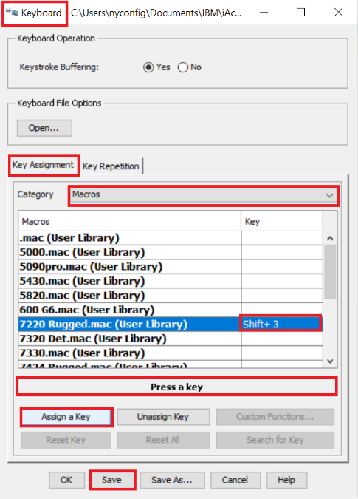Press the save button.
   2. Running the macro
      1. Pressing the key binding set to the macro that you want to be played.