CyberSecurity Homework 2

**Team Members:**

John Crosby, Brian Sumner, and Kevin Yang

**Project Description:**

The tool that we will create will be a password vault. The vault will use encrypted files to store strong passwords for the user to use on various websites. Upon correctly entering a username and password, the program will retrieve and decrypt passwords that the user has stored. The program will be as user friendly as possible, and be able to be expanded upon easily.

**Tool Uniqueness:**

1. While many password vaults are cross-platform, the major password vaults require separate installations for each OS. By using Java, we will make a password vault that is cross-platform.
2. The cross-platform vaults we found are very basic. For example, none of the cross-platform vaults we looked at allows two-factor authentication. We will allow users to select a file to act as a “key”. If they do, users will have to enter their username, password, and key file to open the vault. This two-factor authentication will make our program’s password vaults more secure.[1]

**Programming Language:**

The programming language that we will use is Java. We plan to use built in libraries for robust encryption and decryption. We also plan to use SWT for the graphical user interface. All of the team members have some experience programming in Java, although the encryption libraries will be new to each of us.

**Test Environment:**

We will be using the Netbeans debugger to test our tool along with a custom test suite that we will build using Java. This should be sufficient enough to ensure that all of the features of our program are working properly and consistently. As more functionality of the program is developed, we will add to the testing suite to ensure the final product is complete.

**Story Board:** For this project, John Crosby will be working on the Login Authentication using encryption and a keyfile for an optional 2 step authentication. Kevin Yang will be responsible for the encryption used in the password vault itself, which will store the passwords. He will also be working to make the program cross platform. Brian Sumner will be writing the GUI and working on additional features to make our program unique from other open source password vaults. We have a storyboard image on the next page as well.

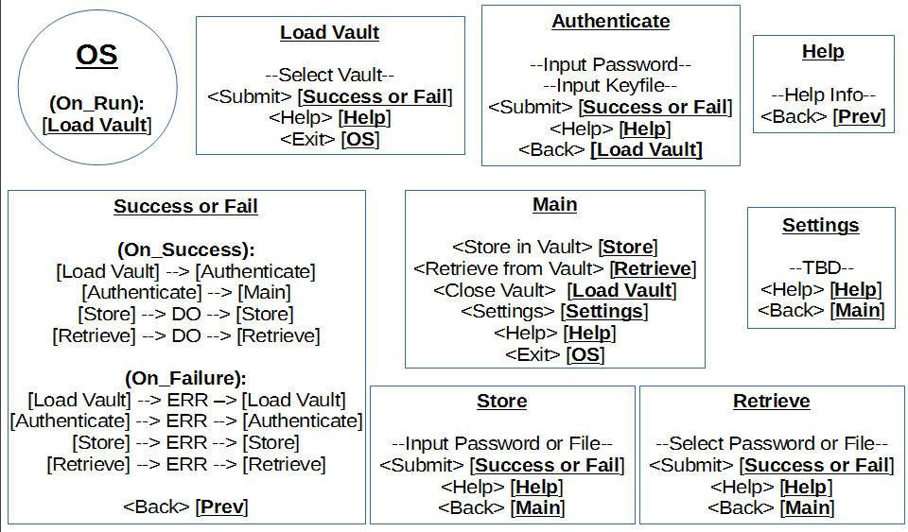

1. Key file idea is taken from KeePass, a password vault that requires different installations for each OS.

   Site: <http://keepass.info/features.html>