公安统计习题集

1. A random sample of 400 police officers was selected to estimate the proportion of using pepper spray (辣椒喷雾) correctly. What is the maximum margin of error if a 95 percent confidence interval is to be constructed? (B)

A. 0.0033 B. 0.05 C.0.113 D. 0.00949

2.A random sample of families was taken in order to estimate the relative between income and level of education (measured in number of years). A confidence interval needs to be constructed for the slope of the regression line. The social worker in charge of the project is debating whether to use 95 percent or a 99 percent confidence interval. Which of the following statements about the length of these interval is true? (B)
A. The 95 percent confidence interval will be wider than the 99 percent interval
B. The 95 percent confidence interval will be narrower (窄的) than the 99 percent interval
C. Both intervals will be the same length, because they are computed from the same people
D. The length of the confidence interval will depend on the sample standard deviation, not on the confidence level.

3. In general, how dose tripling (3倍) the sample size change the confidence interval size? (D)
A. Doubles the interval size
B. Triple the interval size
C. Multiplies the interval size by 1.732
D. Divides the interval size by 1.732

4. If the margin of error is no more than 0.05 in a 95% confidence interval. The population proportion (p) is 0.7. What is the minimum size random sample we need to construct this interval? (B) (Z0.95=1.96)
A. 389 B. 323 C. 274 D.322

6. A random sample of size 10 was taken from a population. The sample has a variance of zero. Which of the following statements must be true? (E)
I. The population also has a variance of zero.
II. The sample mean is equal to the sample median.
III. The ten data points in the sample are equal in numerical value.
A. I only B. II only C. III only D. I and II E. II and III

7. A random sample is taken from a population that is normally distributed with a mean of 100 and a standard deviation of 5. Which of the following is closest to the probability sample is greater than 110? (B)
A. 0.0015 B. 0.0250 C. 0.0500 D. 0.9985

10.For which of the following distributions is the mean greater then the median? (A)
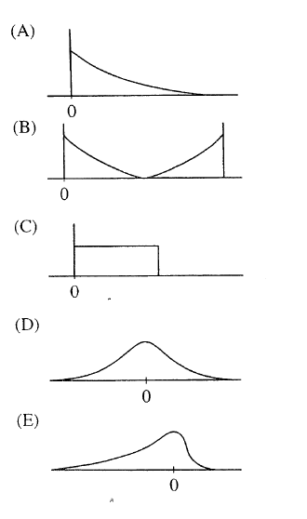

11. The equation of the least squares regression line for the points on the scatterplot below is yˆ = 1.8 +0.73x . Which point is the most goodness of fit for the function? (D)
A. (1,1) B. (4,2) C.(6,4) D.(7,7)
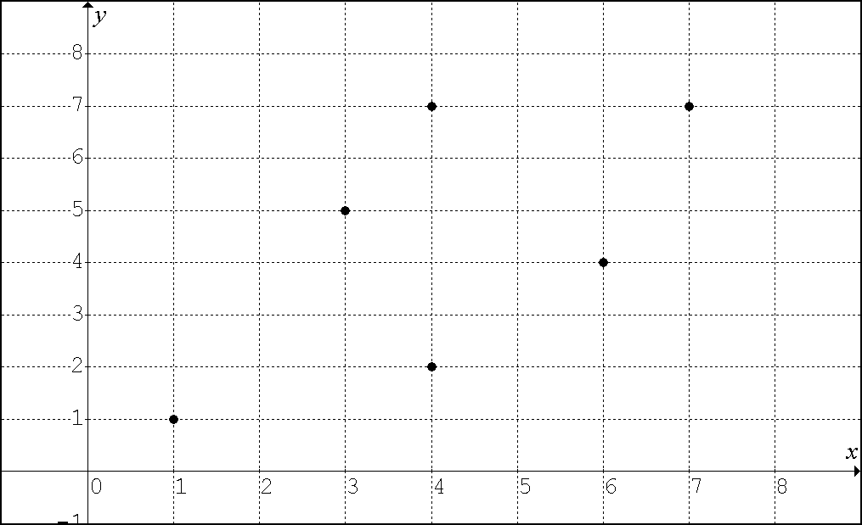

12. A 95 percent confidence interval of the form pˆ +/- E will be used to obtain an estimate for an unknown population proportion p. If pˆ is the sample proportion and E is the margin of error, which of the following is the smallest sample size that will guarantee a margin of error of at most 0.08? (C)
A. 25 B. 100 C. 175 D. 250 E. 625

13. At a college the scores on the statistics final exam are approximately normally distributed with a mean of 75 and a standard deviation of 12. The scores on the public security management final are also approximately normally distributed, with a mean of 80 and a standard deviation of 8. A student scored 81 on the statistics final and 84 on the public security management final. Relative to the students in each respective class, in which subject did this student do better? (C)
A. The student did better in statistics.
B. The student did better in public security management.
C. The student did equally well in each course.
D. There is not enough information for comparison, because the number of students in each class is not known.

14. The student at NFPC wants to conduct a survey of student opinion. It wants to begin with a simple random sample of 60 students. Which of the following survey methods will produce a simple random sample? (D)
A. Survey the fist 60 students to arrive at dining hall (食堂) in the morning.
B. Survey every 10th student entering the school library until 60 students are surveyed.
C. Use random numbers to choose 15 each of first-year, second-year, third-year, and fourth-year students.
D. Number the students in the official school roster (花名册). Use a table of random numbers to choose 60 students from this roster for the survey.

15. A survey was conducted to determine what percentage of college seniors would have chosen to take the CET 6 if they can. In a random sample of 96 seniors, 40 percent indicated that they would take the test. A 90 percent confidence interval for the percentage of all seniors who would take CET 6 is (B)
A. 35% to 45% B. 31.75% to 48.25% C.26.25% to 41.75%
D.30.6% to 37.4% E.31.2% to 36.8%

16. Which of the following is a key distinction (区别) between well designed experiments and observational studies? (C)
A. More subjects are available (可利用的) for experiments than for observational studies.
B. Experiments are less costly to conduct than observational studies.
C. An experiment can show a direct cause-and-effect relationship, whereas an observational study cannot.
D. Tests of significance (显著性检验) cannot be used on data collected from an observational study.

17. Suppose that the distribution of a set of scores has a mean of 47 and a standard deviation of 14. If 4 is added to each score, what will be the mean and the standard deviation of the distribution of new scores? (A)
Mean Standard Deviation
A. 51 14
B. 51 18
C. 47 14
D. 47 16
E. 47 18

18. A random sample has been taken from a population. A statistician, using this sample, needs to decide whether to construct a 90 percent confidence interval for the population mean or a 95 percent confidence interval for the population mean. How will these intervals differ? (A)
A. The 90 percent confidence interval will not be as wide as the 95 percent confidence interval.
B. The 90 percent confidence interval will be wider than the 95% confidence interval.
C. Which interval is wider will depend on how large the sample is.
D. Which interval is wider will depend on whether the sample is unbiased.

19. A statistics class wants to conduct a survey to determine what percentage of students in the college would be willing to pay a fee for participating in after-school activities. Twenty students are randomly selected from each of the 1st year, 2nd year, 3rd year and 4th year classes to complete the survey. This plan is an example of which type of sampling? (D)
A. Cluster B. Convenience C. Simple random
D. Stratified random E. Systematic

20. Which of the following statements is true for two events, each with probability greater than 0? (E)
A. If the events are mutually exclusive, they must be independent.
B. If the events are independent, they must be mutually exclusive.
C. If the events are not mutually exclusive, they must be independent.
D. If the events are not independent, they must be mutually exclusive.
E. If the events are mutually exclusive, they cannot be independent.

21. A simple random sample produces a sample mean, x bar of 15. A 95 percent confidence interval for the corresponding population mean is 15+/- 3 . Which of the following statements must be true? (D)
A. 95 percent of the population measurements fall between 12 and 18.
B. 95 percent of the sample measurements fall between 12 and 18.
C. If 100 samples were taken, 95 of the sample means would fall between 12 and 18.
D. P(12<=x bar<=18)=0.95

22. The correlation between two scores X and Y equals 0.8. If both X scores and the Y scores are converted to z-scores, then the correlation between the z-scores for X and the z-scores for Y would be (D)
A. -0.8 B-0.2 C. 0.2 D.0.8

23. Which of the following statements is (are) true about the t-distribution with k degrees of freedom? （E）
(1) The t-distribution is symmetric.
(2) The t-distribution with k degrees of freedom has a smaller variance than the t- distribution with k+1 degrees of freedom.
(3) The t-distribution has a larger variance than the standard normal distribution.
A. (1) only B. (2) only C. (3) only D. (1) and (2) (E) (1) and (3)

24. The following is the sample space for an experiment with some of probabilities given. If the event J={a,b,c} and P(J’)=0.45. Find the probabilities of c and d. (A)
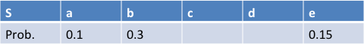
A. P(c)=0.15 P(d)=0.3 B. P(c)=0.3 P(d)=0.15
C. P(c)=0.2 P(d)=0.3 D. P(c)=0.15 P(d)=0.25

25. E and F are events of an experiment with sample space S. Suppose P(E’)=0.6, P(F) = 0.4, and P(E∪F’)=0.7. Compute P(E∪F)= (D)
A. 0.1 B.0.3 C. 0.5 D.0.7 E.0.8

26. Given two events in a sample space, A and B, if P(A)=0.4,P(B)=0.5, and P(A ∪B)=0.7, then the two events are (A)
A. independent but not mutually exclusive
B. mutually exclusive but not independent
C. mutually exclusive and independent
D. neither mutually exclusive nor independent

27. The probability that there will be accident on highway each day depends on the weather. If the weather is wet that day, there is a 3.0% chance of an accident. If the weather is dry that day, there is a 0.6% chance of an accident. Today, the weather station announced that there is a 40% chance of the weather being wet. What is the probability that there will be an accident on highway today? (B)
A. 0.0132 B. 0.0156 C. 0.0030 D.0.0095

28. The statistics bellow provide a summary of the distribution of heights, in cm, for the sample of 200 young children.
Mean: 110.84cm
Median: 114.3cm
Standard deviation: 7.62cm
First quartile (Q1) : 109.22cm
Third quartile(Q3): 121.92cm
About 100 children in the sample have heights that are (C)
A. less than 109.22cm B. less than 121.92
C. between 109.22 and 121.92 cm D. between 103.22 and 118.46 cm

29. In which of the following situations would it be most difficult to use a census? (A)
A. To determine what proportion of fish in Xianlin Lake are bass (鲈鱼)
B. To determine what proportion of students in our college are female
C. To determine what proportion of single-family living in a small town have tow cars.
D. To determinie what proportion of licensed bicycles on a university campus have safety lock.

30. Independent random samples of 100 cars in a certain city are examined to see if they have fire extinguishers（灭火器）. Of the 100 cars, 30 have fire extinguishers. Which of the following is a 90 percent confidence interval from the populations of cars repersented by these sample. (B)
A. $0.3±1.98\sqrt{\frac{(0.3)(0.7)}{100}}$ B. $0.3±1.65\sqrt{\frac{(0.3)(0.7)}{100}}$
C. $0.7±1.65\sqrt{\frac{(0.3)(0.7)}{100}}$ D. $0.3±0.83\sqrt{\frac{(0.3)(0.7)}{100}}$

31. A fair coin is to be flipped 5 times. The first 4 flips land “heads” up. What is the probability of “heads” on the next (5th ) flip of this coin? (B)
A. 1 B. 0.5 C. $\left({5 \atop 1}\right){\left(\frac{1}{2}\right)}^{4}(\frac{1}{2})$ D. ${\left(\frac{1}{2}\right)}^{4}(\frac{1}{2})$

32. Let X represent a random variable whose distribution is normal, with a mean of 100 and a standard deviation of 10. Which of the following is equivalent (相等的) to P(X>115) ? (B)
A. P(X<115) B. P(X<85) C. P(85<X<115) D. 1-P(X<85)

33. Tom generates a sample of 20 random integers(整数) between 0 to 9 inclusive. He records the number of 5’s (数字5的个数) in the sample. He repeats this process 99 more times, recording the number of 5’s in each sample. What kind of distribution has he simulated? (C)
A. The sampling distribution of the sample proportion with n=20 and p=0.6
B. The sampling distribution of the sample proportion with n=100 and p=0.1
C. The binomial distribution with n=20 and p=0.1
D. The binomial distribution with n=100 and p=0.1

34. 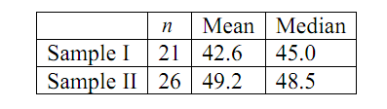
The table above shows the sample size, the mean and the median for two samples of measurements. What is the median for the combined sample (将两个样本合二为一) of 47 measurements? (D)
A. $\frac{42.6+49.2}{2}$ B.$\frac{21×42.6+49.2×26}{47}$ C.$\frac{21×45+48.5×26}{47}$
D. It can not be determined from the given information

35. The histograms below represent the distribution of five different data sets, each containing 28 integers(整数)，from 1 through 7, inclusive. The horizontal and vertical scales are the same for all graphs. Which graph represents the data set with the largest standard deviation? (D)
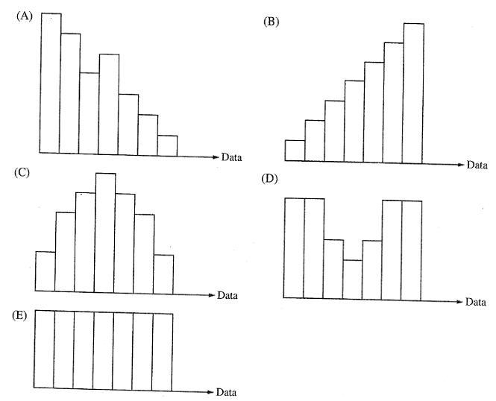
36. Which of the following is NOT a characteristic (特征) of stratified random sampling? (D)
A. Random sampling is part of the sampling procedure.
B. The population is divided into groups of units that are similar on some characteristic
C. Each individual (个体) unit in the population belongs to one and only one of the strata.
D. Every possible subset (子集) of the population, of the desired (需要的) sample size, has an equal chance of being selected.

37. 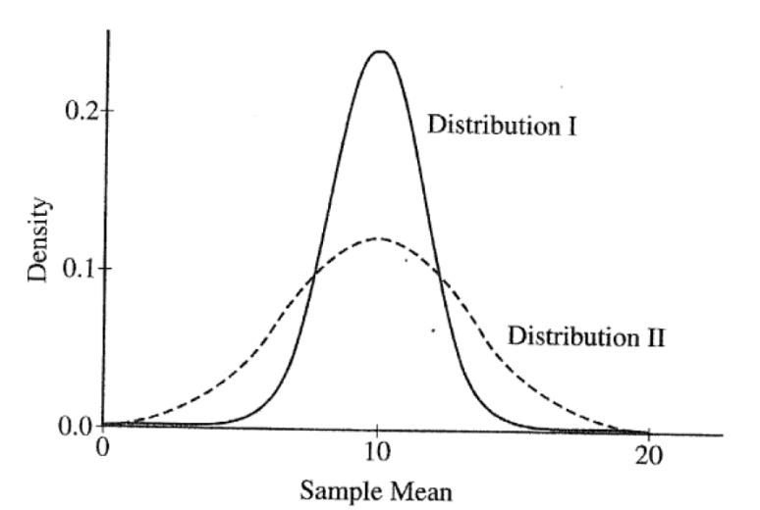
The graphs of sampling distributions, I and II, of the sample mean of the same random variable for two different sizes are shown above. Which of following statements must be true about the sample sizes? (B)
A. The sample size of I is less than the sample size of II.
B. The sample size of I is greater than the sample size of II.
C. The sample size of I is equal to the sample size of II.
D. The sample size does not affect the sampling distribution.

38. Four estimators for a parameter are being evaluated. The true value of the parameter is 0. Simulations (模拟) of 100 random samples, each of size n, are drawn from the population. For each simulated sampling distributions for the five estimators. Which simulated sampling distribution is associated with the best estimator for this parameter? (B)
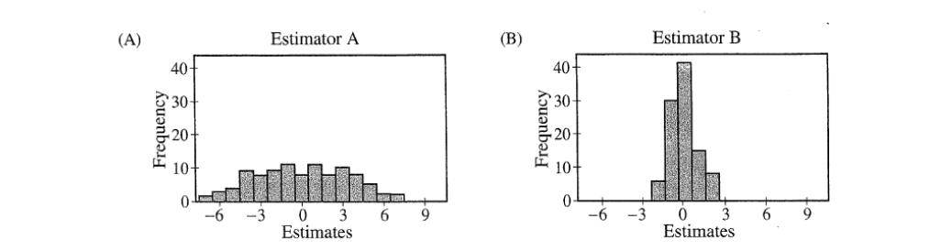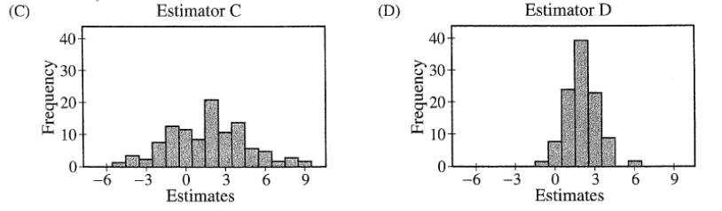

39. A survey in Nanjing Public Security Bureau is interested in estimating (估算) the proportion of its police officers are in favor of offering incentives to using a high-tech equipment to patrol (对在巡逻中使用高科技装备的奖励措施感兴趣的比例). A random sample of police officers was selected. The sample size is 100. All of them were asked the same question about it. 50% of the police officers in the sample said “yes”. A 95% confidence interval for the proportion of police officers in favor of offering incentives can be calculated . Which of the following statements is correct? (B)
A. At the 95% confidence level, the estimate of 0.5 is within 0.05 of the true proportion of police officers in favor of the offering incentives to using a high-tech equipment to patrol.
B. In repeated sampling, 95% of sample proportions will fall in interval (0.4, 0.6)
C. In repeated sampling, the true population of police officers in favor of the offering incentives to using a high-tech equipment to patrol will fall in interval (0.35 0.55)
D. In repeated sampling, 95% of the true proportion of police officers in favor of the offering incentives to using a high-tech equipment to patrol will be equal to 0.5.

40. An experiment has three mutually exclusive outcomes, A, B, and C. If P(A)=0.12, P(B)=0.61, and P(C)= 0.27, which of the following must be true? （D）
(1) A and C are independent
(2) P(A and B) = 0
(3) P(B or C) = P(B) + P(C)
A. (1) only B. (1) and (2) C. (1) and (3) D.(2) and (3)

A random sample of 16 policing mobile terminal was selected to estimate the mean battery life of all this type mobile. The sample mean was 1000 hours, with a standard deviation of 100 hours. Assuming that the battery life are approximately normally distribution.
41. What type of distribution of the sample mean is most probably being? (B)
A. Normal distribution B. t-distribution
C. F distribution D. binomial distribution
42. Which is the degree of freedom of this distribution? (C)
A. 13 B. 14 C. 15 D.16
43. What is 90 percent confidence interval to estimate the mean of battery life? (Z_{c}=1.75) (C)
A. (912.5, 1087.5) B. (997.2, 1002.8)
C. (956.25, 1043.75) D.(900, 1100)

44. Which of the following statements correctly describe the relation between a t-distribution(short for T) and a standard normal distribution(short for N)? （D）
A. N is centered at 0, whereas T is centered at n-1
B. N has a larger standard deviation than T
C. N is just another name of T
D. T has a larger standard deviation than N

45. Which of following statements is(are) true about the t-distribution with k degrees of freedom?(D)
(1) the t-distribution is symmetric (对称).
(2)the t-distribution with k degrees of freedom has a smaller standard deviation than the t-distribution with k+1 degrees of freedom.
(3)the t-distribution has a larger variance than the standard normal distribution
A. (1) only B. (2) only C. (3) only D. (1) and (3)

46. In a sampling distribution of sample mean, when n<30, which graph is used to testing the distribution? (D)
A. Bar chart B. Histogram C. Line chart D. Boxplot chart

47. The die used in a new game has 12 faces. Each face has a different letter of the alphabet on it. The die is rolled twice, what is the probability the same letter appears on the upper face twice? (A)
A. $\frac{1}{12}$ B.$\frac{1}{144}$ C.$\frac{1}{2}$ D.$\frac{1}{6}$

48. Suppose the smokers are 20 times as likely as non-smokers to development lung cancer. If 30% of the population in a certain city are smokers and 0.0001 of the population develop lung cancer, find the probability that a smoker develops lung cancer. (C)
A. $\frac{0.0001}{0.3+0.7×0.1}$ B. $\frac{0.0001}{0.3×0.7×0.05}$ C. $\frac{0.0001}{0.3+0.7×0.05}$ D. $\frac{0.0001}{0.3+0.7÷0.05}$

49. Two fair coins are tossed and at least one is tail. What is the probability that both coins are tails? (B)
A. $\frac{1}{2}$ B.$\frac{1}{3}$ C.$\frac{1}{4}$ D.$\frac{1}{6}$

51. In the United States, 56% of all children get an allowance and 41% of all children get an allowance and do household chores. What is the probability that a child does household chores given that the child gets an allowance?
A. $\frac{0.56-0.41}{0.56}$ B. $\frac{0.41}{0.41+0.56}$ C. $\frac{0.41}{0.56}$ D. $\frac{0.41×0.56}{0.41+0.56}$
52. A and B shoot a solid (牢固的) target at same time, the probability of A hit the target (命中) is 0.7, and the probability of B hit the target is 0.6. Find the probability of A or B hit the target.(C)
A. 0.9 B.1 C.0.88 D. 0.42

54. A random sample of size n is taken from a population which is normally distributed with mean μ and standard deviation σ, and $\overline{x}\sim N(μ ,\frac{σ}{\sqrt{n}})$ is used for the sample mean distribution. For which of the following sample size is the valid?(C)
A. n=5 B. n=15 C. n=50 D. Any of the above

55.Given that 51.3% of the newly born children are boys, then what is the probability that in a sample of 5 newly born children, exactly 3 are boy? (B)
A. $\left({5 \atop 3}\right){(0.513)}^{5-3}{(1-0.513)}^{3}$ B. $\left({5 \atop 3}\right){(0.513)}^{3}{(1-0.513)}^{5-3}$
C.$\left({5 \atop 2}\right){(0.513)}^{5-3}{(1-0.513)}^{3}$ D. $\left({5 \atop 2}\right){(0.513)}^{3}{(1-0.513)}^{5-3}$

56. Studies of the Greek Ministry of Traffic reveal that 88% of adult drivers do not use seat belts. If 10 adult drivers are stopped at random, what is the probability that at least 2 drivers will not be wearing seat belts? （D）
A. $\left({10 \atop 2}\right){(0.88)}^{2}{(1-0.88)}^{10-2}$ B. 1-$\left({10 \atop 2}\right){(0.88)}^{2}{(1-0.88)}^{10-2}$
C. 1-$\left({10 \atop 2}\right){(0.88)}^{2}{(1-0.88)}^{10-2}$-$\left({10 \atop 1}\right){(0.88)}^{1}{(1-0.88)}^{10-1}$
D. 1-$\left({10 \atop 1}\right){(0.88)}^{1}{(1-0.88)}^{10-1}$-$\left({10 \atop 0}\right){(0.88)}^{0}{(1-0.88)}^{10}$

57. A research team at Cornell university conducted a study showing that approximately 10% of all businessmen who wear ties wear them so tight that they actually reduce blood flow to the brain. At a board of 20 businessmen, all of whom were wearing ties, what is the probability that at most 7 tie are too tight? (If we use Excel function to compute) （D）
A. BINOMDIST (7, 20, 10%, 0)
B. BINOMDIST (20, 7, 10%, 0)
C. BINOMDIST (7; 20;10%; 0)
D. BINOMDIST (7; 20;10%; 1)

58. In Jiangsu province, local police have helped schools set up “campus security team” composed of 70 security guards with batons (警棍)and pepper spray(辣椒喷雾) . The JSTV conducted a survey of residents to assess their support for such an project. What is the population of interest here? (C)
A. All security guards in schools
B. All residents with school-aged children
C. All residents in Jiangsu province
D. All province school system teachers and students

59. For which of the following would it be most unreasonable to use a census? （B）
A. To determine the proportion with national minority in our college.
B. To determine the weight of all the insects(昆虫) in our campus.
C. To determine the mean wage earned by police officers in Nanjing.
D. To determine the mean selling price of houses in Xianlin universities town.

60. Which of the following are important in the design of experiments? （D）
(1). Control of confounding variable
(2). Randomization in assigning subjects to different treatments
(3). Replication of the experiment using sufficient（充足的） numbers of subjects
A. (1) and (2) B. (1 )and (3) C. (2) and (3) D. All of them

61.You take a sample (N = 625) of test scores from a population. The sample mean （样本均值） is 65, and the sample standard deviation （总体标准差） is 7.5. What is the 95% confidence interval (置信区间) on the mean? （z(0.95)=2）（8分）

- Known as N=625, x-bar=65 s=7.5 z(0.95)=2
- ME= $Z_{c}\frac{s}{\sqrt{N}}$=2*7.5/25=0.6
- Confidence interval is (x-bar – ME, x-bar + ME) = (64.4, 65.6)

62. Assuming the possibility of MTBF (Mean-Time-Between-Failure) within 5 years （5年内平均无故障率）of JS 9mm revolver （警用9mm转轮手枪）is 0.6, the possibility of MTBF within 10 years is 0.3; what is the possibility of MTBF in the next 5 years if some revolvers already have been used in 5 years trouble-free （已经无故障使用5年的枪支再无故障使用5年无故障的概率）（请同时画出样本空间图, 7分）?

（1）Known as P(MTBF5) =0.6 P(MTBF10)= 0.3 For P(MTBF10︱MTBF5)
(2) P(MTBF10︱MTBF5)= P(MTBF10∩MTBF5)/ Known as P(MTBF5)= P(MTBF10)= 0.3/ P(MTBF5)= 0.3/0.6=0.5
(3)样本空间图略

63. A random sample of 100 public security management major students （公安管理专业学生） in our college scored 70 on the applied writing test （应用写作测试）with a standard deviation of 5. Is this significantly different （显著性差异）from all the students in our college with mean score is 65 with the significantly level （显著性水平）is 0.05? （请完成5个步骤，Z(alpha=0.05)=1.96）
Step 1:
Random sample
L.O.M. is I-R
The sample is large
Step 2:
H₀: μ = 65
H₁: μ≠ 65
Step 3:
The sample is large, use Z distribution
Alpha (α) = .05
Critical Z = ±1.96
Step 4:
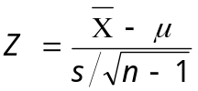
Z=70-65/(5/10)=10
Step 5
Z (obtained) > Z (critical)
So reject Ho. There is significant difference between public security management major students and all the students in our college.

