Adrian Ruiz

Assignment 1

CPE 301

Copy of code:

ldi r16, high(RAMEND)

out SPH,r16

ldi r16, low(RAMEND)

out SPL,r16

start:

;set stack pointer z to the staring addreass

ldi ZL, low(0x0222)

ldi ZH, high(0x0222)

ldi YL, low(0x0400)

ldi YH, high(0x0400)

ldi XL, low(0x0600)

ldi XH, high(0x0600)

clr r16

clr r20

clr r21

clr r22

ldi r20, low(301)

ldi r21, high(301)

;loop that places numbers in the array

loop1:

add r22, ZL ;add high and low

add r22, ZH

st Z, r22 ;store number

mov r23, r22

jmp div

reset:

adiw ZL, 1

clr r22

dec r20 ;inc counter ;check to see if the counter is equal to 300

brne loop1 ;if it isn't the countine placing numbers

cpi r21,0 ;this function checks to see if the counter needs to be reset

brne checknum

jmp done ;else its done;

done:

jmp done

checknum:

ldi r20,0xFF ;reset counter

ldi r21, 0

jmp loop1

div:

clr r24

ldi r24, 5 ;store r24

mov r25, r24 ;r25 = r24

divloop:

cp r22, r24 ;check to if r22%5

breq pos5 ; if remainder = 0 then divisable

brlo neg5 ;r22 < 5, then not div.

add r24, r25 ;r24 + 5

brcs neg5 ;if add op creates carry then not div.

jmp divloop ;loop again

pos5:

add r16, r22 ;add the div by 5 numbers and store in mem

adc r17, r0

st Y+, r22

jmp divdone

neg5:

add r18, r22 ;add the not div by 5 numbers and store in mem

adc r19, r0

st X+, r22

jmp divdone

divdone:

jmp reset

Task 1: Before

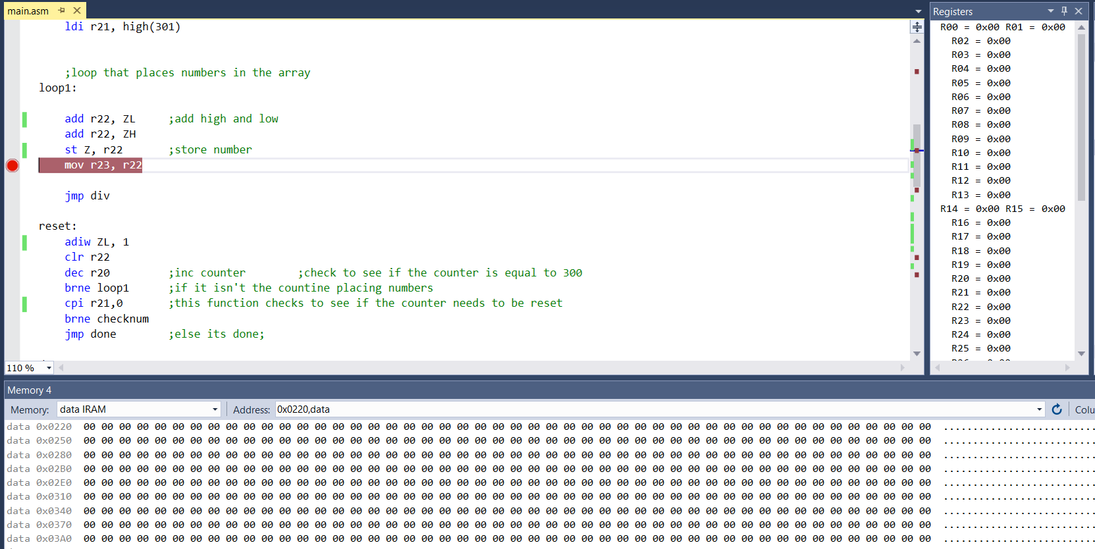

Task 2, 3 Before:

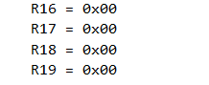

Task 1 After:

0x222 Mem

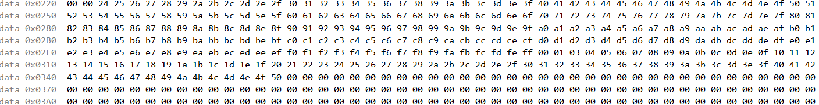

0x400 Mem



0x600 Mem



Task 2, 3 After:

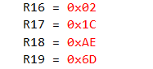

R19:R18 = 0x6DAE = 28078

R17:R16 = 1C02 = 7170

Task 4:



Task 5 Before:



Task 5 After:



Cycle Time Calculations: (64226 cycles)/(16 MHZ) = 4014.1us

