Adrian Ruiz

CPE 301

Design Assignment 3

Flow Chart of Code

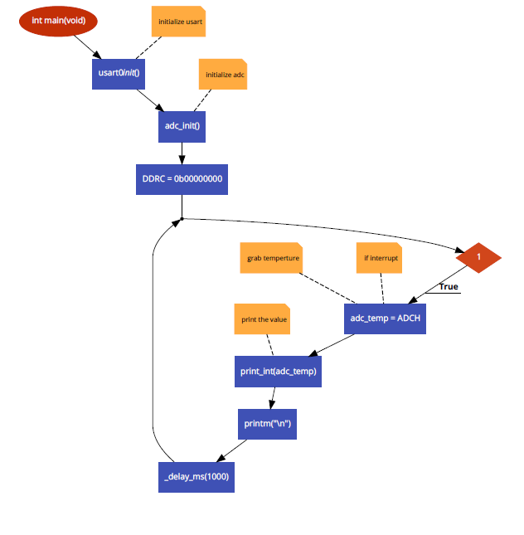

Pictures of Board Circuit. My programmer has a built in usart which is why it is not on the board.

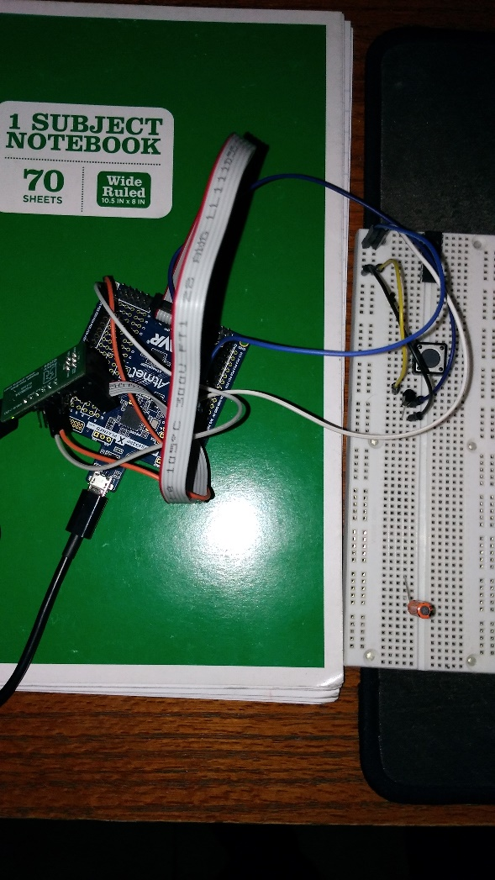

Screenshot of Terminal Displaying Temperature in Fahrenheit

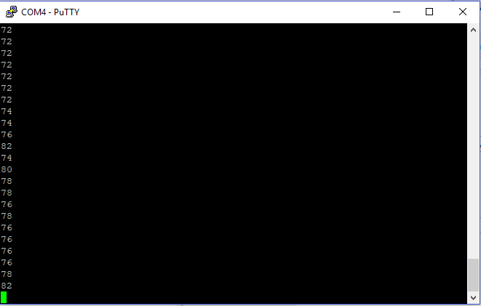

Example of Studio Data Visual in Celcuis. Whenever I tried to display in Farienheit, the Serial Chart program would always crash. 