Adrian Ruiz

CPE 301

Midterm Report

Flowcharts

ISR

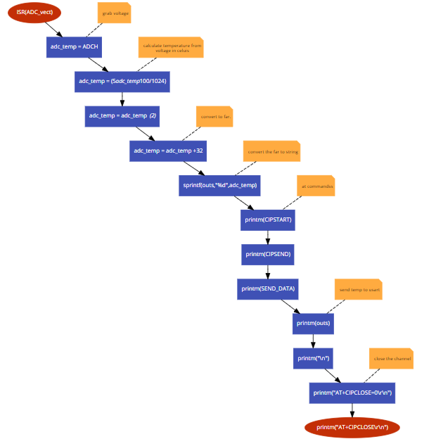

Main

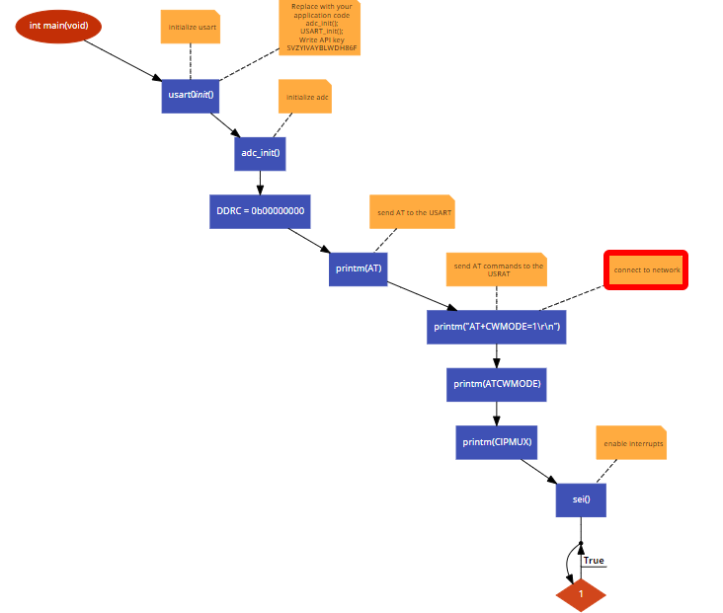

Tasks

1 and 2.I programmed the Xplained mini to read in a temperature and display it to the UART. The reason why is displayed under the temperature is because I flashed my WI-FI to take in AT commands

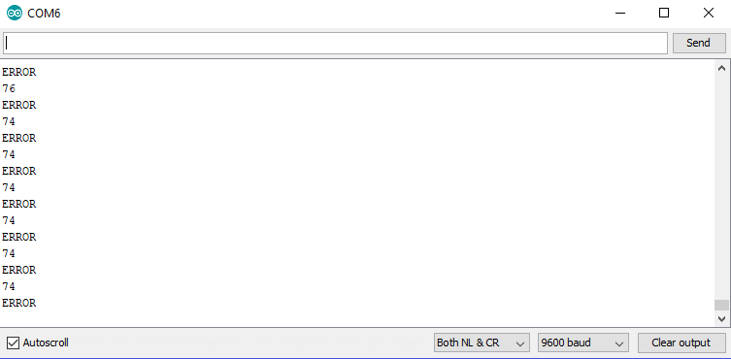

3.WIFI Module taking AT Commands

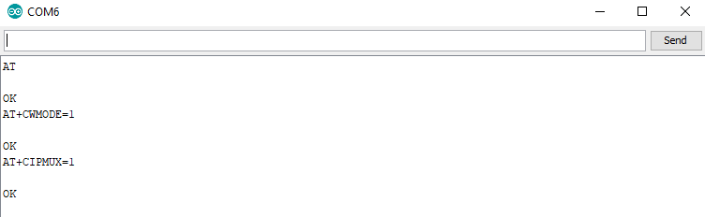

4.The Thingspeak channel before data is sent

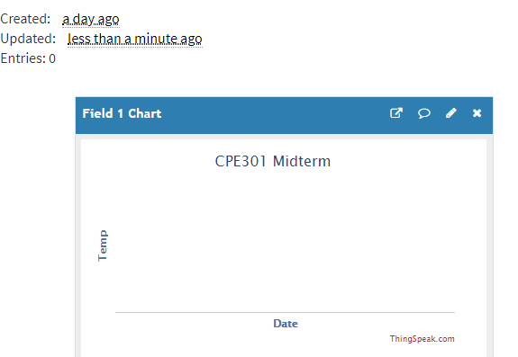

WI-FI module Reset

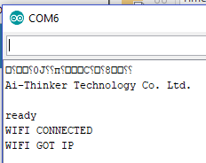

5.At Commands sent through the UART

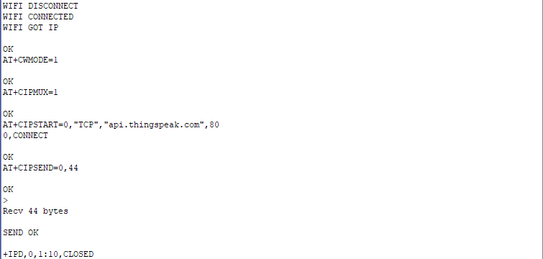

6.Thingspeak after several minutes of running

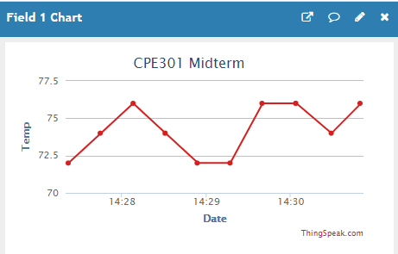

Circuit Picture

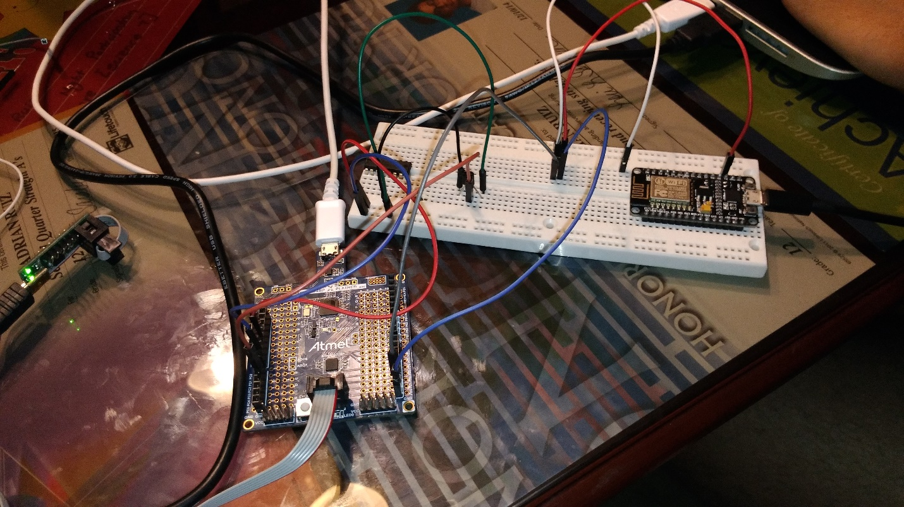

Video link: <https://youtu.be/8PwgL9t5hFQ>