Adrian Ruiz

CPE301

Midterm 2

Partner: Elizabeth Heider

Transmitting Control

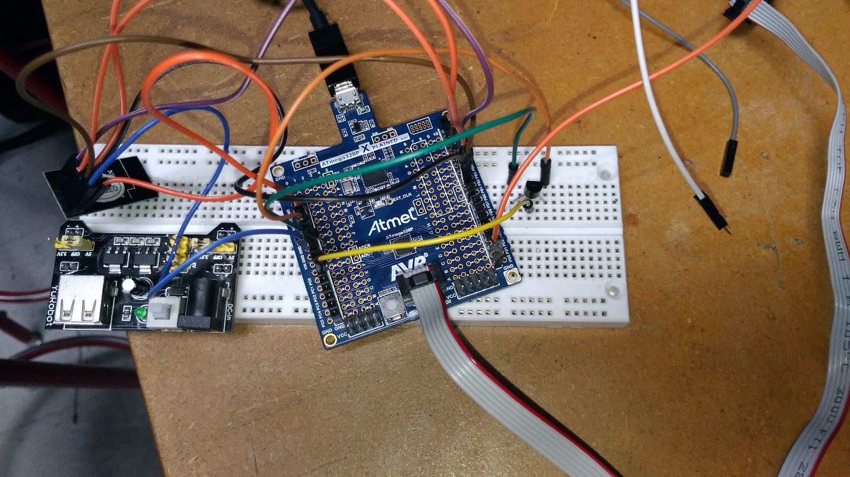

#include <avr/io.h>

#include <avr/interrupt.h>

#include <stdbool.h>

#include <string.h>

#include "nrf24l01.h"

#include "ioe.h"

void setup_timer(void);

nRF24L01 *setup_rf(void);

void adc_init(void);

volatile bool rf_interrupt = false;

volatile bool send_message = false;

volatile int temp;

char outs[3];

int main(void) {

usart0_init_();//init the uart

uint8_t to_address[5] = { 0x11, 0x11, 0x11, 0x11, 0x11 };

DDRC = 0x00; //set Port C read the temp

sei();

nRF24L01 *rf = setup_rf();

setup_timer();

while (true) {

while(ADCSRA & (1<<ADSC)) {}

temp = ADC;

adc_temp = (5*adc_temp*100/1024); //calculate temperature from voltage in celuis

adc_temp = adc_temp * (2);

adc_temp = adc_temp +32; //temp in far

if (rf_interrupt) {

rf_interrupt = false;

int success = nRF24L01_transmit_success(rf);

if (success != 0)

nRF24L01_flush_transmit_message(rf);

}

if (send_message) {

send_message = false;

nRF24L01Message msg;

sprintf(outs, "%d" , temp);

memcpy(msg.data, outs, 3);

msg.length = strlen((char *)msg.data) + 1;

nRF24L01_transmit(rf, to_address, &msg);

}

}

return 0;

}

nRF24L01 *setup_rf(void) {

nRF24L01 *rf = nRF24L01_init();

rf->ss.port = &PORTB;

rf->ss.pin = PB2;

rf->ce.port = &PORTB;

rf->ce.pin = PB1;

rf->sck.port = &PORTB;

rf->sck.pin = PB5;

rf->mosi.port = &PORTB;

rf->mosi.pin = PB3;

rf->miso.port = &PORTB;

rf->miso.pin = PB4;

// interrupt on falling edge of INT0 (PD2)

EICRA |= _BV(ISC01);

EIMSK |= _BV(INT0);

nRF24L01_begin(rf);

return rf;

}

// setup timer to trigger interrupt every second when at 1MHz

void setup_timer(void) {

TCCR1B |= _BV(WGM12);

TIMSK1 |= _BV(OCIE1A);

OCR1A = 15624;

TCCR1B |= _BV(CS10) | _BV(CS11);

}

// each one second interrupt

ISR(TIMER1_COMPA_vect) {

send_message = true;

}

// nRF24L01 interrupt

ISR(INT0_vect) {

rf_interrupt = true;

}

//init the adc

void adc_init()

{

ADMUX =0;

ADCSRA= (1<<ADPS0) | (1<<ADPS1) | (1<<ADPS2); //sample rate of 125kHz at 16MHz

ADMUX |= (1<<REFS0); //Set ADC reference to AVCC

ADMUX |= (1<<ADLAR); //Left adjust ADC Result to allow 8 bit reading

ADCSRA |= (1<<ADEN); //Enable ADC

ADCSRA |= (1<<ADATE); //set ADC auto trigger enable

ADCSRB = 0; //0 for free running mode

ADCSRA |= (1<<ADSC) ; //start A2D Conversion

}

Receiving Control and Code

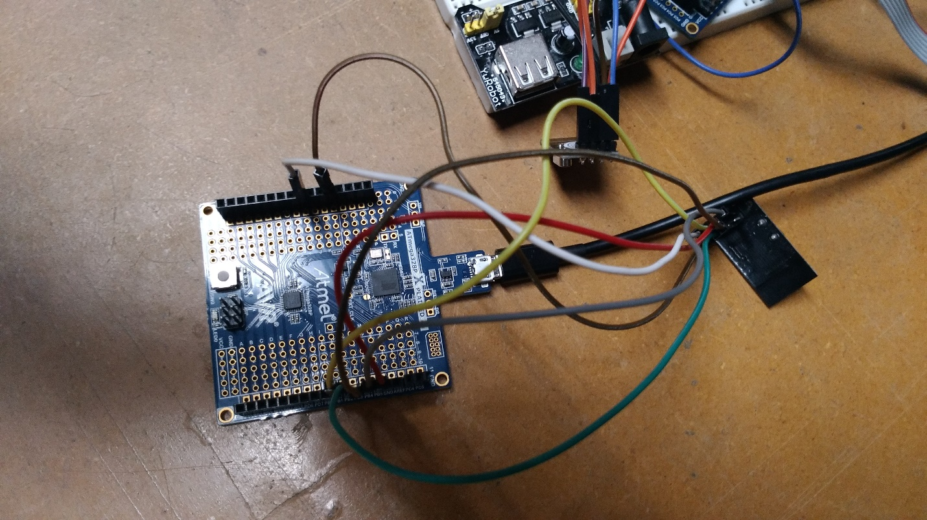

#include <avr/io.h>

#include <avr/interrupt.h>

#include <stdbool.h>

#include <string.h>

#ifndef F_CPU

#define F_CPU 16000000UL

#endif

#include <util/delay.h>

#include "nrf24l01.h"

#include "ioe.h"

#include "nrf24l01-mnemonics.h"

#define UBRR_2400 207

//function protypes

nRF24L01 *setup_rf(void);

void process_message(char *message);

inline void prepare_led_pin(void);

inline void set_led_high(void);

inline void set_led_low(void);

void USART_INIT(unsigned int ubrr);

void USART_tx_string(char* data);

volatile bool rf_interrupt = false;

char* outs[20]; //string buffer

int main(void) {

usart0_init_(); //init the uart

_delay_ms(2000);

uint8_t address[5] = { 0x11, 0x11, 0x11, 0x11, 0x11 }; //the address that the modules try to match

printm("Address INIT\r\n");

prepare_led_pin(); //not used

printm("LED PREP\r\n");

sei();

nRF24L01 *rf = setup_rf();

nRF24L01_listen(rf, 0, address); //listen for the address

uint8_t addr[5];

nRF24L01_read_register(rf, CONFIG, addr, 1);

while (true) {

if (rf_interrupt) { //when an intrupt happens

rf_interrupt = false; //print the temp

while (nRF24L01_data_received(rf)) {

nRF24L01Message msg;

nRF24L01_read_received_data(rf, &msg);

process_message((char *)msg.data);

}

nRF24L01_listen(rf, 0, address);

}

}

return 0;

}

//setup the nrf module

nRF24L01 *setup_rf(void) {

nRF24L01 *rf = nRF24L01_init();

rf->ss.port = &PORTB;

rf->ss.pin = PB2;

rf->ce.port = &PORTB;

rf->ce.pin = PB1;

rf->sck.port = &PORTB;

rf->sck.pin = PB5;

rf->mosi.port = &PORTB;

rf->mosi.pin = PB3;

rf->miso.port = &PORTB;

rf->miso.pin = PB4;

// interrupt on falling edge of INT0 (PD2)

EICRA |= _BV(ISC01);

EIMSK |= _BV(INT0);

nRF24L01_begin(rf);

return rf;

}

//function that prints the temp

void process_message(char *message) {

printm(message);

_delay_ms(1000);

}

inline void prepare_led_pin(void) {

DDRB |= _BV(PB0);

PORTB &= ~_BV(PB0);

}

//not used

inline void set_led_high(void) {

PORTB |= _BV(PB0);

}

//not used

inline void set_led_low(void) {

PORTB &= ~_BV(PB0);

}

// nRF24L01 interrupt

ISR(INT0_vect) {

rf_interrupt = true;

}

//not used

void USART_INIT(unsigned int ubrr){

UBRR0H = (unsigned char)(ubrr>>8);

UBRR0L = (unsigned char)ubrr;

UCSR0B = (1<<TXEN0);

UCSR0C = (1<<UCSZ00);

}

//not used

void USART_tx_string(char* data){

while((*data != '\0')){

while(!(UCSR0A & (1<<UDRE0)));

UDR0 = *data;

data++;

}

}

TX.C Flowchart

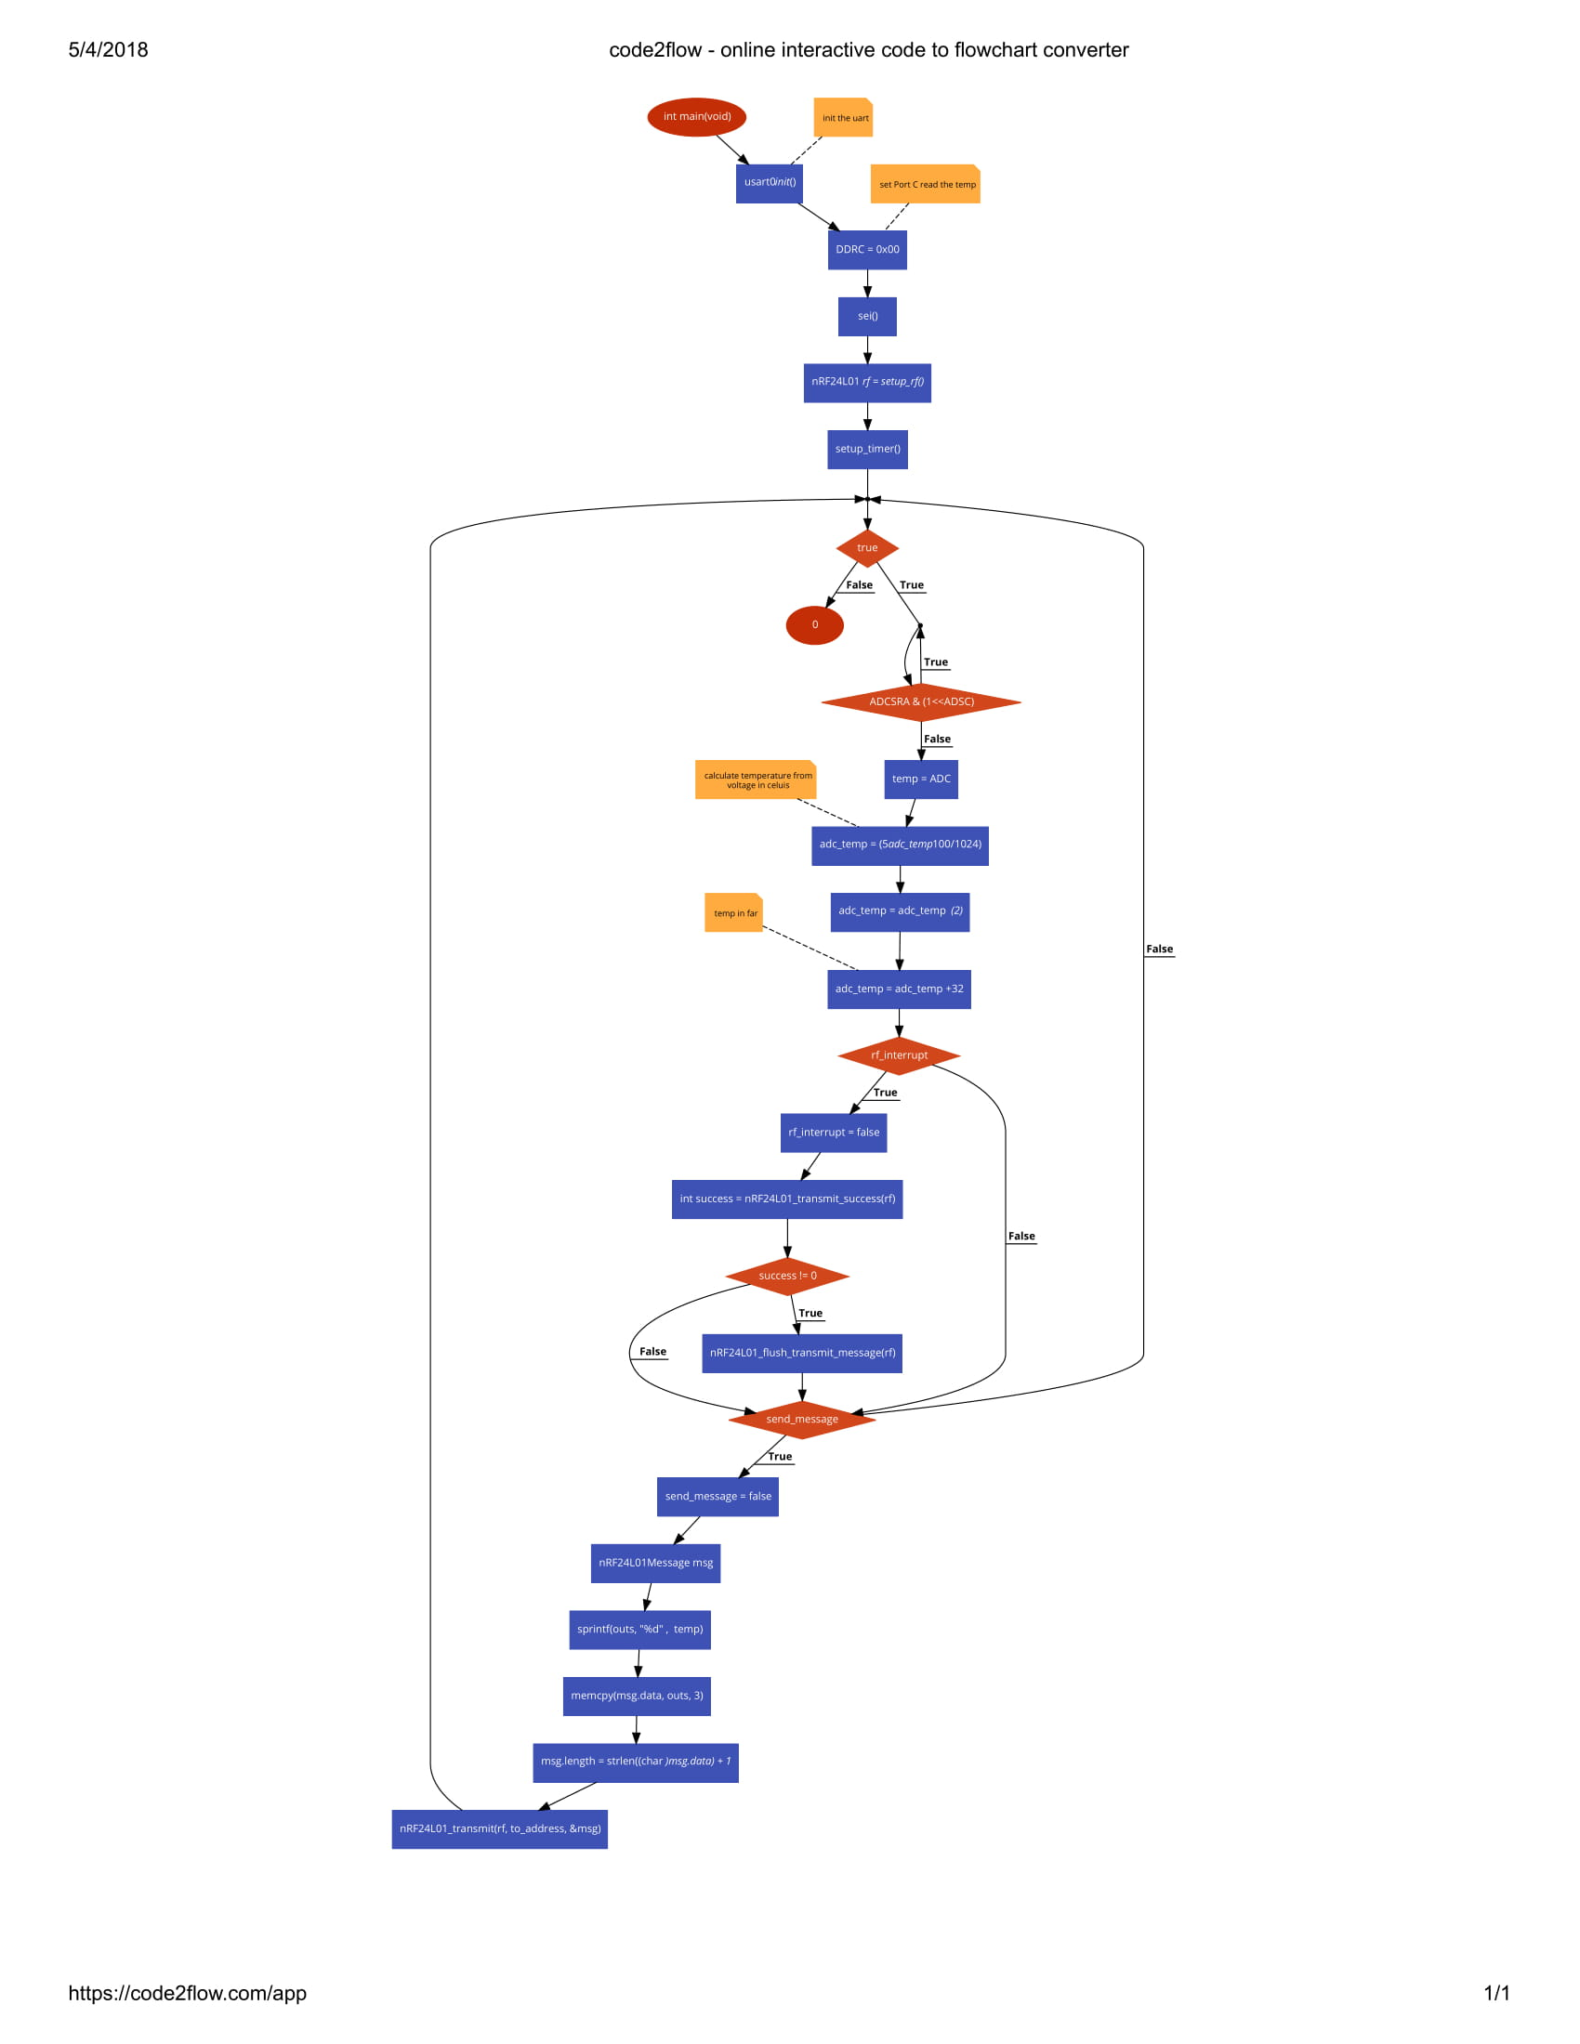

RX.c Flowchart

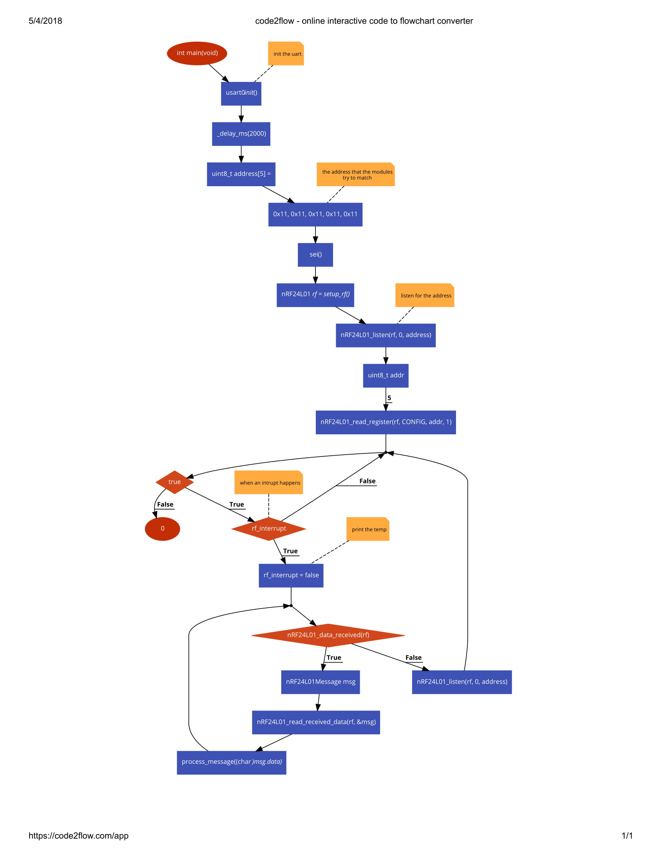

Video Link: