Adrian Ruiz

Cpe 403

CC1350 Lab 5

Screen Shot:

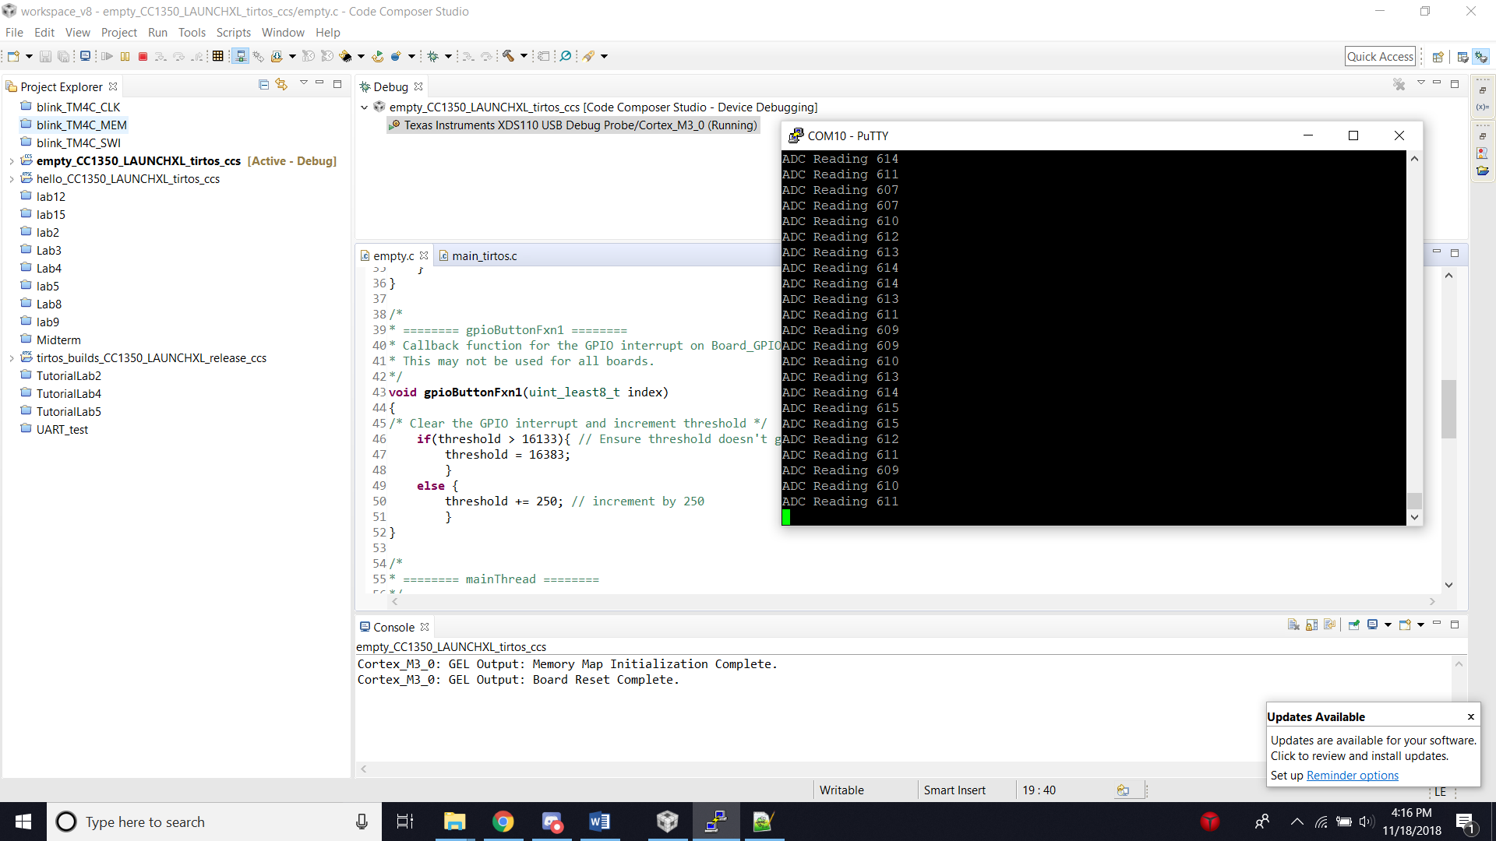

Objective: Read an ADC value from a pin and display it on the terminal. Buttons 0 and 1 are used to increase a threshold which turns on the LED if the ADC value is greater than the threshold.

Code:

/*

* ======== empty.c ========

*/

/* For usleep() */

#include <unistd.h>

#include <stdint.h>

#include <stddef.h>

/* Driver Header files */

#include <ti/drivers/GPIO.h>

#include <ti/drivers/ADC.h>

#include <ti/display/Display.h>

// #include <ti/drivers/I2C.h>

// #include <ti/drivers/SDSPI.h>

// #include <ti/drivers/SPI.h>

// #include <ti/drivers/UART.h>

// #include <ti/drivers/Watchdog.h>

/* Board Header file */

#include "Board.h"

/* GLOBAL VARIABLES FOR GUI COMPOSER */

uint16_t adcValue **=** 0**;**

uint16_t threshold **=** 100**;**

uint16_t trigger **=** 0**;**

/*

* ======== gpioButtonFxn0 ========

* Callback function for the GPIO interrupt on Board_GPIO_BUTTON0.

*/

void gpioButtonFxn0**(**uint_least8_t index**)**

**{**

/* Clear the GPIO interrupt and decrement threshold */

**if(**threshold **<** 250**){** // Ensure threshold doesn't go below zero

threshold **=** 0**;**

**}**

**else** **{**

threshold **-=** 250**;** // decrement by 250

**}**

**}**

/*

* ======== gpioButtonFxn1 ========

* Callback function for the GPIO interrupt on Board_GPIO_BUTTON1.

* This may not be used for all boards.

*/

void gpioButtonFxn1**(**uint_least8_t index**)**

**{**

/* Clear the GPIO interrupt and increment threshold */

**if(**threshold **>** 16133**){** // Ensure threshold doesn't go above max ADC range

threshold **=** 16383**;**

**}**

**else** **{**

threshold **+=** 250**;** // increment by 250

**}**

**}**

/*

* ======== mainThread ========

*/

void **\***mainThread**(**void **\***arg0**)**

**{**

/* ~10 loops/second */

uint32_t time **=** 100000**;**

/* Call driver init functions */

GPIO_init**();**

ADC_init**();**

// I2C_init();

// SDSPI_init();

// SPI_init();

// UART_init();

// Watchdog_init();

/* Open Display Driver */

Display_Handle displayHandle**;**

Display_Params displayParams**;**

Display_Params_init**(&**displayParams**);**

displayHandle **=** Display_open**(**Display_Type_UART**,** **NULL);**

/* Open ADC Driver */

ADC_Handle adc**;**

ADC_Params params**;**

ADC_Params_init**(&**params**);**

adc **=** ADC_open**(**Board_ADC0**,** **&**params**);**

**if** **(**adc **==** **NULL)** **{**

// Error initializing ADC channel 0

**while** **(**1**);**

**}**

GPIO_setCallback**(**Board_GPIO_BUTTON0**,** gpioButtonFxn0**);**

GPIO_setCallback**(**Board_GPIO_BUTTON1**,** gpioButtonFxn1**);**

/* Enable interrupts */

GPIO_enableInt**(**Board_GPIO_BUTTON0**);**

GPIO_enableInt**(**Board_GPIO_BUTTON1**);**

**while** **(**1**)** **{**

int_fast16_t res**;**

res **=** ADC_convert**(**adc**,** **&**adcValue**);**

**if** **(**res **==** ADC_STATUS_SUCCESS**)** **{**

Display_printf**(**displayHandle**,** 1**,** 0**,** "ADC Reading %d"**,** adcValue**);**

**if(**adcValue **>=** threshold**){**

GPIO_write**(**Board_GPIO_LED0**,** Board_GPIO_LED_ON**);**

trigger **=** 1**;**

**}**

**else{**

GPIO_write**(**Board_GPIO_LED0**,** Board_GPIO_LED_OFF**);**

trigger **=** 0**;**

**}**

**}**

usleep**(**time**);**

**}**

**}**