Adrian Ruiz

CPE 403

CC1350 Lab 5

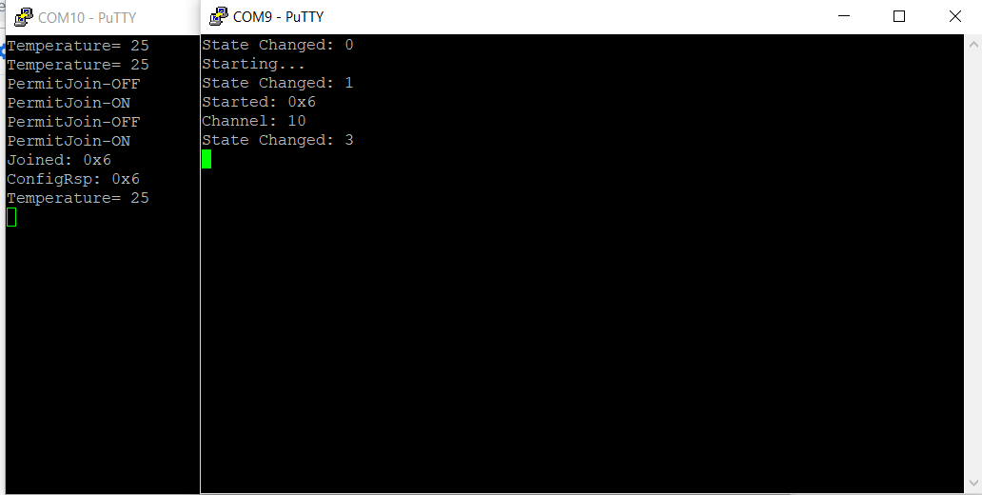

Objective:

The objective is to use the TI 15.4-Stack to enable RF communication between two CC1350 launchpads. The goal is to collect the temperature one launchpad and transmit and print it with the other launchpad.