Adrian Ruiz

CPE 403

CC1350 Lab6

Objective: The objective is to set up a wireless sensor network using the CC1350 launchpads. One launch pad will act as a sensor and gather ADC readings. It will then send its data to the other launchpad which acts as the central hub.

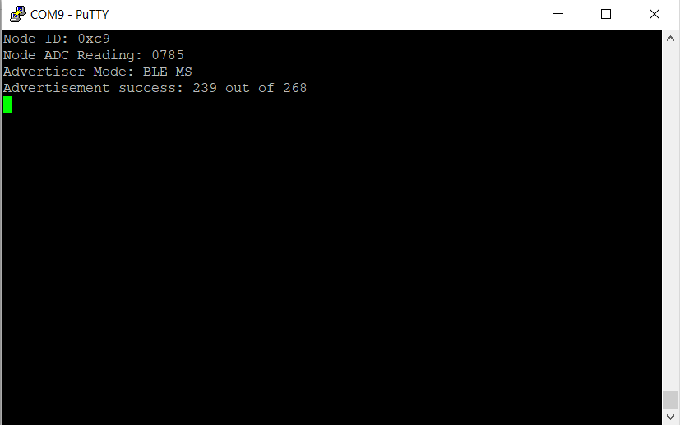

Example of Sensor Launchpad

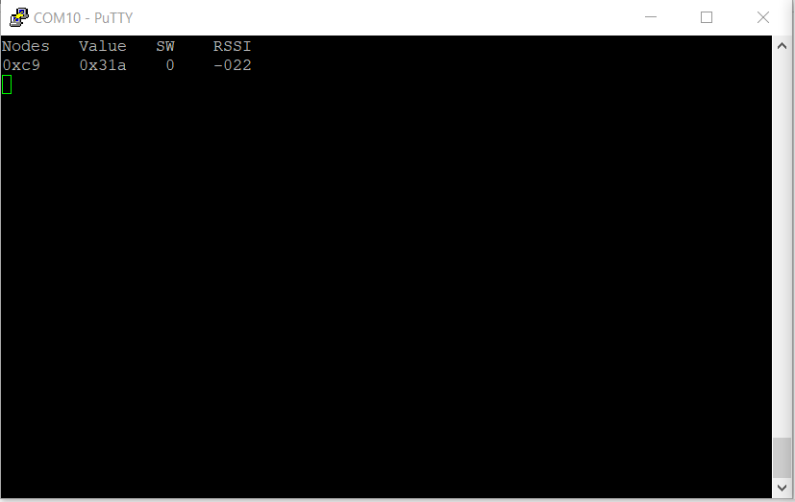

Example of Collector Launchpad