Adrian Ruiz

Dr. Venkatesan

CPE403

December 12, 2018

Sub-1 Ghz Sensor To cloud iot gateway

Problem Statement:

The goal of the project is to implement the Beagle Bone Black (BBB) as a Sub-GHz sensor gateway. There will be two CC1350 launchpads used. One Launchpad will collect sensor data and send it to the other Launchpad. This other Launchpad collects the data and passes it to the BBB. The data passed to the BBB is transmitted to the TI 15.4 Stack Application

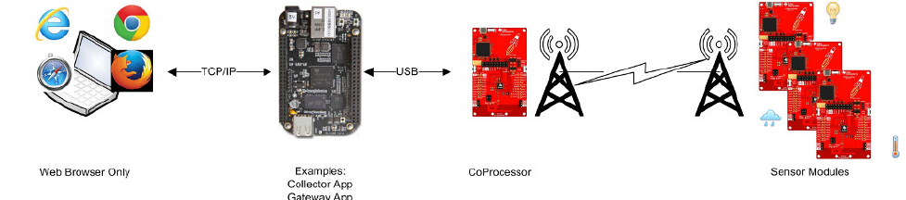

Figure 1. Hardware Setup

pre-requisites:

CC1350:

* Code Composer Studio
  + Download here: [www.ti.com/tool/ccstudio](http://www.ti.com/tool/ccstudio)
  + Install following Processor Support

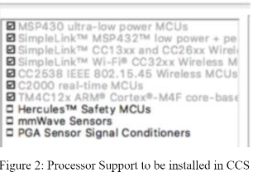

* + Install following debug probes

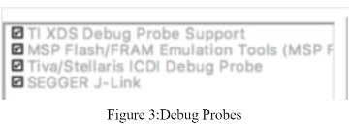

* Install

BBB:

* Virtual Box: installation steps: <https://www.wikihow.com/Install-VirtualBox>
  + Install Ubuntu: <https://www.wikihow.com/Install-Ubuntu-on-VirtualBox>
    - Install TI Stack SDK on Ubuntu: <http://www.ti.com/tool/ti-15.4-stack-gateway-linux-sdk>
* Etcher
  + an image flasher
* Putty
  + Terminal emulator, serial console, and network file transfer

implementation details:

CC1350:

1. Import Sensor Example Code from \Examples\Dev tools\ CC1350 LaunchPad\TI 15.4 Stack folder
2. Import Collector Example Code from \Examples\Dev tools\ CC1350 LaunchPad\TI 15.4 Stack folder
3. Flash one Launchpad with the Sensor code. Flash the other Collector code

BBB:

1. Flash the SD card with the Linux image.
2. Download the TI 15.4 Stack on an Ubuntu machine
3. Place the SD into the BBB and install the required packages and the required libraries
4. Connect the Collector Launchpad to the BBB. Check if the Collector Launchpad works. When running the ls -l /dev/ttyACM*, the output should look like the figure below.

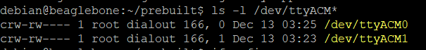

1. Transfer the prebuilt tar file from the Ubuntu machine to the BBB.
2. Extract the tar file and run the demo application
3. Copy the url displayed in the BBB into your Browser

outcomes, results and conclusions:

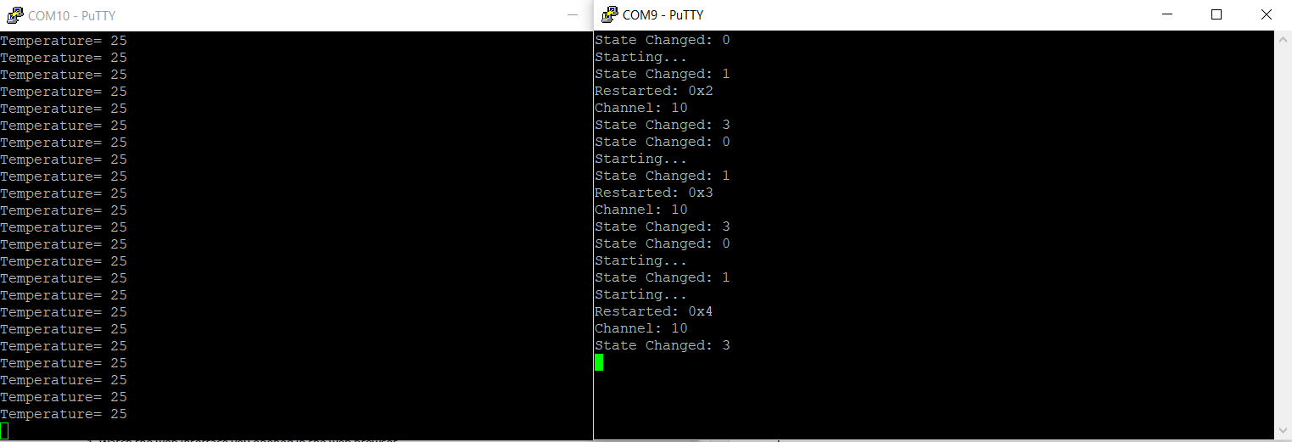

Figure 4. COM10 is Collector Port. COM9 is the Sensor Port

Conclusion: The project was unsuccessful. I was unable to ssh into the BBB with am-evm-linux image, so I had to use Debian. I was able to get the set everything up guide. However, when it came to running the TI-Stack app, I would get error shown in figure 5. Thus, I was able to send data through the gateway. This error probably came from me using Debian instead of the Linux image because that .sh file is never found. Also, the Sensor to Cloud IoT Gateway guide we were suppose to follow had the user a humidity sensor, and a battery pack. Those were not in my lab kit, so I was unable to do those parts of the guide.

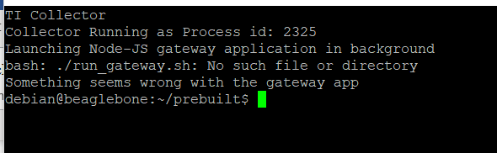

Figure 5. Application Error.