Adrian Ruiz

CPE 403-1001

Lab 3

Task 01: Determine the current period and on-time of the LED blinking. Change the delay of the

LED blink (approx. 0.425 sec) by changing the clock source and configuration – do not change

the delay value – determine the CLK frequency – verify the delay to be approx. 0.425 sec.

In order to create a 0.425 second delay, I changed the system clock to run at around 4.65 MHz.

|  |  |  |
| --- | --- | --- |
| 2*43 | 2E6 | =0.425s |
| 400MHz |  |  |

Code:

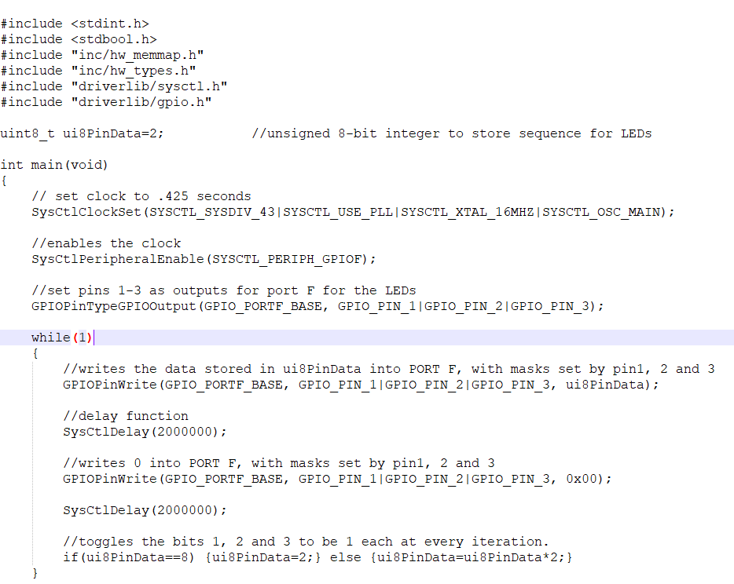

Task 02a: Change the sequence of LED blinking

Code:

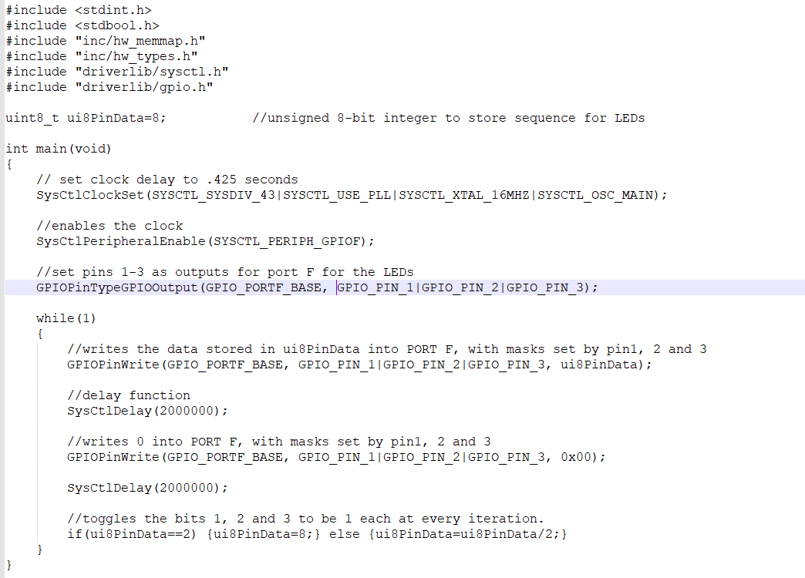

Task 02b: Blink LEDs in a sequence

Code:

