Adrian Ruiz

CPE 403

Lab 9

Task 01:

Code:

#include <stdint.h>

#include <stdbool.h>

#include <math.h> //Math Functions

#include "inc/hw_memmap.h"

#include "inc/hw_types.h"

#include "driverlib/fpu.h" //Floating Point

#include "driverlib/sysctl.h"

#define TARGET_IS_BLIZZARD_RB1 //Symbol to access ROM

#include "driverlib/rom.h"

#ifndef M_PI

#define M_PI 3.14159265358979323846 //pi

#endif

#define SERIES_LENGTH 100 //100 calulations

float gSeriesData**[**SERIES_LENGTH**];** //holds calculated data

int32_t i32DataCount **=** 0**;** //count of data to iterate

int main**(**void**)**

**{**

float fRadians**;** //holds two pi

ROM_FPULazyStackingEnable**();** //turn on lazy stack

ROM_FPUEnable**();** //turn on fpu

ROM_SysCtlClockSet**(**SYSCTL_SYSDIV_4 **|** SYSCTL_USE_PLL **|** SYSCTL_XTAL_16MHZ **|** SYSCTL_OSC_MAIN**);** //Clock to 50 MHz

fRadians **=** **((**2 **\*** M_PI**)** **/** SERIES_LENGTH**);** //segment of 2pi

**while(**i32DataCount **<** SERIES_LENGTH**)**

**{**

gSeriesData**[**i32DataCount**]** **=** sinf**(**fRadians **\*** i32DataCount**);** //calculate sine value

i32DataCount**++;** //get the next sine value

**}**

**while(**1**)**

**{**

**}**

**}**

Task 02:

Altered Code:

I increased the number of samples to 1200 in order to get a better graph and to get around 5 Hz frequency. I also added a cosine function for the second half of the equation.

Code:

#include <stdint.h>

#include <stdbool.h>

#include <math.h> //Math Functions

#include "inc/hw_memmap.h"

#include "inc/hw_types.h"

#include "driverlib/fpu.h" //Floating Point

#include "driverlib/sysctl.h"

#define TARGET_IS_BLIZZARD_RB1 //Symbol to access ROM

#include "driverlib/rom.h"

#ifndef M_PI

#define M_PI 3.14159265358979323846 //pi

#endif

#define SERIES_LENGTH 1200 //1200 calulations

float gSeriesData**[**SERIES_LENGTH**];** //holds calculated data

int32_t i32DataCount **=** 0**;** //count of data to iterate

int main**(**void**)**

**{**

float fRadians**;** //holds two pi

float Pi2 **=** **(**M_PI **/** 2**);**

float temp**,** holder**;**

FPULazyStackingEnable**();** //turn on lazy stack

FPUEnable**();** //turn on fpu

SysCtlClockSet**(**SYSCTL_SYSDIV_4 **|** SYSCTL_USE_PLL **|** SYSCTL_XTAL_16MHZ **|** SYSCTL_OSC_MAIN**);** //Clock to 50 MHz

fRadians **=** **((**2 **\*** M_PI**)** **/** SERIES_LENGTH**);** //segment of 2pi

**while(**i32DataCount **<** SERIES_LENGTH**)**

**{**

temp **=** sinf**(**fRadians **\*** i32DataCount **\*** M_PI **\*** 100**)** **;** //calculate sine value

holder **=** 0.5**\***cosf**(**fRadians **\*** i32DataCount **\*** 400 **\*** M_PI**);**

gSeriesData**[**i32DataCount**]** **=**temp **+** holder**;**

i32DataCount**++;** //get the next sine value

**}**

**while(**1**)**

**{**

**}**

**}**

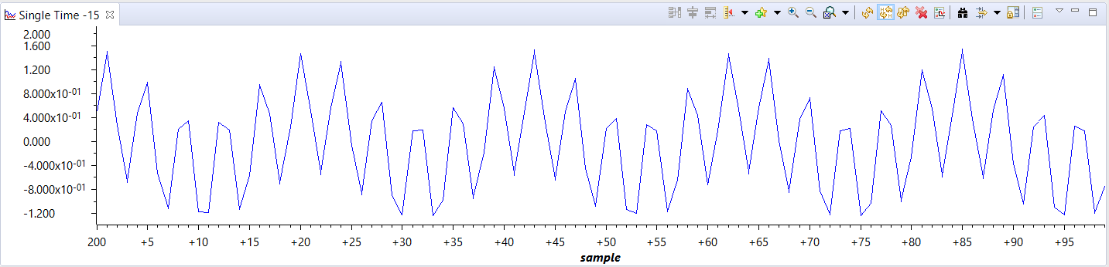

Since the equation y = sin(100πt) + 0.5cos(400πt) values change frequently, the graph doesn’t match the equation. When the sample is calculated, the next one changes crazy so it is not a smooth graph. A smooth graph was made when the equation is sin(πt) + cos(4πt) which has the same shape.

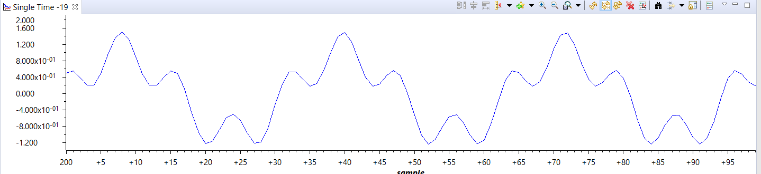

Frequency:

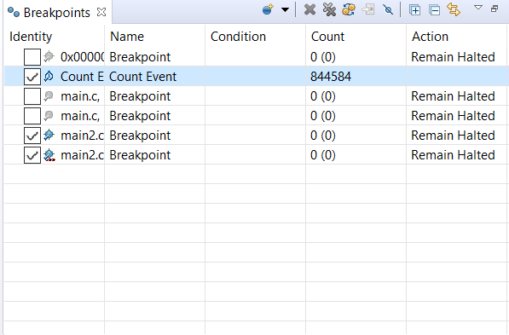

It took about 8446 clock cycles to run the calculations. With the clock of 50Mhz, that translates to a time of .169 milliseconds, and because there were 1200 samples, the total time is about .2 seconds or 5 Hz