Top level view

This shows list of containers available on each docker hosts and their various performance metrics like CPU Utilization, Memory Utilization, Network Configuration, Disk Usage and status

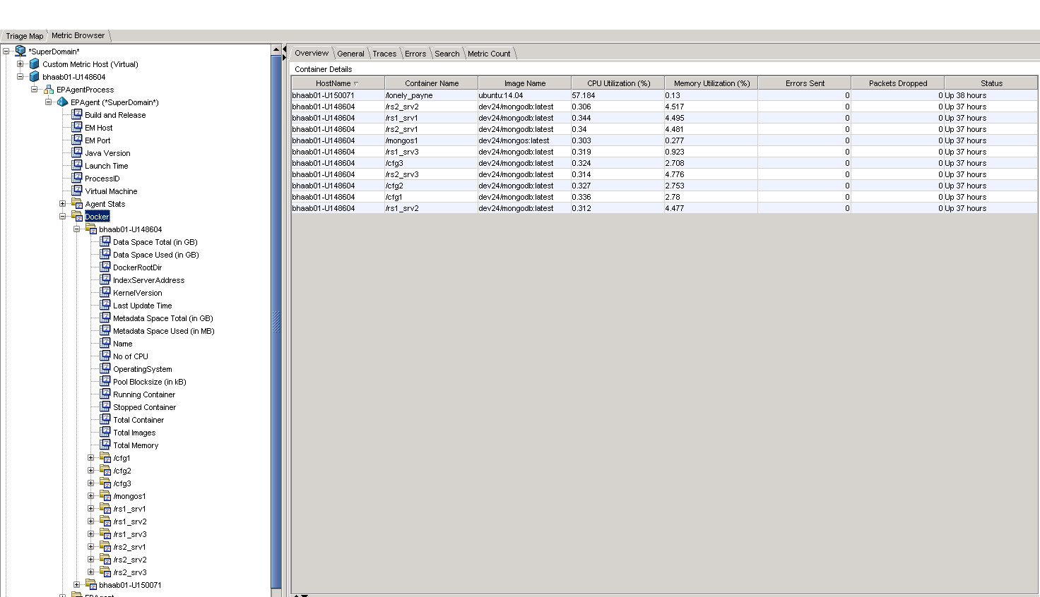

List of containers at Host Level :

This contains information on the list of docker containers on each host and their *performance* metrics. The top level infomation contains some useful information on the docker application on that host name

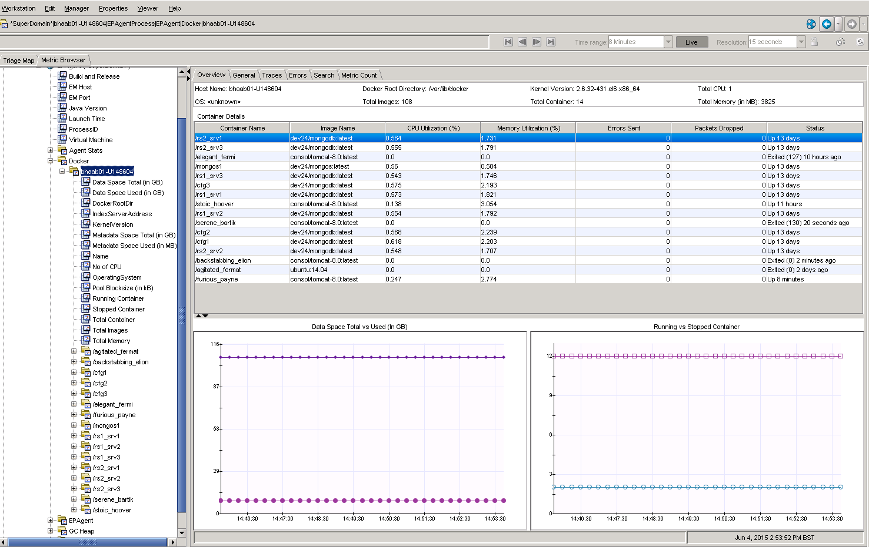

Each container details:

At each container level, this contains useful performance metrics

