**FTP Response Time Probe (ftp_response) v1.02**

**Documentation**

logo

Nimsoft GmbH  
Leopoldstraße 244  
80807 München  
Germany

|  |  |  |  |
| --- | --- | --- | --- |
| Title: | Ftp_reponse manual | | |
| Author: | Chris Lükermann (chris.luekermann@nimsoft.com) | | |
| Document Version No: | V1.02 | Document Version Date: | 11/March/2010 |
| Revision History |  |  |  |
| Date | **By** | Changes |  |
| 11/March/2010 | Chris Lükermann | Initial version | |
|  |  |  | |

# Introduction

The FTP Response Time probe is used to monitor File Transfer Protocol servers by logging into the server, performing various optional upload/download steps and logging out.

For each step, the response time as well as the general availability of the ftp login is being reported.

The probe supports a unlimited amount of profiles to be monitored at individual intervals.

# Requirements

Software requirements:

Nimsoft Robot v. 3.x or higher

Nimsoft Perl Runtime or Perl Runtime for Windows platform

# Probe installation and configuration

Drop the probe package from the archive to the robot but do not activate it just yet. Double-click the probe and use Raw Configure to specify the configuration values.

When done, activate the probe to start monitoring.

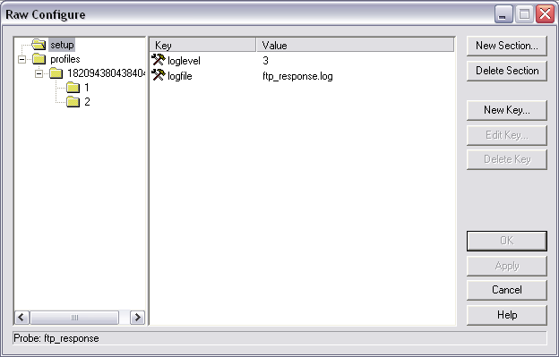

|  |  |  |
| --- | --- | --- |
| **Key** | **Values** | **Explanation** |
| Loglevel | 1-5 | Level of detail of log messages. |
| Logfile | Name of a file | The file to send log messages to. You must not modify this unless you want to redirect output for debug purposes. |

# Configuration of a monitoring profile

Using “Raw Configure” you can specify as many monitoring profiles you want.

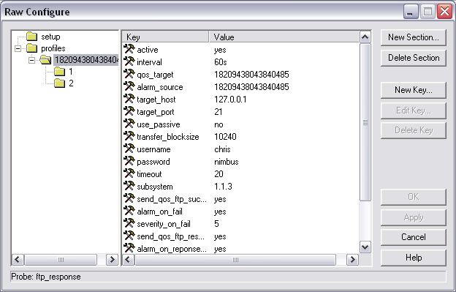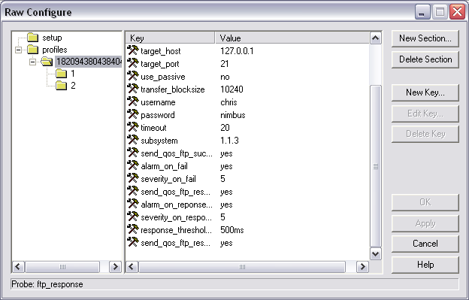

|  |  |  |
| --- | --- | --- |
| **Key** | **Values** | **Explanation** |
| Active | yes|no | Whether this profile should be monitored. |
| Interval | Interval in seconds (e.g. 60s) | The interval in seconds in which to perform this check. |
| Qos_target | String | Under which target should QoS messages be published? |
| Alarm_source | String | What value should be put into the source-attribute of generated alarms? |
| Target_host | String | The hostname/ip address of the target ftp server. |
| Target_port | Integer | The tcp-port of the target ftp server. |
| Use_passive | Yes|no | Should the FTP passive mode be used? |
| Transfer_blocksize | Integer | The blocksize to use when transferring files via ftp. |
| Username | String | The username used to log into the ftp server. |
| Password | String | The password used to log into the ftp server. |
| Timeout | Integer | The timeout in seconds. |
| Subsystem | Subsystem-ID | The subsystem-ID to be used when generating alarms. |
| Send_qos_ftp_success_login | Yes|no | Should a QoS-value of 0|1 be sent on whether the login succeeded? |
| Alarm_on_fail | Yes|no | Should an alarm be generated if a step fails? |
| Severity_on_fail | 0-5 | The severity of a generated alarm if a step fails. |
| Send_qos_ftp_response_login | Yes|no | Should the response-time of the login to the ftp server (in milliseconds) be sent as a QoS-value? |
| Alarm_on_responsetime | Yes|no | Do you want to generate an alarm if the login takes longer than a certain threshold? |
| Severity_on_response | 0-5 | The severity of a generated alarm if the response time threshold for the login is being exceeded. |
| Response_threshold_login | Integer | The threshold (milliseconds) for the response time for the login. |
| Send_qos_ftp_response_quit | Yes|no | Should a QoS-value be sent on the time it took to log off from the ftp server? |

In addition to the login checking, as many upload/download steps can be defined.

## Put-Step

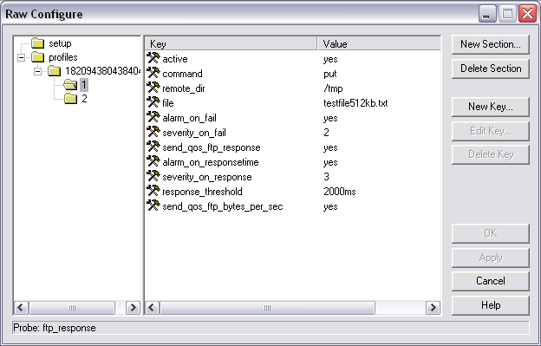

|  |  |  |
| --- | --- | --- |
| **Key** | **Values** | **Explanation** |
| Active | yes|no | Whether this step should be executed. |
| Command | Put | Do not change |
| Remote_dir | String | The path to the remote-directory where to upload the file. |
| File | String | The name of the file to upload. |
| Alarm_on_fail | Yes|no | Should we generate a alarm if this step fails? |
| Severity_on_fail | 0-5 | The severity of the alarm if this step fails. |
| Send_qos_ftp_response | Yes|no | Should a qos-Value of the response-time for this step be sent (in milliseconds)? |
| Alarm_on_responsetime | Yes|no | Do we want to monitor the response time for this step? |
| Severity_on_response | 0-5 | The severity of the alarm if the response time for this step exceeds the threshold. |
| Response_threshold | Integer | The threshold for the response time monitoring in milliseconds. |
| Send_qos_ftp_bytes_per_sec | Yes|no | Should the transfer rate (size of transferred size in bytes / response time in seconds) be sent as a qos-value? |

## Get-Step

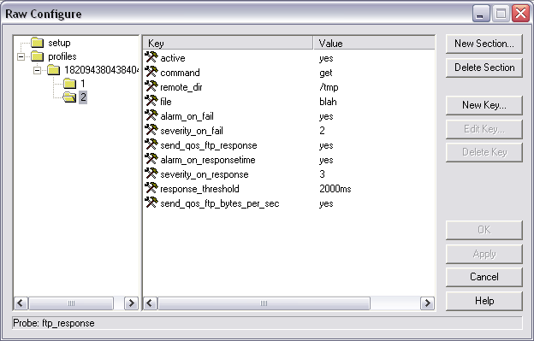

|  |  |  |
| --- | --- | --- |
| **Key** | **Values** | **Explanation** |
| Active | yes|no | Whether this step should be executed. |
| Command | Get | Do not change |
| Remote_dir | String | The path to the remote-directory where to download the file. |
| File | String | The name of the file to download. |
| Alarm_on_fail | Yes|no | Should we generate a alarm if this step fails? |
| Severity_on_fail | 0-5 | The severity of the alarm if this step fails. |
| Send_qos_ftp_response | Yes|no | Should a qos-Value of the response-time for this step be sent (in milliseconds)? |
| Alarm_on_responsetime | Yes|no | Do we want to monitor the response time for this step? |
| Severity_on_response | 0-5 | The severity of the alarm if the response time for this step exceeds the threshold. |
| Response_threshold | Integer | The threshold for the response time monitoring in milliseconds. |
| Send_qos_ftp_bytes_per_sec | Yes|no | Should the transfer rate (size of transferred size in bytes / response time in seconds) be sent as a qos-value? |

# Payload sample files

The probe comes with a subdirectory containing various ascii-text files to be used for testing purposes.

The available files are:

* testfile1kb.txt
* testfile64kb.txt
* testfile512kb.txt
* testfile1024kb.txt