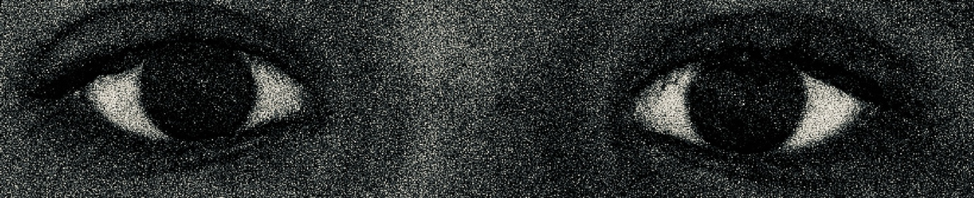
Does Bliss Come from Blindness?
[SPEAKER is concealed from the viewer, though every word is heard clearly. The viewer sees a shadow move across a sterile room towards a hospital bed.]
THE SPEAKER: Happiness.
[His voice is disorienting; it’s pitch and intonation flawed.]
THE SPEAKER: I think that everyone would agree with me when I say that happiness is something we all chase.
[THE SPEAKER pauses, considering. The viewer feels a presence.]
THE SPEAKER: Humans covet every butterfly that flutters its wings from the confine of our rib cages— and hang onto every hit of dopamine we get, for as much time as we can wrench from the hands of Fate. For as long as it can possibly last us.
[The universe watches THE SPEAKER, idly pulling strings.]
THE SPEAKER: I struggle to put these feelings— of possession, of joy, of misery and more —into words. It is as if we were not meant to understand this world— nor ourselves.
[THE SPEAKER sighs, now moving over to a rack of sinister instruments methodically laid out on a silver table. He is the only thing hidden from the viewer.]
THE SPEAKER: And as I stand here, I wonder; Why do we covet this singular emotion with such hunger? Is it because we are man, and man is that which feels, so ardently and wholly?
[He produces a pen from his coat pocket and plucks a scalpel from the workbench, examining each in turn.]
THE SPEAKER: Or is it because of the very wiring of our brains which make us follow such a pursuit as joyfulness?
Well, I don’t know, but I could guess.
[THE SPEAKER begins speaking again, now with renewed vigour.]
THE SPEAKER: I think the darkness of opposing emotions— fear and sorrow, for example —give off such a shadow that can only be vanquished by the glow of elation. And so, only by experiencing the lows of pain and misery, can you truly understand the true height of happiness. I suspect that they know this. These people who experience suffering worthy of such a high return, and they shift to more convenient methods of handling their unhappiness. Ones that will provide them with the release they crave.
[He waves his hand excitably. Pen, scalpel, and other instruments are replaced by a pouch of white powder, a bottle of gin, and a sleeping pill.]
THE SPEAKER: And so, the dilemma is; If was possible to medically cure heartbreak and loneliness with a pill, would we? I’m an optimist, I like to think I wouldn’t toss away my humanity like that.
[He turns.]
THE SPEAKER: What do you think? Would you take a sip from the flask titled “ESCAPISM”, content to bask in your bliss until it wears off and you head out to buy some more?
[THE SPEAKER suddenly grows angry; the viewer watches his shadow as it sweeps the objects off the table. The alcohol bottle shatters upon impact with the ground.]
[THE UNIVERSE leaves.]
THE SPEAKER: Would I? What would your father do? Your mother? The man in the alleyway down the block, sleeping in a cardboard box? Are your problems valid, do they haunt you? Are they horrifying enough to wish away your agency with the swallowing of a pill?
[He runs a hand over what the viewer can assume is his face.]
THE SPEAKER: In your left hand you hold pain, heartache, and truth—
[He cuts himself off, and speaks quickly as if running out of time]
THE SPEAKER: —in the other you hold joy, sweetness and lies. Which one do you choose? You choose the right of course, but the sweetness rots in your mouth and the joy burns your eyes until you are blind and unfeeling while lies turn your ears deaf to all foreign sound.
[He is silent for a moment, and all the viewer hears is THE SPEAKER’s heavy breathing before he pulls himself up to sit on the hospital bed.]
THE SPEAKER: Would you even know which choice is which? Perhaps the left appears to you as the better path, a good kind of life. After all— pain is the best teacher and in order to grow, you must bleed. It is well known. And so, you choose the right in fear of being deceived by a kind lie.
[He reaches underneath the thin pillow; THE SPEAKER holds something within his right hand.]
THE SPEAKER: Hm, perhaps I’m beginning to side with the pessimists. After all, to be human is to feel. And elation is the most powerful feeling of all.
[THE SPEAKER turns to look the viewer in the eye, and the scene fades to black just as he opens a blood-stained pill bottle labeled “HAPPINESS”]

