Alec Austin - J00501671

Lab 11

Part 1:

Part 2:

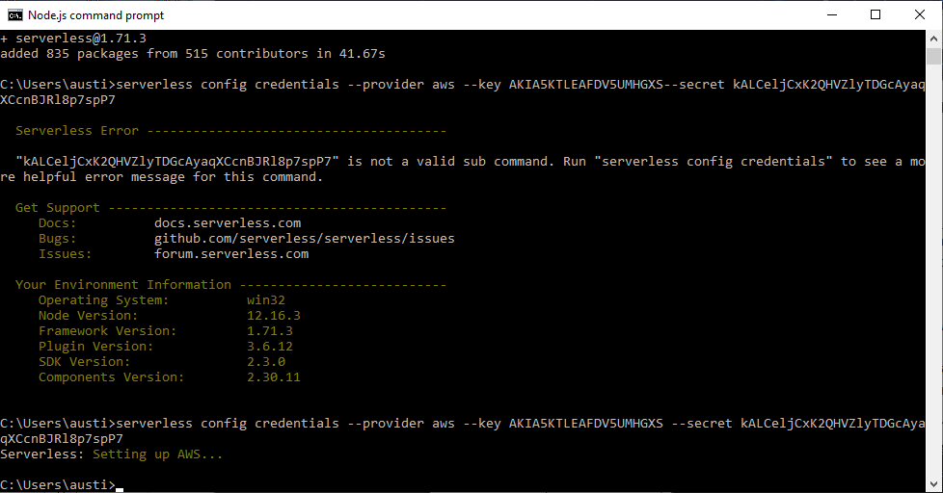

Part 3:

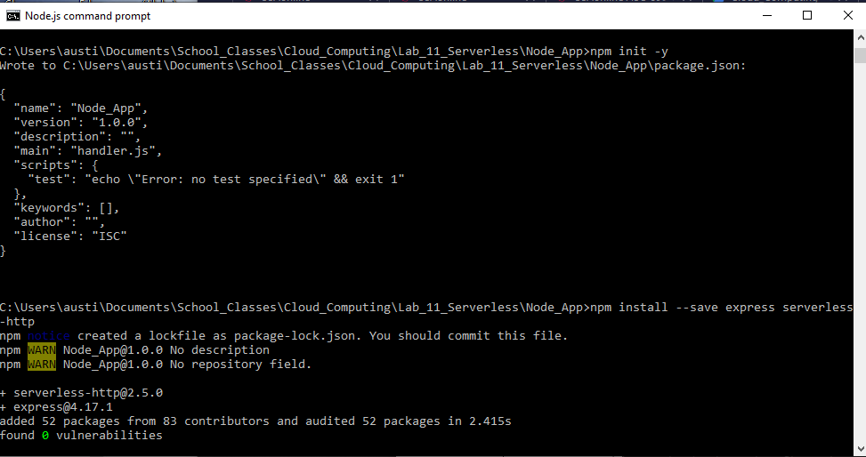

Part 4:

Part 5:

