Alec Austin - J00501671

Lab 5

Part 1:

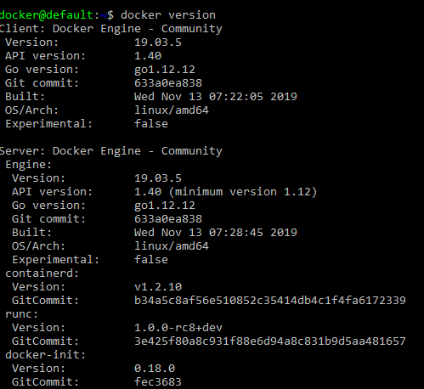

Part 2:

